Measuring the Speed of Earth around the Sun
Astronomy Activity
TEACHER NOTES
Level: Moderate to advanced level for High School.
Objective: This is a deep 1-2 week exploration of modeling the motion of the Earth around the Sun, then working with, or acquiring, data from the DSPIRA Radio Horn Telescope.
Recommended Sequence of Activities
DSPIRA Activity | General Astronomy Students | Physics Students | Goal
 | Check student math understanding with circumference, units, conversion and Sci Not | Standard teacher generated Circular Motion and Univ. Law of Gravity lessons | Preparation for a long “real science” journey
A1 | How Fast are We Moving? | Understanding Gravity | To calculate the Earth’s Speed around the Sun.
E2 | Modeling the Earth’s Motion around the Sun | Modeling the Earth’s Motion around the Sun | Graphically determine the radial velocity component of the Earth’s velocity at various points around its orbit
E3 | Earth’s Motion with respect ot the Galactic Center | Earth’s Motion with respect ot the Galactic Center | Tying actual dates to the Mode using Stellarium
 | Intro Lecture to Doppler Effect | Intro Lecture to Doppler Effect | Prep for next activity
E4 | Working with actual Radio Horn Data to determine Speed towards Galactic Center | Working with actual Radio Horn Data to determine Speed towards Galactic Center | Introducing Doppler Equation and working with spectra from Gal Center to compute radial speed
E5 | Comparing Earth’s motion Model to Actual Spectra Data | Comparing Earth’s motion Model to Actual Spectra Data | Compare Datasets from Model Activity (2) with data from Doppler Analysis in Activity 4
E6 | Obtaining your own Galactic Center Spectra for Analysis | Obtaining your own Galactic Center Spectra for Analysis | An Opportunity for Students to obtain a Spectrum to analyze and add to the dataset.
Pre-Knowledge of Students:
- Basic Algebra and calculator skills.
- If the students are led from Activity 1, each one will build towards the next.
- Physics Students should have gone through basic circular motion and Newton’s Universal Law of Gravity lessons with the teacher prior to attempting the Understanding Gravity activity.
Key Terms:
Tangent, Velocity, Doppler Effect, Radial Component, Galactic Center
Related Videos for Teacher:
Activity E2 - Hints for Modeling Earth Diagram
Activity E3- Quick tutorial for Stellarium - Web Version
Activity E3- Stellarium - Web or Download version?
Activity E4 - Example of analyzing the spectrum graph
Teacher Preparation:
- This is a multi-activity sequence that will involve a fair amount of prep time. The activities are meant to be very instructive to help the students through each activity on their own. From previous teacher experience. top performing students have made it through many of these activities on their own, but many students will have questions...Many teachers may have questions.
- The videos are attempts to cover problems that students have experienced.
- Answer keys are currently not being generated since the intent of these documents is to be accessible by all. It is always good to try the activities on your own to get a sense of the activity before giving them to the students. It is an opportunity to generate an answer key.
Activity E2- Modeling the Earth’s Motion around the Sun
- Activity E2 - Modeling Earth….You may want to make copies of the protractor on transparencies so the students can see through the protractor for easier alignment.
- Activity E2 - The Model Diagram is a .png file. It was kept separate since it was designed to be printed at 100% size so that the grid squares are 1 cm each.
Activity E3-Using Stellarium to find the Galactic Center
- Activity E3 - This activity is meant to be doable from just the instructions and access to Stellarium Web online version.
- Activity E3 - If you are venturing deep into DSPIRA activities and eventually working with the Radio Horn Telescope, you may wish to take on working with the downloadable version (still free). It would be good to have it downloaded on a few laptop computers that might also be used with the Horn Telescope.
Activity E4- Measuring the Earth’s Motion Around the Sun using the Doppler Shift
- This lesson is expected to follow E2 and E3. The idea is that the Model is set, and here is real data to analyze to test the Model.
- The actual data was taken by DSPIRA Teachers over the course of a year to test out the ability to measure the Earth’s Speed around the Sun...The experiment was considered successful.
- The nice thing about students getting data graphically is that their ability to read graphs and interpret data will establish a range of values around the class that should hover around the same values, but all won’t be exactly the same. It can be a good group discussion point.
Activity E5 Earth Model vs Actual Data
- This is a short activity to bring all the data from the Earth MODEL chart (E2) and the actual velocities from the DOPPLER Chart (E4) into one space.
- Each student will have 6 data points for the difference between the Model and the Actual Data. Because of graph work, their interpretation of the data should lead to a unique set of numbers, though they should all be in the same neighborhood.
- There is an opportunity to have them share their data with the whole class. If you have a Google Classroom or a similar shared document environment, they can add their data to a shared spreadsheet (Google Sheet attached). Their data should create a nice histogram to help build confidence in the data.
- If done correctly, their data should NOT bounce around 0. Once the difference between the model and the actual spectra comes in, there is a notable difference. It can be left as a major discussion point for speculation as to why.
- The year long dataset collected by DSPIRA teachers and students resulted in a difference of +7.0 +/-1.0 km/s. Though the data has shown a solid sinusoidal nature, there is a skew in the data. The reason is that the Sun’s motion around the center of the Galaxy is also elliptical, and currently, it is believed that the Sun has an inward component of velocity of about 10 km/s. So, the DSPIRA result is in the neighborhood of this value.
- 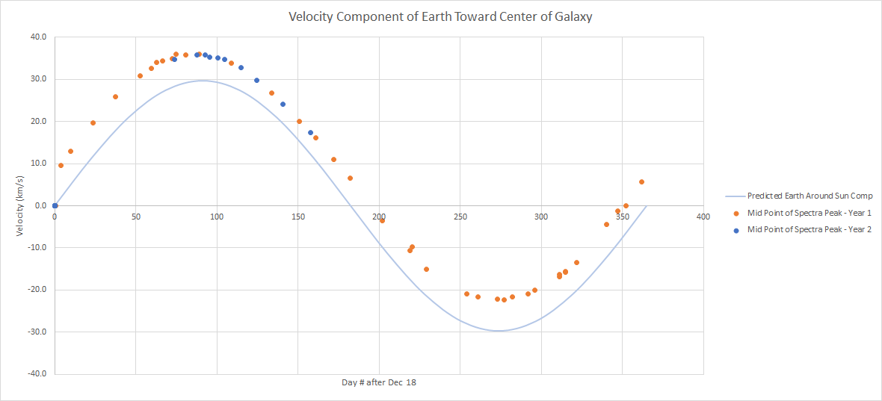
Activity E6 - Student generated spectrum and data analysis
- There is no E6 Activity Document for this activity. The students will be getting their own spectra with the DSPIRA Radio Horn Telescope. Once they have the data, then they can put the data into a spreadsheet and create their own graph and follow the procedures from E2 and E4 to eventually agree with the results from the previously done analysis of Activity E5.
Activity Notes:
  - The order of the sequence is specifically designed and shouldn’t be done out of order.
  - The first activity in both the Astronomy and Physics sequences listed in the table is the only stand alone activity.
  - The last activity could be left as extra credit, and is the only one that actually requires the Horn Radio Telescope.

