Horn and can assembly
  - Teaching guide
Overview of Telescope Design
- The Horn is designed as an ‘optimal’ horn, constructed from 1 gallon square paint thinner can and aluminized insulation board.
- The cradle provides a frame for the horn to be easily connected to any support stand of your choice. The cradle design presented here provides an ability for the horn to be rotated on an axis to set any elevation desired.
- The cradle can be connected to any base desired. The wooden support stand presented here provides sturdy support for the horn. It is a simple design that is affordable and easy to construct. Its largest dimension is 75 cm so that it just fits through a standard doorway.
1. Horn-Can Assembly

MATERIALS NEEDED
- 4’ × 8’ sheet of aluminized home insulation board – one sheet can make one horn; two sheets can make 3 horns
- 1 gallon square paint thinner can (F-style metal gallon container)
- Copper wire for probe (gauge 4 or 6) – the probe is 5.25 cm long
- Panel mount 4 hole male bulkhead SMA connector for the feedthrough
- Aluminum flashing – for providing support between the horn and the can
- Foil tape – e.g. 3M HVAC tape or Metal Repair tape – for taping the horn interior
- Duct tape – because you can’t do a building project without it.

ASSEMBLING THE HORN
1. Cut the horn sides out of the 4’ × 8’ sheet of aluminized home insulation board, as illustrated below:
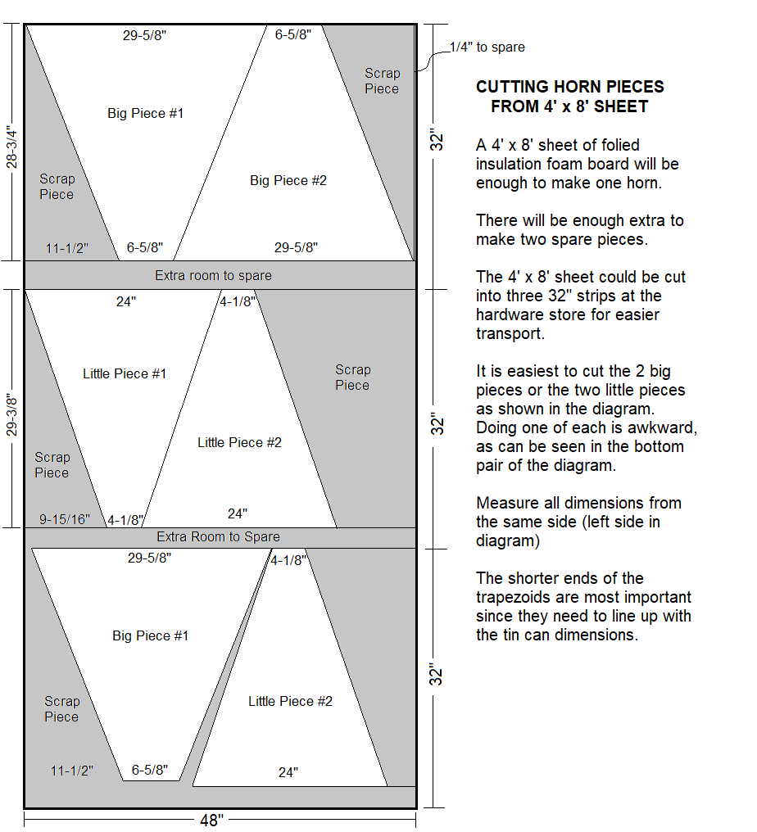
2. With the silver side of the panels facing upward, align the panels side by side and use the foil tape to tape the panels together, as shown below:
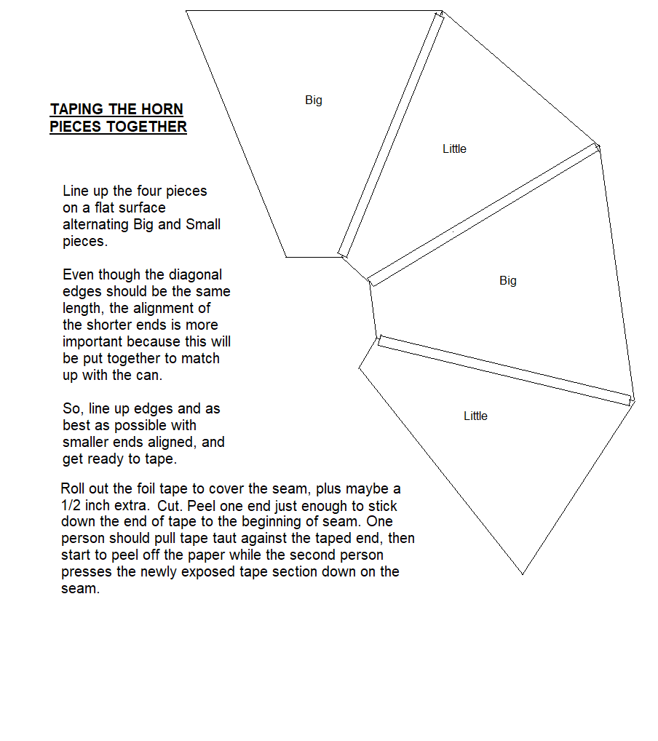
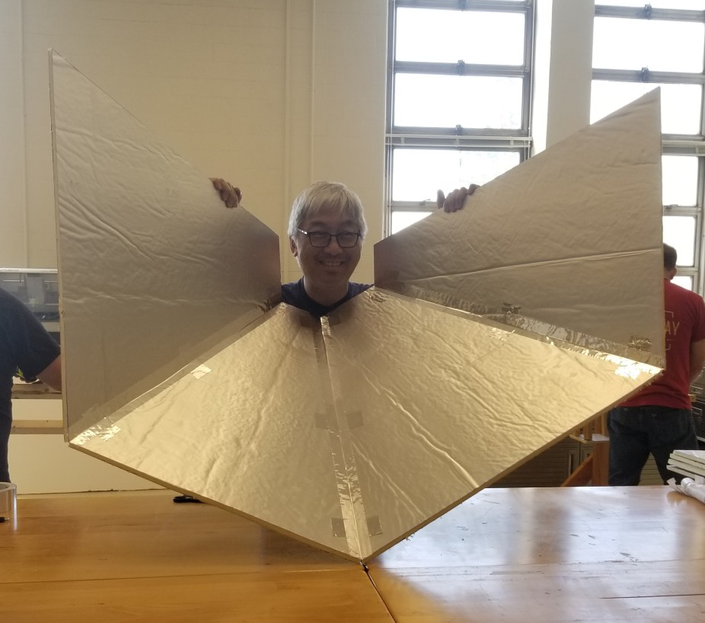
3. Complete the horn assembly by taping the remaining edges together to form a square pyramid horn.
NOTE: The silvered faces of the panels are the inside surface of the horn.
4. Tape over the top and bottom edges of the horn using the foil tape so that the edges are sealed. This provides protection to the horn edges from damage. (It also looks nice.)

ASSEMBLING THE CAN
1. Cut off the bottom of the can using a smooth edge can opener (e.g. an Oxo Smooth-edge can opener).
2. Solder the 5.25 cm long copper probe to the pin of the SMA feedthrough. See below.
3. Drill a ¼ “ hole through the side of the can along the midpoint at a distance of 5.25 cm from the capped end of the can, as illustrated below.
Suggestion: Place a block of wood on the inside of the can as you drill. This helps prevent the can from collapsing during drilling.
4. Solder the SMA feedthrough to the can with the copper probe extending into the can.
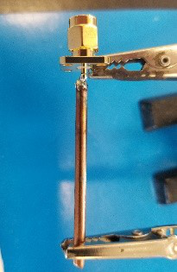
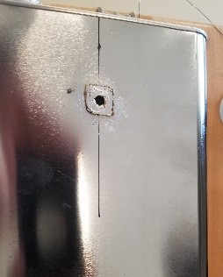
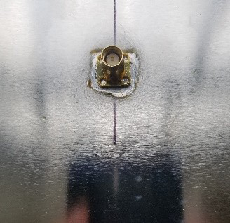

ATTACHING THE HORN TO THE CAN
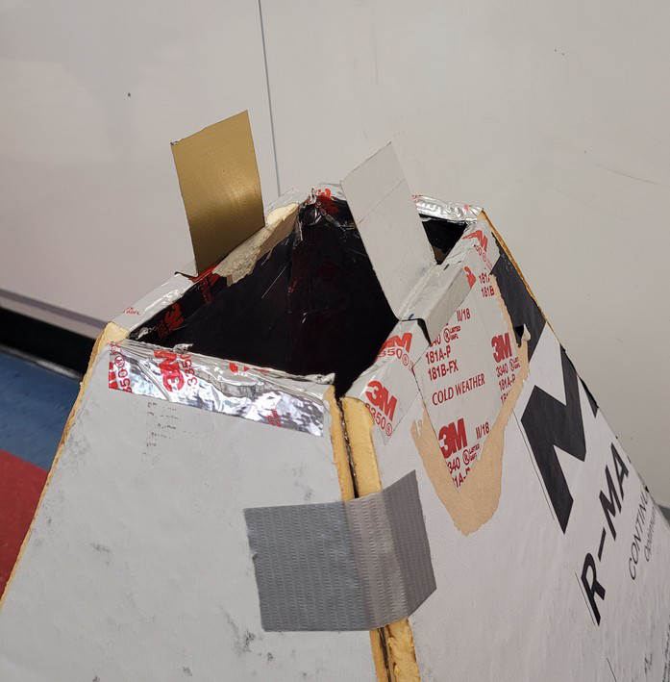
1. Cut two 2” × 6” pieces of the aluminum flashing. Mold the flashing into a square “S” shape. These will fit along the contour of the can-horn connection to provide structural support.
2. Place the horn upside down on the floor. Tape the flashing to the horn as illustrated in the photo below.
3. Place the open end of the can on top of the horn, and align the openings with the flashing pieces on the outside of the can, is illustrated in the photo.
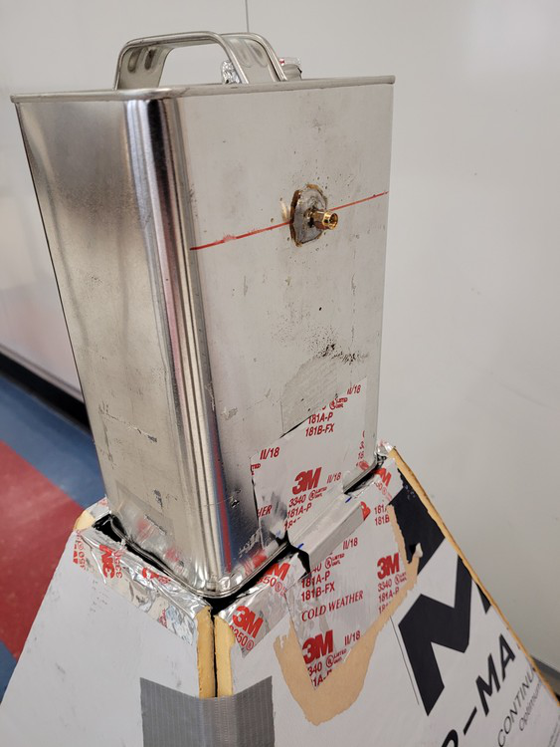
4. Fit each flashing piece into the contour of the junction between the horn and the can on the outside, and tape the flashing pieces to the can., with either duct tape or foil tape.
5. Use the foil tape to tape the horn and can pieces together on the inside. Be sure to completely cover the adjoining seams so that there are no openings or gaps.
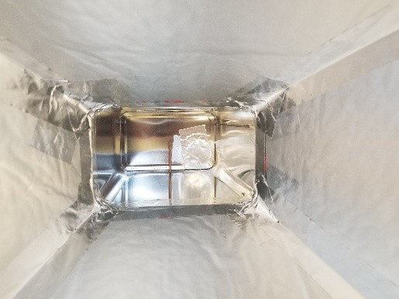
Looking down into the can from the mouth of the horn. Notice the taping along the corner edges and at the can/horn seams.

