The 21 cm hydrogen line
  - Teaching guide
The Milky Way Galaxy, like most, is full of one of the most basic atoms in space - neutral hydrogen, consisting of one positively charged proton, with a single negatively charged electron orbiting it. These atoms can emit radio waves at 1420 MHz. Much of the light from the stars in the galaxy is absorbed by dust clouds in the galaxy. However, the radio waves from hydrogen gas penetrates the dust clouds, and therefore, they are able to reach us on earth. We can use these radio signals to get a map of the hydrogen in the galaxy.
The 1420 MHz radiation comes from the transition between the two slightly different levels of the hydrogen 1s ground state. Both the proton and electron have a property called “spin”, which is the term used to describe a certain quantum mechanical property related to angular momentum. It does not describe an actual rotation of the proton and electron. (Despite this, the spin property is actually often visualized as a rotational state of the particle.) There are only 2 possible states of the spin – either up or down.
The higher energy state of this neutral hydrogen atom occurs when the electron and proton spins are aligned, said to be “parallel”. The electron can spontaneously switch to its opposite spin state, and the spin states become anti-parallel, which is a lower energy state than the parallel spins. Because of the quantum properties of radiation and the principle of energy conservation, hydrogen in its lower energy state can absorb a photon with a frequency of 1420.4 MHz to transition to the higher energy state. Similarly, hydrogen in its the higher energy state can emit a photon at 1420.4 MHz to transition to its lower state. These absorbed and emitted radio waves have a wavelength of 21 cm.
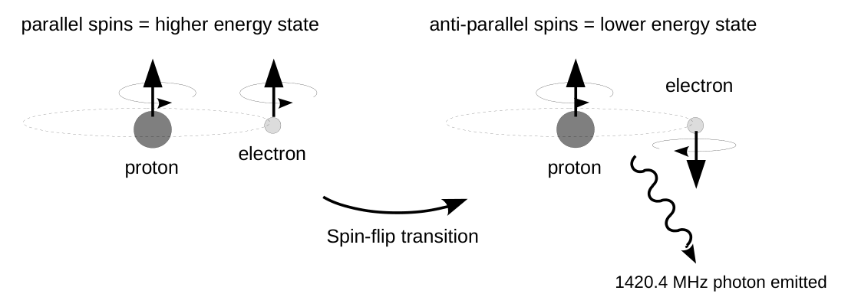
The FM radio in your car tunes to signals with frequencies between 87 MHz and 107 MHz. If you could tune your car radio all the way up to 1420.5MHz, you would be able to listen to the neutral hydrogen in our galaxy. The horn telescope is specifically designed to detect signals with frequencies around 1420 MHz, optimal for detecting the hydrogen radio signals from our galaxy.
Exercise: The energy of a photon is directly proportional to its frequency, f, through the relationship:
E_{photon} = hf
where h = Planck's constant. Look up the value of Planck's constant and calculate the energy of the photon emitted during the spin flip transition in neutral hydrogen. Express your answer in joules.

