Velocity Curve Activity Part 2:
Quadrant I Observations and Spectrum Analysis
TEACHER NOTES
Level: HS Advanced, College
Objective: In this activity, the students will take measurements of HI spectra along the galactic plane in quadrant I to determine a velocity curve of the Milky Way Galaxy rotates. The curve will be used to compare with the expected velocity curve for different mass distributions of the galaxy.
Pre-Knowledge of Students:
- The students have been exposed to the horn telescope and understand how to read a spectrum.
- The students understand what radio waves are, and they understand that the spin-flip in hydrogen atoms is the source of the 21-cm waves detected by the horn telescope.
- The students understand how to apply the Doppler shift to the spectrum peaks in order to find the relative velocity of the detected hydrogen.
- In Part 1: Galactic Plane Observation the students discovered that radio waves from hydrogen in galactic quadrant II are mostly blue-shifted, and radio waves from hydrogen in galactic quadrant III are mostly red-shifted. From this the students should be able to deduce that the galaxy is rotating.
- If the students have not fully realized that the MWG rotates, the rationale for why the galaxy must be rotating is brought out in the Pre-Observation Reflection.
- For the students to complete the Pre-Observation Reflection, as well as the post-experiment analysis, they are expected to understand Newton's law of gravitation and satellite orbits.
Key Terms: horn telescope, HI spectrum, galactic coordinates, Horizontal Coordinates, Stellarium, Doppler Shift
Related Videos for Teacher:
Teacher Preparation:
- Pre-Observation Reflection is optional. Its purpose is to get the students to start thinking about why the galaxy must be rotating, and the role of gravity in this rotation.
- This activity can be done with a single horn shared with the class, or with multiple horns assigned to groups of students.
- The students have used a horn telescope before. It is recommended that the following lessons have been completed:
  - Intro to the Horn Telescope
  - Electromagnetic Spectrum
  - The 21 cm Wavelength of Neutral Hydrogen
  - Understanding Coordinate Systems
  - Velocity Curve Activity Part 1 Galactic Plane Observation
Observation Notes:
  - Break the class into groups of two.
  - Assign each pair one or two galactic coordinates from ℓ = 0º to ℓ = 90º in increments of 10º. [ℓ is the standard symbol for galactic longitude.]
  - Use Stellarium to find dates when this part of the galactic plane is visible from your observation site.
  - Plan ahead so that you can have the telescope set up and ready when class time begins.
  - Calibration of the telescope is not necessary. The peak positions will be accurate without calibration.
  - An integration time of 10 s should work fine.
  - The Capture Current Spectrum button in the spectrometer is used to save each spectrum to the specified folder.
  - Use the azimuth and elevation text boxes on the spectrometer screen to record each group's coordinates. These will show up in the data file names and will make data identification easier after the observation.
  - It is recommended to run the gnuradio spectrum program ran for approximately 15 minutes before collecting data to allow it to warm up adequately.
  - When it is a group’s turn to collect a spectrum, that group uses a compass and level to orient the telescope to their horizontal coordinates.
SUGGESTION: Mark North-South and East-West lines on the ground where the telescope will be located. This can help speed up the process of pointing the telescope. The best case would be to have 10º increments marked for the azimuth.
  - When the data is actually written to a file for a group, they should record the time, as this can be used to verify their data file in case the azimuth and elevation were not recorded on the spectrometer screen, since the time stamp appears in the file names.
  - A class of 10 groups should be able to collect the data within a total of 30 minutes.
  - After all of the data is collected, it is recommended to share the files in Google Docs or some other file-sharing environment for easy access of the files by the students. Subsequent analysis in Google Sheets is then straight forward.
Spectrum Analysis Notes:
  - If the students scale the frequency range on their graphs from 1419.5 to 1420.5 MHz. Scale with major gridlines at each 0.1 MHz and a minor gridline count of 10 for 0.01 MHz intervals. The students should then be able to read the peak positions to a 0.01 MHz precision directly from the graph.
  - Students will determine the most red-shifted point on the peak where it emerges from the background signal, as illustrated below. This is from the hydrogen that is moving away from us at the fastest speed, which we assume is at the tangent point along the direction that the horn is pointed.
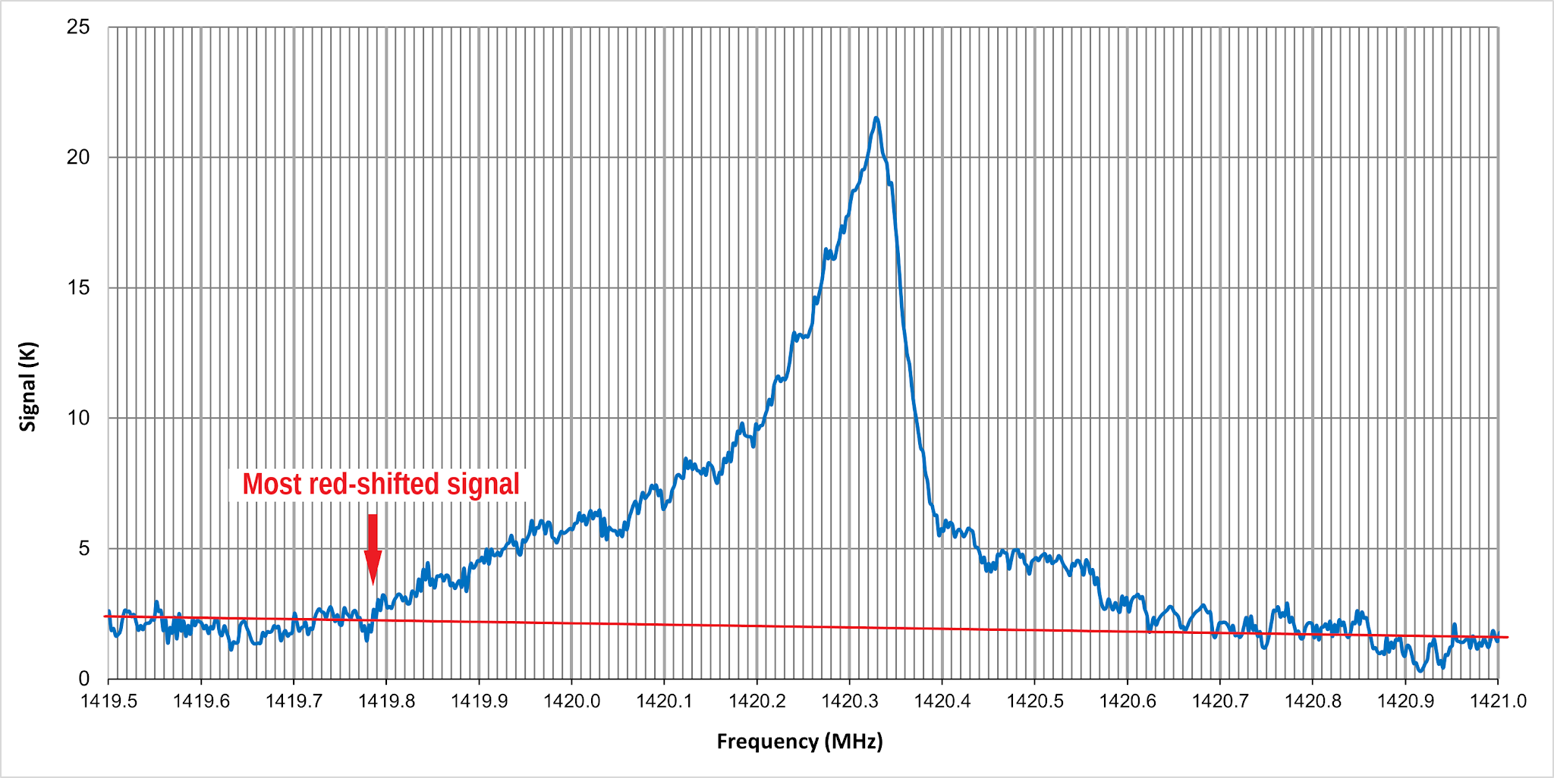
  - Students use the relative velocity equation to calculate the velocities indicated by this frequency:
v =$\frac{(f_{most red-shifted} - 1420.41 MHz)}{1420.41 MHz} × 3.00 × 10^{5} km/s$
  - Negative velocities are red-shifted, where the object is moving toward us, and blue-shifted velocities are positive.
Notes on Determining a Velocity Curve:
  - A typical velocity curve might look like the following:
  - A discussion of these results can vary depending on the level of the course.
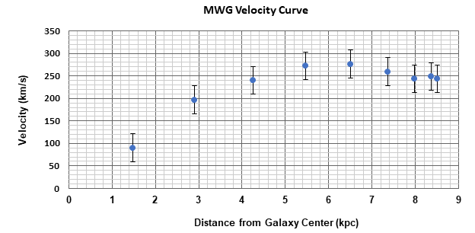
  - On the simplest level it is obvious that the velocity curve is very much non-Keplerian. This implies that most of the mass of the galaxy is not at the center.
  - A uniformly dense galaxy model would lead to the speed being linear in distance from the center.
  - A third model to discuss is for v = constant. For instance, what density model would lead to this.
  - At a more advanced level, the discussion could include an estimate of the mass of the galaxy implied from the velocity curve. Compare this to an estimate of the visible mass from observed stars in the galaxy. A comparison of these would show that the visible mass accounts for only approximately 10% of this mass. From this the need for “dark matter” can be deduced.

