Using Physics to Find the Speed of the Earth around the Sun
Astronomy Activity
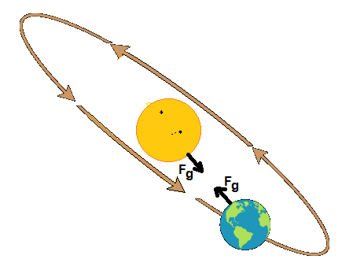
Objective - Using the Universal Law of Gravity and the concept of centripetal force to find the speed of the Earth around the Sun.
This will be a specific example based on what you have learned about Newton’s Law of Gravity and centripetal motion.
Questions
- What is the equation for Universal Law of Gravity?
There are two masses in the equation...the 2 masses of consideration, and in this example the 2 objects in the image at right.
- What is the equation for Centripetal Force on the smaller object, in terms of mass, radius, and velocity? This time there is only one mass. It is the smaller of the two masses since it is the one exhibiting the circular motion.
- Equate the above two answers and solve algebraically for velocity (of the Earth)? Put a box around your final result. (Remember, no substitutions, just variables)
- Find the values and units for the following:
Universal Gravitational Constant
Mass of the Sun (kg)
Mass of the Earth (kg)
Distance between the Earth and Sun (m)
- Start by rewriting your derived equation from 3), then process in solving for the velocity of the Earth. Show all work, with units.
- Optional- Which of the four values from the chart above did you not need to use in your calculations? ________________________________
- The speed of the Earth is often given in kilometers per second (km/s) So, convert your answer, to one decimal place, for the speed of the Earth in km/s.
Velocity of Earth = ______________________km/s

