Measuring the Speed of Earth around the Sun using Doppler Effect
Astronomy Activity

Objective - The last activity on Modeling the Earth’s Motion Around the Sun was making a “paper” prediction on what we would expect with regards to the Earth’s motion with respect to the Center of the Galaxy. Now, it is time to look at actual data to check the model...

Background
Trust the Spectrum! Elements of the Periodic Table have been tested countless times by scientists in laboratories around the world and over the centuries. When they observe and record the emission spectrum of a particular element, it will always be the same…We have learned to trust them.

Hydrogen is the simplest element, and the most abundant element in the Universe. If you have ever looked at a discharge tube of excited gas (like a neon light) in a science class, and used a spectroscope to see the different spectral lines, there is a good chance one of the samples was Hydrogen. It’s visible light spectrum has 4 very well known frequencies (colors) given off.
However, there are other non-visible spectral emission lines from Hydrogen. And since Hydrogen makes up 90% of the atoms (by number) in the Universe, it is hard not to see it. There is a low-energy emission line in the radio frequencies that cold Neutral Hydrogen gives off.
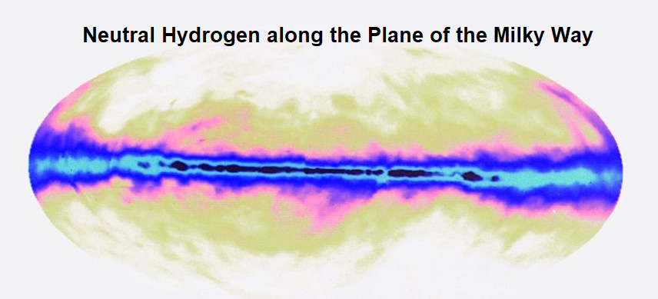
Again, the frequency of this emission is very well known from work in laboratories. Ask that fine inter-webs place you go to on your phone “What is the frequency of Neutral Hydrogen?” (3 Decimals)

Neutral Hydrogen Frequency = ___________________________________-MHz

Name___________________

The six graphs are of neutral hydrogen in the area of the Galactic Center on different days throughout the year as the Galactic Center crossed the Meridian. Even though neutral hydrogen is doing its thing to emit the radio waves, it appears to shift its frequency over time. This could be, and is hypothesized here, due the Earth orbiting the Sun. Thus, sometimes heading slightly TOWARDS the Galactic Center, and sometimes AWAY. This is where the Doppler Effect can be very helpful!

WHAT TO DO?
1) Look at the vertical axis on the graphs. Note the value of the
frequency where the vertical axis crosses the horizontal axis __________________________Mhz (This number should look familiar from the last page!)

2) The overall shape of the “bump” in each graph is fairly symmetrical with a slight asymmetry at the top, so we are going to take the midpoint frequency where the graph cuts through intensity 30. (the vertical units are arbitrary for these graphs)
DRAW A DARK LEVEL HORIZONTAL LINE THROUGH EACH GRAPH AT Vertical level =30
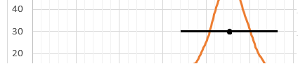

3) Mark the midpoint along the “30” line for the peak (1/2 way between the two “30” intersections.

4) Look! Use the graph to record the Frequency to the nearest 0.004 MHz. (Column C in Chart)

5) Fill in the DOPPLER Chart
Column A = Easy! Just the day of year off Graph Title (year not needed here)
Column B = We learned in the last activity (Earth Moving Around Sun – Deeper Look) that the Sun and Galactic Center line up on Dec 18th, so we will let that be day 0 of the 365 day cycle (almost 1° per day) We need to count the days from Dec 18th forward to know how far along the orbital path the Earth is on a given day. (This will be a positive number...many have counted backwards...DON’T)
Column C – Record your determined Mid Peak Frequency from steps 3) and 4)
Column D – Super Easy! Write down the value for freq. of Neutral Hydrogen from last page (3 decimals)
Column E – Subtract Col D from Col C ([Col C] – [Col D]) Keep the negative! (if [col D] > [col C])

Determining the Velocity Towards or Away Center
In English, the ratio of the frequency shift to original frequency is equal to the ratio of the speed of the object (Earth) to the speed of light
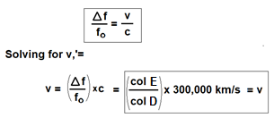
In math, that translates to

Column F = Use the equation in the bottom box to calculate the part of the Earth’s velocity heading towards or away from the Galactic Center.Name DATA GRAPHS FOR EARTH SPEED DOPPLER SHIFT (EARTH SPEED Activity 2 DATA)
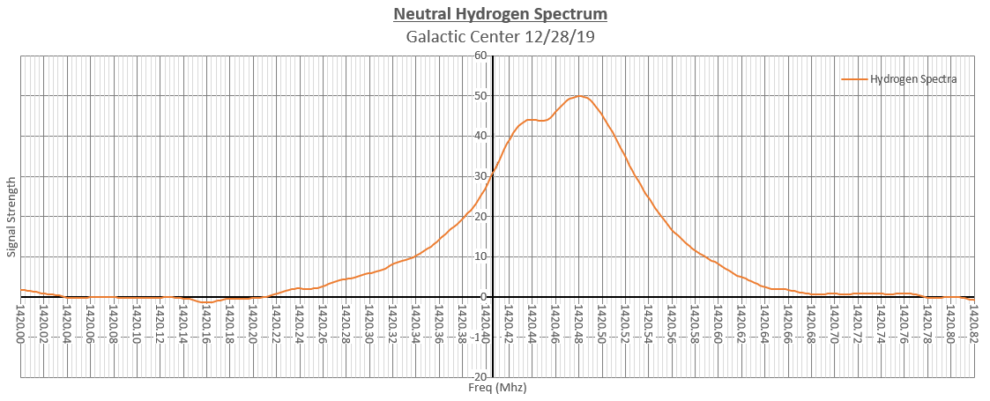

(Ignore the year. Just count days from previous Dec 18th)
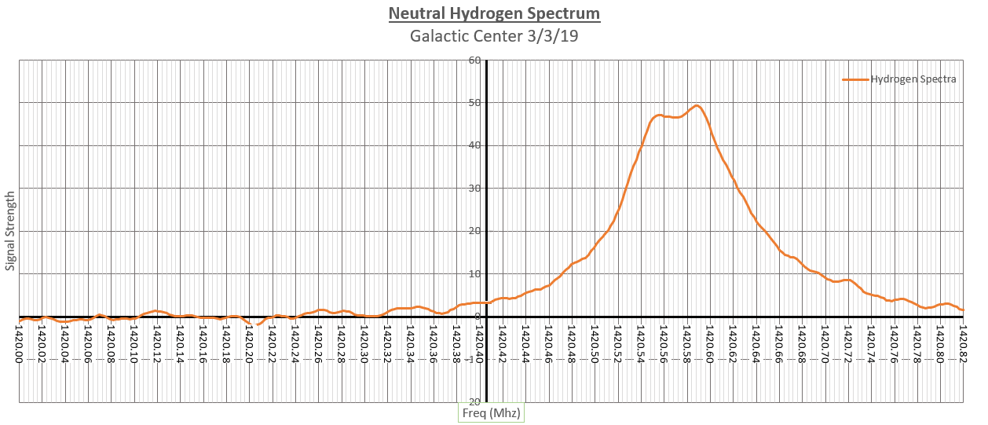
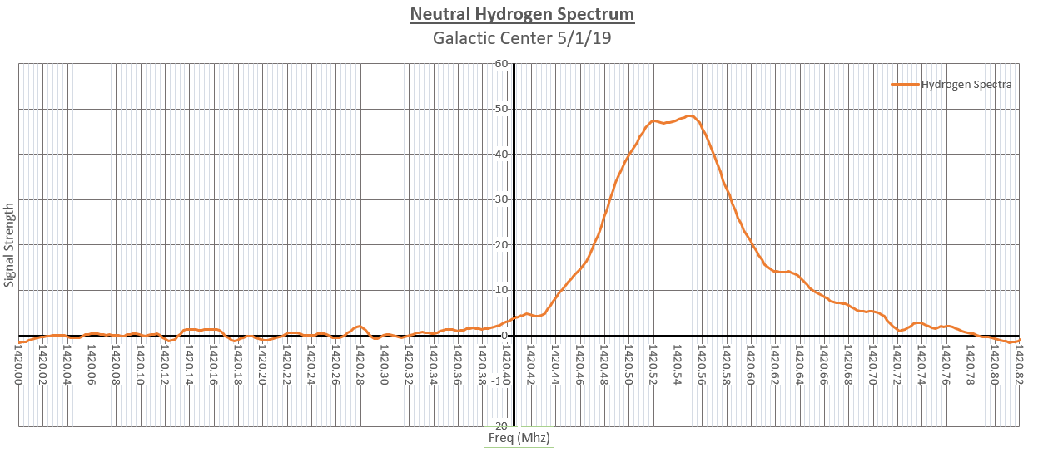
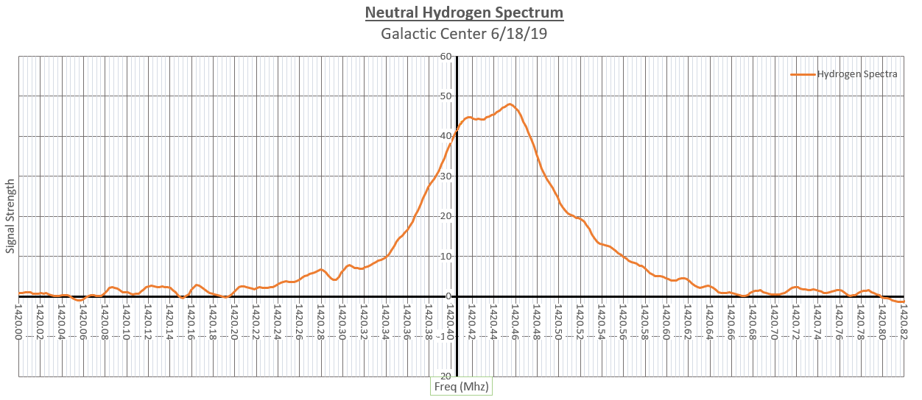
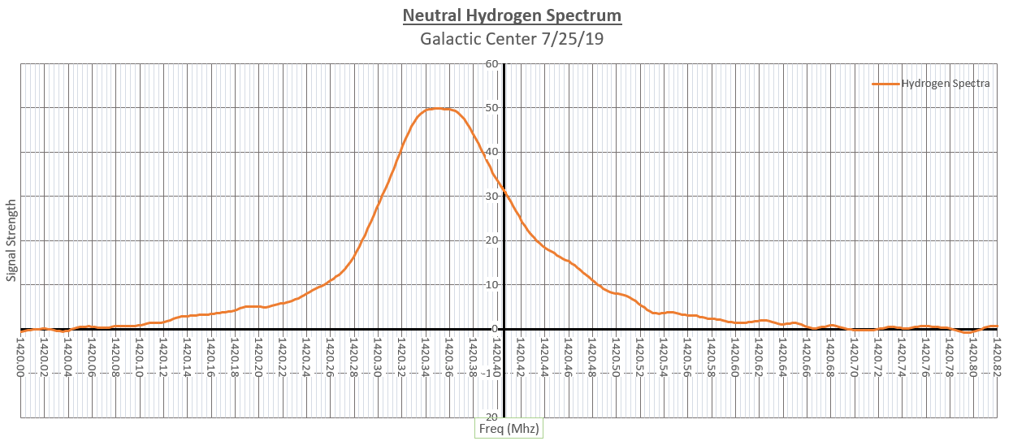
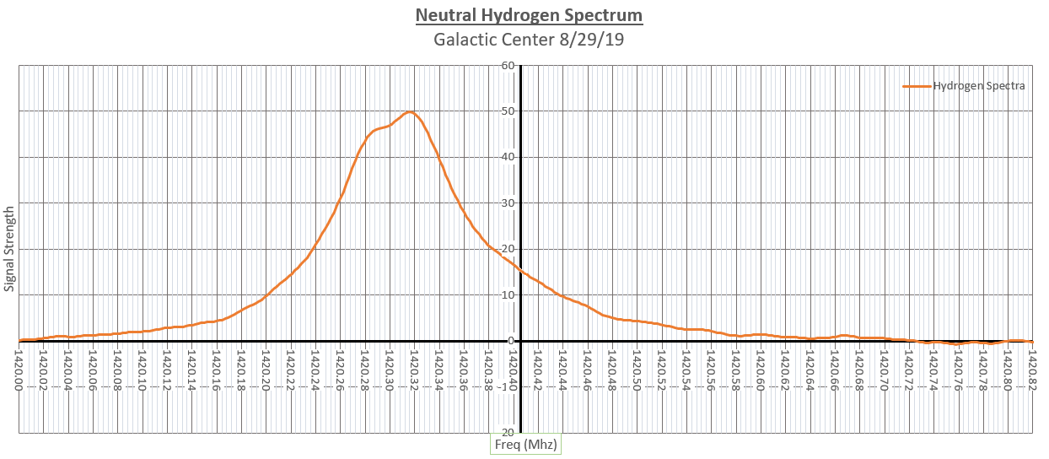
_________________________ Doppler Shift Sheet
Instructions for working with Data graphs and filling in this chart are on (page Act E4-2)
DOPPLER Data Chart
(This is the DOPPLER CHART referenced in final conclusion activity coming up in near future)
A | B | C | D | E | F
Date of Year  (ex: Jan 16) | Day # from Dec 18 (count forward from 12/18) | Freq of Center of Peak (MHz) | Neutral Hydrogen Freq (MHz) | Shift in Freq (col C-col D)  (MHz) | Speed To-or Fro Galactic Center (km/s)

Yes, you did the following questions already, but rewriting the answers will take a minute and reinforce the points in your head. (You also wrote it 6 times in col. 4)

Neutral Hydrogen Frequency = ___________________________________-MHz

DOPPLER SHIFT
Remember, we discussed if there is a detectable shift in the frequency of a known source, it is an indication that the object is moving AWAY FROM or TOWARD the observer. Things like the Big Bang Theory (Theory, not TV Show) and Tornado detection rely on Doppler…Remember, or interwebs…

REDSHIFT means the Object is moving ________________us and the Frequency will be _____________.

BLUESHIFT means the Object is moving ________________us and the Frequency will be ____________.

Now for some real data!…

All the following spectrum graphs were created in Microsoft Excel using data collected by a DSPIRA Radio Horn Telescope between March and December 2019.

