Electromagnetic spectrum
  - Student activity
Name ______________________________ Date __________________
Identify each region of the electromagnetic spectrum. Compare the direction of increasing frequency with increasing wavelength.
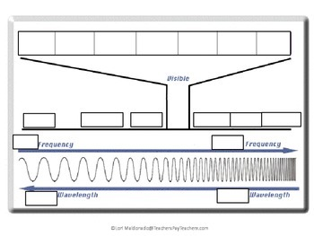
Diagram credit: Lori Maldonado. Original credit remains in the artwork.

Spectrum labels
Position from left to right | Region
1
2
3
4
5
6
7

In which direction does frequency increase? __________________________
In which direction does wavelength increase? ________________________

