Building a waveform generator
  - Student activity
Name ______________________________ Date __________________
GNU Radio is very popular and robust software defined radio package. It is open source and is relatively easy to use. All “coding” is done using flowgraphs comprised of interconnected Digital Signal Processing (DSP) blocks. Most commonly used blocks come predefined as part of the software package. One can program one's own blocks as well.

Let’s get Familiar – Building a Waveform Generator
For our first project we will build a program that generates a real-valued cosine signal with a frequency of 400 Hz, and outputs it to a speaker. We will also display the signal in a time domain graph and in a frequency domain graph. Then we will modify it so that we can adjust the frequency in real time.
Step 1. Open GNU Radio
- To open GNU Radio, open a terminal window. Type "gnuradio-companion" and hit Enter.
This opens GNU Radio Companion (GRC):
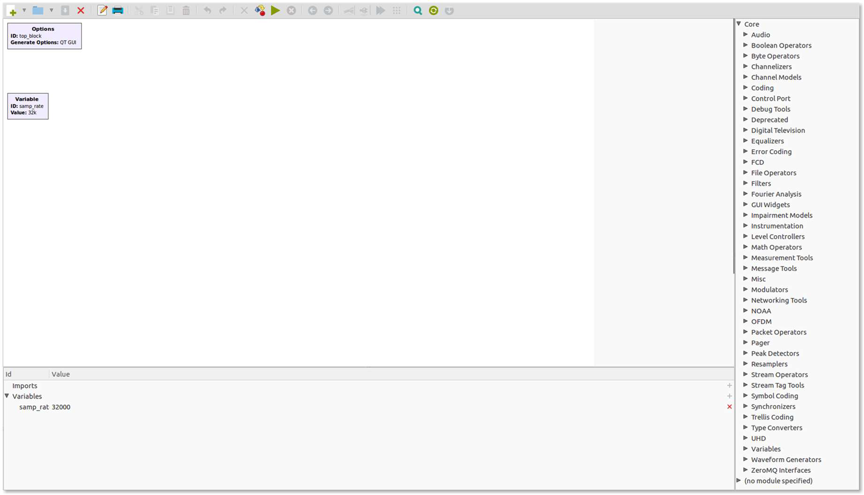

- The canvas window is mostly empty. On the right side of the canvas is a list of the block categories that are available. Click on a triangle next to a category to see what blocks are available in that category. Look under the waveform generator category and look for the Signal Source block. Alternatively, we can click on the magnifying/looking glass to the top right and search for the block we need.
- Add the Signal Source block to the canvas by dragging it into the canvas window (or double-click):
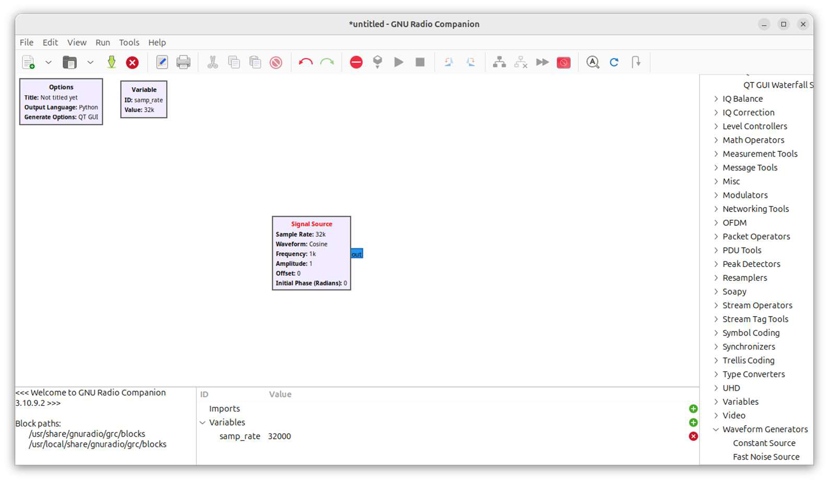

Helpful Information About GNU Radio

Block Port Colors
Notice that the Signal Source block has a blue port on the right. The color of a port indicates the type of data generated for an output port or the type of data accepted for an input. The most common data types that we will use are:
- Orange is for "Float" data types, which are real-valued 32-bit floating point data samples.
- Blue is for "Complex" data types, which are complex-valued 32-bit floating point data samples. [Electrical engineering and digital signal processing often use complex functions and data.]

Connecting Blocks
To connect two blocks, click on the output port of the first block and then click on the input port of the second block. An arrow will appear connecting the two ports. For the flowgraph to work both ports must use the same data type (i.e., both ports must be of the same color). If they are of different types, then the arrow of the connection will be red instead of black, indicating a problem.
NOTE: If you see any red arrows or red writing in a flowgraph you will not be able to run the flowgraph until
the offending condition has been fixed.

Editing a Block
To edit a block, double-click on it. A window will open for editing the block. Back to building a waveform generator:
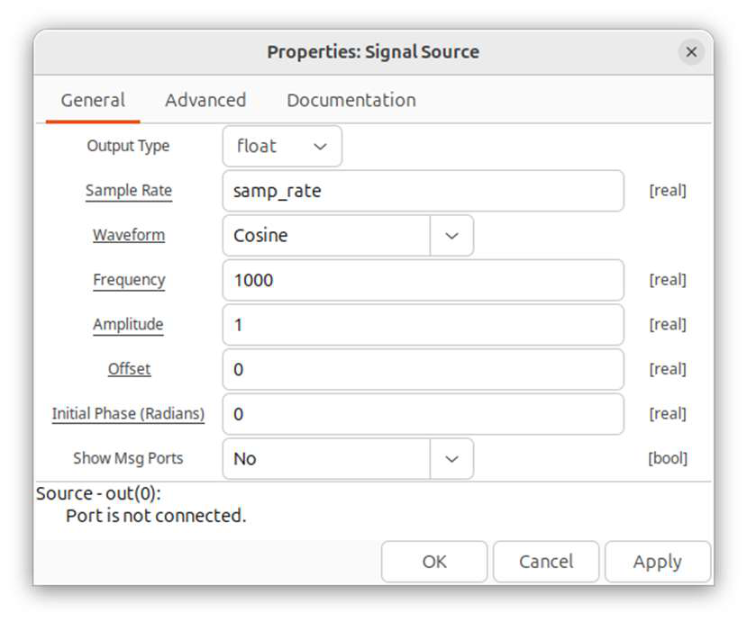
Step 2. Change the "Output Type" in the Signal Source block
to "float" and hit Ok.
The output terminal on this block should now be orange.
Step 3. Let's add a speaker and graphical display to the signal output:
- Change the Signal Source frequency: Double-click the Signal Source block. Then type in “400” for the frequency value.
- Add a speaker to the output: Choose the Audio Sink block under “Audio”. Connect this to the output of the Signal Source block.
- Add a graphic output: Choose “QT” under “Instrumentation” (or just simply search for “QT GUI Sink”) and add a QT GUI Sink to the canvas. This block will allow you to see the waveform at the input in the frequency as well as in the time domain. Connect this to the output of the Signal Source block. Be sure that all of the data types are properly set.
- The program now should look like the following:
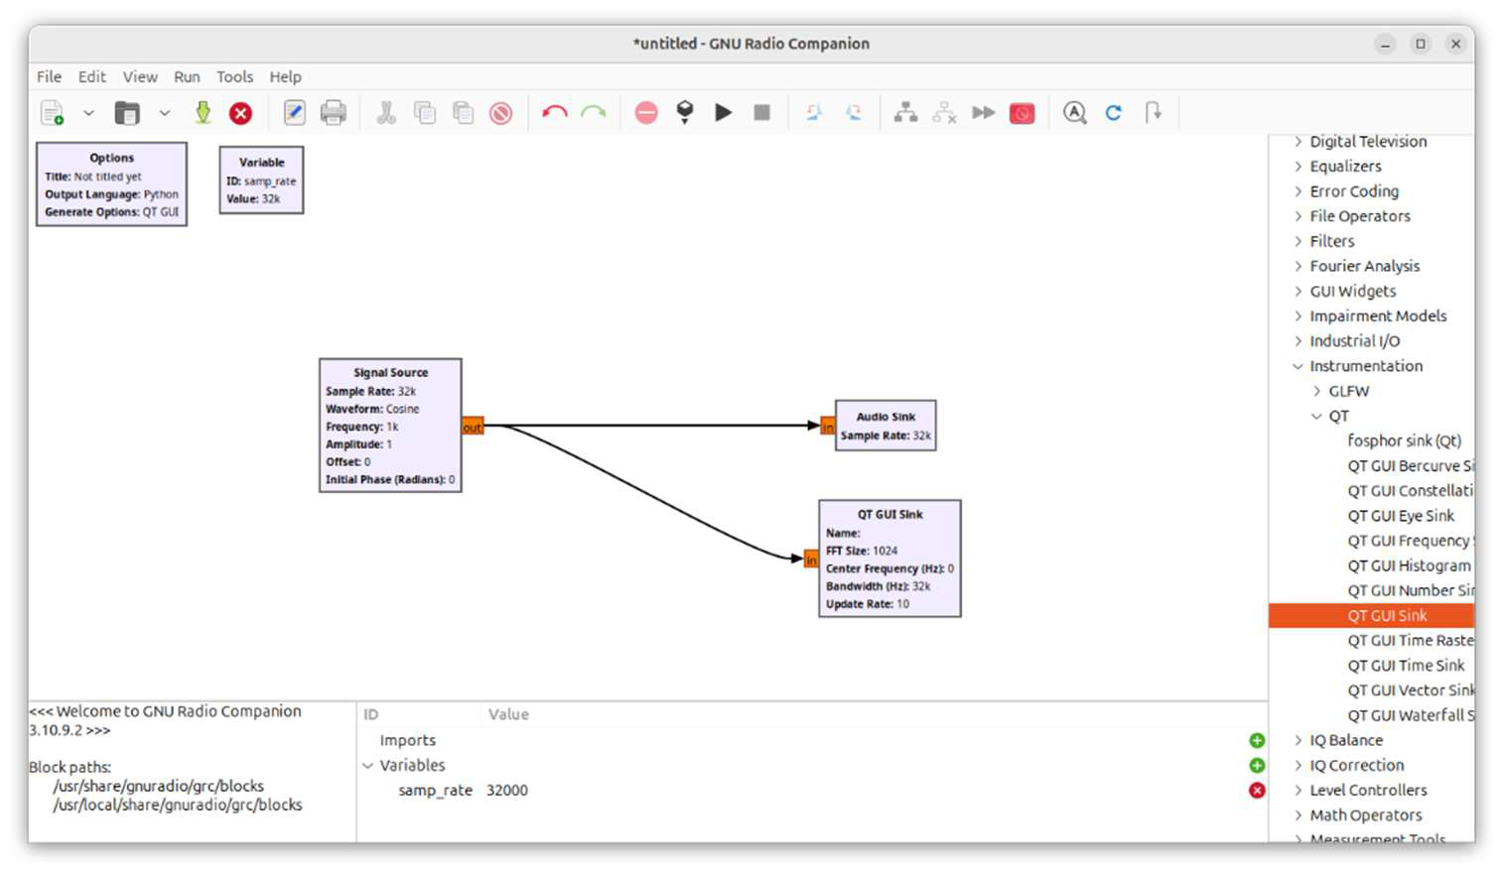
- Run the program: Click the triangular Run button above the canvas, or choose Run from the menu.
When prompted to save the file, create a new folder for your work.
NOTE: The WARNING message that appears can be ignored. It will appear only the first time you run GNU Radio.
- To view the graphs, you can choose between the “Frequency Display” and the “Time Domain Display” tabs. Study these graphs, and examine the other graphical displays as well.

Let's Make Some Modifications
Let's add a few features to the program. We want to be able to change the frequency and amplitude of the source signal while the program is running. We will us the QT GUI Range block to define a variable that can be changed while the program is running.
- Add a frequency variable: Search for and double-click on QT GUI Range to add it to the canvas. This block type allows you to define and control a variable. Change the ID to "frequency" and the Label to "Frequency". Set the default to "400" and the range in the Start and Stop boxes as shown below.
- Add an amplitude variable: Add a QT GUI Range block. Change the ID to "amplitude" and the Label to "Amplitude". Set the default to "1", and the range in the Start and Stop boxes as shown below.
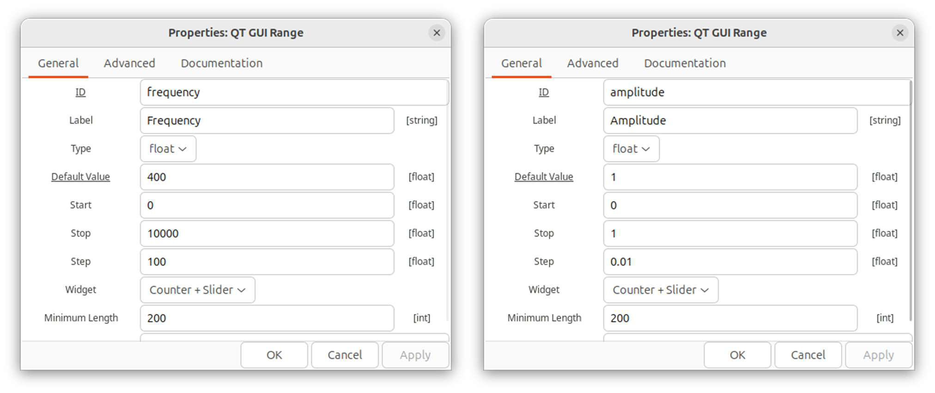
- Make changes to the Signal Source block to match these variables: change the Frequency value to “frequency” and Amplitude to "amplitude."
- The program now should look like the following:
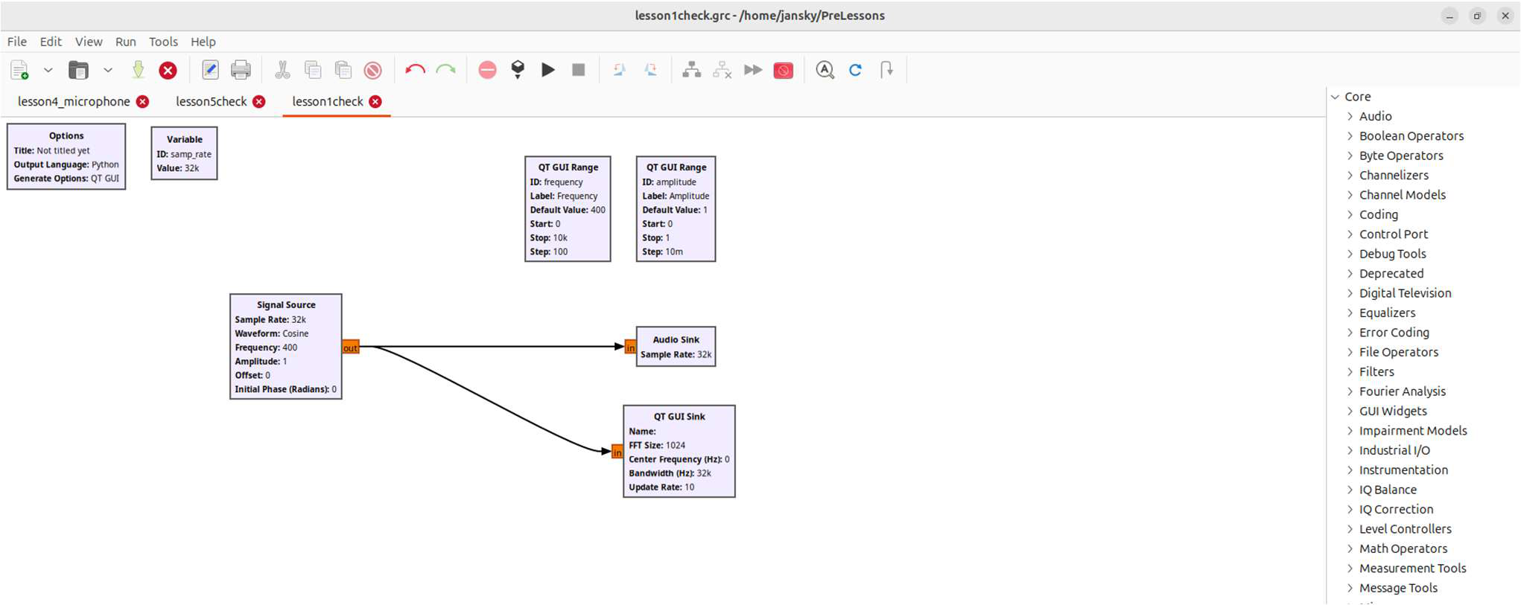

- Re-run the program: Adjust the frequency and amplitude sliders, and observe changes in the Time domain graph and the Frequency domain graph.

