Multiple signal sources
  - Student activity
Name ______________________________ Date __________________
In this activity you will construct a program that is a signal generator comprised of multiple sine waveforms with the ability to control their amplitudes and frequencies. These are added together to create a more complex output.

Build a Two Waveform Signal Generator
- Open your signal source frequency file from Lesson 1.
- Save as . . . using a new file name.
We will be working with sine waveforms.
- In the Signal Source block, change the Waveform type to "Sine". Also change the name of Frequency to "frequency1" and Amplitude to "amplitude1".
- In the QT GUI Range block for "frequency", change the ID to "frequency1", and in the QT GUI Range block for "amplitude", change the ID to "amplitude1".
- Add a second signal source by completing the following:
- Copy the frequency1 QT GUI Range block, and paste it on the canvas. Then change the ID to “frequency2”.
- Copy the amplitude1 QT GUI Range block, and paste it on the canvas. Open this block, and change ID to "amplitude2".
- Click on the Signal Source block and copy it (right-click Copy, or ctrl-c) and paste it on the canvas.
[Alternately, import a Signal Source block from the library on the right. Be sure to change the Waveform type to "Sine".]
In this new Signal Source block change the Frequency to "frequency2" and Amplitude to "amplitude2".
- Delete the connections from the original Signal Source block. (Highlight and hit "Delete".)
- Add an Add block to the canvas. Make sure its IO Type is set to "float".
- Connect both Signal Source blocks to the inputs of the Add block, one to each input.
- Connect the output of the Add block to the Audio Sink and QT GUI Sink.
- Your canvas should look similar to the following:
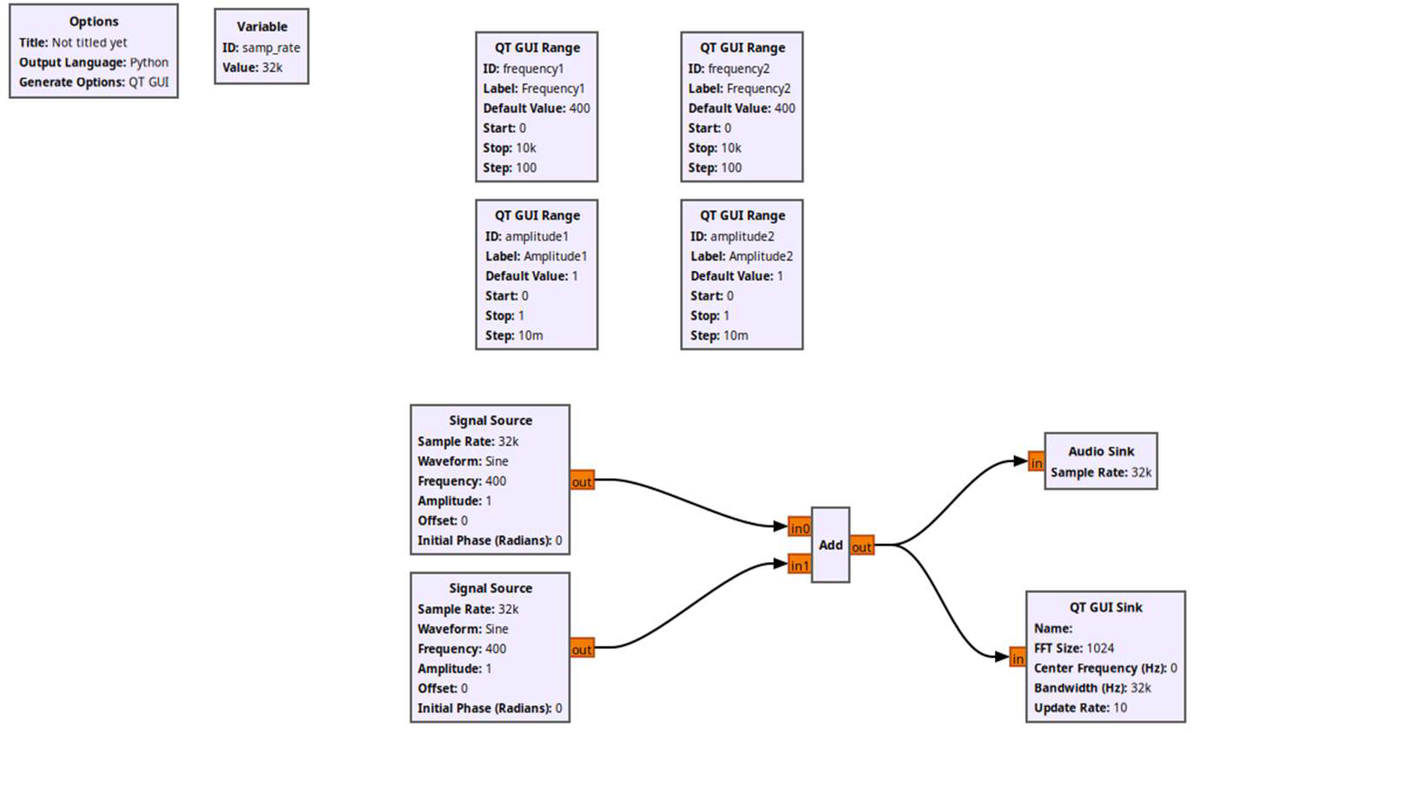
- Run the program.
- Explore the graphical displays and audio output while changing the frequencies and amplitudes.

Build a Three Waveform Signal Generator
- Add a third signal source:
- Repeat the steps above to add a third Signal Source. Be sure to add the appropriate frequency and amplitude variables by adding additional QT GUI Range blocks.
- Change the Num Inputs in the Add block to "3".
- Run the program and explore the output audio and the displays by the changing the frequencies and amplitudes of each input.

Build a six Waveform Signal Generator
- Add 3 more signal sources to make a signal generator comprised of 6 sine waveforms.
- We will be using this in Lessons 3 and 4.

