Galactic plane observation 1
  - Student activity • 2018 source edition
Name ______________________________ Date __________________

Introduction
We previously made some observations of the Milky Way Galaxy (MWG) using the horn radio telescope, detecting the 21 cm wavelength radio waves emitted from neutral hydrogen atoms, (referred to as “HI”). You will now be given an assigned coordinate in the galactic plane to look at with the horn telescope. You will analyze the HI peak detected, and as a class we will compare all of our results.

Pre-Observation Prep
1. Assigned galactic coordinates: ___________________________
2. Use Stellarium to look up what horizontal coordinates (azimuth and elevation) correspond to your galactic coordinates on the dates specified below.
Observation date __________________
Time and time zone | Azimuth | Altitude

Alternate date __________________
Time and time zone | Azimuth | Altitude

3. Before the day of collecting data, practice pointing the telescope in the classroom using a compass and a level.

Data Collection
Assigned galactic coordinate: gal. long. = _______________; gal. lat. = 0º
Horizontal coordinates (azimuth and elevation):
Az = ______________; El = ______________
Exact time when the data was saved to a file: ______________
Name of your data file: ___________________________________

Analysis of the Spectrum
1. Open the .csv data file in a spreadsheet program, either Google sheets or Excel. (If any screens pop up regarding the format of the data, just hit enter to select the defaults.)
2. Organize the Data
a. In the spreadsheet, insert a row above the first row.
b. In the first row of Column A type “Frequency (Hz)”, and in the first row of Column B
give it the label “Signal (K)”.
c. Then label the first row of Column C “Frequency (MHz)”, and the first row of Column D “Signal (K)”.
d. In cell C2, type the following: “= A2/1000000”. This will convert the frequencies from
Hz in Column A to MHz in Column C, which will be easier to work with.
e. In cell D2, type the following: “= B2”. This will simply copy the signal values. It easier to work with cells you are graphing when they are side by side, in the order x, then y.
f. Copy these formulas to all of the rows in columns C and D, as explained in class.
3. Graph the Data
a. Click on the column labels C and D. This should highlight their entire columns, respectively.
b. Insert Chart. Choose Smoothed Line. Under Data Range, select “use row 1 as headers”
and “use column C as labels”.
c. Add axis titles with units.
d. Add a graph title.
e. Change the axis scales to focus more on the peaks near 1420.4 MHz.
f. Add grid lines.
4. Analyze the peaks
a. Measure the frequencies at which the tips of the peaks occur. Record these in the table below to the hundredths of a MHz.
b. Compare the measured frequencies to the frequency expected for neutral hydrogen.
Explain what this comparison implies about the neutral hydrogen detected.
Frequency  (MHz) | Velocity  (km/s) | Red Shifted or Blue  Shifted?

c. Use the Doppler shift formula to calculate the velocities from the peak frequencies. Show your work.

Comparison of Class Data
1. Record the results of the other groups:
Galactic  Longitude | Galactic  Quadrant | Velocity  (km/s) | Red Shifted or  Blue Shifted?

2. Conclusions – Refer to the diagram of the MWG below to help you draw conclusions about the results in the table above. The velocities refer to the velocity of the detected HI relative to us.
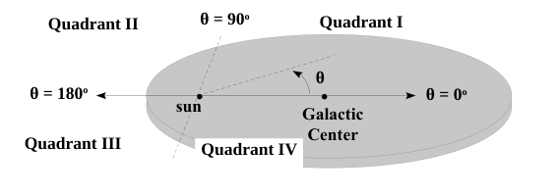
Conclusions, with justifications (supporting evidence):

