Galactic plane observation 1 conclusions
  - Teacher reference • 2018 source edition

Introduction
We need to analyze our observations of the Milky Way Galaxy (MWG) using the horn radio telescope pointed at our assigned coordinates in the galactic plane. What can our results tell us about the MWG?
1. Comparison of Class Data
Galactic  Longitude | Galactic  Quadrant | Velocity  (km/s) | Uncertainty  (km/s) | Red or Blue  Shifted?
105° | II | 4.3
120° | II | 12.7, 54.9
135° | II | 5.4
150° | II | 21.1, 29.6
165° | II | 18.6
180° | II | 10.6
195° | III | -2.1
210° | III | 8.4
225° | III | 12.7
240° | III | -19.6, -63.4

2. Estimate an uncertainty
The Milky Way galaxy is extremely large in comparison to our solar system. However, the earth is moving around the sun, and the motion of the earth relative to the sun can contribute to the red or blue shift of an HI peak in the spectrum. If we know exactly how the earth is moving relative to the direction of our observation, we can make a peak shift correction.
However, this is a little more advanced than we need to be at this point. We will simply take the velocity of the earth relative to the sun as an uncertainty in our measured velocity values.
Calculate the orbital speed of the earth around the sun. The earth travels at an average distance of 1.50 x 10¹¹ m from the sun. Show your work:
Speed of earth around the sun in km/s: ________________
Record this in the uncertainty column in the table above.
3. Conclusions
Refer to the diagram of the MWG below to help you draw conclusions about the results in the table above. The velocities refer to the velocity of the detected HI relative to the sun.
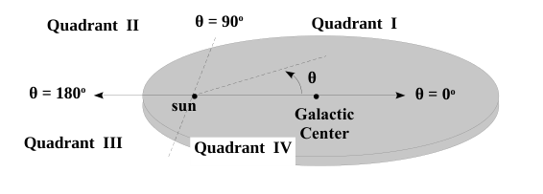
Study the results in the table and draw conclusions. Provide an argument to support your conclusions.

