Electromagnetic spectrum and space
  - Teaching guide

Learning objectives
- The student will be able to describe the purpose of using radio telescopes
- the student will be able to define radiation
- The student will be able to define the electromagnetic spectrum?

Materials
- Colors we See activity (spectrum, stickers?)
- EM Spectrum Worksheet
- Colored Pencils/crayons- Red, Blue, Yellow, Green, Purple
- Manipulative Terms

1. "Colors" we see Activity
- Background
- How do we "see" colors?
- 1. Reflected vs. Absorbed
- Different Colors have Different properties
- 1. Mix Red and Yellow= Orange
- 2. Mix Yellow and Blue = Green
- Property=wavelength
- Procedure:
- Head to head competition
- Students race to place sticker on portion of spectrum that we "see"
- 1. Green Absorbed-students place stickers on green area of spectrum
- 2. Yellow, Blue, Green-Reflected-students would place stickers on red, orange and purple.
- 3. All colors reflected- white
- 4. All colors absorbed-black

Transition: small to large scale

2. Studying Space
- Space Studied?
- Telescopes
- Special Telescope- Radio Telescope

3. What is being "viewed/studied" for space?
- Sun
- Heat
- 1. Heat=tells us Energy is present
- Energy-Radiation
- Cartoon Drawing of Sun
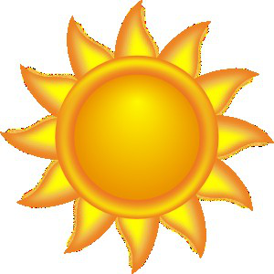

4. Organizing Space Information
- Electromagnetic Spectrum
- Electro-Electricity
- Spectrum-arranges it
- Magnetic-magnetism
- Everything in space= gives off Radiation (ENERGY)

5. Electromagnetic Spectrum
- Manipulative
- Students color visible light portion

