Mini horn telescope construction and operation
  - Teaching guide

Materials needed (makes two horn telescopes) (between Lowes and Amazon all are easy to find)
1 4’ x 8’ x .5” sheet of metallic foam insulation (one sheet can make six horn antenna cones)*
5 2” x 2” x 8’ pieces of lumber*
1 roll aluminum foil tape
1 roll of masking tape
24 3½ “ bolts with wing nuts
4 3½ “ flat head wood screws
8 1” flat head wood screws
2 F-style oblong 1 gallon metal paint can**
2 4” piece of 4 gauge solid copper grounding wire*
2 SMA male plug panel mount 4 hole solder terminal with RF coax adaptor
1 roll of solder
* these parts might be donated or reduced as scrap. A broken foam board is fine provided it is 16” x 48” A piece of scrape wire 6” long can provide the copper wire for the antennas. Left over pieces of 2”x2” can be used provided you have a total of at least 40’ of wood to work with.
Use a new, empty metal can. Do not cut, drill, or heat a container that held flammable liquid.

PARTS to order
2 Airspy mini SDR dongle (via airspy.com to purchase)
2 male sma to male sma coax cable, min. length 3’
2 custom built LNA’s – request from WVU DSPIRA program

Tools
Drill, drill bits, saw, screwdriver, tape measure, box cutter, markers, long straight edge
1 Soldering iron
1 Soldering hot air gun

Construction process
There are three parts to the construction process; the horn antenna, the paint can receiver, and the stand to hold the assembled telescope. Each part can be conducted separately before assembling the complete horn radio antenna.

Assembling the horn antenna
The horn antenna is constructed from a 1/2” thick foil covered sheet of rigid foam insulation. These sheets are sold in 4’ x 8’ sheets which is more than needed but the sheets are inexpensive, and the excess can be used later for new horns or repair.
The first step is to cut the 4’ x 8’ sheet in half so you have two 4’ x 4’ sections to work with. You will only need one of the sheets to make two horn antennas. Each 4’ x 4’ section can produce enough sections to construct 3 complete antennas. The list of materials provided will support the construction of two complete horn radio antennas.
Starting at one edge, mark the sheet with the measurements and lines shown below. The layout will produce 4 panels that will be taped together to create a rectangular shaped flared horn. Use a sharp box cutter knife to carefully cut along the marked lines. A metal sharp edge to guide the cutting is recommended. Repeat this process to create a second set of horn antenna panels.
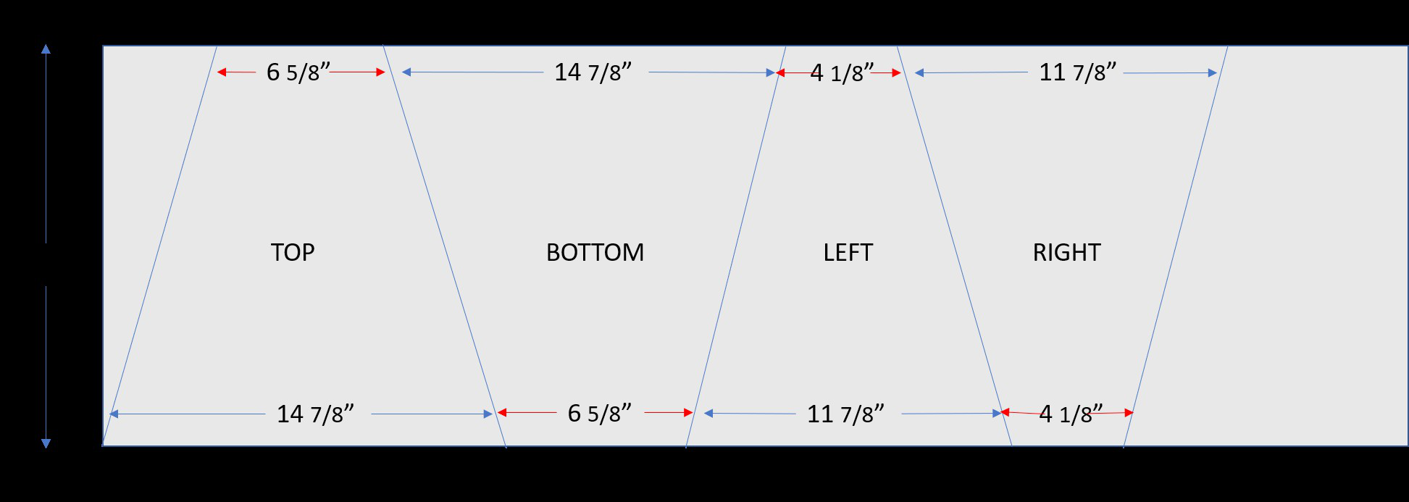
Once the four panels have been cut out lay them following the diagram below. Using the 2” foil tape, tape together the 3 places where the edges of each panels butt up against each other. To complete the assembly, fold the sheets until the two untapped edges come together. Note: match the two pieces inside edge to inside edge so they match the construction of the other panels.
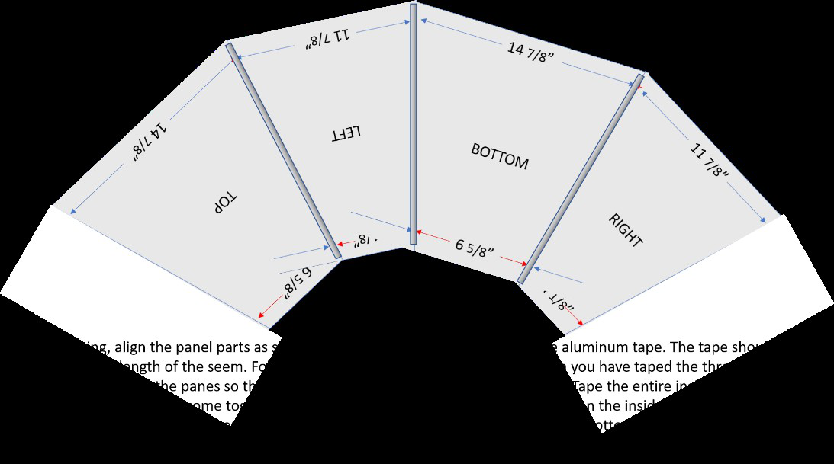
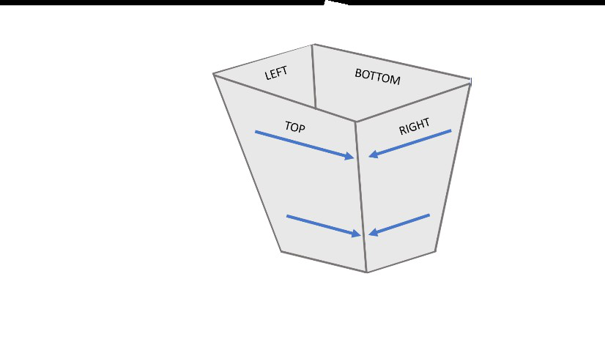
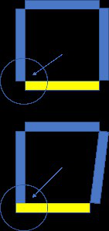
Do not let the two pieces overlap and tape the outside of one to the inside of the other. Use a few small sections of tape to hold the parts together then tape along the entire inside edge of where the two panels butt against each other.
Once the inside seems are taped proceed to taping all the outside seems then place tape over the top and bottom edges to complete the assembly.
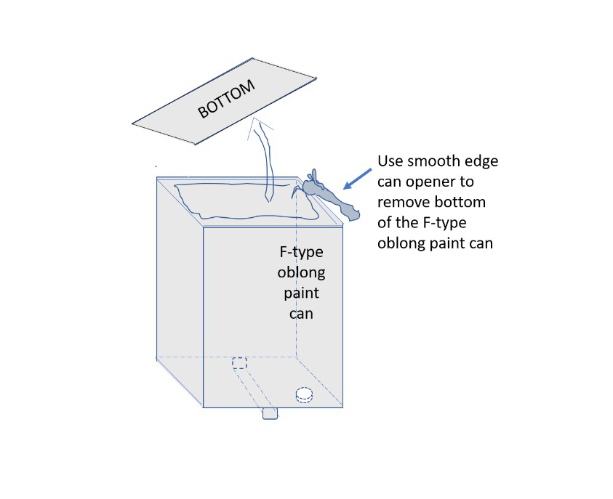

Constructing the paint can receiver
The first step in preparing the F-type oblong paint can is to remove the bottom of the can using a smooth edge can opener. This type od opener is critical as it produces smooth edges where it cuts and reduces the need to file off sharp edges.
The second step is to drill a 1/8” hole on the wide side of the can. The hole needs to centered between the two edges of the can and should be drilled 5.25 cm from the top of the can. Remember, you removed the bottom of the can earlier! Place a small block of wood that fits snugly inside the can so the can does not bend while it is being drilled. Remove the block after drilling the hole. Keep the block as you will use it again.
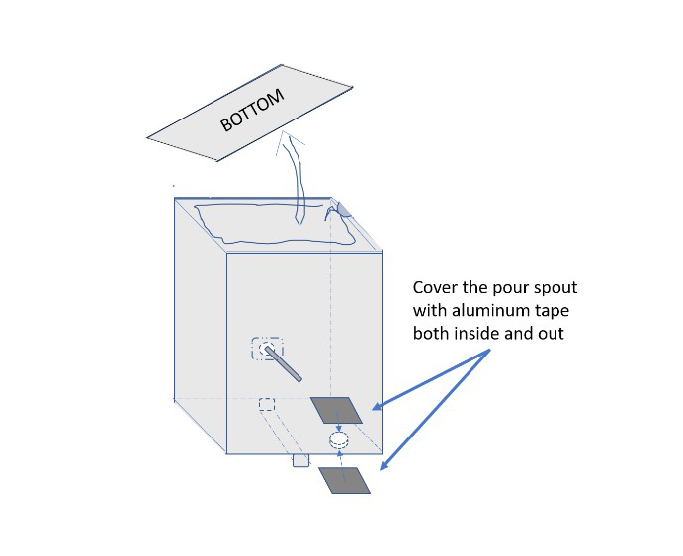
Using the aluminum foil tape, cover both the inside and outside of the pour spout.
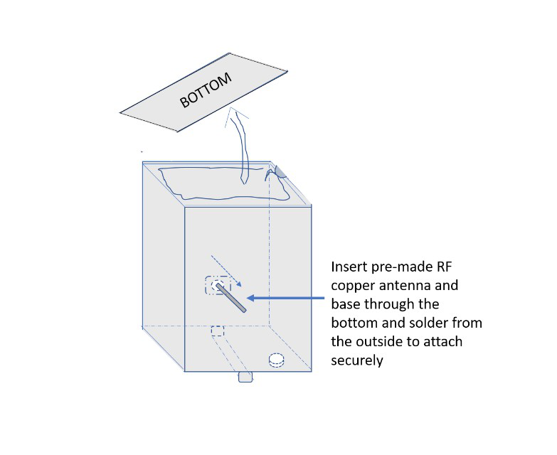
Position the can with the drill hole side up. Heat the can and place some solder around the hole. Carefully place the RF antenna coupler through the hole leaving the copper wire antenna inside the can and the 4-hole plate flat on the outside over the hole. Important: make sure the copper antenna wire does not touch the sides of the hole! Position it carefully in the center. The antenna will not work if the copper antenna is in contact with the metal can. Using the hot air soldering gun. Heat the solder between the base and the can until it shines and liquefies at which point you will see the 4-hole plate drop down a little. Remove the heat and let the solder solidify before moving or touching. The can will be hot!
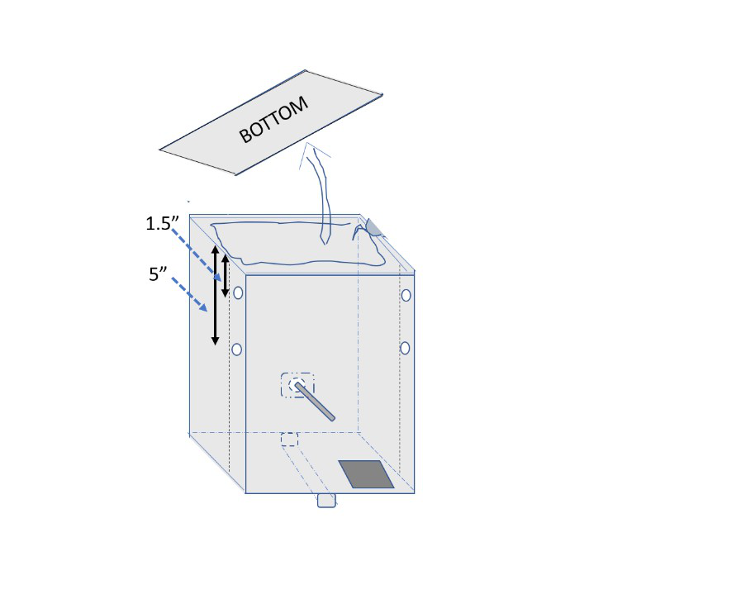
The last step is to drill the holes that will later attach the wood side supports to the can. Place the can on the table with the antenna connector facing up. Place a piece of 2” x 2” next the can so both the can and the wood are in contact and each are sitting in the table. Using a marker, draw a line on the can using the piece of wood as a guide. Do this on both sides of the can. You will drill two holes on each side of the can using these lines as a guide. Make a mark on each side of the can 1.5” and 5” from the open edge of the can and centered between the edge of the can and the line you drew on the can previously. On each side drill a 1/8” hole at the two marked points. Now fit the snug block of wood inside the can so the can does not bend while drilling the four holes. Remove the block when finished drilling.

Building the support stand
Constructing of the support stand will require 3 2” x 2” x 8’ pieces of lumber which are cut into smaller sections using the diagram below as a guide. Several different types of saws could be used to make the required cuts.
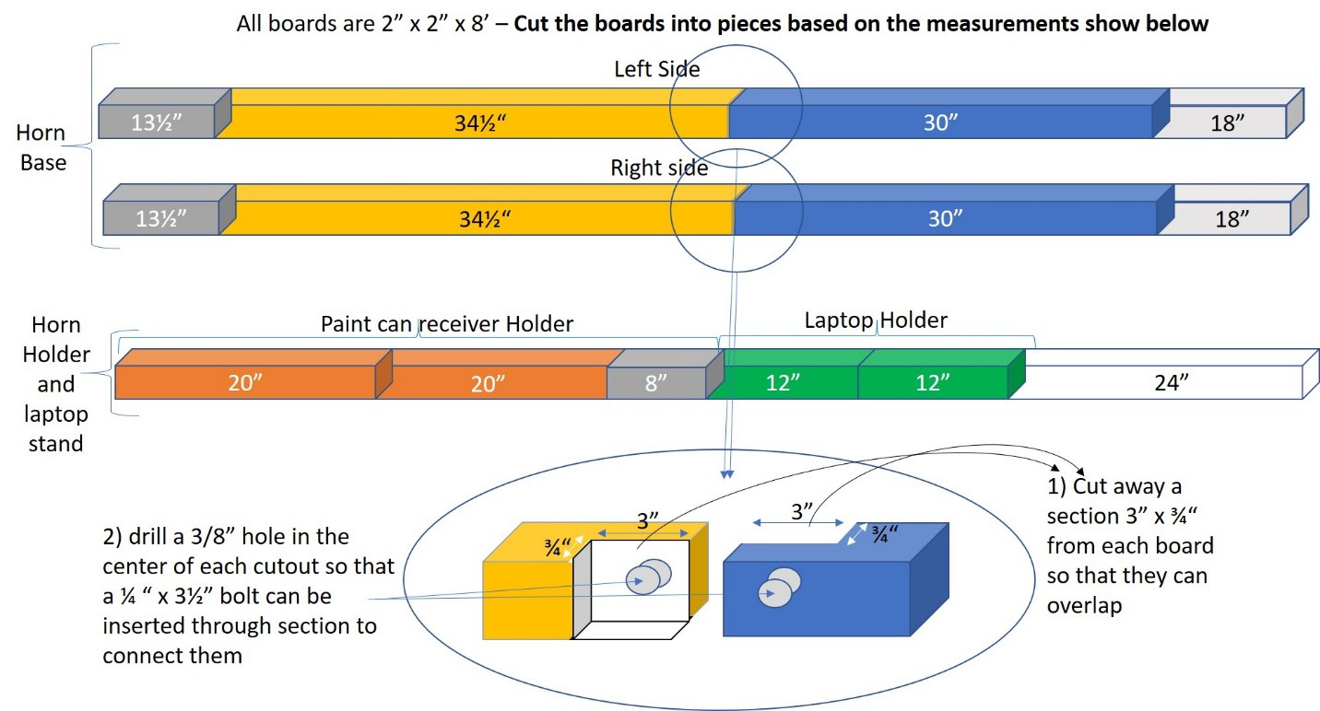
Once the pieces have been cut as indicated we can begin to prepare them for assembly by drilling 3/8” holes in the wood to allow the 3 ½“ bolts to pass through and hold the stand together. These holes need to be drilled in specific locations. It will be easier to overlap the pieces for drilling so that the holes in each piece of wood are well aligned. The picture below shows where the cut pieces will go to build the frame.
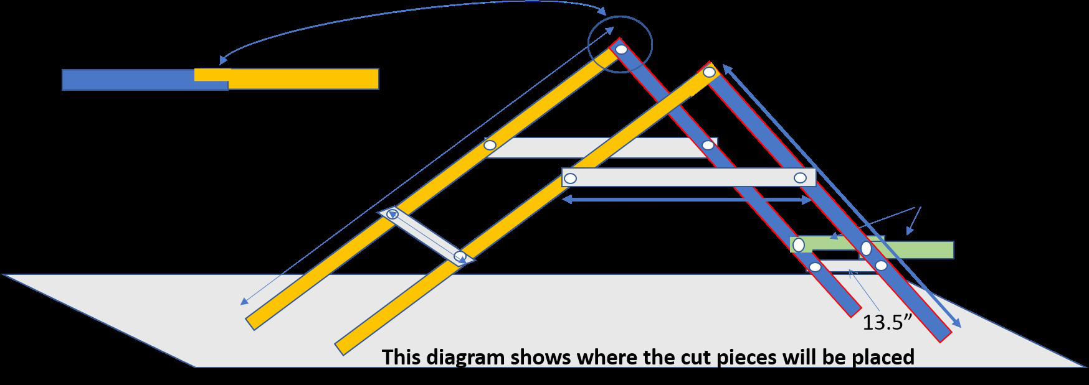
The diagram below shows where to place the pieces and where to drill the holes that will let the 3½“ bolts pass though.
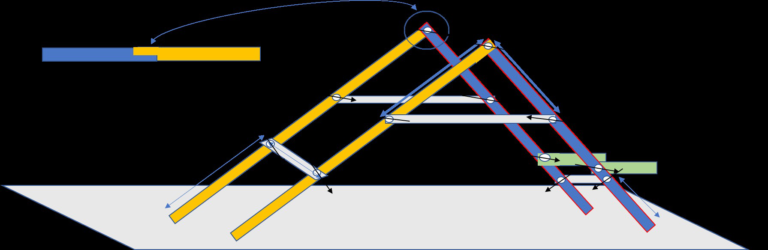
After the holes are drilled insert the bolts into the holes that were drilled to hold the stand assembly together. Insert the bolts from the outside. The threaded part of the bolt should be on the inside. Attach a wing nut snuggly to each bolt to assemble the stand. The antenna base should now be able to stand on its own without twisting or moving.

Attaching the wood support frame to the paint can receiver
The paint can wood “U” shaped form is constructed from the two 20” pieces of wood and the 8” piece of wood. Attach the 20” pieces to the paint can before connecting the two pieces with the 8” cross connecting piece of wood. The 8” piece of wood will need to cut down to fit between the two 20” pieces. Expect to cut the piece down to around 6 5/8” which is the width of the can. Use the diagram below to guide you. Placing the pieces of wood on the table next to the bottom of the paint can will make the assembly work easier.
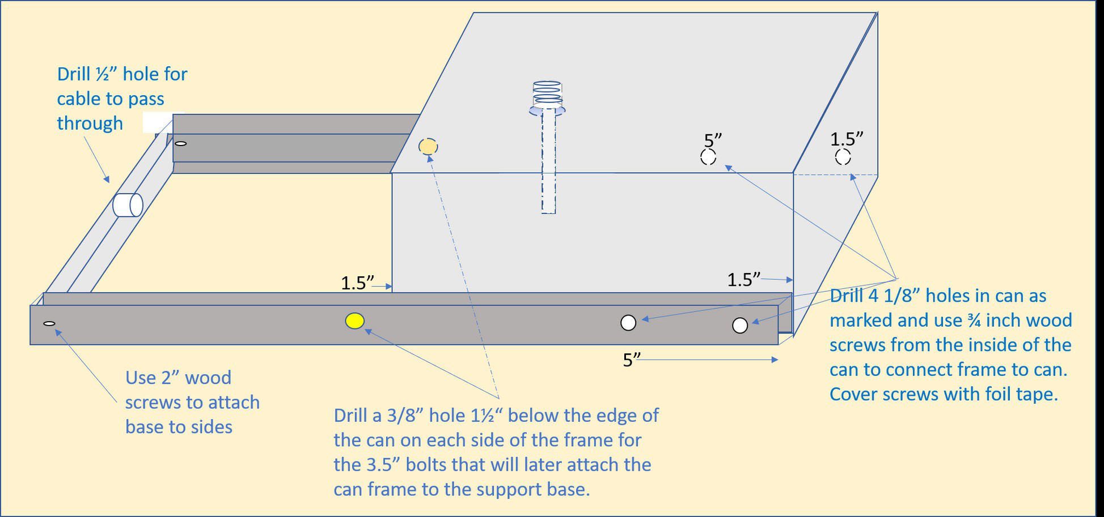

Attaching the horn antenna to the paint can receiver
Attaching the paint can to the cone can be done in one of two ways. You can slide the can with the handle side down into the large end of the cone and carefully push the can through the small end until only the edge of the can is inside the hole. If the hole is too big to hold the can then place the can at the edge of the can and use a few pieces of foil tape the hold it in place both inside and outside of the cone. To hold the can firmly in place use the foil tape to completely tape the entire inside and outside edges of the can to the cone. The tape on the inside should hide the entire edges of the open end of the paint can. The tape on the outside needs to be strong enough to keep the can from moving. You can place pieces of foil tape both vertically and horizontally to complete this task.
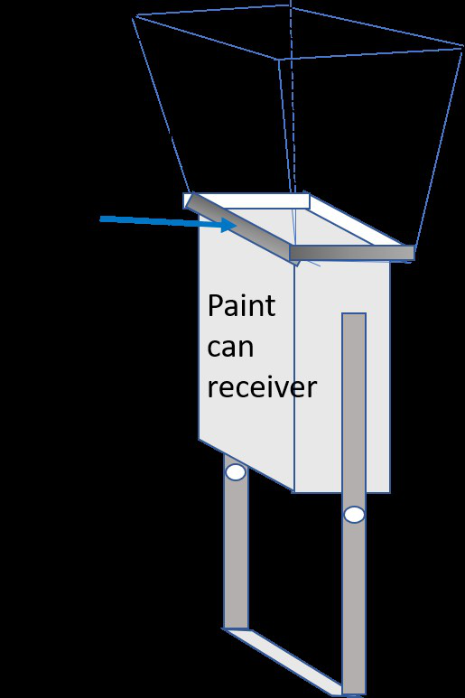
Remember to tape both the inside and outside of the can to the horn using lots of foil tape.

Attaching the assembled horn antenna and can to the support stand
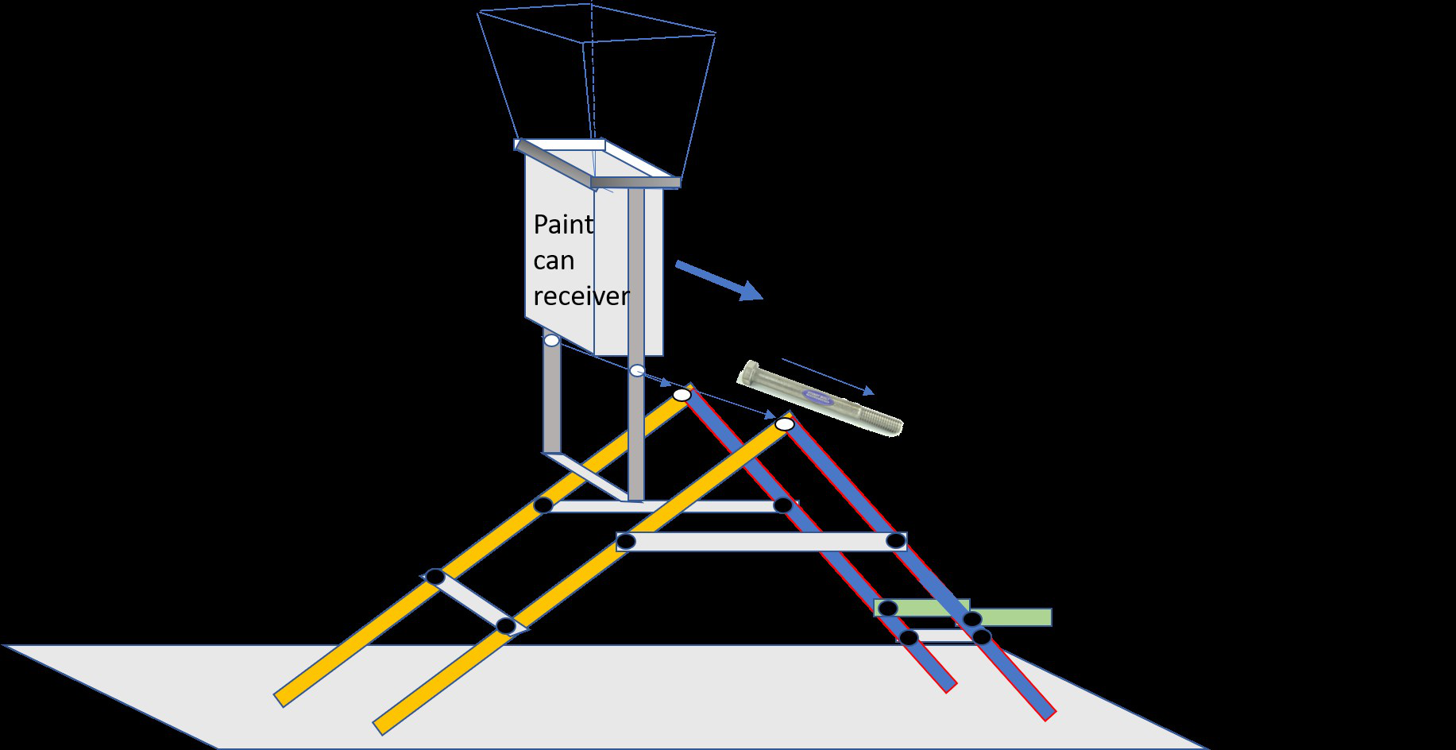

Telescope Electronics Hook Up
Once the radio horn telescope is assembled, the electronics to make it work need to be hooked up. Four pieces of electronics will be attached to move signals collected by the telescope to the laptop computer for storage and analysis. The parts needed, and included with the lending kit are:
1) the LNA [the “low noise amplifier” that is the size of a large pack of gum and attaches to the paint can antenna RF plug on the outside of the can]
2) the Airspy [the small black box with a coax connector on one side and a USB connector on the other]
3) the RF cable that attaches to the LNA to the AIRSPY [each end is the same so it’s easy to connect]
4) the thin cable that runs between the AIRSPY and a USB port on the laptop computer [each end is different so it’s easy to know which end goes where]
The LNA has two RF type plugs. The one on the bottom pointing perpendicular to the LNA is screwed onto the RF antenna connection portion on the outside of the can.
The other end of the LNA has a plug pointing parallel to the LNA and attached onto the male SMA connector at one end of the RF cable. The other male SMA end is screwed onto the matching connector on the AIRSPY.
The AIRSPY comes with a second thin wire cable. The small end goes into the small matching AIRSPY port and the other end plugs into a USB port on the laptop PC.
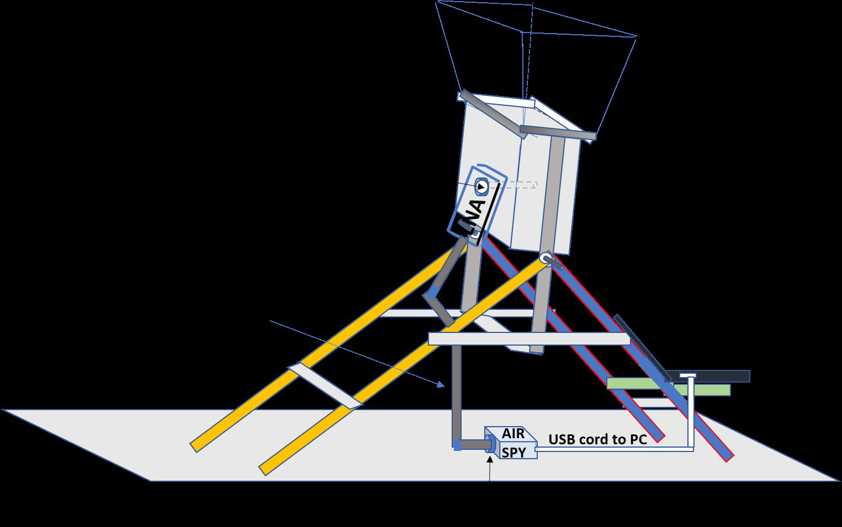

How to set-up the laptop PC to run the Radio Horn Telescope software based spectrometer
In the lending kit electronics box you should have received a flash drive. This flash drive will allow you to run our spectrometer program from your school’s pc as all functions for running the pc with our program are on the flash drive.
NOTE: before beginning this connection process make sure your laptop is off to start with.
First, hook up the Radio horn telescope electronics as described above. When that is completed and the USB plug from the Airspy has been plugged into the laptop then you can plug in the flash drive to a separate USB port on your laptop.
Second, follow the instructions to turn on your pc and direct it to our flash drive to boot up and run the computer from the flash drive.

Running on a pc
1. With the computer off, insert the flash drive in a USB port.
2. Turn on the computer and hold down the F12 button to access the Boot menu.
3. Choose the flash drive for booting. (this will happen automatically if you just wait)
4. The Ubuntu operating system should boot up. THIS WILL TAKE A FEW MINUTES. BE PATIENT.
5. After the desktop has loaded, run the “spectrometer_w_cal.grc” file by double-clicking on it. BE PATIENT, THIS WILL TAKE A MINUTE.
6. The spectrometer program should be ready to run.
7. NOTE: When the save/write to file buttons are hit, the data files are written to the grc_data folder on the flash drive.
8. NOTE: The system clock time defaults to UTC/London. Change it if needed.
If you need a replacement flash drive, use the current DSPIRA setup guides. Check the image requirements before downloading.

Creating a bootable USB drive
DSPIRA bootable images and instructions
1. Open the guide above and choose an image that matches your computer.
2. Download the image and extract the ZIP file into a folder.
3. Use a USB drive with the capacity required by your chosen image. Back up its contents first.
4. Use balenaEtcher to write the extracted image to the USB drive. This erases the selected drive.
5. Boot the computer from the USB drive, following the guide for your image.
6. Check the receiver settings and recording folder before collecting observations.
For a new GNU Radio 3.10 installation on Ubuntu, use the current software guide:
https://wvurail.org/dspira/install-software/

How to calibrate and operate the spectrometer to collect data from your radio horn telescope

Operating a Horn Telescope

By Dr.John Makous, DSPIRA program participant and Physics Teacher

The Horn Telescope: An Overview
A horn telescope is simply an antenna designed to pick up radio waves. The horn used in DSPIRA is specifically designed to pick up radio waves emitted by neutral hydrogen atoms in the Milky Way Galaxy, which have a frequency of approximately 1420 MHz.
Because it is an antenna, a horn telescope will pick up all radio waves that are incident on it, regardless of their origin. As a result, the signal that is displayed on the spectrometer output includes signals from outer space as well as those from the local environment here on earth. Some of these signals are inherent in the data processing system. Because we are primarily interested in signals that are coming from astronomical objects, such as the galaxy, we need to subtract out any other signals that the telescope might be picking up. The spectrum_w_cal.grc GNU Radio program enables the user to do just that so that we can view spectra of signals that are only from the astronomical object of interest.

What Can a Horn Telescope Measure?
The graph below shows a typical spectrum of radio waves from neutral hydrogen detected using the DSPIRA spectrometer program with a horn.
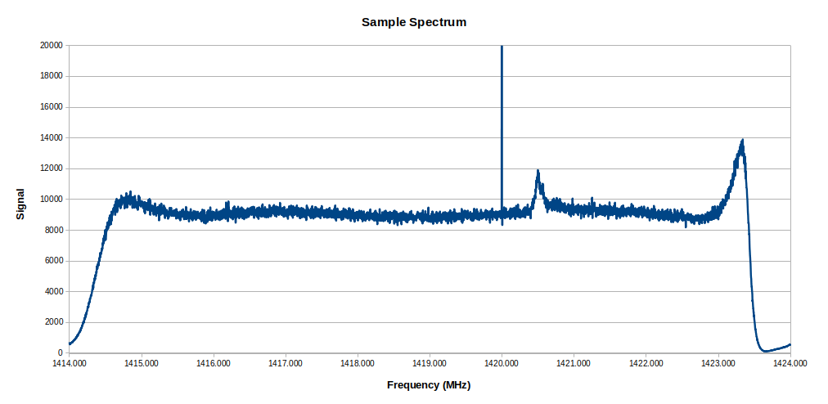
This graph displays the amplitude of radio wave signals collected as the spectrometer scans across frequencies ranging from 1414 MHz to 1424 MHz. The neutral hydrogen signal appears at approximately 1420.4 MHz.

What are the features appearing in this graph?

The System Background Signal
As mentioned above, part of the signal displayed in the graph is from sources that are not from the galaxy. This can be from noise sources in the local environment as well as signals from the horn detector system itself. The part of the signal that comes from the horn system itself, which includes the electronics and data signal processing, is highlighted in red in the graph below, which is typical for the Airspy software defined radio device used with the DSPIRA telescope.
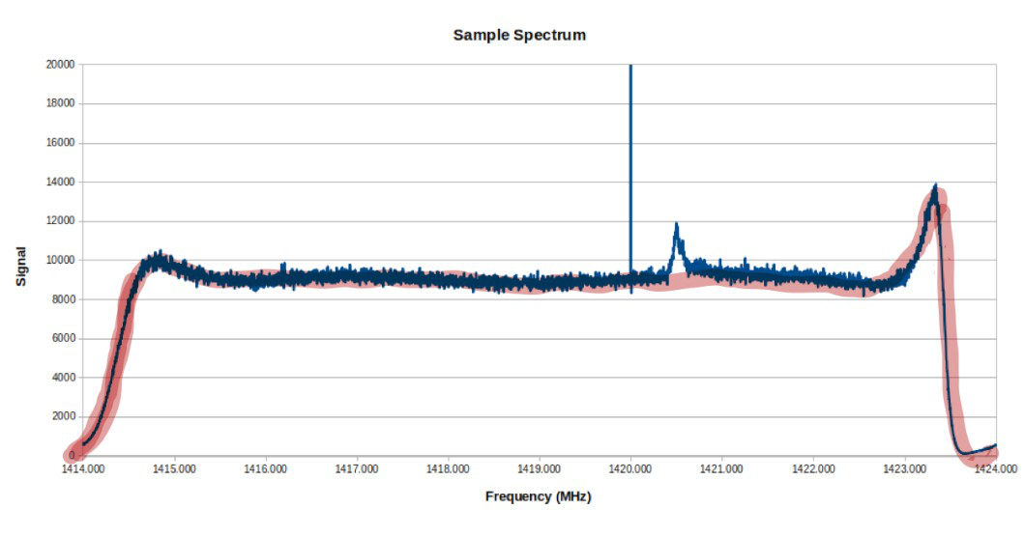
If the telescope is pointed in many different directions, such as different parts of the sky, at the ground, at a building or a tree, the viewer will notice that the characteristic feature highlighted in the spectrum above does not change in shape. For stronger signals, the height of the graph will increase, but this general background shape is always there. This is a result of the data signal processing electronics of the telescope system.
Another feature that typically appears with the Airspy SDR we use is the single line spike that appears at 1420.0 MHz. This comes from the Airspy electronics and is not of interest to us.
The spectrometer_w_cal.grc spectrometer program is designed with the capability of reducing noise spikes and subtracting out the characteristic background signal. This allows the user to display the spectrum of signals that come from only the galaxy.

The Signal from Neutral Hydrogen
For spectral line viewing, the peak that we are interested in is the small peak that may appear at a frequency of approximately 1420.4 MHz. This is the peak identified in the spectrum below.
This 1420.4 MHz signal is from radio waves detected from neutral hydrogen atoms in our galaxy. These radio waves are emitted from these hydrogen atoms as a result of a transition that takes place with the electrons in the atoms. The signal emitted from each atom is extremely weak. Fortunately, there is a very large amount of neutral hydrogen in our galaxy; so we are able to detect this hydrogen with our radio telescope here on earth. We cannot see these hydrogen atoms directly with the naked eye. This is where the horn radio telescope becomes useful!

Operating the Horn Telescope
The program used to run the telescope is a GNU Radio program called spectrometer_w_cal.grc. It is available from the WVURAIL/dspira-software repository in Github. The spectrometer_w_cal.grc program has several features to make data collection with the horn telescope user-friendly. Each feature on the display is described below.
Set up the horn and connect the LNA to the Airspy with a cable, and the Airspy to the computer USB. [See the setting up horn video.] Then open the spectrum_w_cal.grc program in GNU Radio. [See the operating spectrum_w_cal.grc video.]

1. Features of the Spectrum Tab
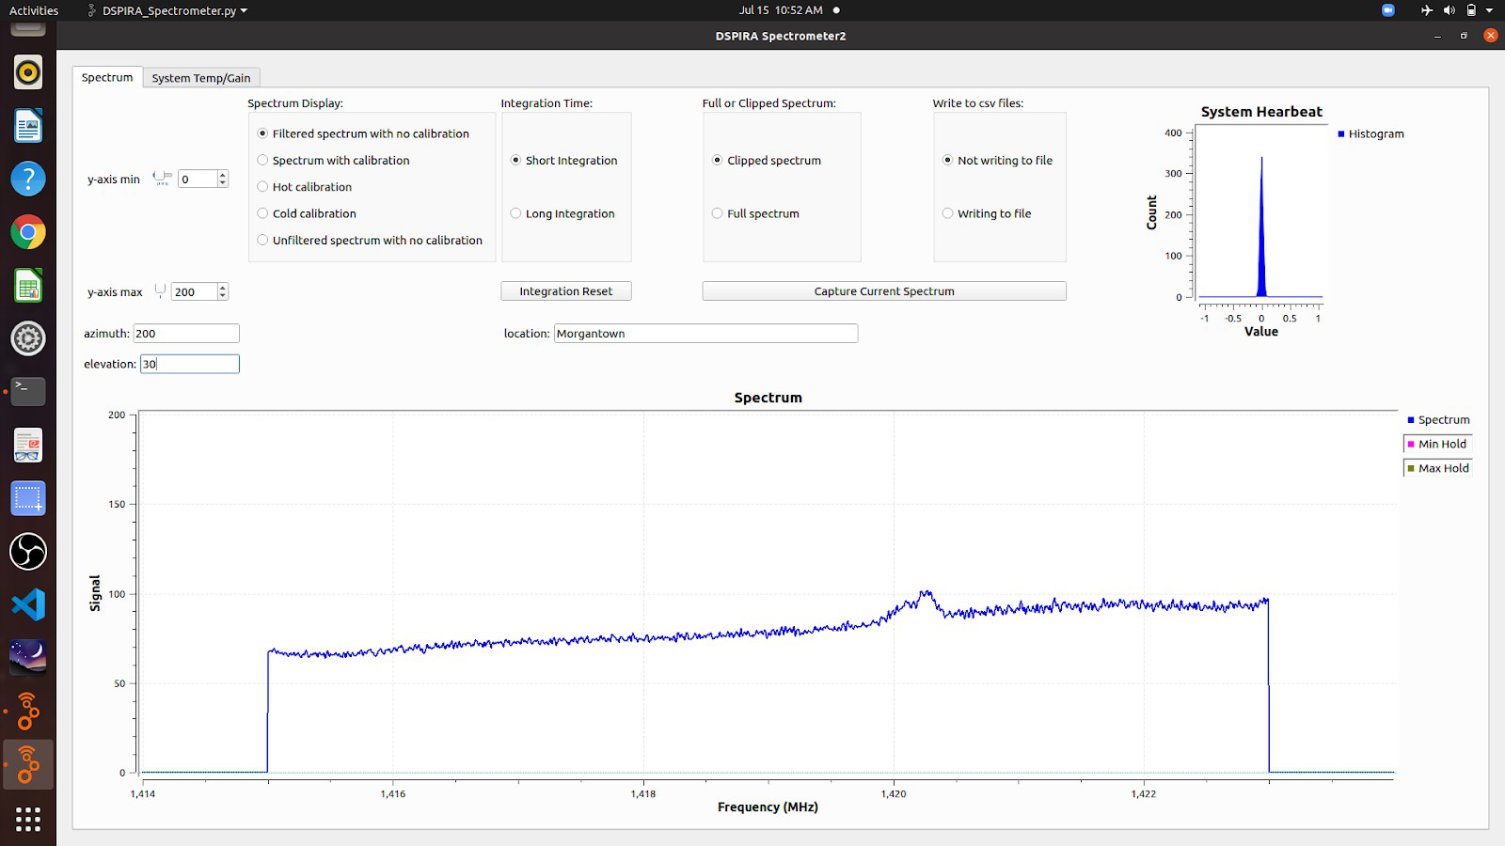
- Graphical Display Boxes:
- Spectrum graph – shows the signal vs. frequency spectrum, which is the primary focus of our investigations with a radio telescope.
- System Heartbeat – This is actually a histogram of signals being detected. During normal, this display should continuously jump up and down during a run. As long as its “beating,” things are good. If this graph looks frozen, then the program has probably stopped running, and you will need to restart the program.
- Spectrum Display options:
- filtered spectrum with no calibration - the raw spectrum collected is displayed with the noise spikes filtered out
- spectrum with calibration - the hot and cold calibrations are factored in to display the true signal received from the galaxy.
- hot calibration – Select when pointing the telescope at the “hot” source (the ground) during the calibration procedure.
- cold calibration — Select when pointing the telescope at the cold source (open sky) during calibration.
- unfiltered spectrum with no calibration - the raw spectrum collected is displayed with no changes made to it.
- Integration Time options:
- Because the radio signals being detected are extremely weak, it is necessary for the software to add together (integrate) the signals detected over a period of time. This is the integration time. This averages out the noise in the signal, making the galaxy signal more prominent. The user has the option of setting two different integration times when using this spectrometer.

Short Integration
- This is useful for quick sampling of what the telescope is looking at.
- The default of the shorter integration time is 0.4 s.

Long Integration –
- This is useful for when smoother data is desired. Usually the user will use the longer setting for targeted pointings where “good” data is needed.
- The default of the longer integration time is 10 s.
- Both of these integration times can be set by the user before running the program. The settings are in the variable blocks in the upper right corner of the GNU Radio canvas.
- Integration Reset – This resets the data averaging when the long integration time is selected. This is needed if the telescope pointing is changed in the middle of a long integration to assure the spectrum displayed is the average of the new pointing.

Full or Clipped Spectrum
- Clipped spectrum – In this display the ends of the spectrum, between 1414 and 1415 MHz and between 1423 and 1424 MHz, are clipped off. This removes the distracting background portions of the spectrum, as discussed in the previous The System Background Signal section.
- Full spectrum – This is self explanatory.

Capture Current Spectrum button
- The live spectrum being displayed on the main graph can be captured in a .csv text file for easy access later.

Write to .csv File
- This option enables the spectrum to be written to newly created files once every integration time so that data can be collected without the user’s presence.
- [see the saving data video.]

2. Features of the System Temp/Gain Tab
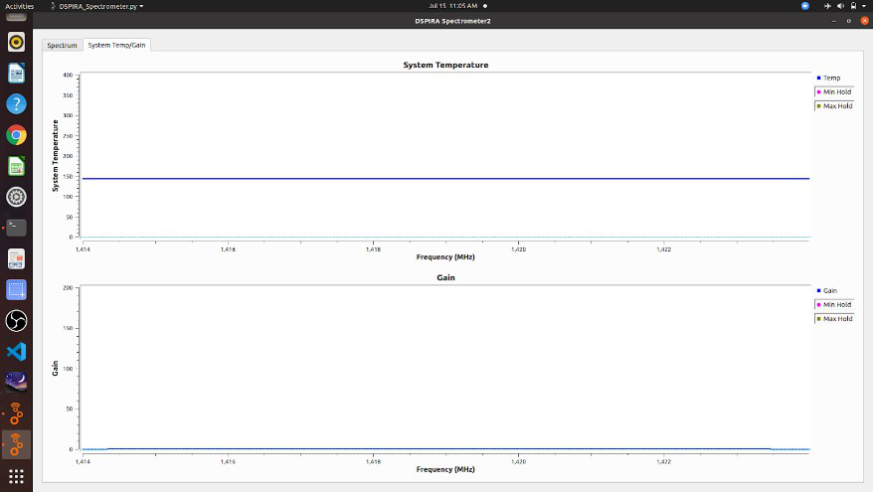
- These graphs are not needed during most telescope runs. They are mainly for those who are interested in the quantitative performance of the telescope.
- System Temperature Spectrum – This graph is an indication of the amount of signal that is coming from the telescope system itself.
- Gain – This is the factor that is used by the spectrometer to scale the detected signal into known astronomical units.

3. Using Systemp_w_calibration

[See Spectrometer_w_cal_Description.mp4 video]

A. Before Starting a Run
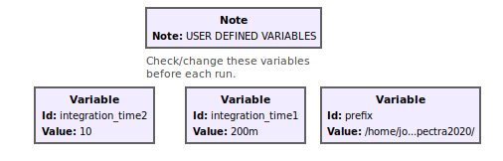
- Check the user-defined settings illustrated above. These are the Variable blocks in the upper right corner of the GNU Radio canvas.
- To change any values, double click on the box. Type the value in the Value box.
- integration_time1 is the short integration time, and integration_time2 is the long integration time. These can be changed to any value at 0.4 s or above.
- Be sure that the file path correctly in the prefix box. This is the folder location where the data files will be written.
Hints on setting the file path correctly:
1. Open the File Navigation window (folder icon).
2. Navigate to the folder to which you want to save the spectrum files.
3. Right click on the folder.
4. Select Properties.
5. Double click the "Parent folder:" path and copy it to the clipboard.
6. In the prefix variable box paste the path name inside quotes in the Value box. (Delete any existing path name.)
7. Then append the actual folder name to the end of the parent path. Be sure to separate folder names with / and end with /.
Example:
Parent folder: home/Jansky/radio_astronomy
data folder name: horn_data_2020
Value to put into the prefix variable box:
"home/Jansky/radio_astronomy/horn_data_2020/" (Include the quotes)
CAUTION: If you run the program on a laptop without the power cord plugged in, the computer may go into a sleep mode and stop running the GNU Radio program, depending on the length of the run. Change the power settings on your computer so that it never suspends or goes to sleep.

B. After Starting the Program
- The first screen that appears looks like the following:
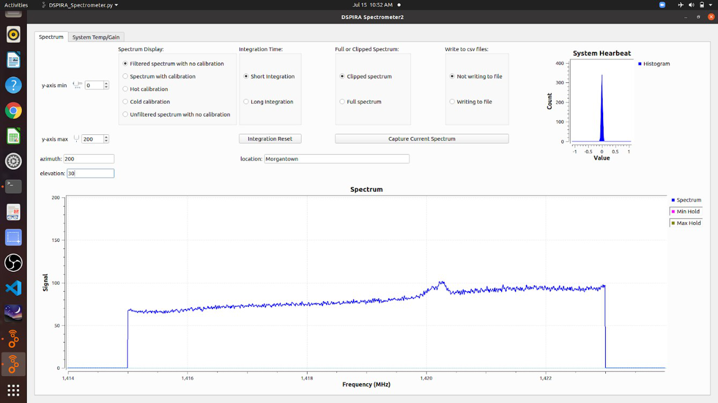
- This display is commonly used for typical observations.
- Adjust the ymin and ymax values to scale the graph as desired.
- Fill in the azimuth, elevation, and location, if known. When entering these values, you must hit ENTER after each entry in order for it to get recorded by the program.
Note: When data is written to a file, these parameters are included in the title, as described below under Data File Format.
- The Short Integration is good for quick observations and demonstrations. Switch to Long Integration for smoother data when a pointing is settled on and you are ready for a longer run.
- The Clipped Spectrum is the better selection for most viewings. The Full Spectrum is good for demonstrating how the signal processing affects the spectrum, as discussed in . It also might be useful for the expert user who wants the full spectrum for some reason.

C. Saving a Spectrum to a Data File

[See the Spectrometer w cal savingdata.mp4 video]
- The spectrum that is currently being displayed on the screen can be written to a .csv data file by clicking the Capture Current Spectrum button. The data file is written to the folder under the path in the prefix Variable box.
- When Writing to file is selected under the Write to csv File window, a data file will be written to the folder each time an integration time elapses. For instance, if Long Integration is selected and is 10 s, then every 10 s a new file is written. So for a 10 minute run, a total of 60 files will be written to the data folder.
This option is useful when running a drift scan or for when the user sets the telescope to collect data at a later time when the user is not able to be present.
- Data File Format:
- The .csv format is a .txt data file that can be opened in any spreadsheet.
- When opened in a spreadsheet, the data will appear in 2 columns. The first columns contains the frequency, in MHz, from 1414 MHz to 1424 MHz. The second column is the signal.
- A graph of Signal vs. Frequency can easily be created after opening a file in a spreadsheet.
- The file name has a format that contains the date, time, location, azimuth, and elevation, with “_spectrum” at the end. The location, azimuth, and elevation are recorded from whatever values were typed into the corresponding fields on the spectrometer interface screen.
- As an example, the filename “2020-07-15_11.06.14.0_Morgantown_200_30_spectrum” contains data that was collected on July 15, 2020 in Morgantown with the telescope pointed at an azimuth of 200 degrees and an elevation of 30 degrees.

4. Calibrating the Telescope [See the Spectrometer calibration video]

Some pointers
- For the best results, after starting the program, allow the system to warm up for approximately 20 minutes before calibrating.
- Re-calibrations can be done any time during a viewing session.
- For consistency, it is recommended to re-calibrate occasionally during a viewing session.

Procedure
1. Point the telescope toward the ground at an angle. The video shows how this is done.
2. Switch the Spectrum Display to Hot Calibration.
3. Select the Time Integration to be Long Integration.
4. Watch the spectrum displayed. You may need to change the ymax value to fit all of the signal on the graph. Wait for the graph to settle to a steady display. Then switch the Spectrum Display to Cold Calibration. DO NOT MOVE THE TELESCOPE UNTIL THE SPECTRUM DISPLAYED HAS BEEN CHANGED TO Cold calibration.
5. Switch the display to Cold Calibration and the Time Integration to Short Integration.
6. Point the telescope at open sky. Continue to re-direct it until you find a patch of sky that does not show any hydrogen peak near 1420.4 MHz. After doing so, switch the Time Integration to Long Integration.
7. Wait for the graph to settle to a steady display. Then switch the Spectrum Display to Spectrum with Calibration. DO NOT MOVE THE TELESCOPE UNTIL THE SPECTRUM DISPLAYED HAS BEEN CHANGED TO Spectrum with calibration.
8. The spectrometer is now calibrated, and the graph should now be showing only the true signal from the galaxy.

Some More Things to Note
- After completing a calibration, the signal is in units of Kelvin (K). This sounds odd, but it is how radio astronomers quantify radio signals.
- For most amateur applications, it is not necessary to get bogged down trying to understand these units of Kelvin.
- After completing a calibration, the baseline signal would theoretically be steady at approximately 10 K, the temperature of empty space. However, in reality, the base level after calibration will fluctuate. This is due to several factors, but it is mostly due to the LNA because its temperature will fluctuate some over the span of a viewing session.
- The background level can actually go negative! No need to worry. Re-calibrating usually takes care of this and brings the base level back up to approximately 20 K.
- The background level will not affect any peak positions or shapes.
- Even though the background level might not stay the same, the calibrated spectrum can still be used for quantitative analysis by offsetting the data so that the background level is zero. This is typically what is done when analyzing the area of the peaks.

