Build a simple spectrometer
  - Teaching guide
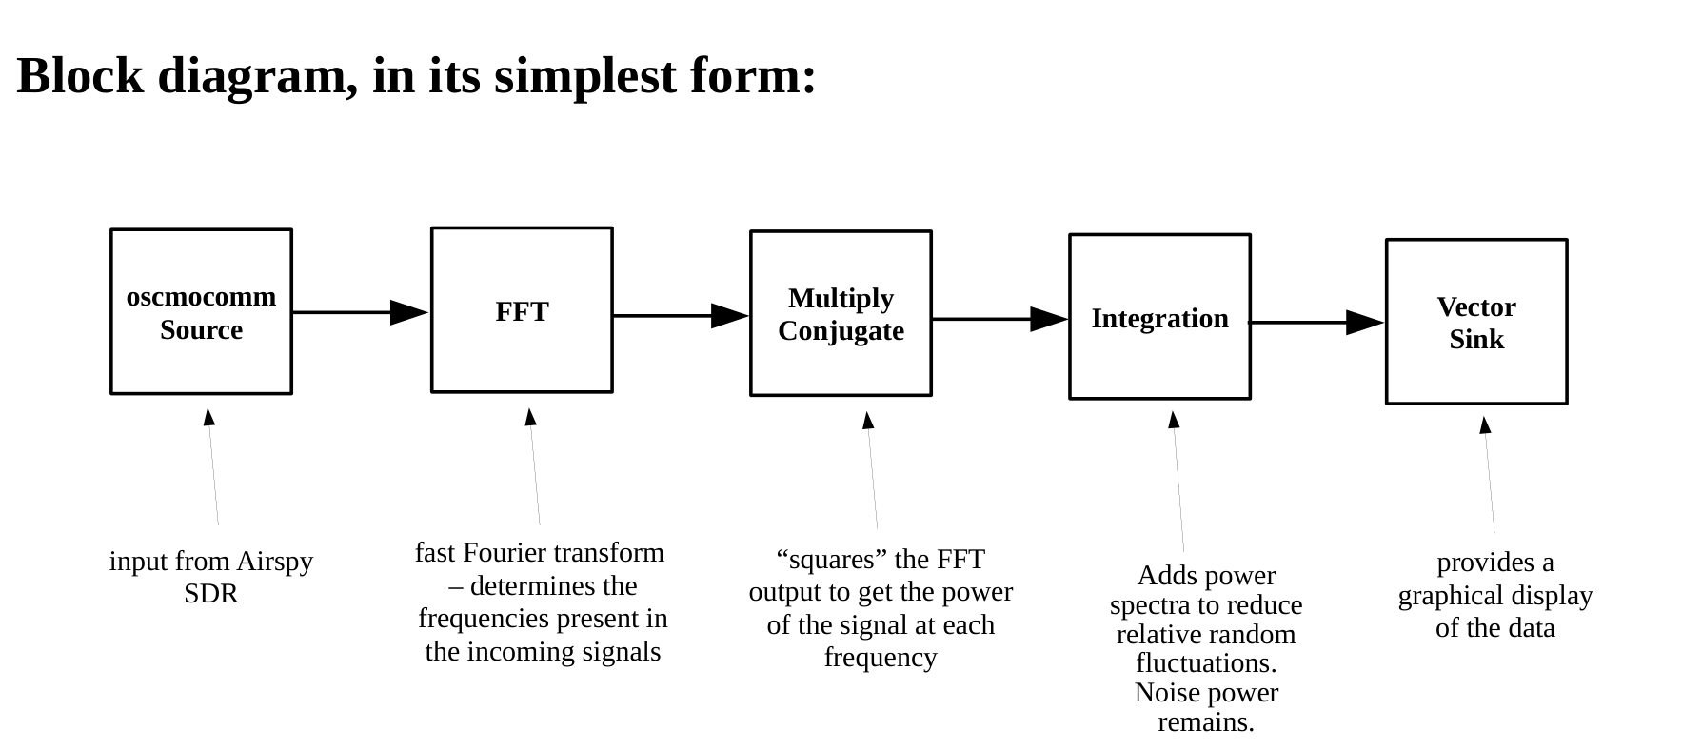

The completed GNU Radio program
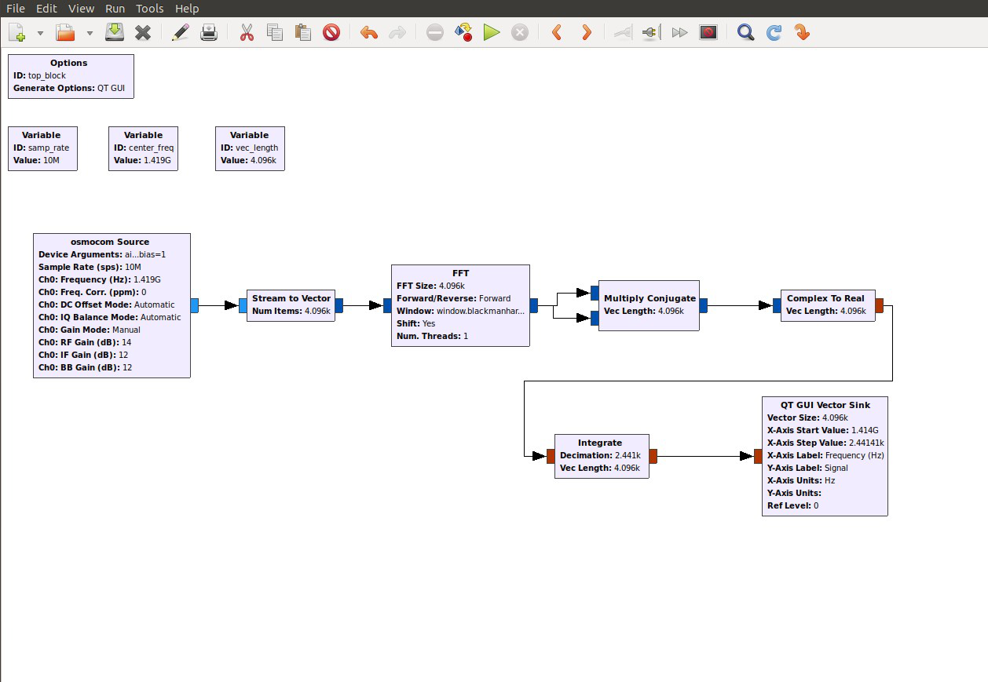

Building the Spectrometer, with Explanations

Osmocom Source block
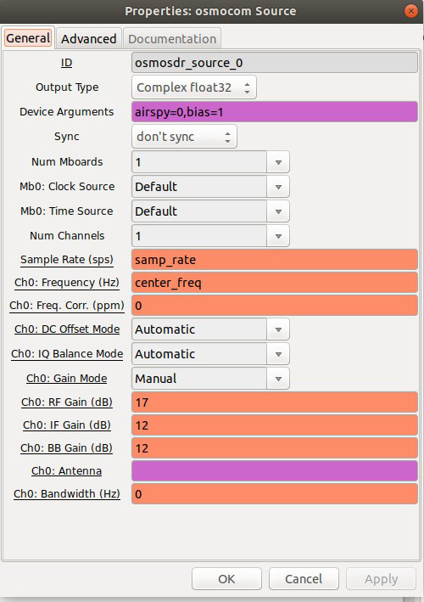
- indicates the Airspy as the input block, and its settings.
Settings:
- Device Arguments
- airspy=0 identify Airspy as the input device
- bias=1
enable antenna-cable power for a compatible LNA
- sample Rate: samp_rate value set as 10 MHz in Variable block
- Ch0: Frequency: center_freq
- indicates middle frequency of the 10 MHz Airspy bandwidth, which we will set at 1419 MHz in the center_freq Variable block.
- RF Gain: 17
- IF Gain: 12
- Leave thd other settings at their default values.
USB powers the Airspy itself.

Stream to Vector block
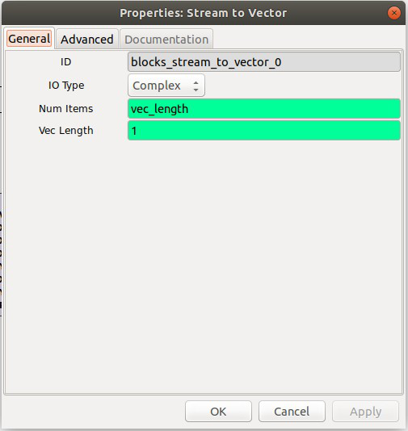
- bundles the continuous data stream from the Osmocom block into vector chunks to be processed by the FFT block.
Settings:
- Num items: vec_length variable set by a Variable block (value = 4096)

Vec Length: 1
- NOTE: This nomenclature is confusing; the Vec Length is not really a vector length; it indicates that 1 bunch of 4096 Num Items is sent into the FFT at a time. This is not to be confused with the variable vec_length, which does describe a vector length.

FFT block
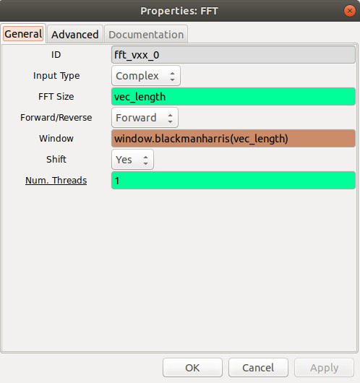
- performs a Fast Fourier Transform on the data, one vector stream at a time.
Settings:
- Input Type: Complex
- FFT Size: vec_length (value = 4096)
- Window: window.blackmanharris(vec_length)
- NOTE: There is a vector size needed in the Window function that must match the FFT size. (It’s easy to overlook this.)

Multiply Conjugate block
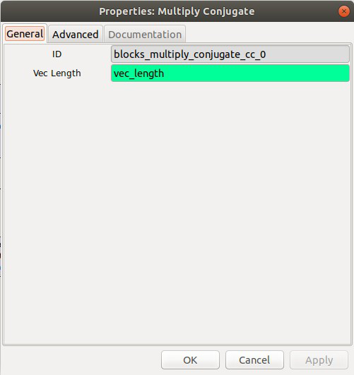
- calculates the product of the FFT output with its complex conjugate.
- This results in a computation of the spectrum power, which is what we want displayed.
Settings:
- Vec Length: vec_length
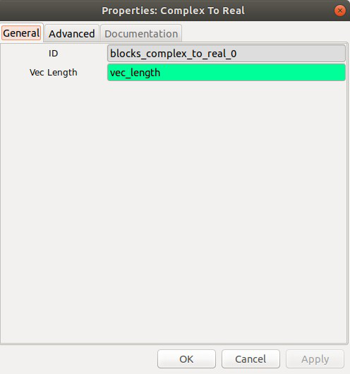

Complex to Real
- Converts the data stream to a real value.
Settings:
- Vec Length: vec_length
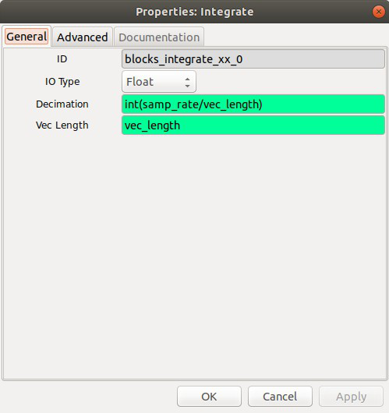

Integrate
Adds corresponding power channels across successive spectra. Random fluctuations decrease relative to the mean as more spectra are combined. The mean noise power remains; it does not cancel.
Settings:
- IO Type: Float
- Decimation: int(samp_rate/vec_length)
Number of complete spectra to add for each output vector.
Example:
At 10 MHz and 4096 samples per FFT, 10,000,000 / 4096 = 2441.40625 spectra per second.
Decimation 2441 adds 2441 spectra, giving about one output per second. Divide by 2441 if you want an average. Summing also increases the mean noise level.
- Vec Length: vec_length

QT GUI Vector Sink
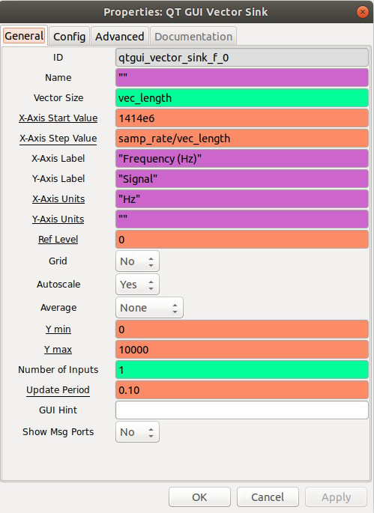
- This displays the processed signal in a signal vs. frequency graph.
Settings:
- Vec Size: vec_length
- X-Axis Start Value: 1414 MHz = 1414e6
- We want the 1420.4 MHz of the HI signal to be displayed approximately in the middle of the graph. We will set the 10 MHz sample rate of the Airspy to start at 1414 MHz and stop at 1424 MHz.
- X-Axis Step value: samp_rate/vec_length
10,000,000 Hz / 4096 = about 2441 Hz per channel. There are 4096 channels across the 10 MHz bandwidth.
- Axis labels are as indicated.
- NOTE: The axis units are not automatically displayed on the graph, which is why they are included in the X-Axis Label. The X-Axis Units setting will enable the units of the x-axis (Hz) to be displayed when a the cursor is moved to an (x, y) coordinate on the screen.
- Autoscale: Yes
- Y min: 0
- Ymax: whatever (since Autoscale is on)
- Leave other settings at their default values.

