What is an “Ubuntu”?
Introduction- If you are reading this, you are looking to venture into creating a usable radio horn telescope and about to travel along a fairly specific, but guided journey through a software installation process. There is a lot to learn and do, and you are not asked to have any previous knowledge, just curiosity. This document is meant to refresh, reveal and/or clarify some important computer terms that you may only be vaguely familiar with.

OPERATING SYSTEM (OS)
We (humans) all interact with computers and smartphones. All of these human-to-computer interactions (communications) are done through an OPERATING SYSTEM.
If you are a PC user (maybe 90% of you), you are very familiar with WINDOWS as your OS.
If you are a Mac user (10-20%), you use the Mac OS system.
...iPhones use Apple IOS...other smartphones use ANDROID OS
Well over 99% of us are familiar with, and use, at least one of these systems.
Here is an online article for a more in depth look at the 5 most common operating systems
https://www.wgu.edu/blog/5-most-popular-operating-systems1910.html#openSubscriberModal

UBUNTU (LINUX)
The fifth OS on the list of top 5 is LINUX. It is a free, open source operating system. More computer savvy people will be very aware of it, but most of us who rely on some of the other 4 OS systems to live our computer-aided lives, may not be aware of LINUX. Because of the non-proprietary, open source nature of LINUX, it sometimes evolves into different OS “versions”. UBUNTU is a popular LINUX-based operating system.
UBUNTU is the operating system that will be used for running the GNURadio software that will make the radio horn telescope functional.
This whole Radio Telescope experience, and the software needed to make it work doesn’t come in a typical “out of the box” format with a simple “Setup.exe” file that you just click on once to get all software needed onto your computer. (Yet!) So, you will have to venture a little deeper into the world of computing than normal.

GUI vs CLI
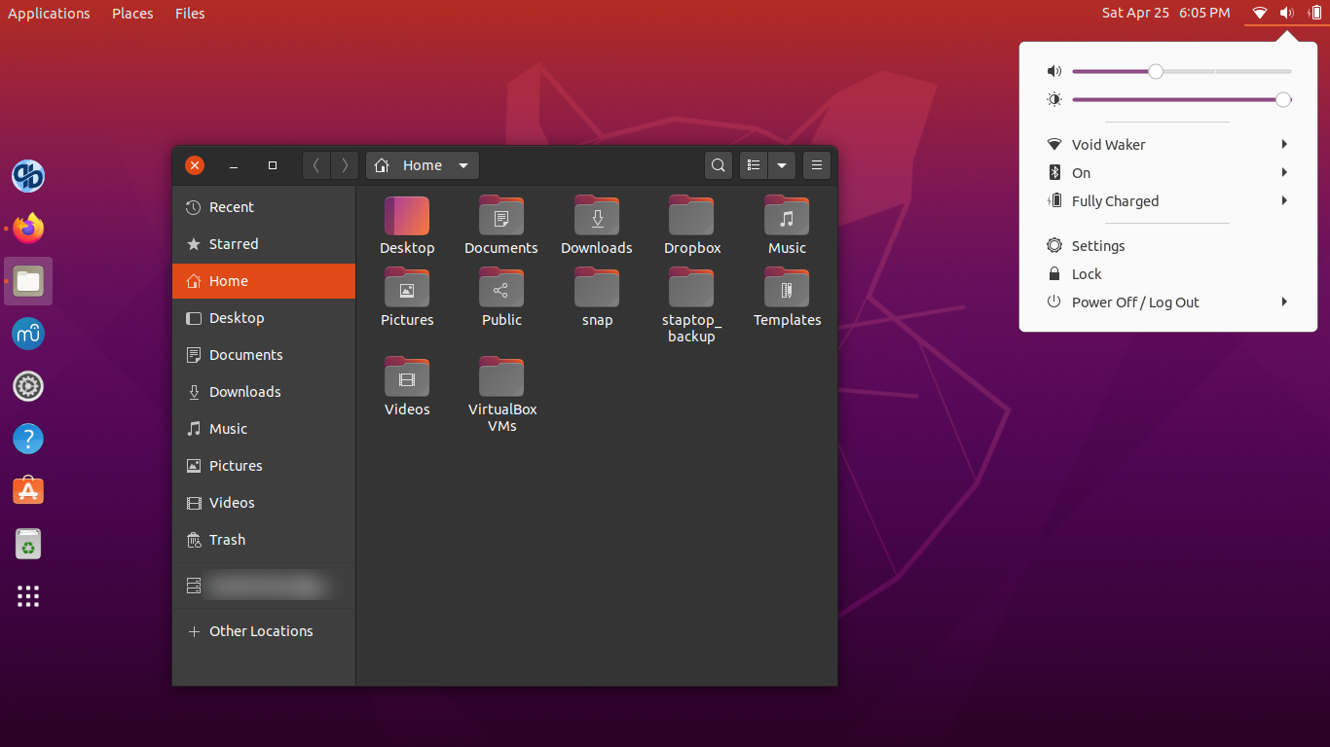
GUI- Graphical User Interface - Simply stated - ICONS. You have grown accustomed to clicking on icons to open your web browser, emails, programs, and apps. Computer programs for all OS systems have worked hard to make GUI the way that most of us interact with the computer. You may very well have had 100% of your computer interactions over the past 20 years through GUI.
AT RIGHT - A typical UBUNTU home screen. Familiar, but different.
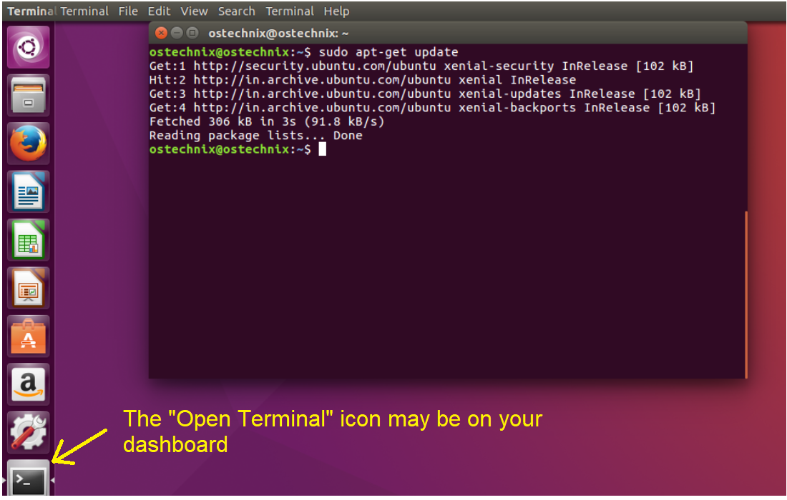
CLI- Command Line Interface - This looks like an old school black screen window with words only. If you have done any computer programming, or remember computers from 30 years ago, you may remember it, though you haven’t had to use it in years… You will now have to use it again!
“How to Open Terminal on UBUNTU’
AT LEFT - The TERMINAL window opened in UBUNTU.

