Testing the Effectiveness of the DSPIRA Radio Telescope for Public Use
Victoria Blanton and DJ Pisano
WVU SURE Program and WVU Physics and Astronomy Department

ABSTRACT
Radio astronomy can be an expensive and inaccessible activity which can discourage its exploration and popularity. The DSPIRA radio telescope is designed by Greenbank Observatory, the NSF, and WVU. Materials used are publicly available, have varying price ranges for all components, and have options of self-construction or pre-built for certain, more complex components. The total price will average under $300. After completion, we will make a digital neutral hydrogen (HI) map which will be compared with pre-existing maps to test its accuracy. Through HI detection, we can measure the rotation and weight of the Milky Way while locating HI clusters that suggest future star formation. This contributes to our understanding of how our galaxy moves and evolves. With the success of the radio telescope project, we hope to contribute to the study of astronomy while encouraging others to take an interest in its increased availability.
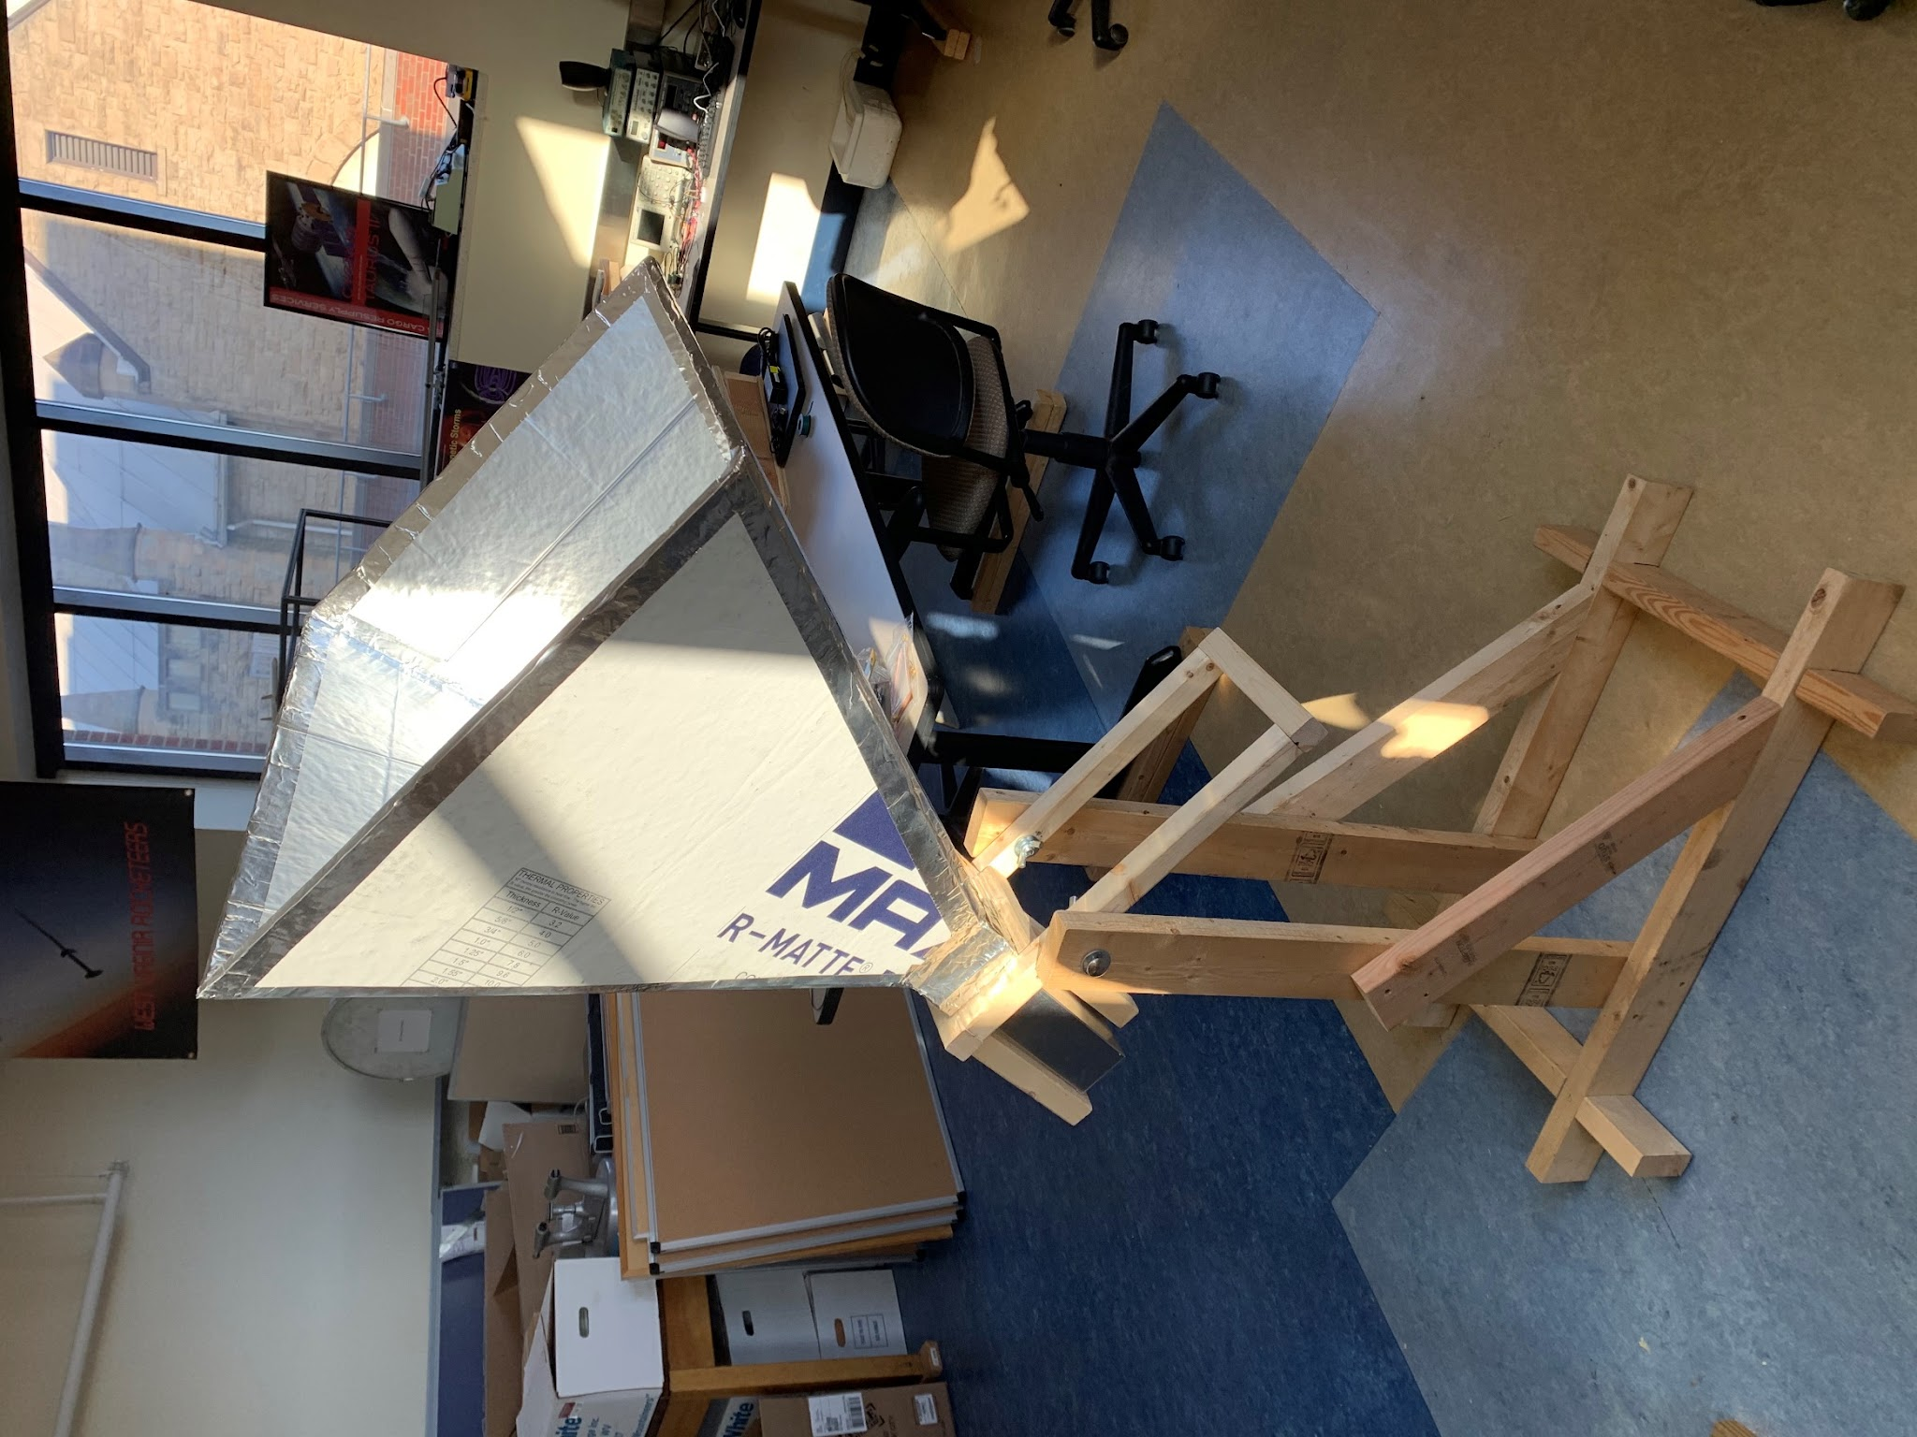
Fig. 1: Radio telescope without electronic components
Radio telescope (minus electronic components). Consists of a large aluminum insulation pyramid on an adjustable wooden support stand.

METHODS
- Construct the base of the telescope with wood to support the horn.
- Construct the horn in a square pyramidal shape with aluminum insulation.
- Solder or purchase the LNA circuit board.
- Download the GNURadio software for the guided website.
- Connect the computer with the GNURadio software to the telescope through the LNA and SDR.
- Use GNURadio to analyze radio wave data received from the probe in the horn of the telescope.

MATERIALS
Budget Item | Cost/Unit Price | Extended Cost
Lumber (2x4) | $10/plank | $20
Lumber (2x2) | $8/plank | $8
Aluminum Insulation | $0.50/sq ft. (64 sq ft.) | $32
Power Drill | $40 | $40
Screws | $6/box | $12
Computer (capable of running Linux) | $200 | $200
Airspy | $179 | $170
LNA Circuit | $60 | $60
Additional electrical components | $30 | $30
DSPIRA Software | Free | Free

OBJECTIVES
- Finish the construction of the radio telescope with the materials listed in the guide.
- Build a circuit with the listed parts guide.
- Use the DSPIRA software to detect neutral hydrogen (HI) in the night sky.
- Compare self-created hydrogen maps with pre-existing HI maps.
- Allow the Descriptive Astronomy 106 class to use the telescope for educational purposes.
- Submit any corrections or suggestions to the original guide creators.
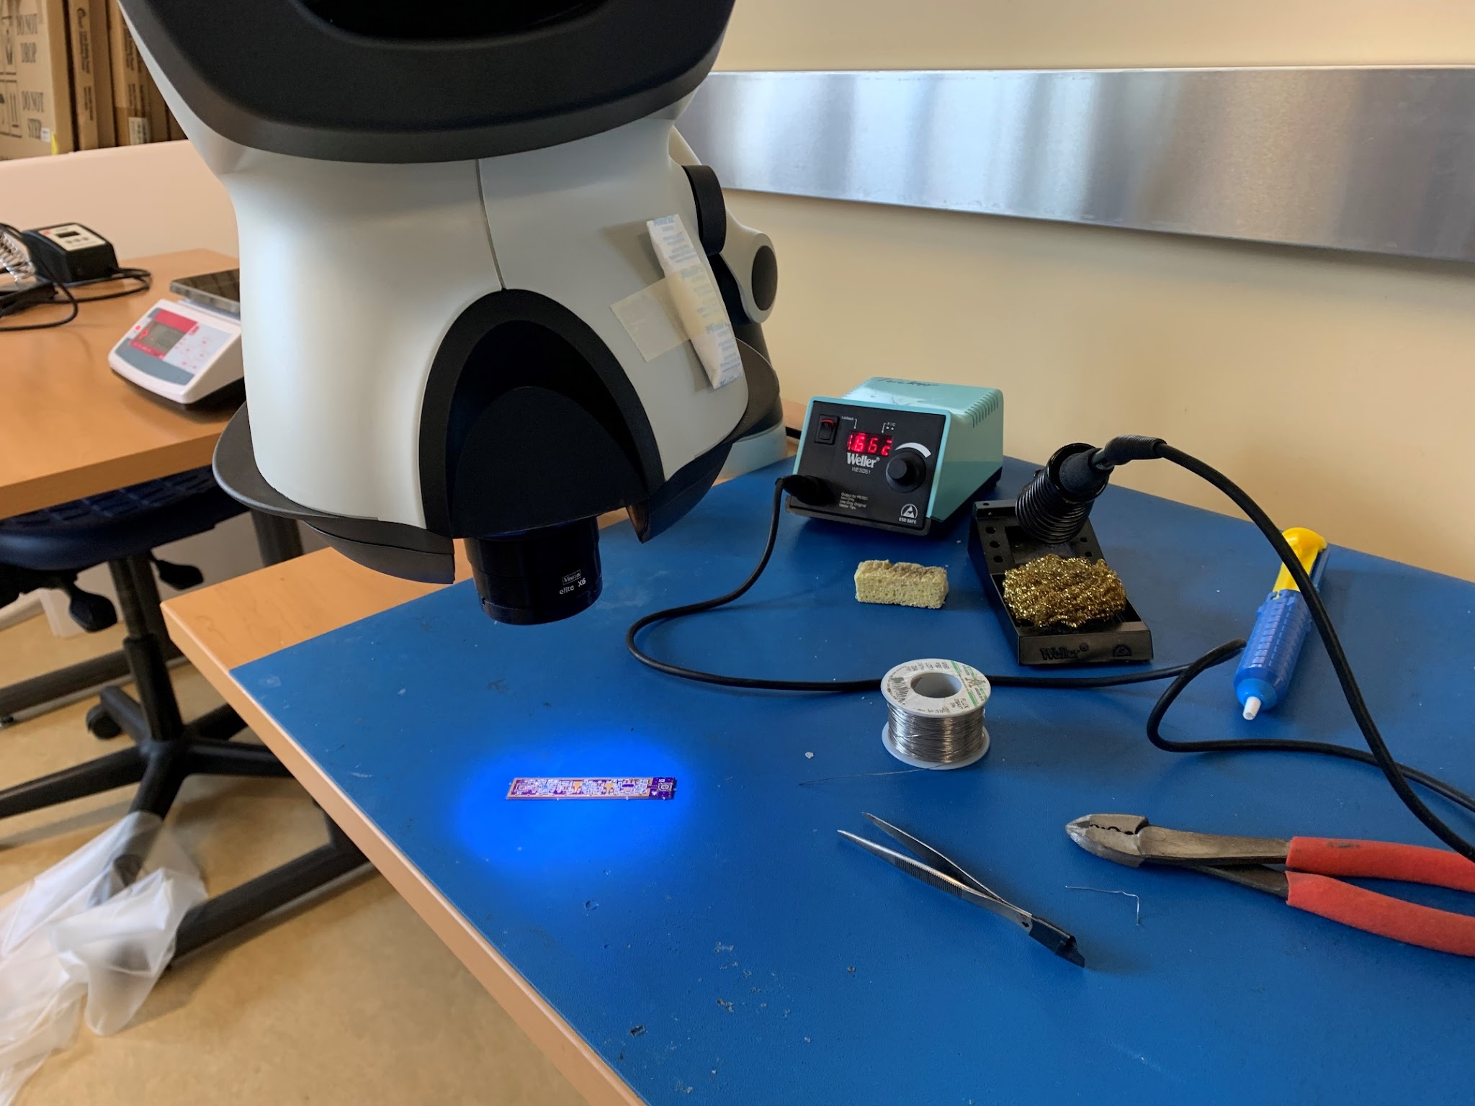
Fig. 2: Soldering station with the circuit board
A soldering station showing the microscope, soldering iron, unfinished circuit board, wire, sponge, and suction pen.
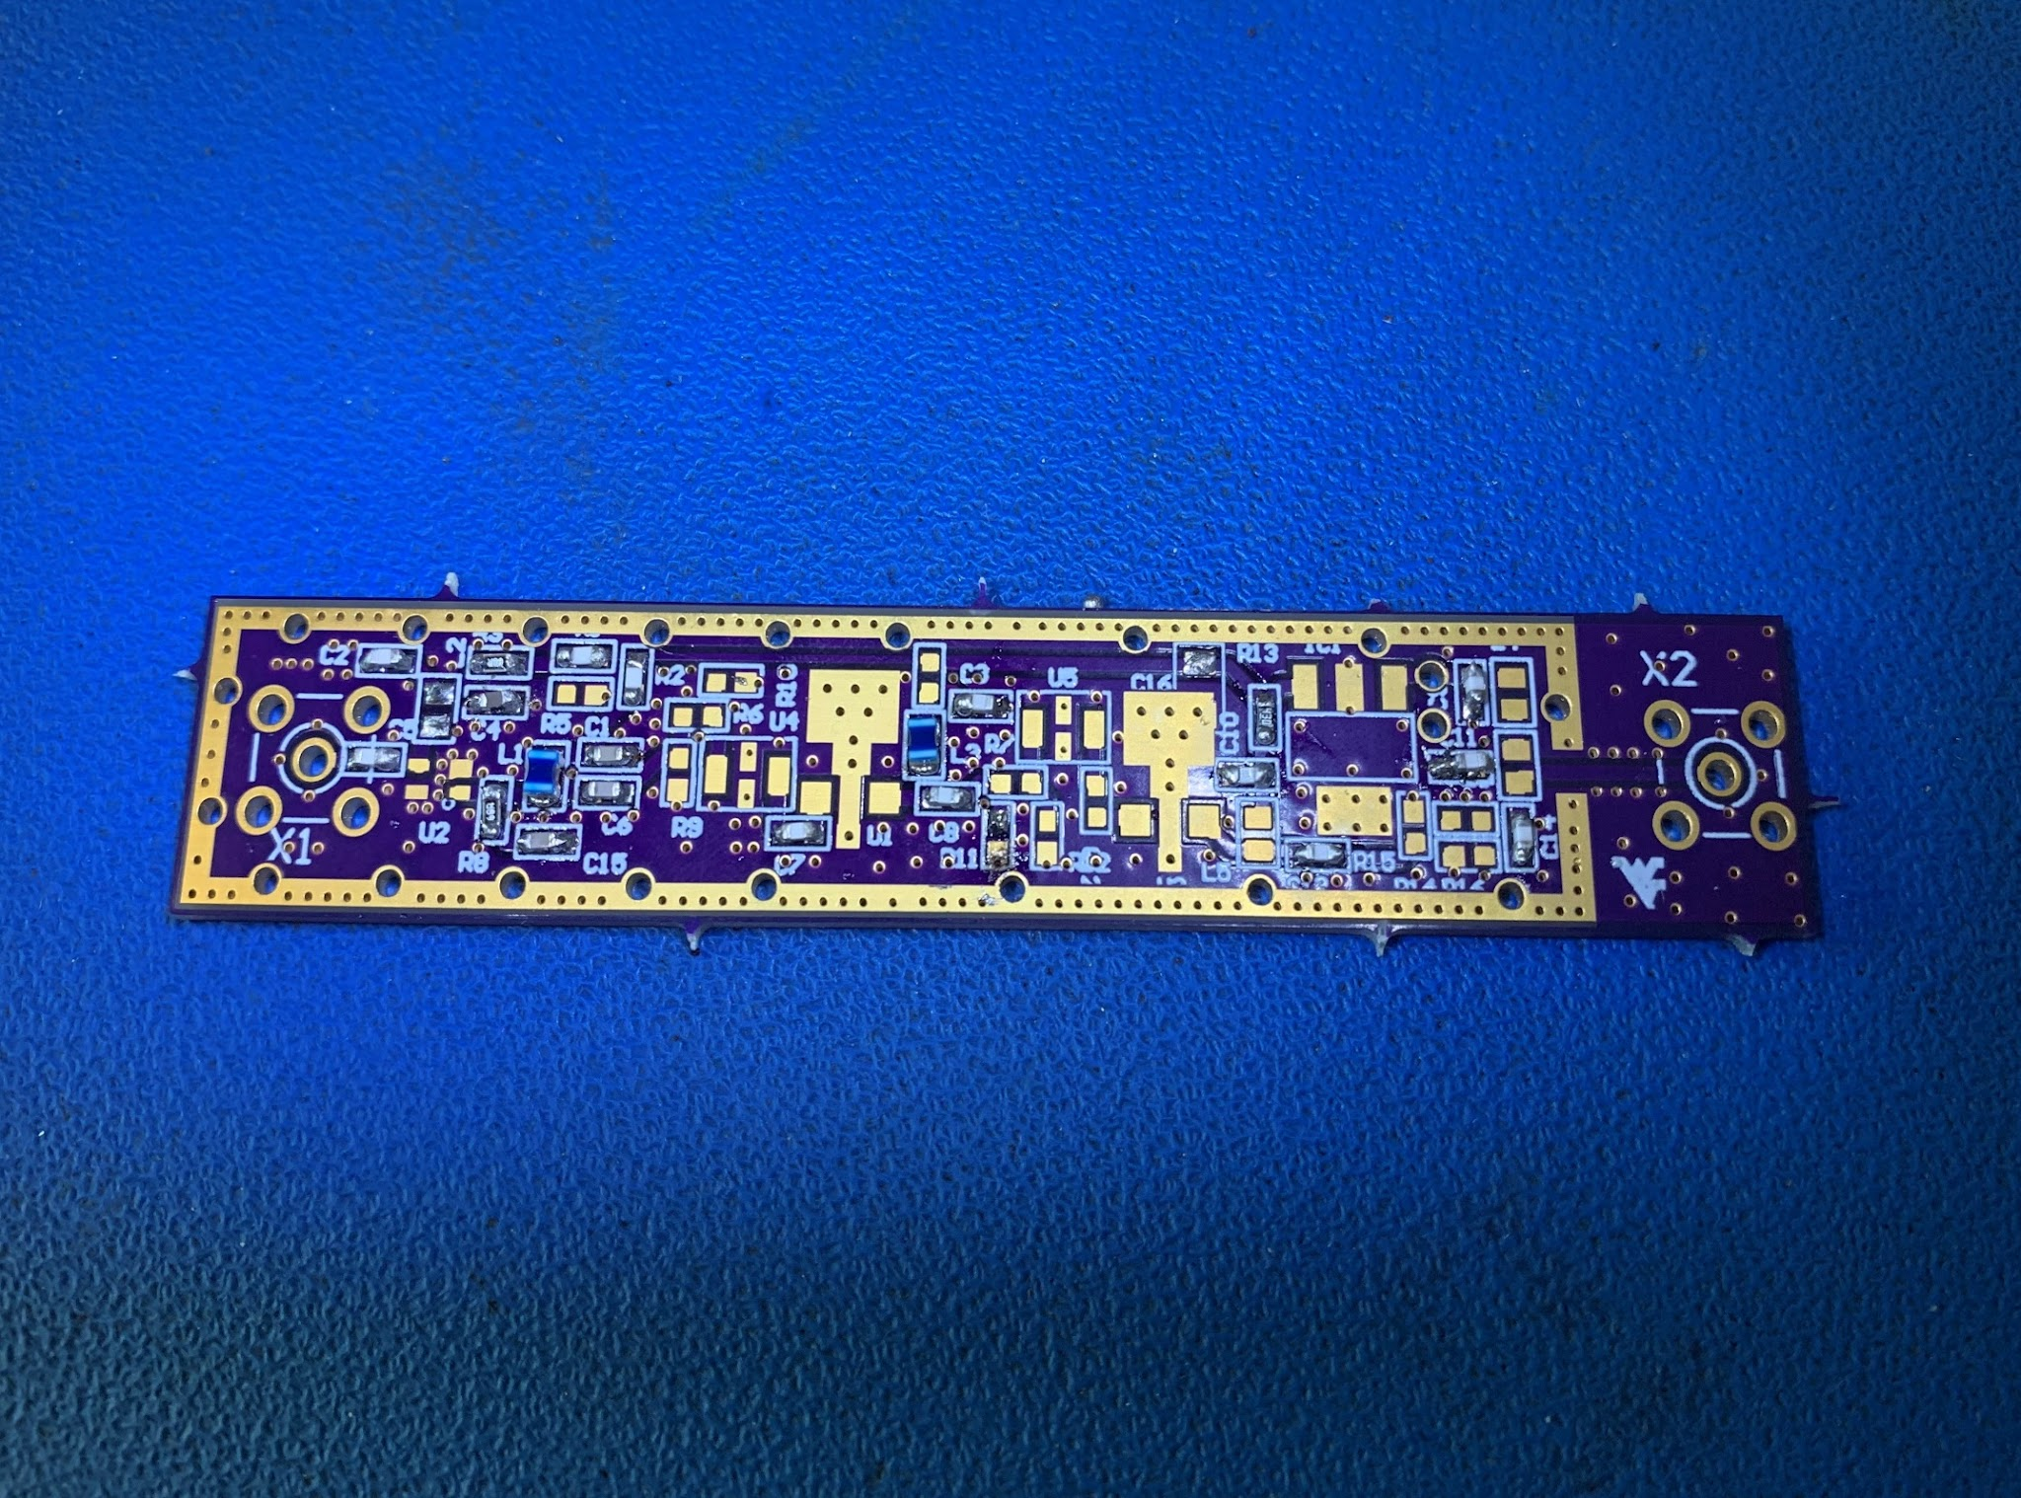
Fig. 3: Completed circuit board.
Completed circuit board under the microscope light.

REFERENCES
Green Bank Observatory, The National Science Foundation, & West Virginia University. (2021). DSPIRA Guided Tour. Digital Signal Processing in Radio Astronomy Lesson Portal. https://wvurail.org/dspira/

