HOW FAST ARE WE MOVING?
Astronomy Activity

What are the motions of the Earth?
We have recently learned about Earth’s place in space and how it moves. Rotation and Revolution are part of every earth science curriculum. However, there was a time in human history where none of these motions were suspected because they never “felt” the motion. Most likely, YOU have never felt any of these motions....yet they do happen!
- We move in a circle around the Earth’s axis.
- The Earth moves in a (near) circle around the Sun.
- The Solar System moves in a (near) circle around the center of the Milky Way Galaxy.
- The Earth wobbles in a circle around a line perpendicular to the ecliptic (This one can be left for extra credit)

So we move…but how fast? Well “fast” is speed, and speed is distance/time. And in these cases, the distance we travel is a (near) circular path.

So the first thing is to know the formula for the circumference of a circle, which is ___________________
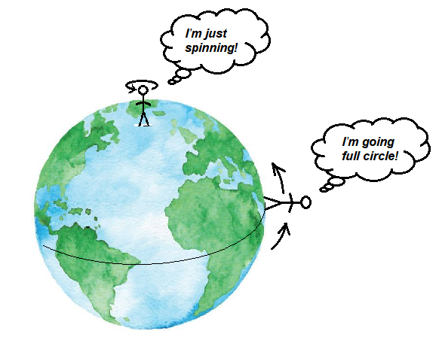
- Earth spinning on its axis is called ________________________

Assume that you are at the equator where the Earth speed due to spinning is the fastest..

What is the radius of the Earth? ___________________________km (let’s do kilometers)
Cite your source: ____________________________________________

How far is one complete circle at the equator? _________________ km

Show your work here

How long does it take to do one circle? _________________________ (let’s do seconds)

Show conversion work here

How fast would you be moving at the Equator?_____________________km/s

Show work here (don’t just “look it up”)

Orbiting the Sun is called
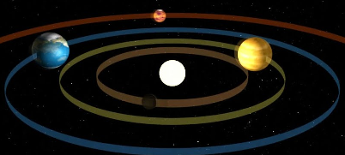

____________________________

The “astronomical unit” is a convenient unit for Solar System astronomers to use. It is simply defined as the average distance from the Sun to the Earth.

How far are you from the Sun? _____ (let’s do AU’s …very little space on the blank line is for a reason)

How far are you from the Sun?

_____________________________________ (let’s do kilometers)

Cite your source: ____________________________________________

How far is one orbital trip around the Sun? __________________________________ km

Show your work here

How long does it take to do one circle? ___________________________________ (let’s do seconds)

Show conversion work here

How fast is the Earth moving around the Sun?__________________km/s

Show work here (don’t just “look it up”)

Milky Way Orbiting (no special name)
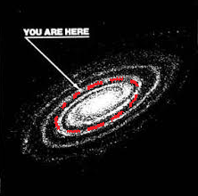

How far are you from the center of the Milky Way? __________________l.y. (let’s do light years)
Cite your source: ____________________________________________

The “light year” is a convenient unit for galactic astronomers to use when talking about large distances to the stars. It is simply defined as the distance a beam of light would travel in one year.

How far are you from the center of the Milky Way?

____________________________ (let’s do kilometers)

Show conversion work here

How far is one orbit of the Sun around the Milky Way? __________________________ km

Show your work here

How long does it take to do one circle? ______________________ years

Cite your source: ____________________________________________

How long does it take to do one circle? _________________________ (let’s do seconds)

Show conversion work here

How fast is the Sun moving around the center of the Milky Way?_________________________km/s

Show work here

