Measuring the Earth’s Speed around the Sun- Final Comparison Model meets Experiment
Astronomy Activity
In Science, there is a constant play between theory and observation...
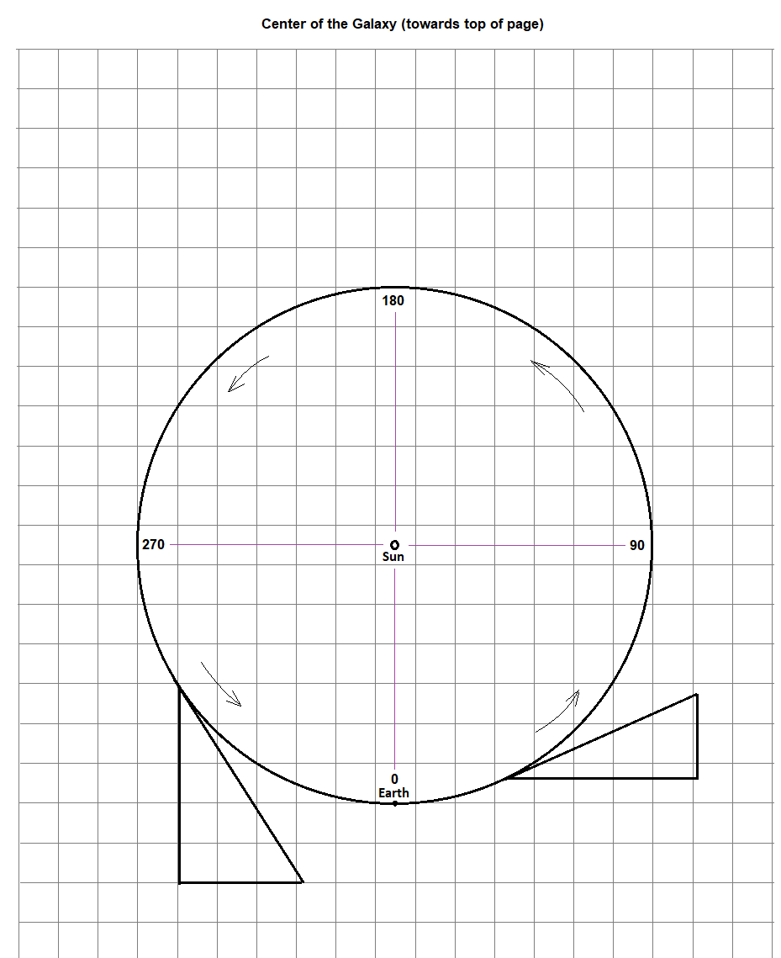
The theoretical orbit for the Earth around the Sun (assuming a circular path) was first modeled on the sheet with the circle on it (like the one seen at right). (Activity E2 - MODEL)
Our second activity analyzed actual data taken (by Mr. Herman) over the course of the past ½ year. The idea is that the detected Neutral Hydrogen line had been Doppler Shift based on whether the Earth was moving towards or away from the Galactic Center. (Activity E4 - DOPPLER)
Here we will take information from the MODEL chart and compare it to the calculated data from the DOPPLER chart. So, have the two tables ready to go…

FINAL COMPARISON Chart
A | B | C | D | E | F
DOPPLER col A | DOPPLER col B | MODEL col A | DOPPLER col F | MODELl col C | New (col D)-(col E)
Date of Year | Day # from 12/18 | Angle Position 12/18 =0° | Speed To-or-Fro Galactic  Center (km/s) | Speed To-or-Fro Galactic  Center (km/s) | Diff from Model and Observed (km/s)

If life is good, the values from the last column should bounce around 0, unless there is something else going on. Place 6 dots in the number line to represent the 6 values from the last column.
QUESTIONS
1) So, what was the AVERAGE of the 6 values from your last column (F)? ____________________km/s

2) What was the RANGE/2 of the 6 values (highest – lowest)/2? +/-____________________km/s

3) Column D is the final velocity results from the actual data. Column E is the final velocity derived from the Model. Are they the same?
Based on the above two answers to 1) and 2), does it seem reasonable that a difference of 0 km/s between Actual and Model is something that you could claim to be true? Explain (maybe make reference to the number line at the bottom of the last page).

4) (If your class is accumulating classwide data) Go to the Class Data spreadsheet on the and add your six values from the last column (F) to the class data set.

5) Does the Class Data support the notion that the data sits around the difference of Model and Observation was 0 km/s, or does there seem to be something else to consider? Explain.

