Using Stellarium to find the Galactic Center
  - Astronomy Activity

Objective- The orientation of the Earth’s orbit around the Sun needs to be established with respect to the Center of the Galaxy in order to match it up with the Model of the Earth’s motion around the Sun created in the last activity (Astro Act E2)

Note: If you are doing this activity through “The Milky Way” sequence of activities (MW#3), this first question will make no sense, so move onto 2)
(Answer this only if you did Act E2-1 Modeling the Earth’s Motion around the Sun) This is the same question as the last question from the last assignment, but it is the link between the two, so there is no harm in asking it again….
Q1) Look at the Earth around the Sun Model from the last activity. What angle position would the Earth need to be at in order for the Sun and
Galactic Center to appear along the same line? _______ °
(That means line the ruler straight up and going from Earth, through center, to top of page)

The model you created shows the Earth’s orbit, but you need to determine WHEN the Earth is at specific locations.

- Open Stellarium Web on a computer.
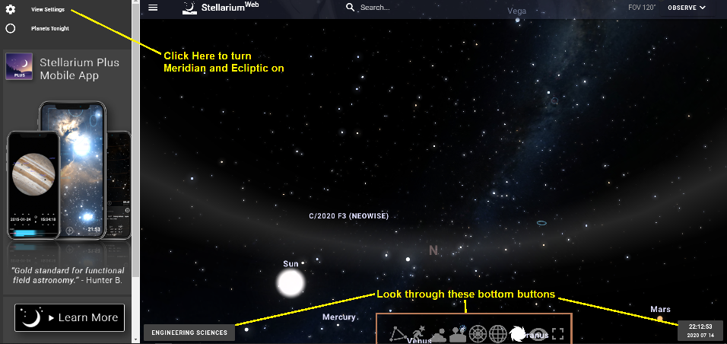
- Along the center panel on the bottom of the screen, click on the Atmosphere Button to turn BLUE SKY OFF.
- Now, click on the Equatorial Grid to add these gridlines.
- Click on View Settings and click on both the Meridian and Ecliptic.
- Click on the Location button lower left and choose someplace near you. (It might already know!)
- Since we want to keep an eye on the Sun, click on the Time Button and set the time to about Noon. (Pause time will help) The day doesn’t matter since you will be moving day by day shortly.
- On Star field, click and drag the sky to look south. The Meridian should be straight up the middle. The sun should be near the Meridian.
- Get the Sun as close to the Meridian as you can by toggling through the minutes on the clock..
The next goal will be to see when the Sun “appears” closest to the Galactic Center in the sky. The sky has its own Longitude and Latitude system known as Right Ascension (R.A) and Declination (Dec)

The Galactic Center is not represented on Stellarium. It is at R.A. 17h 46m Declination -29° 0’
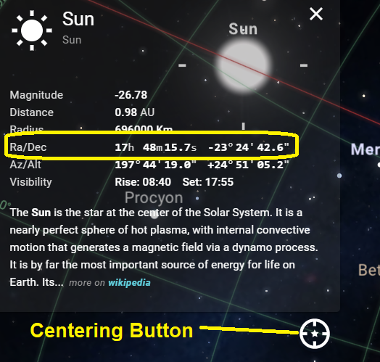
- What is the R.A of the Galactic Center? _____
(Yes, the answer is right in the line above!)

- What is the Dec of the Galactic Center? _____
- Click on the Sun to open the info box (Hint: Clicking on the word “Sun” seems to work better than clicking on the object). Note where the R.A value is.
- Click on the Center button just below the Info box to lock the Sun in the Center. Now as you Time step, the Sun will remain at the center.
- Time Step forward by clicking the up arrow above the Day number while keeping an eye on the Right Ascension (RA) number at the edge of the screen.
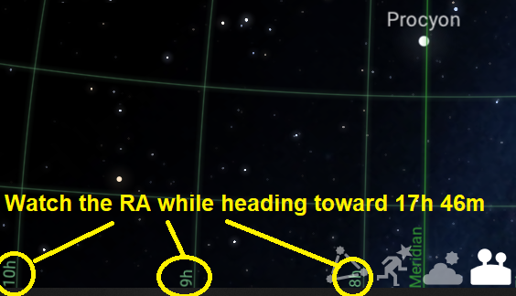
- Continue until you get the Sun as close to RA 17h 46m. As you get closer to 17h, you can zoom in to see the hours and minutes on the grid lines.
- What day of the year is the Sun closest
to RA-17h 46m? _________________
This will become the Date of Angle 0° on the Earth Orbit Model you created in the last assignment. (If this is an electronic assignment, include a screenshot of Stellarium that led you to the above answer,)
- What is the Declination of the Sun on this Date? _______________

- Approximately, how many degrees is that from the declination of the Galactic Center? _____________
(Remember, the Gal Center Dec is listed above...simple subtraction, please)

- A quarter of a year later (90° along orbit later) is 365/4 = 91 days.
What is the date of the year 91 day after the answer to 16)? _______________

This is the day that the Earth is heading most directly towards the Center of the Galaxy.
Or, towards the top of the page on the paper model.

- Can you project? What date is the Earth heading most AWAY FROM the GC? _____________

