Modeling the Motions in the Milky Way
Astronomy Activity
Introduction- In the last activity, Things we CAN’T see in the Milky Way, you saw (if you did it correctly) that there could be both Blueshift and Redshift happening in Quadrants I and IV, only Blueshift in Quadrant II, and only Redshift in Quadrant III.
This activity will be looking at modeling HOW MUCH SHIFT occurs at specific angles within the Quadrants...Better said is… “How much shift occurs at each Galactic Longitude along the plane of the Galaxy?”
The Model Galaxy sheet has dots that are equally spaced on all orbits. By moving “stars” an equal number of dots per time step, this will represent that any star in the galaxy, whether in an inner orbit or outer, will be moving at the same speed. Again, observations of regions of the galaxy shows that the speeds are reasonably consistent, so this will make a good approximation model. It would be like making a circle model of the Earth’s orbit. Though the actual orbit is slightly elliptical, a circle model is a good approximation over no model at all. (It worked for Copernicus!) The Galaxy is big, so there is a lot of data to gather. However, each student is only getting 20 data points each and will add it to the collection class data set.

WHAT TO DO
You will be “watching” one star from an Inner or Outer “Lane” from the Sun’s vantage point as they both move around the Galaxy.
You should work with a partner, but each individual is responsible for a data set.
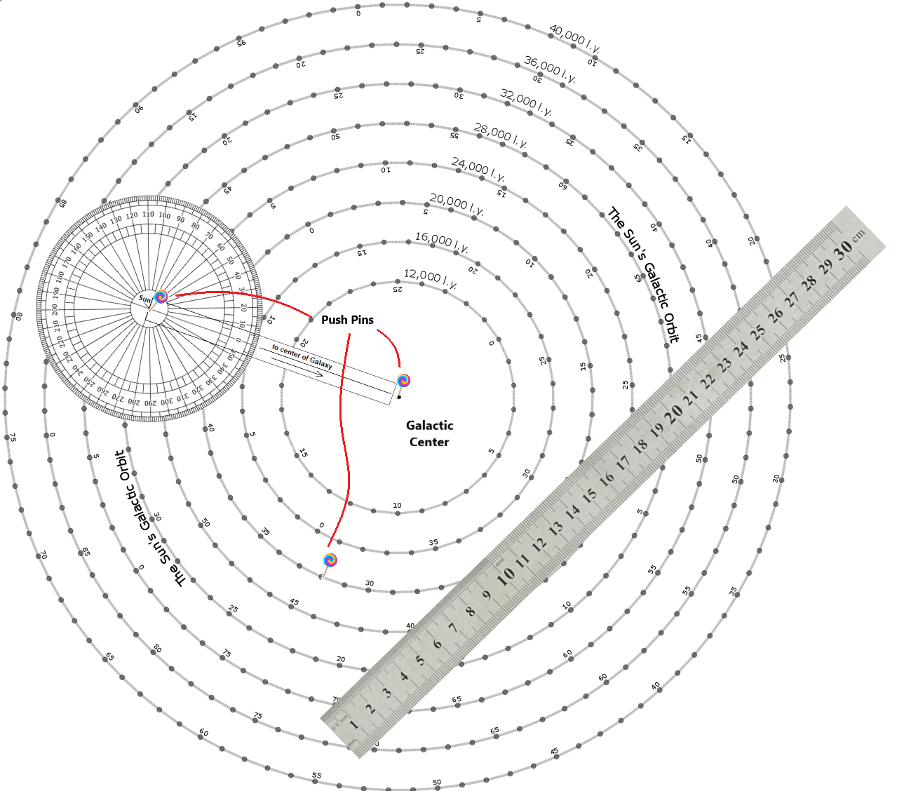
- Get a 30cm Ruler and a MIlky Way Model (foam base, Milky Way image, 3 pins, one circle protractor with extension arm)
- Get your 3 Random Numbers from the Teacher. It will include: 1) your Sun start position# on circle, 2) which Lane your Target Star is in 3) your Target Star’s start position#.
- Stick pin#1 through Protractor (may be done already) and into Sun Start Dot
- Stick pin#2 in the Galactic Center and the center line on the extension arm on the protractor.
- Stick pin#3 in your Star’s starting position
- Place Ruler against Sun and Star pins and read the angle. This the Galactic Longitude value.
- Measure distance, with the ruler, from Sun to Star to the nearest 0.1 cm.
- Record this in your data chart line 0
- Move the Sun and Star pins two dots forward (clockwise) along their respective paths.
- Repeat 6) - 9), Enter the data in the next line on Chart.
- Continue the process until the table is full.
Your Data Chart
 | Data Pt # | Galactic Longitude of your Star (Angle from 0° to 360°) | Distance from Sun to your Star (cm) | Change in Distance from last recording (cm)
Who's Data | 0 |  |  | 0
 | 1
Sun's Start # | 2
 | 3
Star's Lane | 4
 | 5
Star's Start # | 6
 | 7
 | 8
 | 9
 | 10
 | 11
 | 12
 | 13
 | 14
 | 15
 | 16
 | 17
 | 18
 | 19
 | 20
The first two columns will be filled with your recorded data.
The third column is the extent of the math being asked of you. If the Sun-Star distance in row 0 is 15.6 cm and the next measure is 15.2 cm, then the CHANGE went down 0.4, thus would be -0.4 cm. That goes into column 3, DO NOT IGNORE THE NEGATIVE SIGN.
(Teachers: the following needs to be edited for your class as to how you want the students to get to the spreadsheet for them to enter data)
Once your table is full, grab a computer, open the (click here) Galaxy Model Spreadsheet.
Find a block without any data and go to town(Enter yours)!
File Resources:

Protractor with extension Arm
You may have to play with scaling a bit to get this right. As long as the extension arm to the Sun distance is longer than the Model’s distance from Galactic Center to Sun’s Orbit.
It is suggested that you copy these on transparencies so the students can see through them.
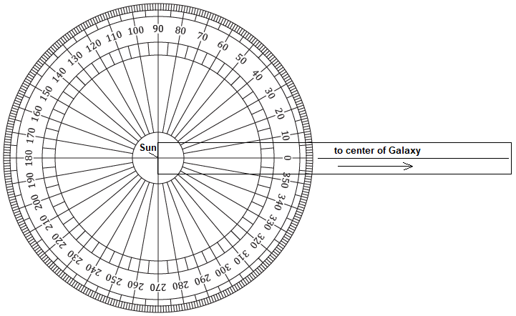

Galaxy Model PDF Galaxy Model Spreadsheet
Click to retrieve click to retrieve
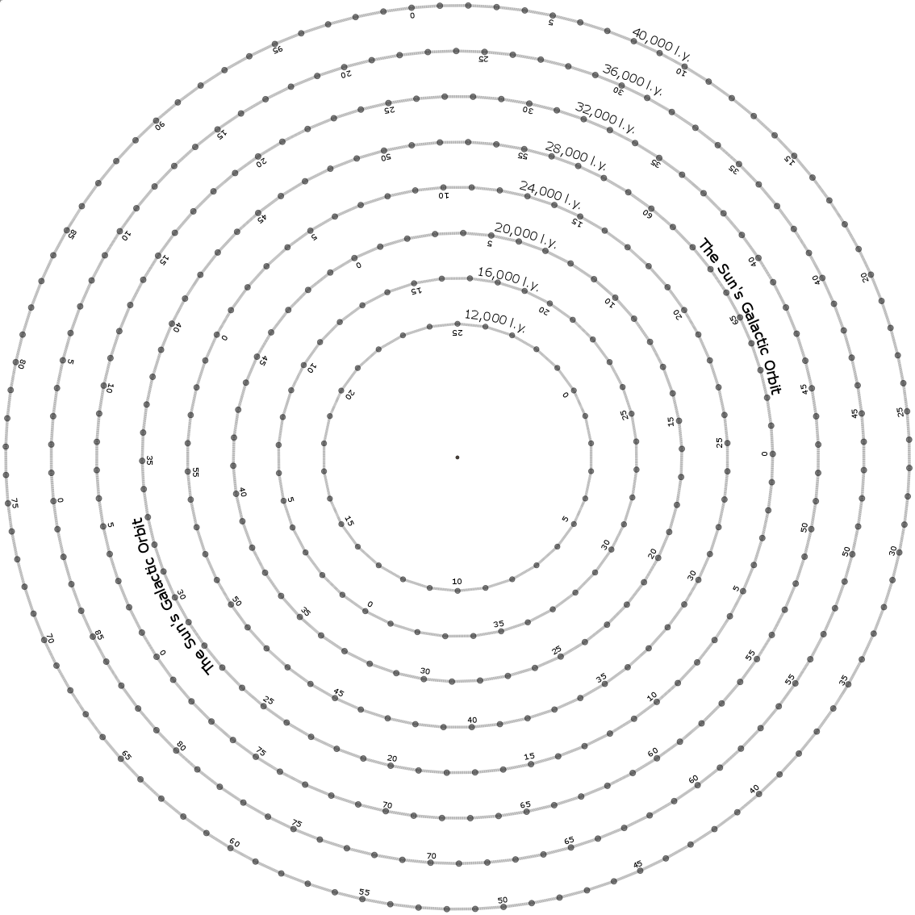
You will have to make a copy of the file so it
becomes to you.

