Galactic plane observation 2
  - Student activity • 2019 source edition

NOTES FOR THE TEACHER
This culmination of this investigation is this lesson in which the students will create a velocity curve of the MWG using data collected by the horn telescope.
In this investigation up to this point:
- The students have been exposed to the operation of a horn radio telescope.
- The students understand radio waves and the source of the 21 cm wavelength radio waves from the galaxy.
- In Galactic Plane Observation 1 the students discovered that radio waves from hydrogen in galactic quadrant II are mostly blue shifted, and radio waves from hydrogen in galactic quadrant III are mostly red shifted. From this the students were able to deduce that the galaxy is rotating.
- If the students have not fully realized that the MWG rotates, the rationale for why the galaxy must be rotating is brought out in the Pre-Observation Reflection.
- For the students to complete the Pre-Observation Reflection they are expected to know Newton's Law of Gravitation. Lesson 7 was introduced in the AP Physics class shortly after covering the unit on gravitation, which includes Newton's Law of Gravitation and gravitational orbits. Both of these are needed for the students to complete Lesson 7.
In this lesson the students will complete the following:
- The students will complete the Pre-Observation Reflection if needed, as described above.
- The students will collect spectral data using the horn telescope. These observations will be made in galactic quadrant I.
- After analyzing the spectra to determine the relative velocity of the hydrogen that is the most blue shifted in the spectrum, the tangent method will be used to determine the speed of the tangent point along the line of observation.
- The class data is accumulated to generate a velocity curve of the MWG.
NOTES:
- Students work in groups of two.
- There were 10 groups. Quadrant I was observed in 10 degree increments from galactic longitude of 0º to 90º.
- Stellarium is used by the students for determining the horizontal coordinates of their assigned galactic coordinates on the day chosen for the observation. This may require some planning in advance to assure that quadrant I is visible during the time that the class meets.
- During the class period when data was collected, the telescope and GNU Radio spectrum program ran for approximately 15 minutes before data was collected to allow it to warm up adequately.
- During the class period, when ready a group would use a compass and level to orient the telescope to their horizontal coordinates. Then the data was collected for that group, who noted the time stamp for identifying their data file.
- The 10 groups were able to collect the data within a total of 30 minutes.
- The data files were shared in a Google Docs folder, and the students analyzed their spectra using Google Sheets.

AP Physics Radio Astronomy Galactic Plane Observation 2

Pre-Observation Reflection: Milky Way Galaxy Models
Model Assumptions
- the galaxy is comprised of lots of “stuff” - stars, neutral hydrogen atoms, and other interstellar material
- the galaxy exists in a 3-dimensional region of space
1. Static Model: The matter in the galaxy is stationary. Apply what you know about gravitational forces to explain why a static model probably does not describe the Milky Way Galaxy.
2. Non-static Models: We know from our previous galaxy observations that there is motion in the galaxy. Apply what you know about gravitational forces as well as your understanding of the laws of mechanics that we have studied so far to explain why the galaxy is in motion and what type of motion it is most likely undergoing. [Think about the motions of the planets around the sun. What would happen if the planets stopped moving?] Incorporate what we have learned about the red and blue shifts of the different quadrants of galaxy to support your explanation.

AP Physics Radio Astronomy Galactic Plane Observation 2

Introduction
Up to this point we have learned that the horn radio telescope detects 21-cm radio waves from neutral hydrogen atoms in the Milky Way Galaxy (MWG). By observing spectra in quadrants II and III of the MWG, we determined that the galaxy rotates.
In this investigation we want to determine more details about the rotational behavior of the MWG. Does it rotate like a solid disc, or do different parts of the galaxy rotate at different rates? To determine the answers to these questions, we will determine the speed of the galaxy at different distances from the galactic center (GC). In this investigation we will be making observations in quadrant I of the galaxy.

Pre-Observation Prep
1. Assigned galactic coordinates: ___________________________
2. Use Stellarium to look up the horizontal coordinates (azimuth and altitude) that correspond to your galactic coordinates on the date and time we will be making the observations.
Note: You may want to prepare a range of pointings over a 20 minute period of time, or so, in case we get off schedule.
Date | Time (EST) | Azimuth | Altitude

Data Collection
Assigned galactic coordinate: gal. long. = _______________; gal. lat. = 0º
Actual Horizontal coordinates (azimuth and altitude):
Azimuth = ______________; Altitude = ______________
Exact time when the data was saved to a file: ______________
Name of your data file: ___________________________________

Data Analysis of the Spectrum
1. Spectrum Analysis:
- Plot a graph of the spectrum of your observation. Convert the frequencies to MHz, and plot a range from 1419.5 MHz to 1421.5 MHz.
- Measure the frequency at which the greatest blue shifted peak occurs in the spectrum.
- Use the Doppler shift formula to calculate the velocities from this frequency. Show your work, and record the results in the table below to the hundredths of a MHz.
2. Distance Calculation: Using the tangent method, calculate the closest distance to the GC along the direction of observation. The earth is approximately 8.4 kpc to the GC. Show your work, and record the results in the table below .
Frequency  (MHz) | Velocity  (km/s) | Galactic  Longitude  (degrees) | distance from  GC  (kpc)

The Tangent Method For Estimating The Galactic Rotational Velocity
Study the figures below and try to explain the “tangent method”, applied to radio astronomy spectra, is used for determining the speed of the galaxy as a function of distance from the galactic center (GC).
Note the following:
- A radio telescope will detect radio waves from objects at all points along the same line from the galaxy, regardless of the distance of those points from the earth (i.e. sun in the diagrams).
- The relative velocity of the hydrogen producing the radio waves can be determined using the Doppler shift.
- This relative velocity is the velocity as measured from the us on earth.
- To determine the object's actual galactic orbital velocity, the sun's (our) velocity along the direction of the tangent line to the point of interest must be added to the measured relative velocity:
v_{tangent pt} = v_{radio telescope spectrum} + v_{sun tangent line} See Figure 3 below.
- The sun's orbital velocity around the galactic center is approximately 200 km/s.
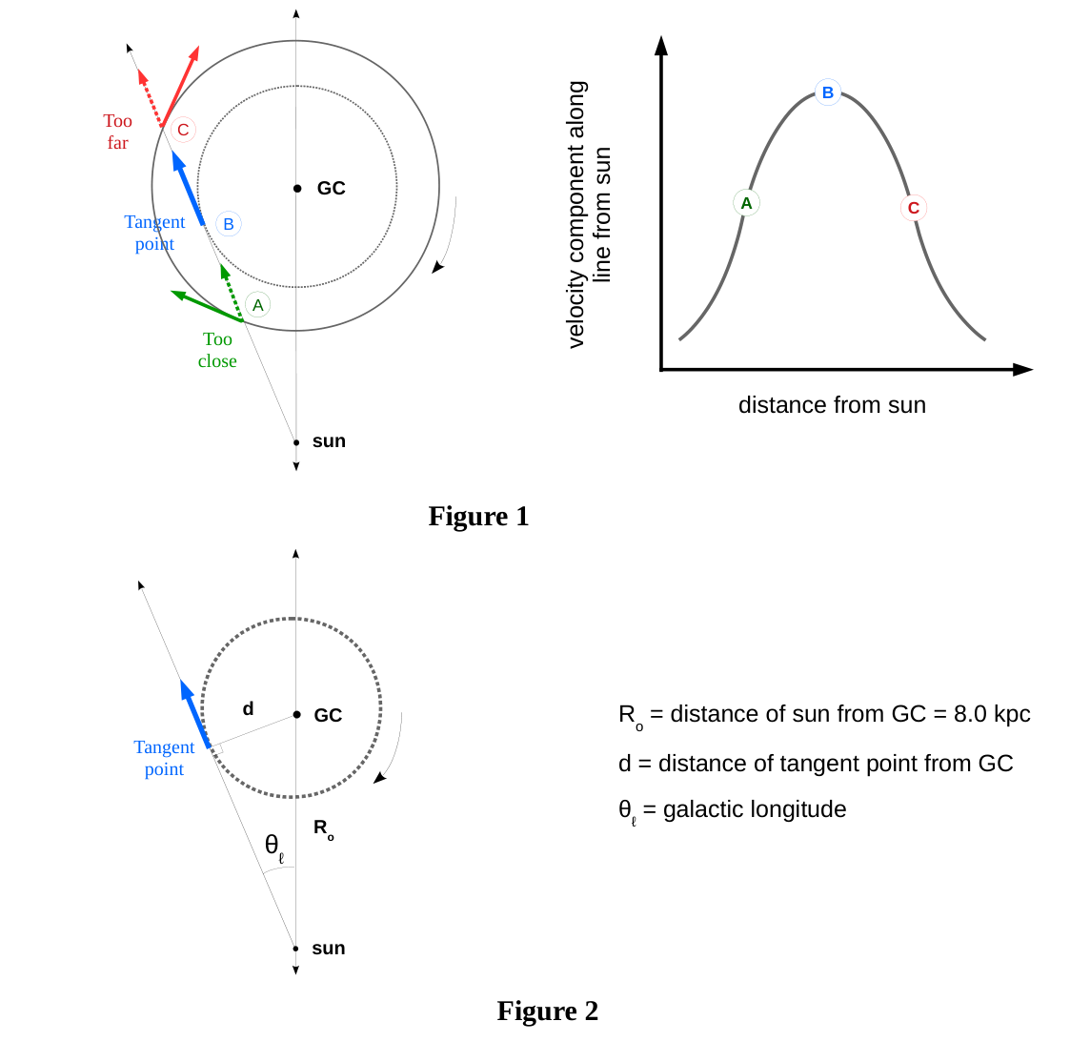
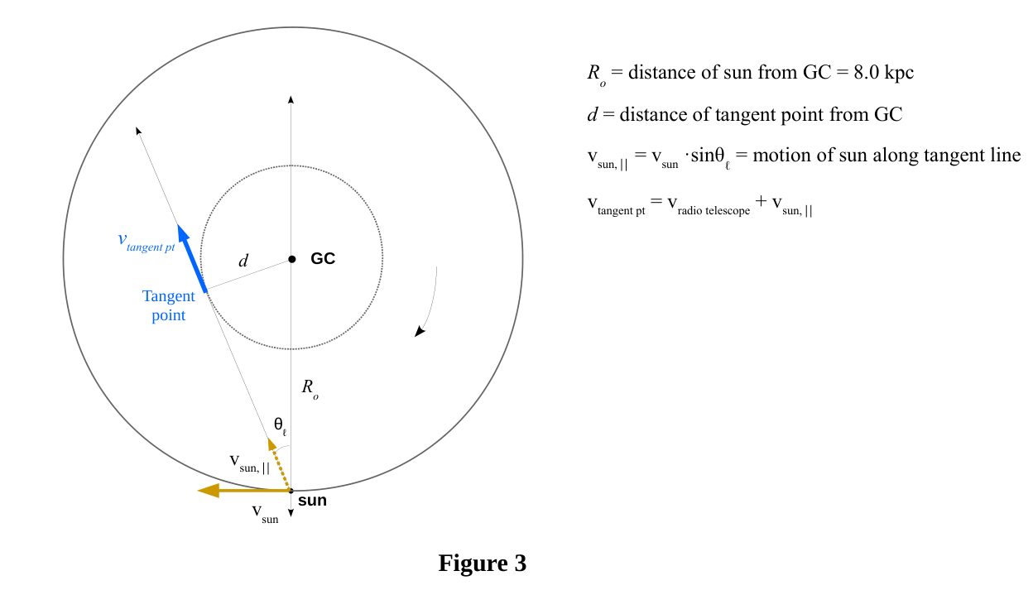
Teacher Notes
Quadrant I Observation on 1/25/19
Time (EST) | Galactic  Longitude | Azimuth | Altitude
8:15 am | 0° | 157° | 23°
 | 10° | 148° | 26°
 | 20° | 139° | 33°
 | 30° | 128° | 38°
 | 40° | 114° | 39°
 | 45° | 109° | 43°
 | 50° | 102° | 42°
 | 60° | 89° | 43°
 | 70° | 75° | 41°
 | 80° | 62° | 38°
 | 90° | 51° | 33°

Rotational Velocity Curve of the Milky Way Galaxy
You will apply the tangent method for determining the velocity of the MWG at your given galactic longitude. As a class we will determine a velocity curve for the MWG, which is a graph of the galactic velocity versus distance from the galactic center.

Procedure
1. From the HI spectrum at the galactic longitude angle your group was given, use the Doppler effect to determine the speed of the most blue-shifted hydrogen detected.
2. Use the tangent method to determine the assumed distance of this fastest moving hydrogen from the GC.

Results
1. Show your work for the calculations done as instructed in the Procedure above. Include a printed graph of the HI spectrum at the angle your group was given.
2. Share your results in the spreadsheet shared in Google Docs.
3. Record the class data in the table below. Then plot a graph of galactic velocity vs. distance from GC.
Galactic  Longitude | Distance from GC  (kpc) | Relative Speed  (km/s) | Rotational Speed  (km/s)
0°
20°
20°
30°
40°
45°
50°
60°
70°
80°
90°

Interpretation
1. According to the Velocity vs. Distance from GC graph, how does the rotational speed of the MWG depend on the distance from the GC?
2. What model of the galaxy might these results fit? To answer this, complete the following:
a. Kepler Model
Assume most of the mass of the galaxy, M_{G}, is concentrated at its center. This model mirrors the model of our solar system, where the sun is at the center. Apply your knowledge of orbital motion in this model to determine the v(r) function, and sketch a graph illustrating this function.
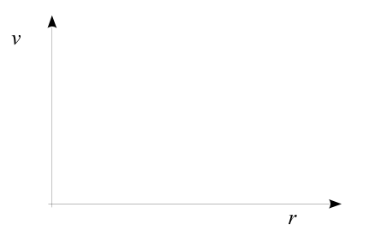
v(r) =
On the graph include a sketch of the v(r) function from the horn data the class collected.
b. Spherical Galaxy with Uniform Mass Density Model
Assume that the galaxy is spherical and its mass, M_{G}, is distributed uniformly. The gravitational force behaves the same as the force inside a spherical planet with uniform density. Assume the galaxy has a radius R_{G}. Apply your knowledge of the gravitational force in this model to determine the v(r) function, and sketch a graph illustrating this function.
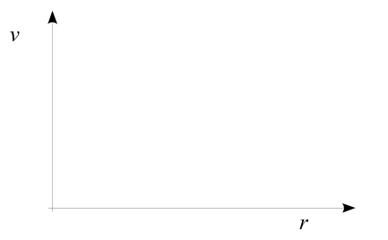
v(r) =
On the graph include a sketch of the v(r) function from the horn data the class collected.

Conclusion
Based on the models represented above and our experimental results, what can you conclude about the mass distribution of the Milky Way Galaxy? Might there be other models to describe the mass distribution of the galaxy?

Class observation record
Group | Galactic longitude | File name | Speed (km/s) | Distance from center (kpc)

