Horn telescope stand assembly
  - Construction guide | 2021 design
Build a wooden stand for the horn telescope cradle. Notched base pieces allow the stand to come apart for transport.

Materials
Quantity | Part
4 | 2 × 4 boards, 3 feet long
2 | 2 × 4 boards, 2 feet long
2 | 2 × 4 braces, 2 feet long, with a 45° cut at one end
As needed | 2 1/2-inch construction screws
2 each | 3 1/2-inch-long 1/4-20 bolts, wing nuts, and washers

1 Cut the base notches
Cut matching saddle notches in the base boards, as shown below. Each notch is 1 1/2 inches wide and 1 3/4 inches deep. Fit the notches together to form the base.
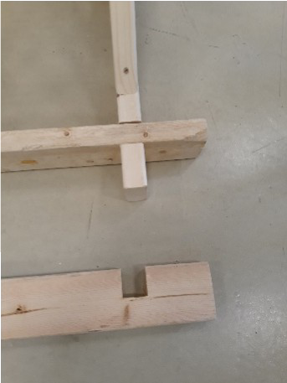
Figure 1. The matching notches let the base boards fit together.

Assemble the stand

2 Attach the uprights
Use 2 1/2-inch screws to join the four 3-foot boards in two right-angle pairs. Position each joint 10 1/2 inches from one end, as shown in the finished stand.

3 Add the braces
Attach the two 2-foot braces to the 3-foot boards. Use the 45° ends to support the right-angle joints, as shown in Figure 2.

4 Attach the cradle
Connect the cradle to the stand with the 1/4-20 bolts, washers, and wing nuts. The completed telescope is shown in Figure 3.
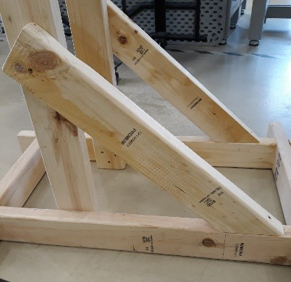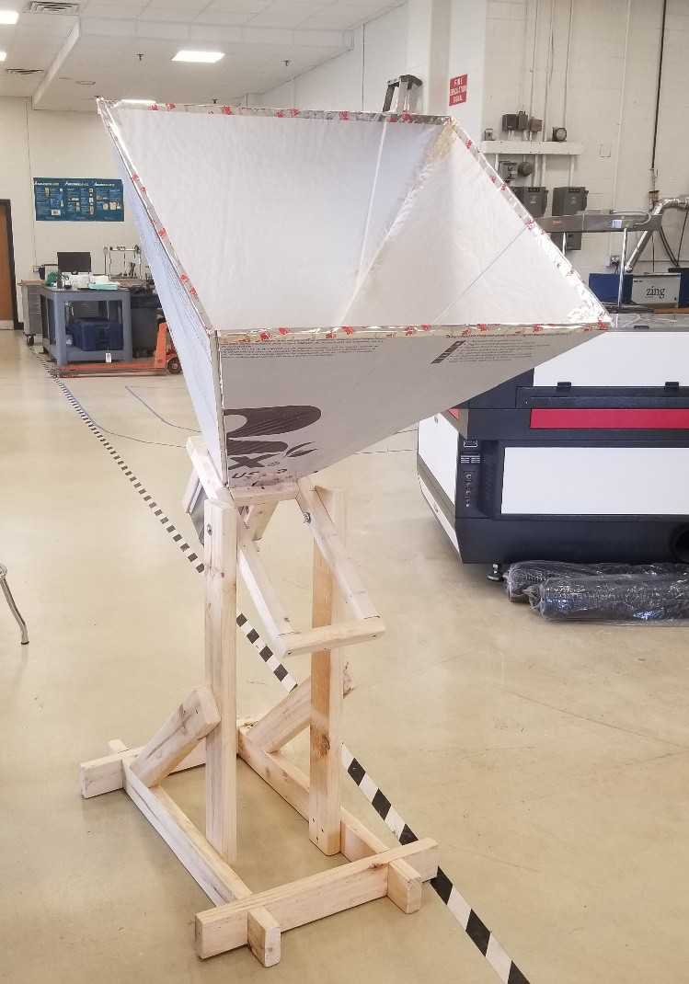
Figure 2. Braced frame (left). Figure 3. Stand with the horn telescope attached (right).

Related construction guide
Horn telescope cradle assembly

