Intro to Electromagnetic Radiation
  - Astronomy Activity

Who discovered Light?
Being able to see is not something we wake up and realize one day. It is just something that has always been part of our existence. (…recognizing that some people are blind). So, nobody discovered light. Scientific minds have wondered for centuries though, how is it that something can happen “over there” and we are aware of it “over here” just by using our eyes? Somehow, the information of a lightning strike, or a rainbow, or a friend in school, or the stars in the sky, has to get to us.

Color and Rainbows
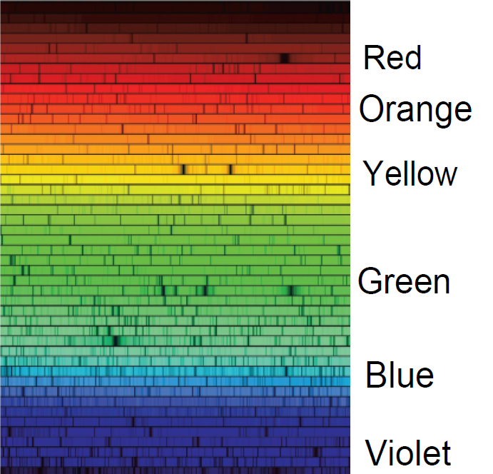
We all learn about colors, usually well before we go to kindergarten. However, it was probably through seeing rainbows, and eventually people (notably, Isaac Newton) making prisms out of ice or glass to create their own rainbows, that we recognized some sort of order to the colors. If you simply looked at the numbers 3, 6, 2, and 8, you would be able to arrange them in some order. However, if you simply looked at something red, blue, yellow, or green, there is no intuitive way to order these colors. We need to understand the rainbow to give us that order. The famous ROY G BIV of the rainbow that many of remember, is a start…

Discovering the unseen
Think about these three things:
1) Going to the dentist and getting an x-ray taken.
2) Getting texts from your friends.
3) Forgetting your sunscreen on a sunny day at the beach, and paying for it the next day.
What do they all have in common? Think about it for a while…

Starting in the early 1800’s, scientists started trying to figure out the nature of light, and breaking light into a rainbow. They discovered things happening beyond the Red and Violet ends of the spectrum. There were things beyond the rainbow causing thermometers to rise, or rocks and minerals to glow. They realized there was more to the rainbow then met the eye! Also, during the 1800’s, the nature of electricity and magnetism were being explored. Without great depth here, it was discovered that the light we see, along with the extensions off the rainbow that had been discovered, could be tied to electro-magnetic theory fully realized by James Clerk Maxwell. Not only did Maxwell’s equations explain the nature of visible light, the infrared, and ultraviolet, it also predicted that there should be a full spectrum of Electro-Magnetic Radiation (EMR) that all travels at the same speed, the Speed of Light.
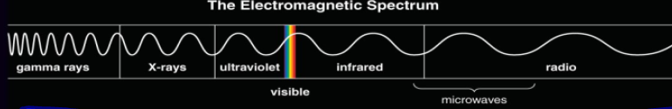
In the end, the visible part of the spectrum that we can see makes up only a tiny portion of the full electromagnetic spectrum. Visible light, Infrared, and Ultraviolet were discovered before the Electro-Magnetic Theory was revealed. Once the theory was in place, it was time to test the theory and to find other types of radiation. This was eventually done through different famous experiments that you will discover in this activity. Without understanding the other types of radiation that we now know about, our world would be a very different place.

Going back to the three examples:
1) “Taking an X-ray” is basically sending X-ray radiation through your body and recording how much gets through your flesh and bones.
2) Texting, or using your phone for any communication, is all about radio waves.
3) Sunburn is Ultraviolet radiation damaging your skin cells.
It all about understanding and dealing with Electro-Magnetic Radiation.

What to do - Use resources around you, or the internet to answer these questions

1) What is the speed of ALL Electromagnetic radiation in a vacuum?

2) It is important for the “in a vacuum” part of the last question. So, in science, what is a vacuum?

3) What is the simple equation for the speed of light,

or the wave speed equation?
4) What is meant by wavelength?

5) What is meant by frequency, and what are the common units used?

FILL IN THIS TABLE
Astronomy almost completely relies on being able to detect all types of EMR to help understand the Universe. Astronomers don’t have many options of going to space and “touch” the things they see. We humans have created telescopes and put them at many locations on the Earth’s surface and into space above the atmosphere so that we can “see” what the Universe is up to.
Type of EMR | Wavelength Range (m) | Frequency Range  (Hz) | Credited for discovering this type of radiation | Year discovered | Can this EMR easily make it through the atmosphere for telescopes to detect
Radio
Microwave
Infrared
Visible
Ultraviolet
X-Ray
Gamma Rays

