Celestial Coordinate Systems
  - Astronomy Activity

How do we describe the position of an astronomical object in space?
- We humans like to describe where things are. For locating things in the sky, a coordinate system needs to be created. For establishing a location of celestial bodies, they are assumed to be on the inner surface of an imaginary sphere of infinite radius with the earth at its center. This conceptual shape is the Celestial Sphere. A planetarium is essentially a large celestial sphere, and if you have been to one, you know how “real” the sky looks.
- For the sake of establishing coordinates, we can imagine the Earth is stationary, and the celestial sphere rotates around us. (Please don’t believe this to really be true!)

Spherical Coordinates:
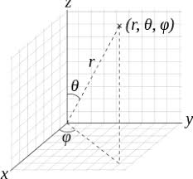
In Math class, we learn to graph things in the x,y coordinate system. This can be extended to the three dimensions, x, y, and z, in three dimensions (See the x, y, and z axis in the diagram). These three numbers are distances from the origin along each axis.
A Spherical Coordinate system can also identify any point in three dimensions , but with 1 distance and 2 angles.

Terrestrial Coordinates: Longitude and Latitude
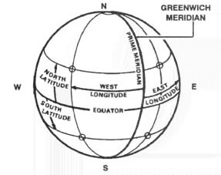
On the surface of the Earth, we describe places with Spherical Coordinates. Since the “distance” coordinate is just the radius of the Earth, then we don’t use it in describing places, just leaving the two angles for describing a location: These are called Latitude and Longitude. The daily rotation of the Earth helps establish the axis from which the 2 angles can be measured.

Questions:
- In what town is your school? __________________________________

- What are the Latitude (north) and Longitude (west) of your location?
(If you go to Google Maps and press down on your location until the red pin locator shows up, your latitude and longitude show up at the top of the page)

Latitude (N) ___________________° Longitude (W) _______________________°

The Local Sky: Your own personal coordinate system!
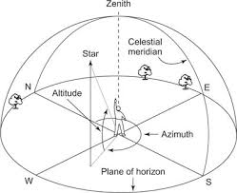
Imagine being in a canoe with a friend out on a big lake at night. You both decide to shoot a laser pointer straight “up”. The two beams are visible in the sky, but they never cross. You each have your own personal “up” direction! You both admire the beautiful stars in the sky, but how do you describe “where” they are in your sky?
Zenith: The point vertically above an observer and is 90º from all points on the horizon. The nadir is 180º opposite zenith.
Celestial meridian is a great circle which intersects the zenith, the nadir, the celestial poles, and goes from north to south.
Local(Astronomical) Horizon is a great circle on the celestial sphere which is perpendicular to the zenith-nadir axis. Unless you are on the ocean, or a high mountain top, your sky usually runs into the surrounding landscape (mountains, trees, houses) above the horizon.
The coordinates of an object are described by its azimuth and altitude(elevation).
- Azimuth is defined in degrees clockwise from due North.
Altitude/(Elevation) is defined in degrees above the horizon.

Equatorial Coordinates: Right Ascension and Declination
- Knowing the Local Sky information is great for you when you want to know when and where to look for an object in YOUR sky, but astronomers need a standard coordinate system for identifying the location of astronomical objects in the sky.
1) locations of stars and deep sky objects are fixed in the equatorial coordinate system.
2) The Equatorial Coordinate system is a projection of the terrestrial longitudes and latitudes onto the celestial sphere.
Celestial Poles: points vertically above the earth’s north and south poles
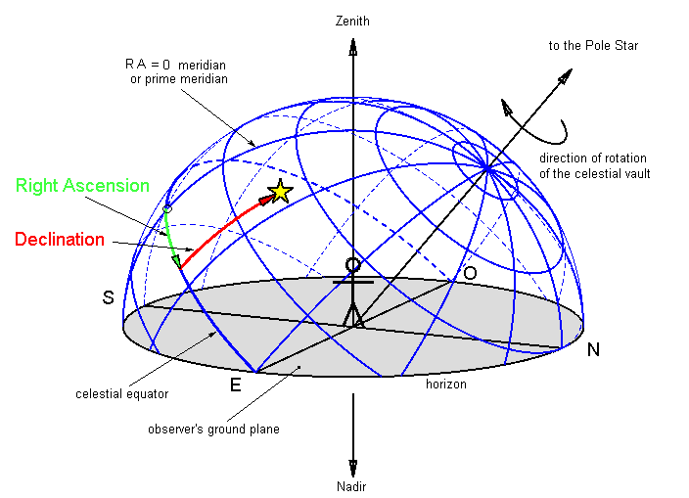
Celestial Equator: projection of the earth’s equator onto the celestial sphere
Right Ascension (RA): (~Longitude)
- This angle is measure in time (24 hours) because the sky rotates once per day
- 1 hr of RA = 15º
Declination (Dec): (~Latitude)
- Dec = 0º at the celestial equatorial
- North Celestial Pole (NSP) = +90º Dec; South Celestial Pole (NSP) = -90º Dec

Galactic Coordinates
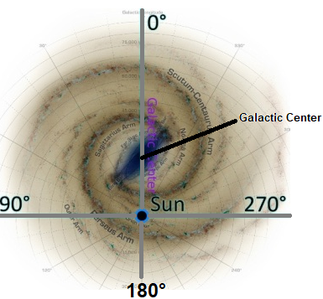
- Choose your coordinates!
- If you are a Galactic astronomer, letting the Milky Way determine the coordinate system has its benefits.
- When we eventually use the radio horn telescope to take readings from the Galaxy, this system will be important to us.
- So, the Galactic Coordinates is a spherical coordinate system with the sun at its center. and the Milky Way plane as its Galactic Equator (0° Galactic Latitude)
- Galactic longitude rotates 360º in the plane of the galaxy.
  - galactic longitude = 0º is toward the center of the galaxy, from the sun's point of view.
  - galactic longitude = 180º is directly away from the center of the galaxy.
- Galactic latitude rotates 180º from the galactic north pole to the galactic south pole.

Galactic Center
sun
θ

θ = 0º
θ = 180º
θ = 90º
Quadrant I
Quadrant II
Quadrant IV
Quadrant III

- The galaxy is divided into 4 quadrants using standard trigonometry definitions, as illustrated in the diagram above.

Quick Review
- Which coordinate system belongs to you, wherever you go? _________________________

- What is the Equatorial Coordinate equivalent to latitude? __________________________

- What is the point directly overhead called? __________________________

- Which is the only coordinate that is measured in hours? __________________________

- What is the line that goes directly overhead from N to S? _________________________

- Which coordinate system has the Supermassive Black Hole
at the center of the Milky Way at (0°,0°) __________________________

