The FFT block
  - Student activity
Name ______________________________ Date __________________
In this activity you will demonstrate how the FFT block in GNU Radio works. The FFT (Fast Fourier Transform) determines the frequencies and amplitudes of the sine and cosine functions that make up the Fourier series of a signal input to the FFT block. This block utilizes some mathematics that are beyond the scope of this presentation; it uses vectors and complex numbers to complete its computations. Several of the blocks will have inputs and outputs that are complex. Using An FFT Block
- Open your 6 function signal generator from Lesson 2.
- Save as . . . using a new file name.
- Delete all of the blocks in the sequence after the Add block.
- Import the blocks that are shown in the diagram below after the Add block:
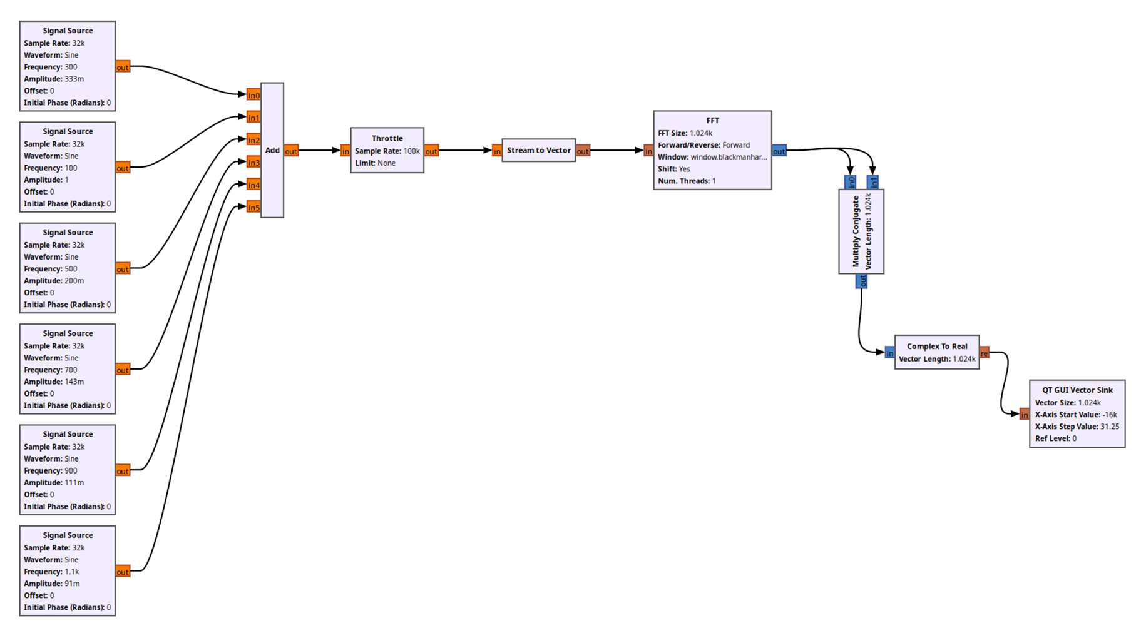
- Open each block and change their settings as described below:
- Throttle – This regulates the flow rate of the signal through the sequence; it has no effect on the
output. In the previous lessons the speaker regulated the flow of the data through the blocks. As no speaker is used in this program, the Throttle block keeps the flow regulated.
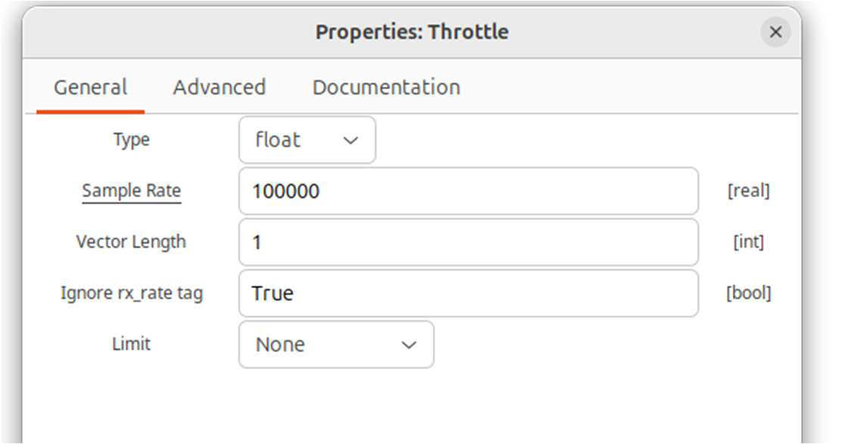
- Stream to Vector – This changes the signal source to a vector to be analyzed by the FFT.
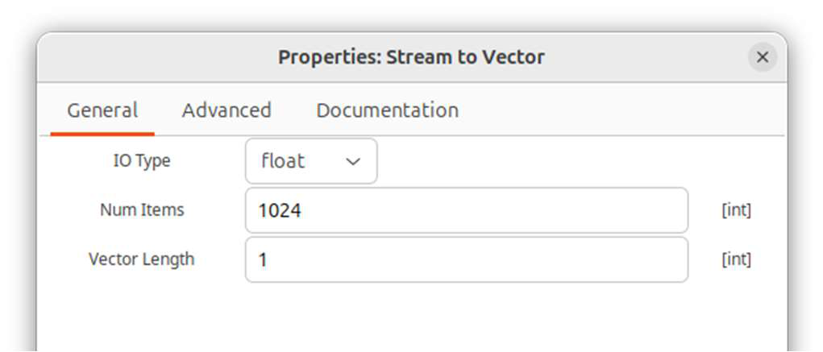
- FFT – This is where the magic is done.
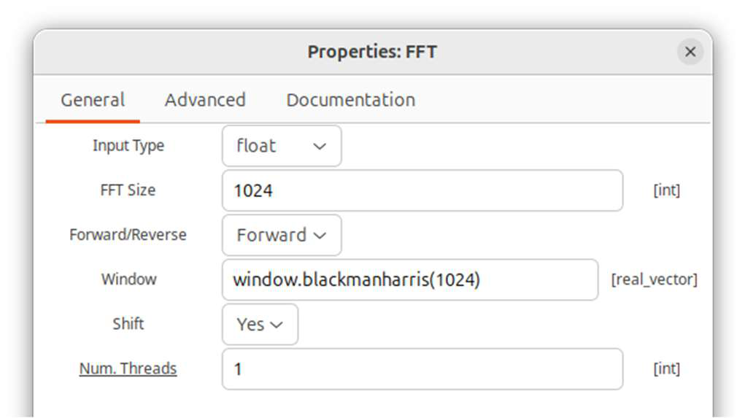
- Multiply Conjugate – The output of the FFT block is a complex number. This block calculates a
number that represents the magnitude of output at each frequency.
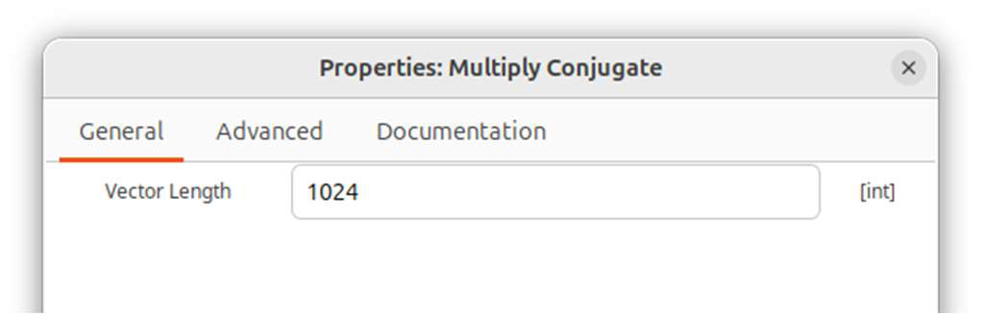
- Complex to Real - This converts the data stream back to a real number.
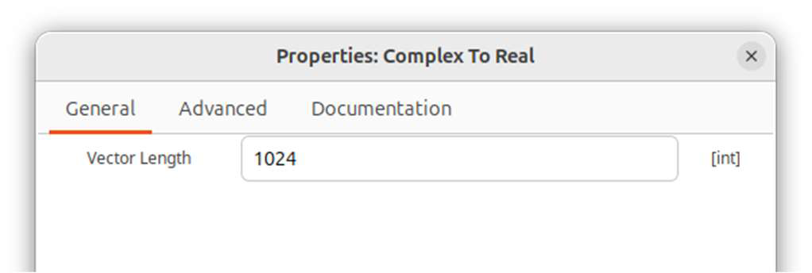
- QT GUI Vector Sink – This displays the output of the FFT graphically, showing the amplitudes
of each frequency that makes up the signal that was the input to the FFT.
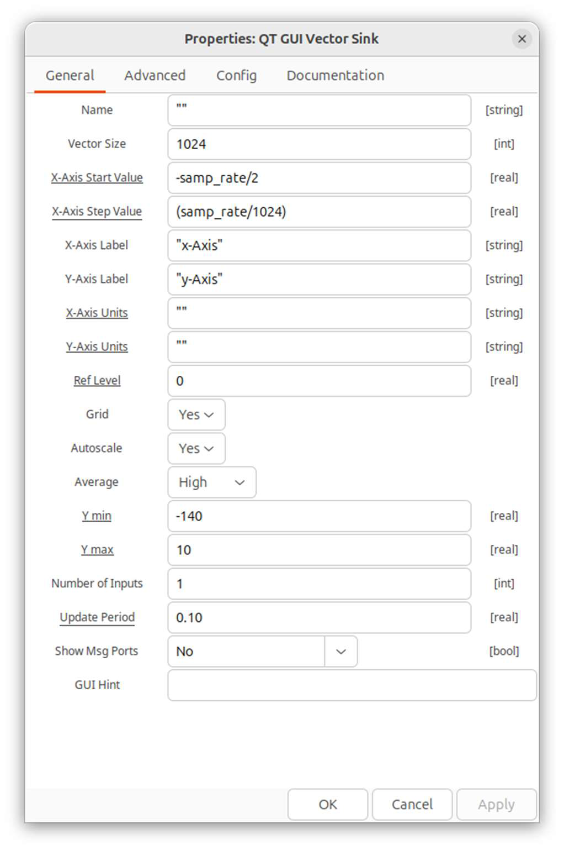
- The "X-Axis Start Value" and "X-Axis Step Value" formulas are needed for the Vector Sink to
interpret the frequencies correctly.

Test the FFT Block
- Run the program. Choose different frequencies and amplitudes of sources 1-6. These can be adjusted using the sliders or counters for each frequency and amplitude.
- Notice how the output in the graph changes as the frequency and amplitude values are changed.
- Also, notice that the zero frequency on the x-axis is in the middle of the axis, and both positive and negative frequencies are possible. This is an interesting possibility with SDR that we will not go into.
- If all 6 frequencies set in the frequency QT GUI Range blocks are at different values, then there should be 12 different frequency values displayed - 6 corresponding to the positive values of these frequencies and 6 that are mirror images of these frequencies in the negative range.
- By placing the cursor over a peak, its frequency can be read as the x-coordinate displayed.
- The peak heights are related to the Fourier coefficients of each frequency. The y-axis is not scaled on this graph.
- Set all of the volumes to 1. The peak heights should all be the same, or very similar.
- Now change one of the signal volumes to 0.5. Notice that the corresponding peak height at this frequency drops to approximately ¼ of its original height. This is because the Multiply Conjugate block actually calculates the power of the signal, which is proportional to the square of the Fourier coefficient. So dropping the volume of one of the input frequencies to ½ results in a power at that frequency that is (½)² = ¼ of its original power.
This activity should give you an idea of what an FFT block can accomplish. Deciphering the frequencies contained in a signal is a very important tool in DSP in general, as it is in radio astronomy. So the FFT block is at the heart of the GNU Radio spectrometers we use. Audio FFT
- Save your progam with a new name (e.g. Lesson4_microphone).
- Delete the six Signal Source blocks and the Add block.
- Replace these with an Audio Source block.
- You will need to add a Stream to Vector block. NOTE: Set the Num Items to 1024, and the Vector Length to 1
- Run and explore with different audio inputs. Have fun!

