Observing Celestial Coordinate Systems using Stellarium
  - Astronomy Activity

Objective- To take the coordinate systems in the last activity and interact with them using the online Web version of Stellarium*, an interactive planetarium program.

*If your school has added the downloadable Stellarium program directly onto its computers, you can still do this activity. However, the directions here will not match the more robust environment of the downloaded version,.

Let’s just look at the night sky!
- Look up “Stellarium online” Click on Stellarium Web Online Star Map (Often, the first question upon opening Stellarium is if you are willing to share your location. Please ask your teacher if “allowing” this is okay.)
- Spend a few minutes clicking on buttons, objects in the sky, click and drag the sky, scroll wheel to zoom in and out…

Location and Time
What town are you in now? _________________________

Date _____________________ Time for observing night sky (ex 8pm) ______________
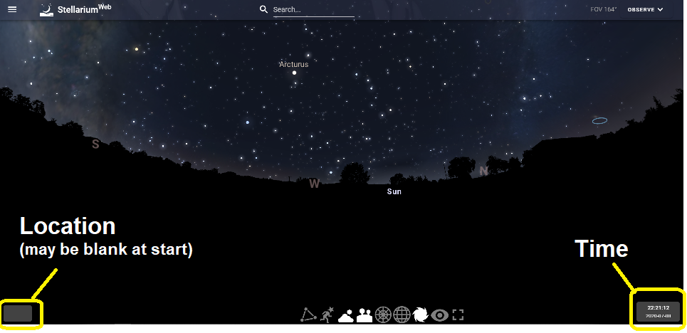
- Let’s see if you can get there (place and time) in Stellarium
- Click on the Location block in the lower left. It may be blank to start. You can click and drag the pin, or use the magnifying lens search box. Set your area’s location.
- Now, go to the Time box in the lower right. Set the time for observing, listed above. There is no text entry, just the toggle or slider. The clock is 24hrs, so add 12 to your chosen evening observation times.
- What Planets are in the sky? (might be “none”) _______________________________
- Is the Moon in the Sky? If yes, then click on it and record its phase (as %) ______%
If no, then search (top center) for “Moon” and click. What time will it rise? _________
- Can you see the band of the Milky Way running across the sky? ____________
Let’s find the most popular star in the sky, Polaris. (No, it is not the brightest star in the night sky!)
- Star names appear based on the level of zoom, but let’s go at it a different way. Down at the bottom of the screen are two circles for two coordinate systems we looked at in the last activity. Click on the Equatorial grid. Remember, this is like our Earth’s Latitude and Longitude system projected onto the Celestial Sphere. Polaris is the North “Pole Star” for this reason and should be very easy to find. With this grid, it is like a big bull’s eye.
- Click in Polaris. A data box shows a variety of information. Record the following:
Right Ascension ______h ______m Declination _____° ______ ‘
(Remember, R.A. is measured in “hours and minutes” because the sky rotates like a clock. You should already know the degree sign, °. You may not know that degrees are broken into 60 arc-minutes. ‘. )
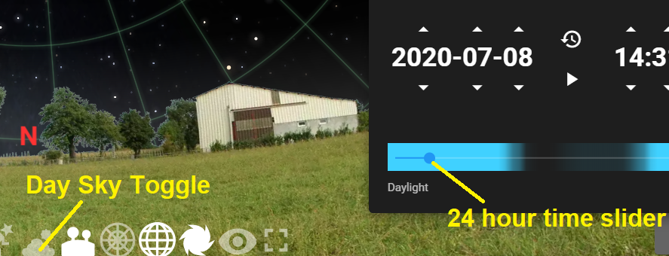
- Click on the Time box in the lower right part of the screen. With Polaris still on the screen, take the little slider dot below the clock and slide it back and forth through a 24 hour cycle. You may want to turn the Atmosphere button off to get rid of blue sky during the day.
- Of all the stars on your screen, which one moves the least over 24 hours? _________
- Which grid lines don’t move over 24 hours, RA or Dec line? _______________
- Now let’s look at your Local Sky. Click on Polaris again, turn the Equatorial grid off, and turn the Azimuthal grid on.
- In Polaris’ info box, record the following:
Azimuth ______ ° ______ ‘ Altitude ______ ° ______ ‘
- The Azimuth angle starts at 0° Due North on the Horizon and completes a full 360° circle in the clockwise direction. Based on your last answer,
How far is the North star from true north? _______________________________
- If you did the last activity on Coordinates Systems, you already answered this question, but it is easy to find.
What is the latitude of your location/school? _____________°
- How far is that value from the altitude answer on 15)?
- Write a quick, complete sentence explaining the 2 very important things Polaris can tell you about your location.

Your Local Sky
- The darkest skies will be straight up, away from the horizon and all the lights in your area. What was that point straight overhead called? ____________
- You should now have the Azimuthal grid on. Find this overhead point at 90° from the horizon.
- Click on the Constellations Button. Which constellation is overhead for your viewing time? ______________________
- Remember, this is YOUR sky, so if you don’t move, then the grid doesn’t move. Click on the Time box and slide through a day (with the blue sky off). . Which named star comes closest to the overhead point?_________________
- What time was that for your date of observation? _________________
“Are you serious? Polaris is NOT the brightest in the night sky? Then which one is?”
- Go to the search bar at the top center and type in Sirius. Sirius in the brightest star anywhere in our night sky.
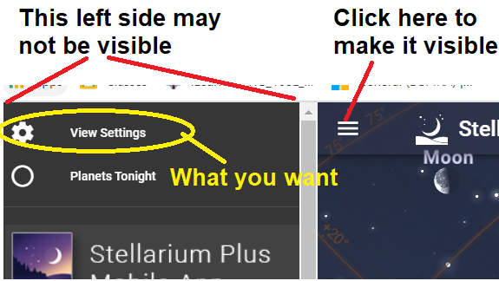
- Try to get Sirius due south. Add the Meridian (Line running overhead from north to south) This can be a bit trickier in Stellarium than other things done so far. You may or may not have a full left bar screen promoting the Stellarium App. If not, click on the little 3 bar menu button at the top left of your star field screen. Click on View Settings and choose Meridian.
- Go back to your star field, drag your screen so you are looking south and the meridian line is straight up and down. Now play with the Time controls until Sirius is due south.
- Record all of the following:
Date __________ Time __________ Rise Time __________ Set Time __________
RA __________ Dec __________ Az __________ Alt __________
- How much time was Sirius in the sky? (even if daylight) _____h _____m
- Go 2 months into the future, get Sirius back to the Meridian, then record the same info
- Record all of the following:
Date __________ Time __________ Rise Time __________ Set Time __________
RA __________ Dec __________ Az __________ Alt __________
- How much time was Sirius in the sky? (even if daylight) _____h _____m

How about that really bright star?
- We can’t forget that the Sun is a star too. You will do the same thing for the Sun that you just did for Sirius. Go back in time to the original date used in 28). Get the Sun to the Meridian.
- Record all of the following for the Sun:
Date __________ Time __________ Rise Time __________ Set Time __________
RA __________ Dec __________ Az __________ Alt __________
- How much time was the Sun in the sky? _____h _____m
- Go 2 months into the future, get Sirius back to the Meridian, then record the same info
- Record all of the following:
Date __________ Time __________ Rise Time __________ Set Time __________
RA __________ Dec __________ Az __________ Alt __________
- How much time was the Sun in the sky? _____h _____m

Conclusions
- Did the amount of time that Sirius was in the sky over the 2 month gap change? ____
- Did the amount of time that the Sun was in the sky over the 2 month gap change? ___
Look over the two Sirius sets of data and the two Sun sets of data. What other things changed for each object over the 2 month gap. You should note that one of the objects had a lot more changes than the other. Please write, in a few complete sentences, what these changes were and what is different about the two objects that allows for these differences.
_______________________________________________________________________
_______________________________________________________________________
_______________________________________________________________________
_______________________________________________________________________
_______________________________________________________________________
_______________________________________________________________________
_______________________________________________________________________
_______________________________________________________________________
_______________________________________________________________________
_______________________________________________________________________

