Celestial coordinate systems
  - Teaching guide
How do we describe the position of an astronomical object in space?
- Celestial bodies are assumed to be on the inner surface of a sphere of infinite radius with the earth at its center.
- Assume the earth does not move, but instead the celestial bodies rotate about it in a predictable manner.
1. Spherical Coordinates:
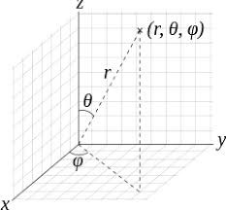
2. Terrestrial Coordinates: Longitude and Latitude
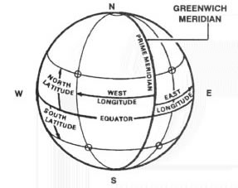
The zero point for longitude is the prime meridian which runs through Greenwich.
3. Horizontal Coordinates: Azimuth and Elevation
Zenith: The point vertically above an observer and is 90º from all points on the horizon. The nadir is 180º opposite zenith.
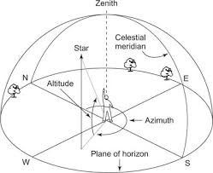
The celestial meridian is great circle which intersects the zenith, the nadir, and the celestial poles.
The astronomical horizon is a great circle on the celestial sphere which is perpendicular to the zenith-nadir axis.
The coordinates of an object are described by its azimuth and elevation.
- The azimuth is defined in degrees clockwise from due North.
- Elevation is defined in degrees above the horizon.
4. Equatorial Coordinates: Right Ascension and Declination
- Most commonly used in astronomy.
- Not tied to observer’s location.
- Locations of stars are fixed in the equatorial coordinate system.
- Projection of the terrestrial longitudes and latitudes onto the celestial sphere.
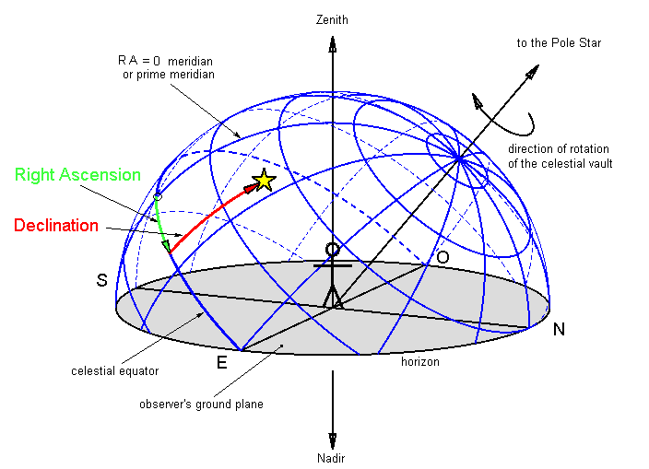
Celestial Poles: points vertically above the earth’s north and south poles
Celestial Equator: projection of the earth’s equator onto the celestial sphere

Right Ascension (RA)
- longitudinal coordinate
- RA = 0º at the prime meridian
- 1 hr of RA = 15º

Declination (Dec)
- latitude coordinate
- Dec = 0º at the celestial equatorial
- North Celestial Pole (NSP) = +90º Dec; South Celestial Pole (NSP) = -90º Dec
5. Galactic Coordinates
- The Milky Way Galaxy is disk-like
- A spherical coordinate system with the sun at its center.
- Describes the positions of objects in the Milky Way Galaxy in relation to the sun (us).
- Galactic longitude rotates 360º in the plane of the galaxy.
- galactic longitude θ = 0º is toward the center of the galaxy, from the sun's point of view.
- galactic longitude θ = 180º is directly away from the center of the galaxy.
- Galactic latitude rotates 180º from the galactic north pole to the galactic south pole.
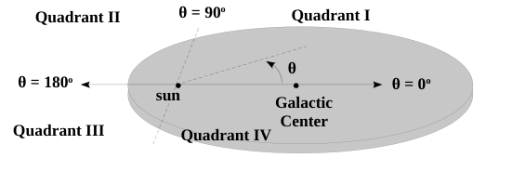
- The galaxy is divided into 4 quadrants using standard trigonometry definitions, as illustrated in the diagram above.

EXERCISES
1. If a person in Charlotte looks straight up, what is the declination of the direction the person is looking?
2. If a star rising in the east and is at an elevation of 30º, then how much will the RA change when the object is directly overhead?

