Electromagnetic spectrum
  - Answer key
Identify each region of the electromagnetic spectrum. Compare the direction of increasing frequency with increasing wavelength.
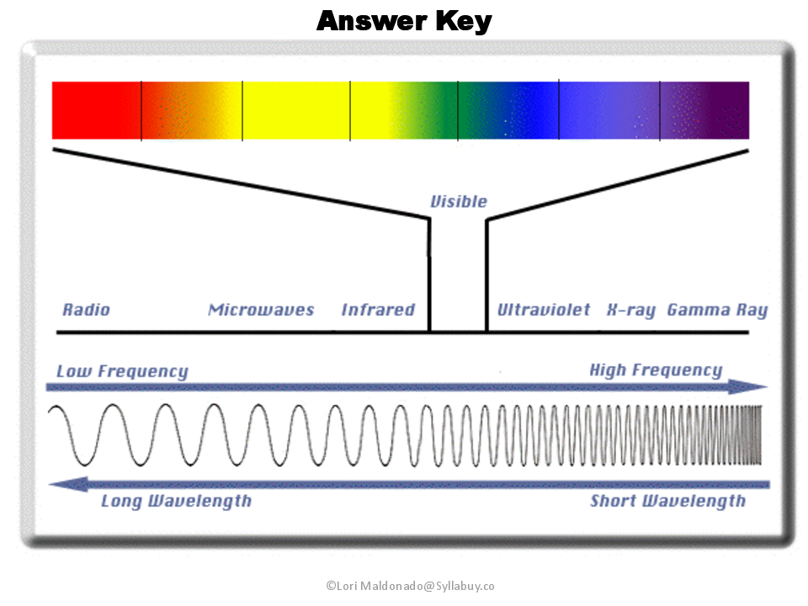
Diagram credit: Lori Maldonado. Original credit remains in the artwork.

Spectrum labels
Position from left to right | Region
1 | Radio
2 | Microwaves
3 | Infrared
4 | Visible light
5 | Ultraviolet
6 | X-rays
7 | Gamma rays

Frequency increases from left to right.
Wavelength increases from right to left.

