Introduction to the Milky Way Galaxy
Astronomy Activity
Part 2: The part we CAN’T see
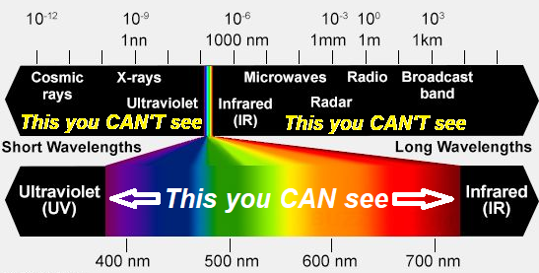
Introduction - In the Part 1 activity, you gathered information about the Milky Way Galaxy for the things we CAN see in visible light. In this activity, we will consider things we CAN’T see when we look at the Galaxy.
The easy answer would be that we can’t see things that are anywhere in the EM Spectrum that is not visible light.
The harder answer is that we CAN’T see a lot of motion… at least not too much of it. Seeing the whole sky move led to a rotating Earth model. Ancient civilizations separated 7 objects in the sky and called them wanderers (planets) because they moved in the sky from night to night. This led to our model of the Solar System. Beyond these handful of observations, out of countless things to see in the sky with eye or telescope, there is no easily detectable motion. Yet, it ALL moves. If you could come back in 10 years or 1000 years, the stars, constellations, and Milky Way would all look the same. An hour hand on a clock moves more in 0.0002 seconds, than the Sun will move around the Galaxy during your lifetime.
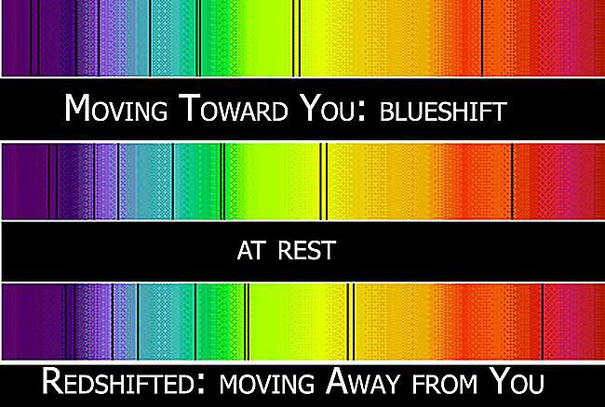
Spectrums and the Doppler Effect to the Rescue!
Being able to break EM Radiation into a spectrum and analyze its frequency shifts has been paramount to modern astronomy. From the expansion of the Universe and the Big Bang Theory, to masses of stars, to finding Exoplanets, to Galaxy Rotation and the concept of Dark Matter all can be traced back to understanding the Doppler Shift.
Objective
In the long march towards using the Radio Horn Telescope to view the plane of the Milky Way and analyze the neutral hydrogen spectrum, an understanding of the current model of the motions in the Milky Way Galaxy will be explored here through a computer simulation generated in Interactive Physics.

What Astronomers have learned about the Milky Way so far
Astronomers (analyzing the Doppler Shift) are finding out, over time, that most stars in the galaxy beyond about 1000 light years from the Galactic center are moving at a reasonably similar speed (between 220 km/s and 240 km/s) These are speeds that are all in about a 10% range of each other. Compare this to the Solar System...we have seen that the Earth is moving at about 30 km/s, where Mercury is moving at 47 km/s and Neptune at 5.5 km/s...quite a range here.

We will save the reason “Why” for current research (Dark Matter!) However, we will try to analyze a model to help us predict what the doppler shifts would be if we look at different parts of the Milky Way along the Galactic Equator.
Getting ready before watching the Simulation - (some of these are similar to questions from the Part-1 activity, so having that handy would be helpful)
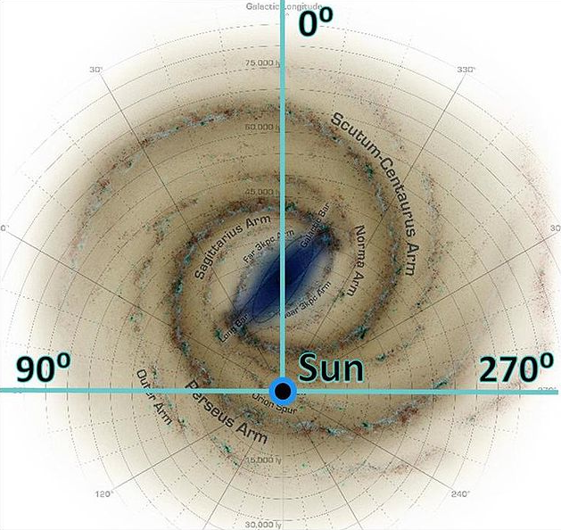

- When we look from the Earth/Sun system, what does the Galactic 0° Longitude line up with?
ANS ______________________________

3) The Galaxy is broken into 4 quadrants. In the diagram, label the 4 quadrants (I, II, III, IV).
Click the link above for video assistance.

4) Which two Quadrants do we see easily from our Northern Hemisphere position here in the US?

ANS ___________ & _____________

A video using Interactive Physics to demonstrate motion with the Milky Way
To General DSPIRA Users…The program this simulation was generated with is Interactive Physics 2000. It is an old, stand alone, physics simulator program not easily found anymore. A video has been created to allow the viewing necessary to answer the questions. The students can scroll through the video as needed to get their answers.
Click here for Video
Video Timeline
0:00-1:40 General Introduction to the purpose of the video
1:40-3:00 Animation running from fixed viewpoint above the Galaxy with background image
3:00-4:00 Animation running from fixed viewpoint….No Background image
4:00-4:30 Transitioning to Sun Reference frame view
4:30-8:00 Running simulation from Sun Reference frame view

It is important to note that all the objects in the fixed reference frame view during the first half of the video are ALL MOVING AT THE SAME SPEED.

QUESTION - What can be said about the speed of all the stars
in the animation’s fixed reference frame (HOME) view shown during the first half of the video? _____________________________

5) The two important buttons on the right of the video are HOME and SUN. These buttons will change the point of view of the animation from the Galactic Center (HOME) to the Sun’s perspective. The first half of the video is in the Home View (like hovering above the Milky Way Center), and the second half is in the SUN view (like hovering above the Sun). Which best represents what we would see from here? (Worked for Ptolemy in modeling the Solar System)

_____________________________________
Question: EVEN THOUGH ALL STARS ARE MOVING THE SAME SPEED (in HOME View), why are some moving AWAY FROM and some TOWARDS the Sun?

___________________________________________________________________________________

___________________________________________________________________________________

The stars are colored to match the distance they are from the Galactic Center. This will help identify them from the Sun’s view. Let’s call the different distances “The Lanes” that the stars travel in during their circular path. There are 7 “Lanes”. If Lane 1 is the inside lane, then fill in the color code.

Lane 1 | Lane 2 | Lane 3 | Lane 4 | Lane 5 | Lane 6 | Lane 7

Which Lane is the Sun in? ____________________

SURVEY DATA!

You are about to work on filling the chart. You will want to watch the part of the video that is in the SUN view for the data collection. This may mean that you will need to view it a number of times.
Take a look at the chart to see the column titles of the things you’ll record.
- So, find the point in the video when it shifts to the SUN view. Hit RUN and let it go for a while until the stars seem fairly random. Then, hit STOP (make sure there are at least 2 stars in Quadrant 2 and 3)
- There should be 27 other stars “floating” around the IP galaxy. You will first take a survey of ALL the stars in each quadrant. If a star is on a line, you decide. Record in the count in the chart.
- Now, break the stars into two groups - INNER STARS (from lanes 1, 2, and 3) and OUTER STARS (Lanes, 5, 6, and 7) Use the color code to help you count. RECORD THE BREAKDOWN
- WHY NOT COUNT LANE 4? Hit the RUN button and watch the stars moving with respect to the SUN. QUESTION - What is most notable about the three other Lane 4 (yellow) stars?

ANS___________________________________________________________________

5) Run the animation for a while again and take another survey...then run again and take a third.
6) Moving Survey- Okay, now run the animation again. Try to note what the INNER and OUTER Stars are doing in each Quadrant. Obviously, some will cross the line...do your best to keep track.

SURVEY DATA- Star count per Quadrant

 |  | Quadrant 1 | Quadrant 2 | Quadrant 3 | Quadrant 4
Survey # 1 | All Stars
Survey # 1 | Inner Stars
Survey # 1 | Outer Stars
Survey # 2 | All Stars
Survey # 2 | Inner Stars
Survey # 2 | Outer Stars
Survey # 3 | All Stars
Survey # 3 | Inner Stars
Survey # 3 | Outer Stars

MOVING STAR SURVEY

 | Quadrant 1 |  | Quadrant 2 |  | Quadrant 3 |  | Quadrant 4
 | Inner Stars | Outer Stars | Inner Stars | Outer Stars | Inner Stars | Outer Stars | Inner Stars | Outer Stars
Stars getting FARTHER from Sun
Stars getting CLOSER to Sun

Circle all correct (none, one, or both) “Shifts” for each statement:

- There will be REDSHIFT and BLUESHIFT detected in QUADRANT 1?

- There will be REDSHIFT and BLUESHIFT detected in QUADRANT 2?

- There will be REDSHIFT and BLUESHIFT detected in QUADRANT 3?

- There will be REDSHIFT and BLUESHIFT detected in QUADRANT 4?

