Introduction to the Milky Way Galaxy
Astronomy Activity
Part 1: The part we can see
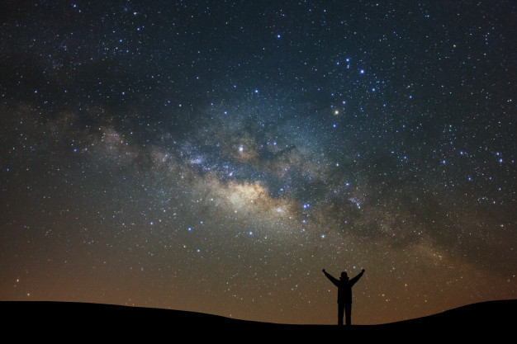
Introduction - If you were asked where you live, what would you say? In a house... in the United States… on Earth…which would it be? One of the less obvious answers, unless you are into astronomy, would be “The Milky Way Galaxy”
This activity is just a quick chance to get a sense of all that makes up the Milky Way Galaxy, at least the part we can see.
If you are lucky, you may have seen the Milky Way as a band of soft light that runs across the whole of the dark night sky. Unfortunately, many who live in big cities, and even suburban towns, are subject to enough light pollution from houses, cars, malls, highways, that our eyes cannot handle seeing the faint glow of the Milky Way. Try to get out into the countryside, or high in the mountains and be amazed to see the “walls” of your galactic home!
What To Do
This activity will only explore aspects of the Milky Way that YOU can see with the unaided eye.
- You have learned enough about the ElectroMagnetic Spectrum by this point
to answer this, “What type of radiation from the E-M Spectrum can YOU see? ______________
TO THE INTERNET! Look up these “vital stats” for our home galaxy?
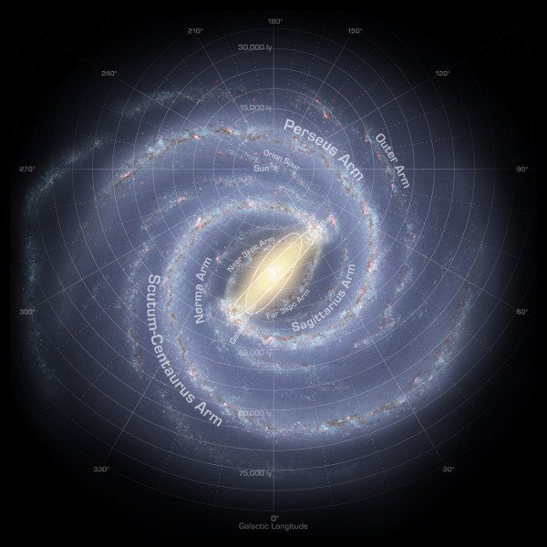
- How many stars are believed to be in the Milky Way Galaxy. You may find an answer expressed as a range of numbers?
_______________________________
- How far across (diameter) is the visible part of the Milky Way Galaxy? (in light years)
_______________________________
- How far is the Sun from the Galactic Center? (in light years)
________________________________
We can take pictures of other galaxies that are millions of light years away, like our neighbor, the Andromeda Galaxy (shown at right), but the artist’s rendition from the last page is the best we could for our own Milky Way. It would be like you trying to take a picture of the whole United States from your backyard. Now, we have sent satellites up to take pictures of the Earth, but we would need to send a satellite 100.000’s of light years away to take a picture of the Milky Way. The farthest spacecraft from Earth, to date, is about 0.002 light years away.
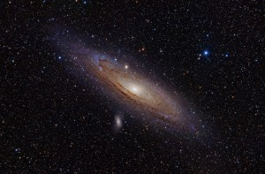
Map it, Measure it!
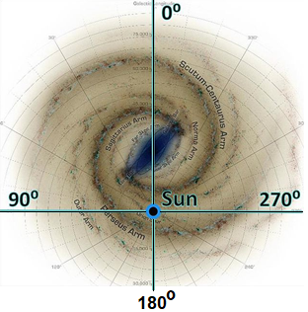
So, we are stuck here in the Galaxy, but that doesn’t stop us from mapping it and studying it. There are astronomers who dedicate their work to just the Milky Way. For them, that band of light in the sky is very important, so they have created another coordinate system, the Galactic Coordinate System. (click for video) In this coordinate system, the Sun/Earth is the center of the system. The Galactic Plane defines the Galactic Equator (which is 0° Galactic Latitude) and the Galactic Center is the (0°, 0°) point.
BACK TO THE INTERNET! Look up these stats for our home galaxy?
- What object is at the center of the Milky Way Galaxy?
______________________________________________
- What Constellation is the Center of the Galaxy in? _____________________________________
- QUADRANTS of the Galaxy - The location of objects within the Galactic Plane are often divided up into Quadrants. Watch the video linked above to learn about the Quadrants Label Quadrants I, II, III, and IV on the diagram above.
- If you placed a penny on the Sun to represent the plane of the Solar System (North up) and tilted it up 60° to the left, that would be about how our Solar System is oriented in the galaxy. We are in the Northern Hemisphere looking out (top of penny). Which 2 quadrants do we see best? The video will be helpful here, too. ________________________________________________________________________

