Filters
  - Student activity
Name ______________________________ Date __________________
In this activity you will use your multiple waveform signal source from Lesson 2 and add different types of filters to see their effect on the output.

Low-Pass Filter
Ideally, a low-pass filter allows signals with frequencies from 0 Hz to the "cutoff" frequency to pass through unchanged, and it chops out signals above the cutoff frequency. You can think of it as a multiplier function that multiplies the signal by 1 for signals below the cutoff frequency, and multiplies by 0 for signals above the cutoff frequency. An analogy with liquids would be how a coffee filter works, allowing particles smaller than a certain size to pass through, and particles greater than a certain size are filtered out and don’t pass through.
Real filters are unable to suddenly cutoff a signal from a multiplier of 1 to a multiplier of 0 at a single frequency. The range of frequencies over which the multiplier changes from 1 to 0 is defined by the transition width, as illustrated below:
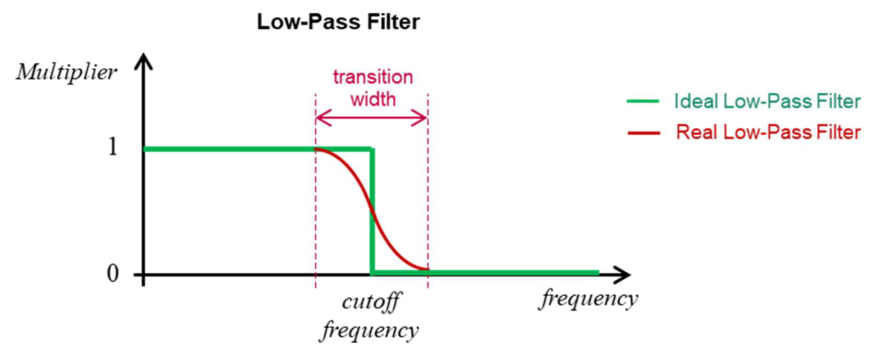
- Open your 6 function signal generator from Lesson 2.
- Save as . . . using a new file name.
- Add a Low Pass Filter block to the canvas, and connect it after the Add block.
- Open this block and change the FIR type to "Float → Float (Decimating)". This block should look like the following:
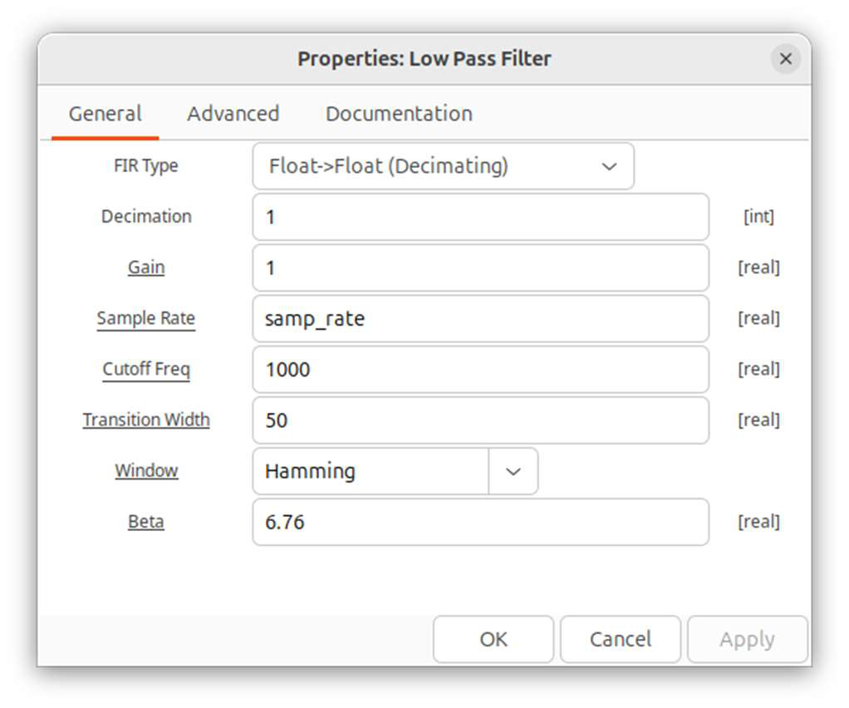
- Start with a Cutoff Freq of 1000 and a Transition Width of 50. The frequency values are in Hz.
- Run the program. Adjust the frequencies of the signal sources, with some above and some below the cutoff frequency.
The frequency graph uses a logarithmic decibel (dB) scale. A 20 dB drop reduces amplitude to 1/10. A signal at -40 dB has 1/100 the amplitude of a signal at 0 dB.
- The Time Domain graph might be more convincing. Set several of the frequencies below the cutoff frequency. Then increase them one by one to values way above the cutoff frequency. When only one signal remains with a frequency below the cutoff, the time graph should look like a single sinusoidal graph at that frequency.
- Explore different Cutoff Freq’s and Transition Widths as well as different source frequencies.
- Does the output behave as you would expect according to the simple model of a low-pass filter?

High-Pass Filter
Ideally, a high-pass filter allows signals with frequencies above the cutoff frequency to pass through unchanged, and it chops out signals below the cutoff frequency. As with a low-pass filter, there is also a transition width associated with a real high-pass filter. A schematic diagram of the profile of a high-pass filter is illustrated below:
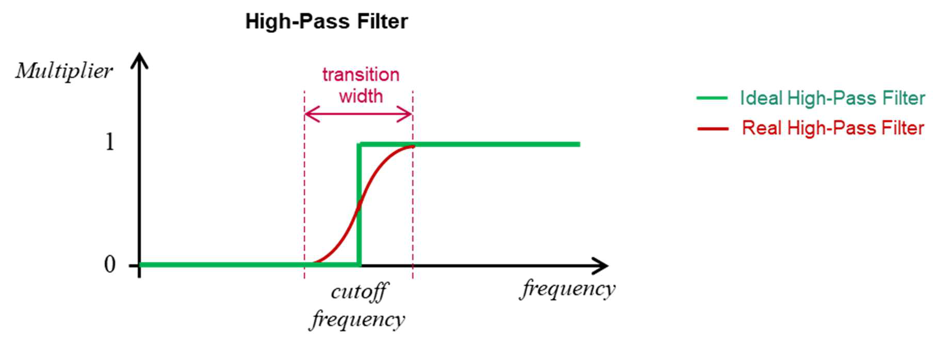
- Replace the Low Pass Filter with a High Pass Filter block.
- Explore different Cutoff Freq’s and Transition Widths as well as different source frequencies, similar to what you did for the low-pass filter.
- Does the output behave as you would expect according to the simple model of a high-pass filter?

Band-Pass Filter
Ideally, a band-pass filter allows signals with frequencies above the “low cutoff” frequency to pass through unchanged, and it chops out signals above the high cutoff frequency. A schematic diagram of the profile of an ideal high-pass filter is illustrated below:
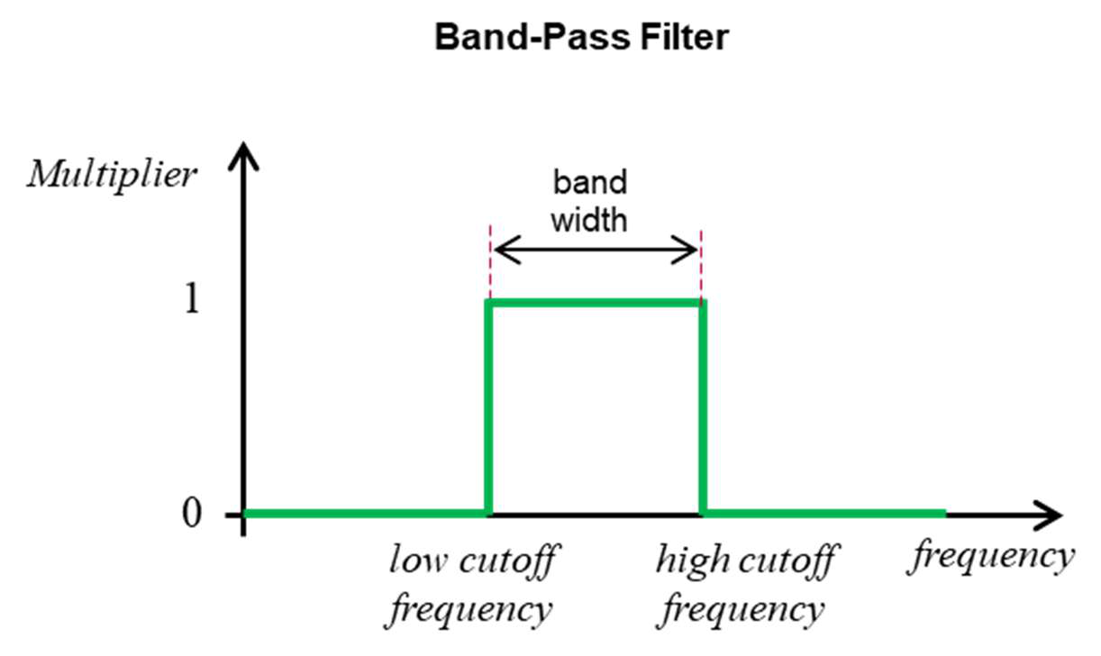
- Real band-pass filters have transition widths, as discussed with the other filters above.
- Replace the High Pass Filter with a Band Pass Filter block.
- Explore different Cutoff Freq’s and Transition Widths as well as different source frequencies, similar to what you did for the other filters.
In general, filters are used extensively in DSP. For instance, a spectrometer might be designed to detect a certain frequency range. An appropriate band-pass filter could be used to remove much of the noise occuring at frequencies above and below the desired range.

