The electromagnetic spectrum
  - Student activity
Name ______________________________ Date __________________
Radio waves are part of the electromagnetic spectrum, also comprised of microwaves, infrared light, visible light, ultraviolet light, x-rays, and gamma rays. All of these are manifestations of electromagnetic energy traveling through space in waves at a speed of approximately 3.00 x 10⁸ m/s.
Properties of Waves Waves are disturbances of a medium in time and in space. For sound waves in air, the medium is air; for water waves, it is the water. For electromagnetic waves the medium can be empty space (the vacuum) or any phase of matter.
Periodic waves can be described by several properties:
- The period, T = the time for the disturbance to oscillate back and forth once; measured in seconds (s).
- The frequency, f = the number of oscillations per time; measured in hertz (Hz).
How are frequency and period related?
- The amplitude, A = maximum disturbance level from equilibrium.
- The wavelength, λ = the distance in space over which the disturbance repeats itself; measured in meters (m).
- Identify the parts of the wave in the diagram below:

- The wave speed = speed at which the disturbance (energy) travels through the medium.
Wave speed depends on the properties of the medium. Electromagnetic waves travel at the speed of light, c = 3.00 x 10⁸ m/s through empty space.
- Relationship between wave speed (v), frequency, and wavelength:
v = f·λ
For electromagnetic waves: c = f·λ = 3.00 x 10⁸ m/s = constant
The Electromagnetic Spectrum All electromagnetic waves travel at the same speed of 3.00 x 10⁸ m/s, but the different parts of the electromagnetic spectrum have different frequencies and, therefore, different wavelengths, according to the wave relation equation c = f·λ. As the frequency increases, the wavelength decreases. Different ranges of frequencies and wavelengths correspond to different parts of the electromagnetic spectrum.
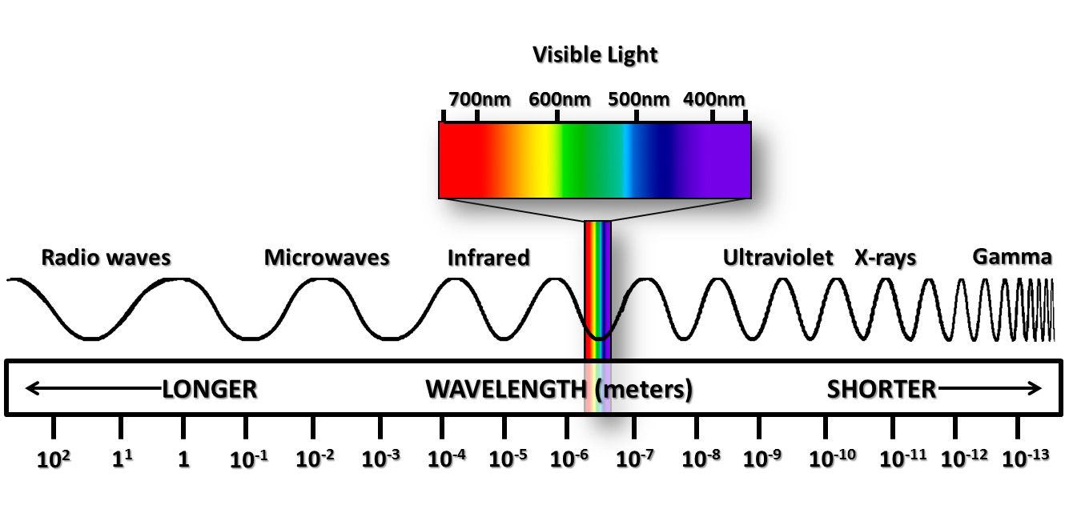

EXERCISES
1. In Lesson 1 we discussed that the horn telescope is designed to detect radio waves at a frequency of 1420 MHz. More exactly, these waves have a frequency of 1420.4 MHz. Determine the wavelength of these waves. Express the answer in cm.
2. FM radio ranges from 87 MHz to107 MHz. Determine the range of wavelengths of these waves, in meters. Which frequency has the longest wavelength?
3. X-rays have wavelengths on the order of the size of an atom. Determine a reasonable value for the size (either diameter or radius) of an atom. Express this in meters. Then determine the frequency of an electromagnetic wave with a wavelength equal to the size of this atom.

