Horn telescope discussion guide
  - Teacher reference
a. What is the telescope detecting?
Radio waves
b. What is the source of these radio waves? How do we know?
- The signals come from outside the earth
→ If we point the telescope at different likely sources on earth, e.g. buildings, radio
towers, other man-made structures, the “peaks” we observed do not show up. Also, the peak signals are strongest from “empty” sky, and the signal does not vary significantly over a large range of sky.
- The signals are radio waves
→ The telescope consists of an antenna (the wire in the can) and a low-noise amplifier
(LNA) designed to magnify and filter signals for the specific frequency 1420 MHz, which is in the radio frequency range.
c. Horn telescope diagram
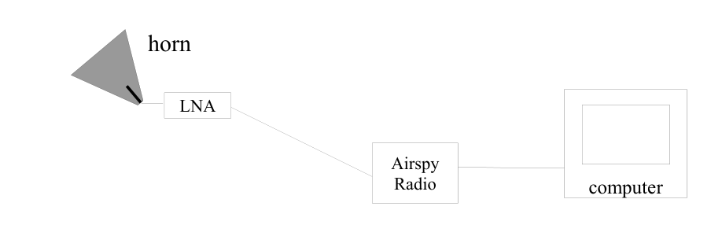
i. Hardware
- horn & tin can
- metal wire
- cables
- amplifier
- dongle
- computer
ii. Software
- GNU Radio – open source software defined radio program

