Subject: Cone Horn Telescope Base Construction Guide
Memo: 36, Revision 7
From: Glen Langston (glen.i.langston@gmail.com, glangsto@nsf.gov)
Date: 2024 December 31

Summary: Cone Horn Radio Telescope Base Construction Guide

A Cone Horn Radio Telescope is your key to discovering the Milky Way! Here we describe the latest telescope base design. We’ve significantly reduced the weight, size and complexity of the horn telescope base. Here we list construction steps for the base.

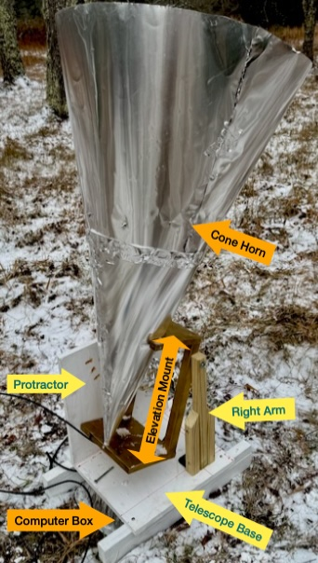
Background
Figure 1: Completed Telescope, marking major parts. Here we describe the Telescope Base (Blue Text). Other memos describe the Cone Horn, Elevation Mount and Computer
The West Virginia University Radio Astronomy Instrumentation Lab (WVURAIL) is a leader in bringing radio astronomy to the public. Though their guidance, they enable everyone to discover the immense size and shape of our Milky Way Galaxy. The WVURAIL team of teachers and engineers enable everyone to find their place in the galaxy. This memo has links to more background info and is a starting point for your experiments.

We describe the parts of the horn radio telescope in LightWork memos, along with suggestions for experiments. Figure 1 shows the major parts of a completed telescope. Our radio telescope has these major parts: 1) a cone horn to gather the radio signals, with elevation mount (Memo 35), 2) the computer to measure the signals, in weather proof box (Software Guide) and 3) a telescope base to hold the telescope during observations. We describe the telescope base in this memo.

We keep continually improving the design. But our goal remains the same, to collect and understand radio signals from the Milky Way. The previous descriptions are still relevant and have more background information. For example, see LightWork Memo 32, Gather a Pail of Milky Way. We hope you will also make even better improvements and make new discoveries!

The Pail of Milky Way telescope has a base is described in Memo 34, a Simple Telescope Base, We’ve further simplified the base design and describe our new construction here. Our base design is wide enough to hold almost all types of small telescopes for observing Hydrogen in our Milky Way Galaxy. We’ve made many different types of horns over the years. For example, see videos of telescopes observing:
- Digital Signal Processing in Radio Astronomy (DSPIRA)
- Bubble Wrap Radio Telescope and Software

Telescope Base Components
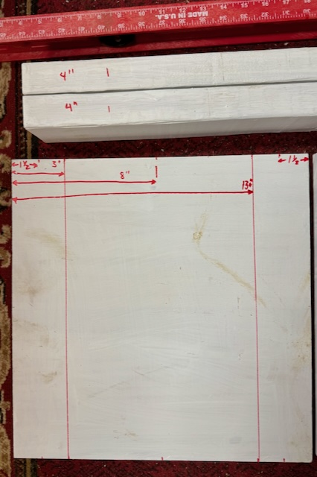
The base has three parts, first, a fixed bottom which supports the left and right arms that hold the telescope. The bottom also covers the telescope computer that is inside it’s weatherproof box. Figure 1 shows the computer box is under the base.
Figure 3: Draw lines +/- 5-inches from the center of the bottom. Mark the leg positions and 4-inches from the ends of the 2x4s.

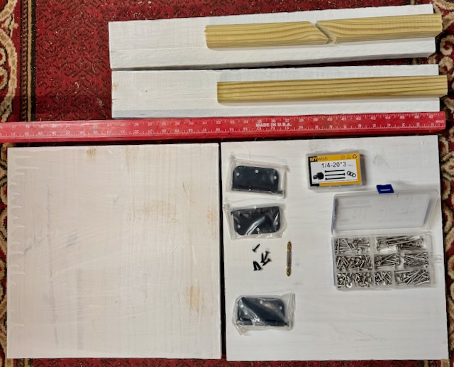
The second part, the left of the arm has pre-measured holes for setting the angle of your observations. The third part is the other arm, made from pieces of a baluster. Together these arms form the elevation axis, for setting the angle of your observations. The telescope metal horn is attached to an elevation mount, which has two holes. Two bolts connecting the arm and the mount enable the telescope to tilt. The parts we’re using are shown in Figure 2.
Figure 2: All parts of the telescope base. At the top there are two 2x4s, each 2-feet long and two 16-inch sections of a baluster. One of these two is cut in half diagonally. The red ruler shows the scale. At the bottom are two 16-inch square boards, ¾-inch thick. At bottom right are three door hinges, a box of assorted screws and a box of 3-inch long, ¼-inch thick bolts.

The telescope base is made from wood, with 4 wood screws, 3 hinges (with screws) and 3 bolts to hold the telescope elevation mount in place. Only very basic woodworking skills are needed to build the base. You can use a hand saw for all cutting, but you will need an electric drill. If the parts are cut and painted in advance, assembly takes about an hour.

Note the base can be made many ways. if you have different size spare pieces of wood, you can redesign you own base. If you do, please document your construction and add to the Lightwork memo series! Email us and we’ll add your memo.

Steps for building the Base
The first step is painting the 16x36 inch shelf and the 2x4 boards. After these has dried, divide the shelf into two equal parts, each 16x16 inches square. Draw lines and use a hand saw to cut the parts. Paint wooden parts with exterior primer and paint. Figure 3 shows the painted and marked bottom of the base.

Cut the 2x4 board into two 2-foot lengths These are the base legs. Place the 2x4 pieces parallel, on the ground, and separated by about 14 inches.

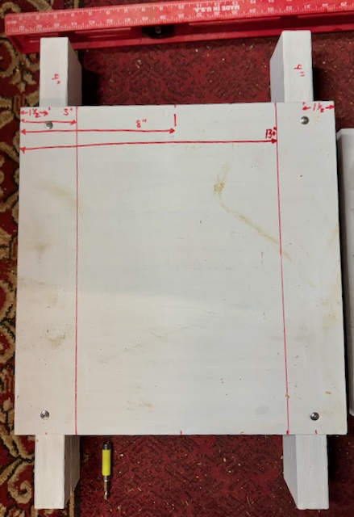
Attach 2x4 Legs to Bottom
Figure 4: Legs attached to bottom of the base.
8 in
10 in
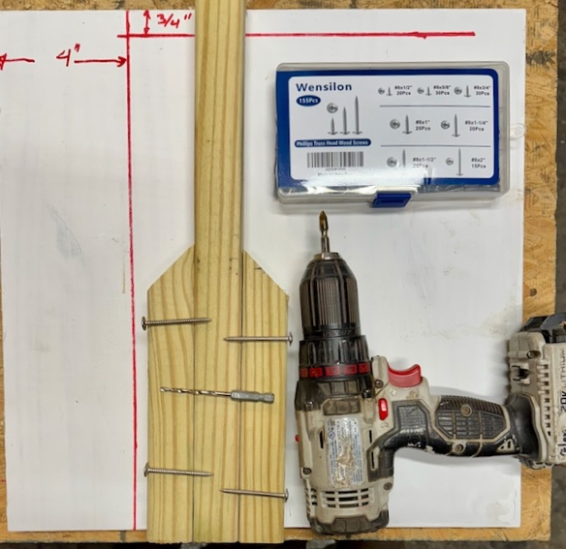
Center the bottom piece on top of the 2x4s, mark points 1-inch from the edges of the bottom. The two legs, the two 2x4s, are centered between the front and back of the bottom, The legs are 1-inch from the side edges of the bottom. Draw marks 4-inches from the ends of the 2x4s. Use a 1/8-inch drill bit and drill holes through the bottom of the base to the legs. Screw the bottom onto the legs, with screws at ends of the legs. See Figures 3 and 4.
Figure 5: Two vertical sides of the base. The right side (brown) is made from a baluster cut into 3 pieces and screwed together. The left side is made from a 16x16 square of shelving, painted white.

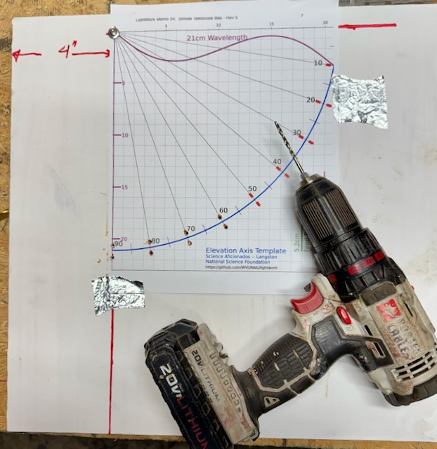
The elevation mount is 10-inches wide and must fit between the vertical arms of the base. The elevation mount is centered on the bottom of the base. So, mark the center of both sides of the base, then measure +/- 5-inches from the center and draw two lines. The vertical parts will sit just outside these lines, shown in Figures 3 and 4.
Figure 6: Make the protractors on the left side. The template is on the lines drawn the taped in place. Use the 1/8-inch drill bit to put guide holes at the top left and at each of the red marks on the template. These are separated by ½-inch.

Make Right Vertical Arm
One of the vertical parts of the base is narrow and is made from two 16-inch sections of a baluster. Balusters are usually pressure treated, so can be used outside without painting. Use a baluster that about 1.25-inches square in cross section. Cut one 16-inch baluster in half diagonally, so that you have two equal pieces a little over 8 inches long. Aline the bottoms, the drill holes on sides with 1/8-inch drill bit. Then attach to make single vertical piece. See Figure 5.

Make Left Vertical Protractor.
The left vertical arm is constructed from a 16x16-inch square cut from shelving and painted. Draw a vertical line 4-inches from the left edge. The draw a horizontal line ¾-inches from the top.

For all holes we will drill, pre-drill all holes using a 1/8-inch drill bit. Using a small drill bit first makes it easier to accurately place parts. The reference point is where the two lines cross. Drill through the template and board, at the top left, reference point. See Figure 6.

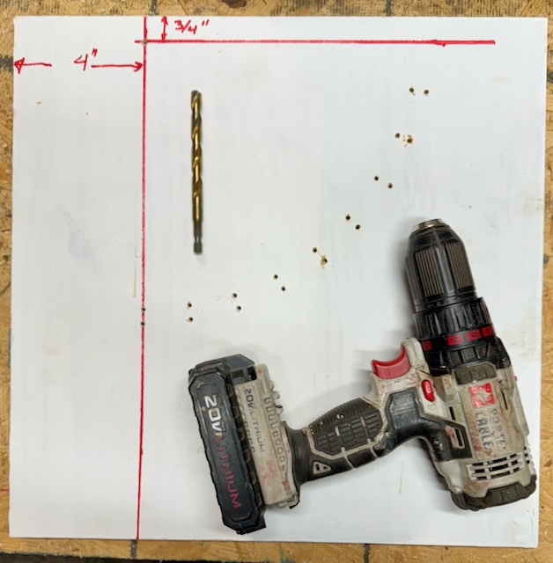
A protractor is used to measure angles, and we are creating a big protractor to set the elevation angle of our telescope. We’re making alignment slots every 10 degrees in elevation. Straight up is 90 degrees elevation and horizontal is 0 degrees.
Figure 7: Pilot holes are drilled. Remove the template. Next, take a 3/8-inch drill bit and re-drill each of the pilot holes. The pairs of holes at each angle should connect, by tilting the drill bit along the line towards the top left corner.

When you’re making observations, you must write down the elevation of the telescope, so that we can calculate where the telescope is pointed. To make this easier, we usually only point the fixed base either due North or South. Our Earth rotates around once a day, so with the telescope at a fixed angle, we see hydrogen from a strip of the sky in 24 hours.

Often, we leave the telescope outside for one whole day, recording the signals from the sky. The next day we pick a different elevation to continue our experiment.

Print the protractor template (at 100%!, don’t shrink to fit) to easily mark every 10 degrees of elevation. The template is in the Appendix and at the WVURAIL Elevation Template link. The hydrogen wavelength is 21.12 cm long.

Tape the template to the two lines drawn on the side. The top left should be exactly aligned with the crossing of the 4-inch and ¾-inch lines.
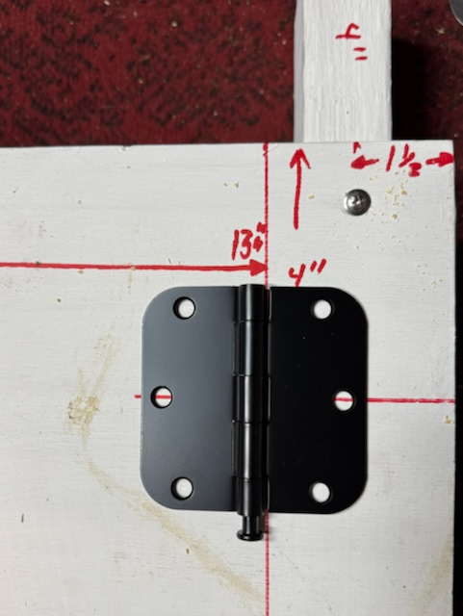
Figure 9: The front hinges are centered 4-inches from the front of the base. Aling the center holes. Drill and attach with screws to the left side of hinge.
Then drill holes at each of the two red marks on the template, marking the angles. See Figure 6.
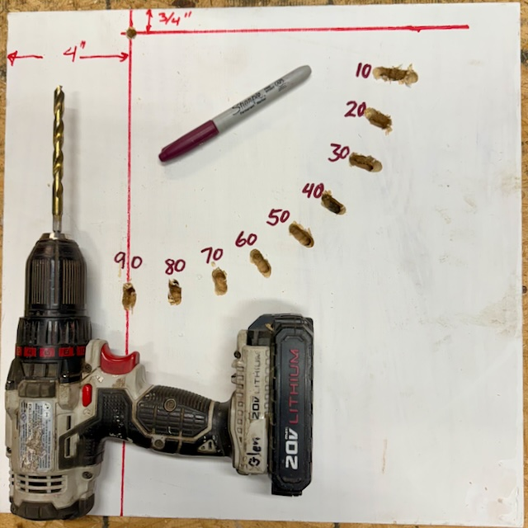
Figure 8: Protractor drilled. Use a permanent marker to add the elevation angles. 90 degrees is at the bottom, for a telescope pointing straight up.

The top left hole is for the bolt acting as hinge for the elevation axis.
Now we drill wider holes for the ¼-inch bolts we use to hold the elevation mount in place. Figure 7 shows the pilot holes drilled and the 3/8-inch drill bit we next use to make the slots to set the elevation angles.

Figure 8 shows the completed protractor for the left side of the base. Write the angles with a permanent marker.

Add Vertical sides with Hinges
We use hinges to hold the sides that attach to the telescope elevation mount because they are strong, adjustable and allow the base to fold to a smaller size for storage. The door hinges come in sets of three, and include screws, so are a little cheaper than other alternatives.

The two arms must have the same height for the bolts acting as the elevation axis. Align the right arm, made of a baluster, to the left arm (protractor) and drill a hole in the top of the baluster at the same height as the reference point. Again, pre-drill first.

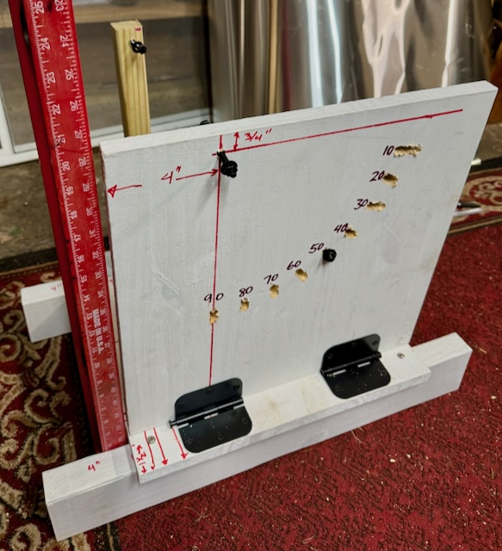
The two front hinges are both placed on a line 4 inches from the front of the base. We use 3.5-inch wide door hinges, but 3 or 4-inch wide hinges would also work.
Figure 10: Protractor side of the base, with hinges screwed in place.

Figure 9 shows the alignment of the right hinge before screwing it to the bottom. The red line is seen through both sides of the hinge, so the hinge is properly aligned. The right arm is outside the hinge.

Attach Right Side with Hinge
The right arm is going to fold left, so put the hinge axis inside the right line. Align center holes with the line-4 inches from the bottom edge. Pre-drill the 3 holes on the right side of the boot, see Figure 9, with 1/8-inch drill bit. The screw the hinge to the bottom.

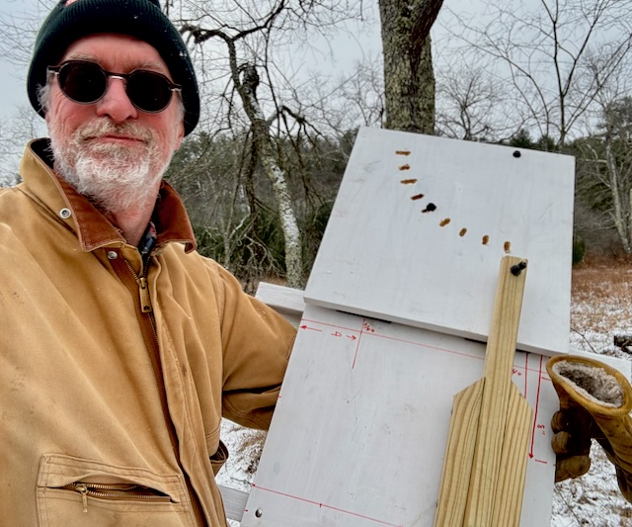
Next, stand the hinge up and attach the right arm, again pre-drilling, then attach the right arm with three more screws.
Figure 11: Glen Langston carrying the folded base to the telescope location. The base is light and transportable.

Attach Left Arm, the Protractor, with 2 Hinges
Figure 10 shows the protractor side attached with two hinges. Align the front hinge with the line 4 inches from the front of the base. The back hinge is aligned with the line 4 inches from the back of the base. Hold the protractor in place, with 10-inches between the sides. Push the front hinge against the protractor side and pre-drill the holes for the hinge. Screw the left front hinge in place.

Attach the other side of the hinge to the protractor. The red vertical line on the protractor should align with the center hole of the hinge.

Attach the rear hinge in the same way. Again, make sure the protractor is outside the 10-inch spacing line.

Figure 11 shows Glen Langston carrying the folded telescope base out to the telescope location. The telescope, base and computer will be outside for months, recording the sky for Hydrogen from the Milky Way, and watching for flashes of radio waves from cosmic rays. With some software you can make a radio picture of the whole sky.

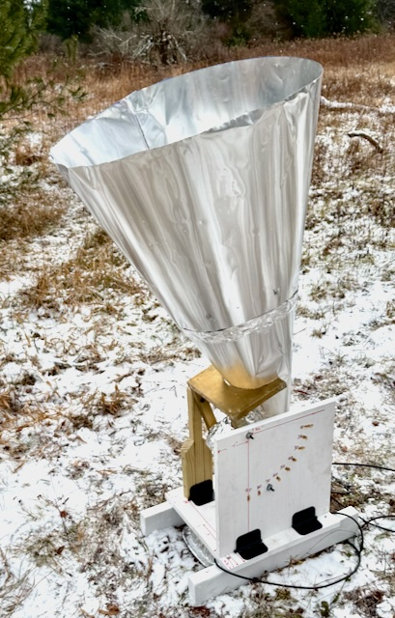
Conclusion
Figure 12: The completed base with double sized cone radio telescope, Because the base is wide and low, it is stable. But it does not hurt to put a concrete block on the base, in case of high wind.
We hope you’ve found it fun and easy to build a radio telescope base. Because this base allows you to easily set the telescope pointing directions, you can discover features of our Milky Way Galaxy, and the motion of the Earth around the sun. An example completed telescope is shown in Figure 12.

Your horn telescope and software so sensitive that you can easily see our Galaxy. With minutes of observations, you can start to discover our galaxy. With your telescope, you can measure the Earth’s motion around the Sun, measured relative to the Milky Way. You can also measure the drift of our Solar System within the Milky Way and estimate how fast we’re orbiting the Milky Way.

We hope you will write up your discoveries and submit Lightwork memos. Email me if you have questions or suggestions for improvements. With a Radio Telescope, you’ll always have Clear Skies. See the Universe from your own back yard!

Thanks to my family and friends for their support for this project.

More Helpful Hints

There are a wealth of activities and experiments on the radio telescopes. GnuRadio Companion (GRC) is fun-to-use visual programming tool. There are many guides online for using different aspects of GRC (see Introduction to GnuRadio for instance). For background on Radio Astronomy see: Short Introduction to Radio Astronomy).
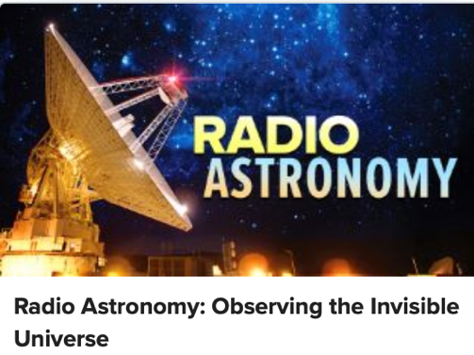
Dr. Jay Lockman provides an excellent video Great Course on Radio Astronomy. He explains what we know about the invisible universe.

For a very short, and enjoyable, introduction to GRC take a look our YouTube “Nsf Listens” video (https://bit.ly/2HsFndr).

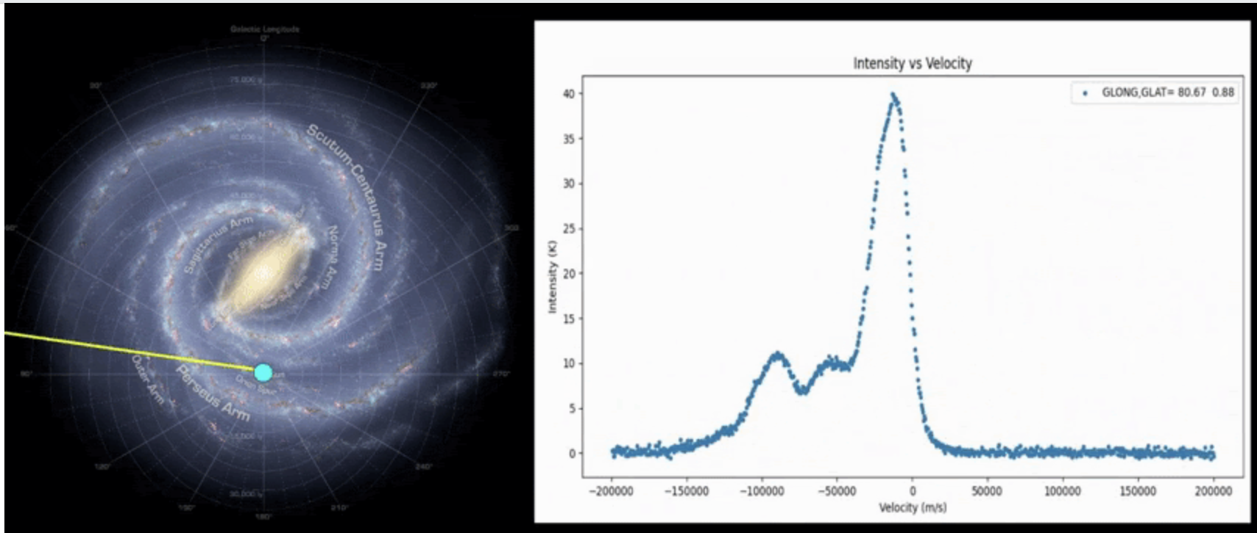
After you’ve built the horn and base, you can setup for telescope to scan the Milky Way. Science teacher David Shultz as done great job of showing how peaks in the plot of horn observations find Milky Way spiral arms.
Figure 13: One observation with horn radio telescope. (left), shows hydrogen intensity on the Y axis versus speed on the X axis. On the right is the coordinate in the Milky Way. This coordinate was measured from the telescope azimuth, elevation and time of the observation.

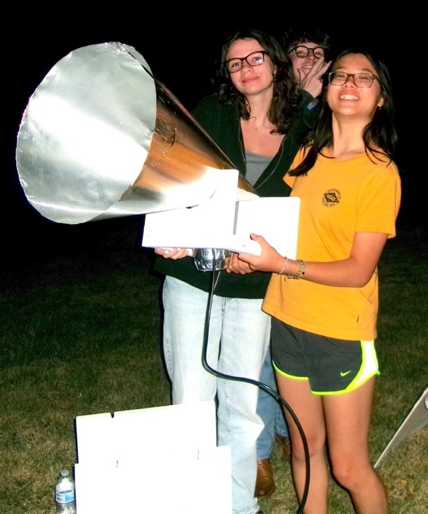
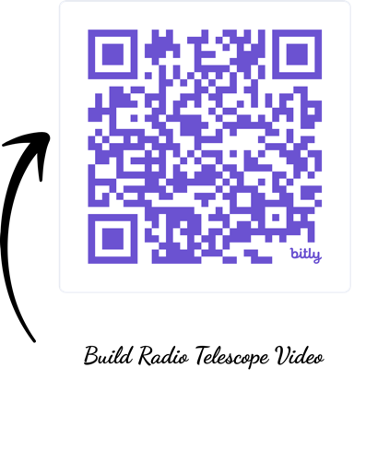
Figure 13 shows one of Dave’s student’s scans of the Milky Way, discovering several spiral arms.
Watch Students build a Radio Telescope on YouTube
2024 Green Bank Summer students Kait, Sophia and Austin with Cone Horn Telescope, 30” tall, on elevation mount.

