Subject: Event Detection: First Light with 4 Horns
Memo: 27, Revision 3
From: Glen Langston, Kevin Bandura, Nathaniel Langston, Pranav, Sophie, Evan, Sue Ann
Date: 2021 February 2
Summary: Short duration (< 1 microsecond) radio flashes are detectable with home built radio telescopes.

This note describes the first detection of short duration radio flashes with student/home built radio telescopes.

Memos showing how to build Horn Telescopes are at:
http://github.com/WVURAIL/lightwork and https://rail.wvu.edu/dspira/

Background
We’ve built radio telescope horns for observations of the Milky Way. The simple design of these telescopes enables hobbyists, high school students and teachers to construct and operate the telescopes. Ideally these horns can be built by teams of school groups. Once built, students can quickly map our Milky Way galaxy and also detect transient events caused by cosmic-rays striking the Earth’s atmosphere.

We setup 4 horns, aligned east-west and separated by 10 feet between each telescope. The Telescopes, shown in Figure 1, were set at fixed elevations, all pointing south.

First analysis
The computer clock precision on the telescope host computers, Raspberry Pi 4B , with 4 GB of memory is measured to be roughly +/- 5 milli-seconds RMS. This is true when providing a GPS based time signal to a host computer and using the Network Time Protocol (NTP) to set the clocks on the individual Pis.

The events are considered simultaneous when occurring within 40 milliseconds of clock time.
For reference there are 2,160,000 forty millisecond intervals in a day. Since the horns are finding roughly 200-400 events per day, it is unlikely that the events found within the same interval are not due to internally generated noise. are not in some way connected if found simultaneously in the intervals. To estimate that one horn determines 400 randomly selected time bins. Then the odds of another horn seeing another random event is the same bin is 400/8640000 or 1 in 21,600. So if 400 more random, unrelated events were found by another horn, then the odds of simultaneous events would be 400/21,600, or one in 54 chance.

Conclusion

Thanks to my family and friends for their support for this project.
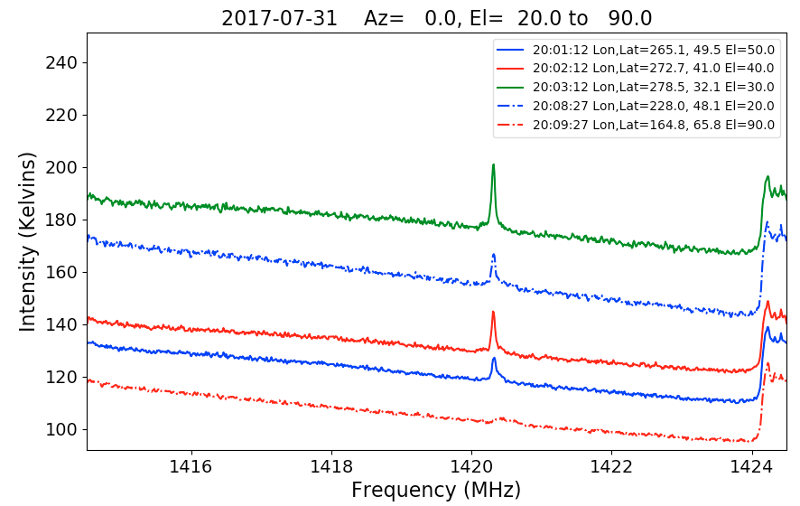
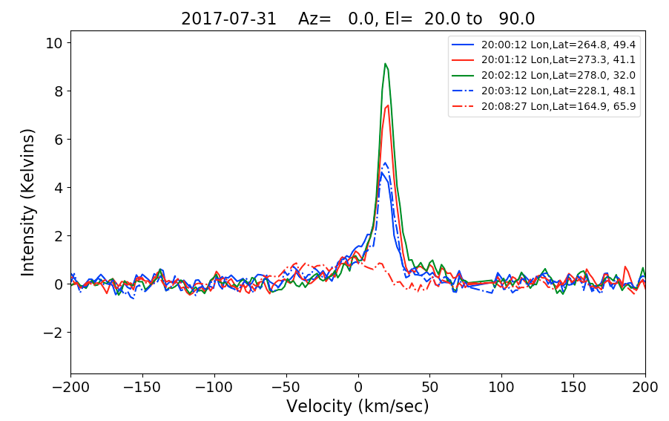
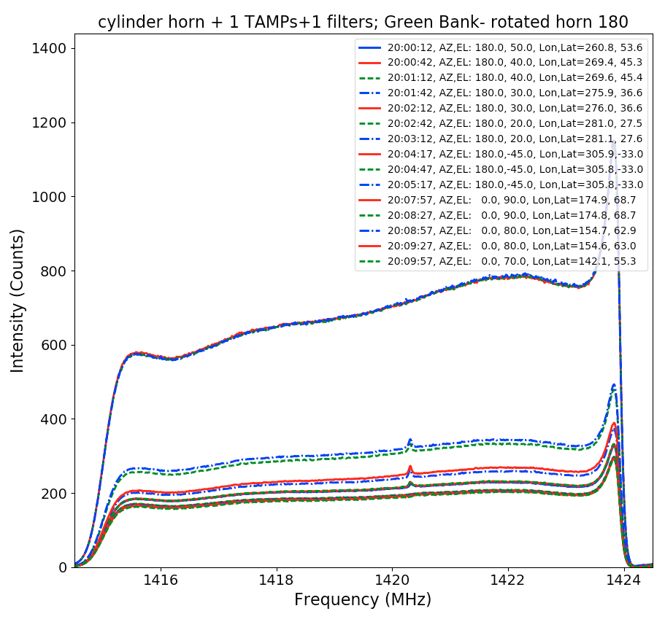
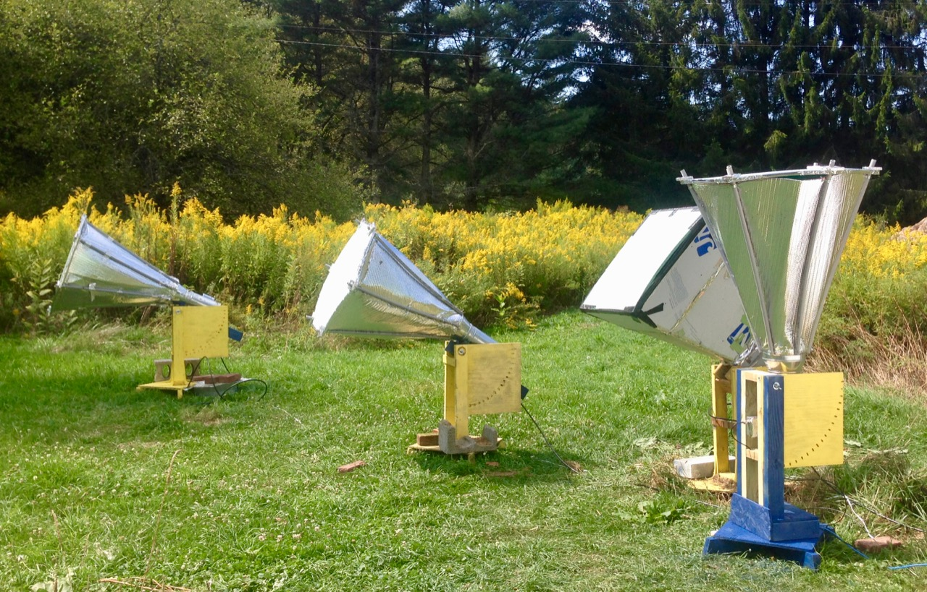

Figure 1: Four radio telescope horns all simultaneously observing different elevations on the sky. These horns each have an aperture area of roughy 0.5 m²

