Subject: Measurement of LNA Noise Temperature, T_{rx}, using different SDRs
Memo: 28, Revision 7
From: Glen Langston
Date: 2021 January 26
Summary: A critical need of every sensitive radio telescope is as low as possible an effective noise temperature, T_{rx}, of the first amplifier. The lower T_{rx}, the better, and low-cost commercially available amplifiers are now providing high gain with noise temperatures below 100 Kelvin, roughly -290 F. We present a relatively simple test of the GPIO Labs HI (1st) LNA performance, demonstrating how the measurements are made. The test was performed with our Science Aficionado Computer box and three different SDRs. The GPIO Labs HI has good performance with a measured, 91 +/- 2 Kelvins effective temperature. The measurements using three different SDRs yield consistent results. This note shows how you can repeat the measurement process.

Background
This memo is intended to ease first observations of our Milky Way Galaxy, by confirming good performance of the 1st amplifier before beginning observations. Our Science Aficionados are generally successful in building their telescopes to see the structure of the Milky Way, but when encountering technical problems need some diagnostic tests. This memo describes one test, confirming the good performance of an LNA, before starting observations of the Sky.

For these tests, the Aficionado needs a computer running one of our Radio Astronomy GNU-radio designs. Many computer configurations have been used successfully. I currently recommend the use of a dedicated small computer, a Raspberry Pi 4B. Descriptions of the computer and operating system are available as an installation guide. The operating system is periodically updated. Aficionado’s should read the latest installation guide Raspberry Pi OS Installation Guide in this on-line Raspberry PI OS directory.

The tests described here are fairly simple. These tests should be done before heading outside to make your first astronomical measurements. These tests confirm you have sufficient signal and sensitivity input to the SDR to make astronomical measurements. The 50 Ohm load (without any power), at room temperature (20 Celsius roughly 68 Fahrenheit) produces a stronger signal than you will measure from the universe, when you are using your telescope.

These tests should be run on any LNA you choose for your telescope. This test example is run using the GPIO Labs neutral hydrogen (HI) amplifier. The input signal source is a simple 50 Ohm Load, available at low cost. Figure 1 shows the GPIO Labs LNAs tested, the 50 Ohm load and the feed probe used for observations of neutral hydrogen. The probe is not used for these LNA tests.

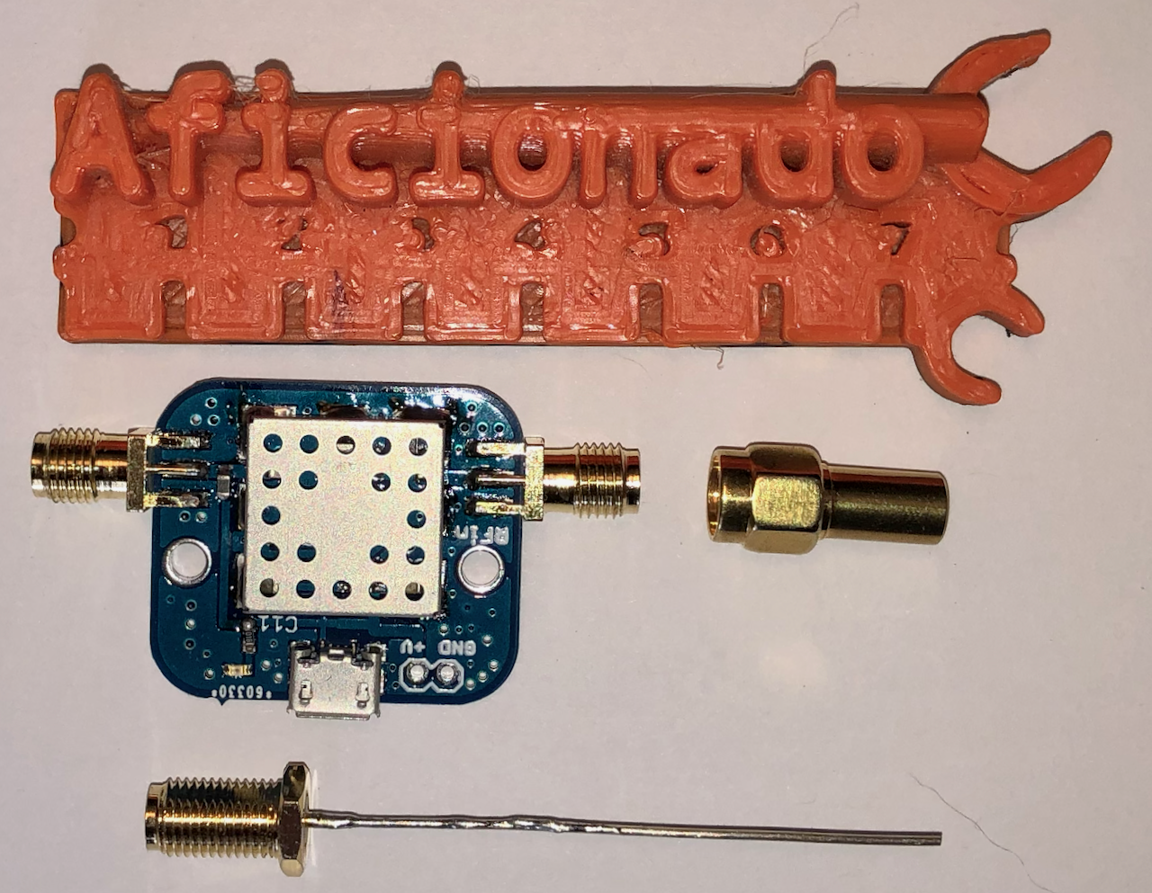
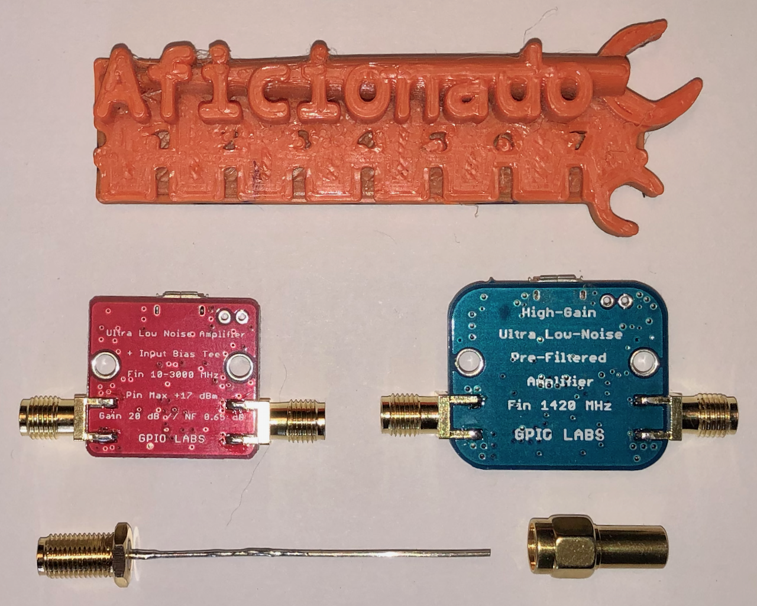
The sky is remarkably cold when observed at radio wavelengths, < 10 Kelvins (< -440 F)! The Earth’s atmosphere is nearly transparent at radio frequencies between 50 and 9,000 MHz. The main sources of signals a radio telescope sees at 1420.4 MHz are the radio telescope itself and the spiral arms of our Milky Way Galaxy, from Neutral hydrogen atoms. The 3 Kelvin cosmic microwave background, from the big bang, is a weak signal, but still significant, due to the high sensitivity of the telescopes.

Figure 1: Components for LNA Effective Temperature Test: At left, the Green Rectangle with SMA female connectors is the GPIO Labs HI amplifier (LNA). The 50 Ohm load is at right and has an SMA male connector. The size of the components is shown in comparison to an 8 cm long, ruler at top. The feed probe, below is 5 cm long, is not used for these tests, but is critical for observations of HI. The 50 Ohm load and the feed probe are input to the LNA. At right, the reverse side of two LNAs are shown. The red square shows a GPIO Labs wideband amplifier with input bias tee for powering the green HI LNA, the amplifier furthest to the right.

Because the 1st LNA makes a major contribution to the noise seen by a radio telescope, it is important to confirm the LNA is working properly and that the noise figure is actually as low as described by the manufacturer. It is also important to confirm the chain of amplifiers can increase the signals to levels appropriate for the SDRs. We repeat the measurement of amplifier noise temperature several times with each SDR and also compare the results using three different SDRs, the SDRPlay, the AIRSPY mini and the RTL-SDR.

We describe the equipment used, the measurement process and plots of the data obtained. Then we compare the measurements of the noise temperature of the amplifier, T_{rx}. We’ll conclude that the GPIO Labs Amplifier is very useful for sensitive radio astronomy research. Each of the SDRs tested may be used for astronomy, with each having different advantages and disadvantages.

Equipment Tested
The main goal of these tests was to measure the effective Receiver temperature of the first LNA of our radio telescopes. These tests used the telescope computer that is normally used for observations. Performing the LNA tests first is convenient since these tests are simpler and quicker than an astronomical observation. Figure 2 shows all the components used in the measurements presented here.

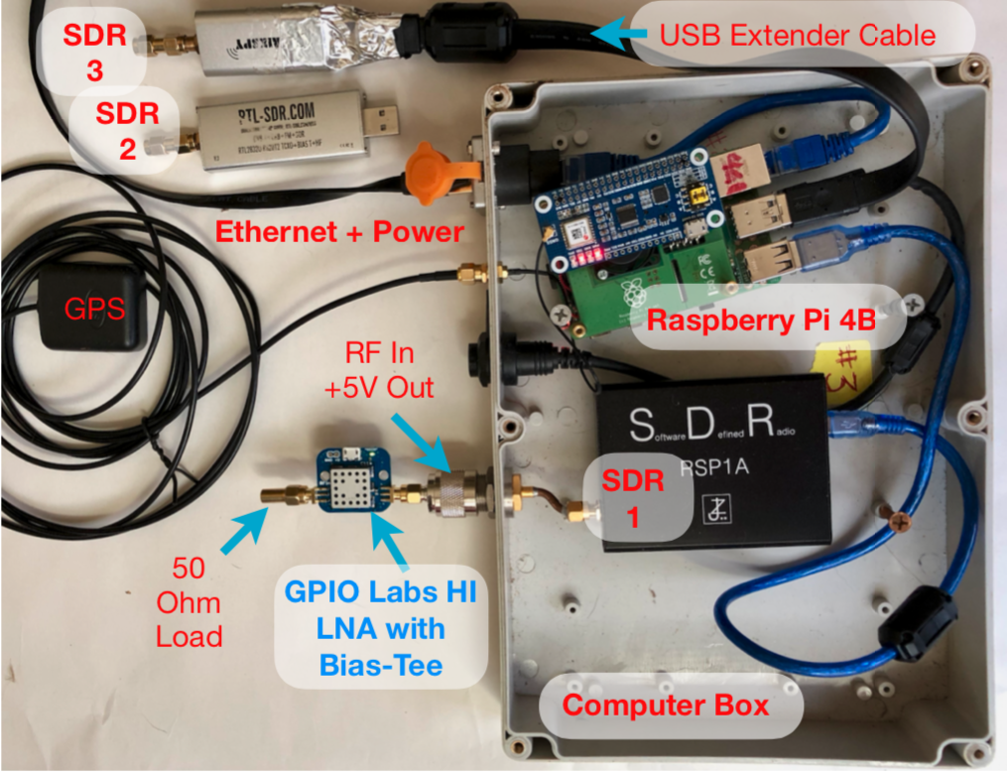
The measurements are performed by comparison of the SDR intensities measured when 1) the LNA has no input (cold) and with a (low cost) 50 Ohm Load (hot). See LightWork Memo 4, revision 3, dated 2015 July 7. This memo shows one of my very first attempts at horn telescope designs and used top-of-the-line commercial amplifiers, costing a few $100. The memo describes the measurement steps and shows some good results, with system temperature T_{sys} measurements of lower than around 150 K (remember lower is better). The system temperature measurement is the most important measurement, showing the overall performance of the telescope, including horn design and feed probe placement. The main contribution to T_{sys} is the contribution from the 1st amplifier, T_{rx}. In this memo we measure the T_{rx} contribution.

Figure 2: Image of components used in the test setup. The main component is the Raspberry Pi 4B computer inside the Aficionado computer box. The computer is fed power and data via a Power Over Ethernet (POE) cable. The Pi has 2 “hats” installed one separates the power from the ethernet connection and the other receives GPS timing signals. The GPIO Labs neutral hydrogen (HI) low noise amplifier (LNA) is shown connected to the coaxial cable port. The port provides +5V to the amplifier and is the radio frequency input to the Software Defined Radios (SDRs). A 50 Ohm load is attached to the input to the LNA.

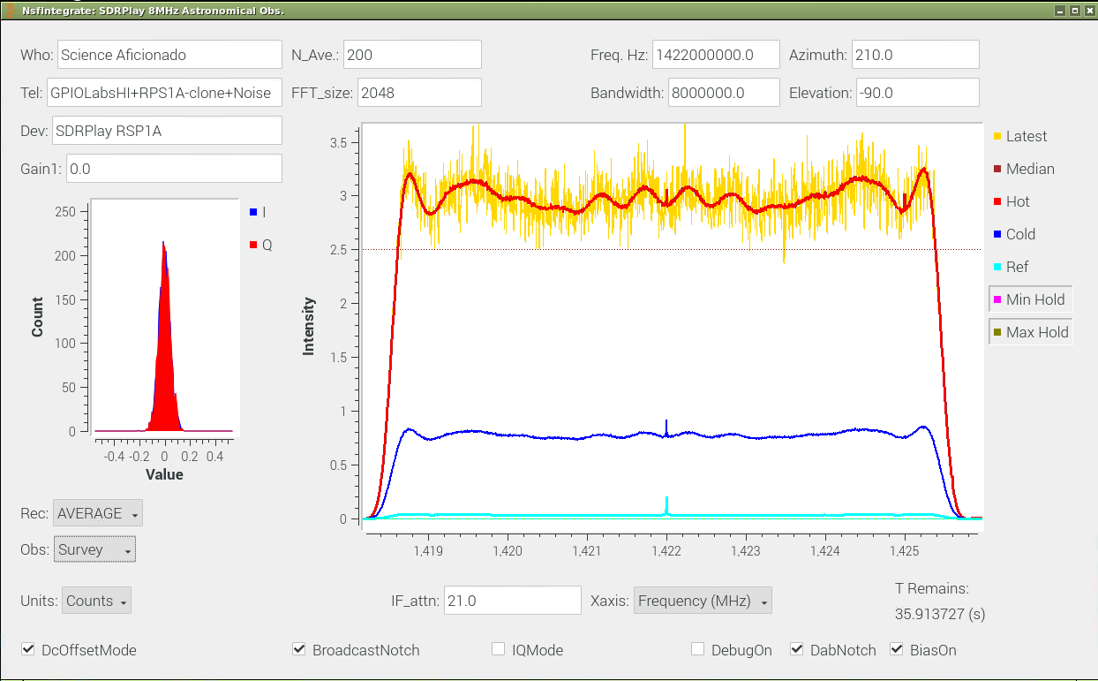
This memo will show that great results are now possible with amplifiers costing only ¼ as much. The system design is much improved and simplified.

Figure 3: Observing Interface for the Hot/Cold Load Tests. This GnuRadio interface provides the Observer with a way of selecting the test frequency, bandwidth and several averaging parameters. In this case the center frequency is 1422 MHz and bandwidth is 8 MHz using an SDRPlay RSP1A clone. The red and blue histogram plot, at left, shows the distribution of input samples. In this case, the input to the SDR is the GPIO Labs HI amplifier with 50 Ohm load attached. The larger plot, at right, shows the Intensity (in counts) versus frequency (in MHz) for plot for 5 different spectra. The gold plot shows a single input spectrum before averaging. The Red plot is the average Hot load spectrum. Because the Hot load plot had just been saved, it is on top of the Average plot. The dark Blue plot is the Cold load plot. The Ref plot (cyan) at the bottom shows the measured intensity with no amplifier attached to the input.

Test Components
The tests are done in “the lab”, i.e. my home, which includes
- Telescope Computer Box
- Raspberry Pi 4
- Power Over Ethernet (PoE) Hat on the Pi
- GPIO Labs Neutral Hydrogen Amplifier
- SDRPlay digital signal processor.
- A 50 Ohm Load (SMA Male)
- Raspberry Pi Radio Astronomy Operating System

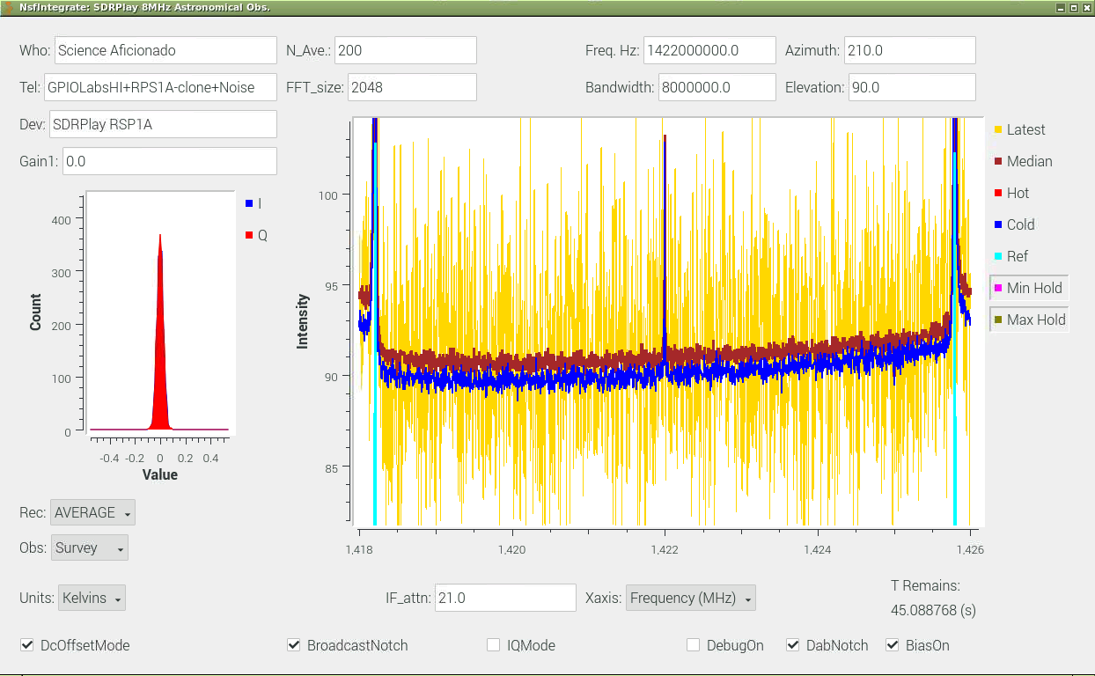
In addition to the above components, we tested additional LNAs. These tests are summarized, without supporting measurements in the conclusions section. We also compared the measurements with three SDRs.

Figure 4: Calibrated (Kelvins) Receiver Temperature (T_{rx}) measurements using the same observing interface as shown in Figure 3. The plot shows calibrated Intensity (Kelvins) versus frequency in MHz over the 8 MHz bandwidth of the SDRPlay observations. The Gold plot shows a single input spectrum before averaging. Dark Blue plot shows the first measurement of T_{rx} (ie the Cold Load signal). The Maroon plot shows the second measurement of the T_{rx}. The average value is 90 +/- 1 (K) for the first measurement and 91 +/- 1 for the second. There is a slight curvature to the plot. The spike feature at the center is internal to the SDRPlay. The features at the edges are also due to the electronics and should be ignored. Excepting these features, the central part of the calibration is excellent.
- SDRPlay (Using 8 MHz bandwidth)
- AIRSPY Mini (Using 6 MHz bandwidth)
- RTL-SDR (Using 2.4 MHz bandwidth)

Figure 2 shows that during the measurements we also had a GPS HAT installed on the computer box. The GPS is not needed for the LNA measurements but is very valuable for astronomical observations. The USB extender cable is also not normally needed as only one SDR is in the computer box. The SDRs directly plug into the Pi.

Note that there are no monitors, keyboards or mice attached to the Raspberry Pi. All the control of the Pi computer was done using a Virtual Network Connection (VNC).
I have a laptop on my Ethernet network and used VNC to login to the Pi and record the measurements. The operating system starts the Pi with VNC automatically running after each reboot.
The VNC configuration is good for running multiple telescopes in your network. Also by using VNC you can work with student astronomers world-wide. I often share my telescope observations by letting others log into our system.

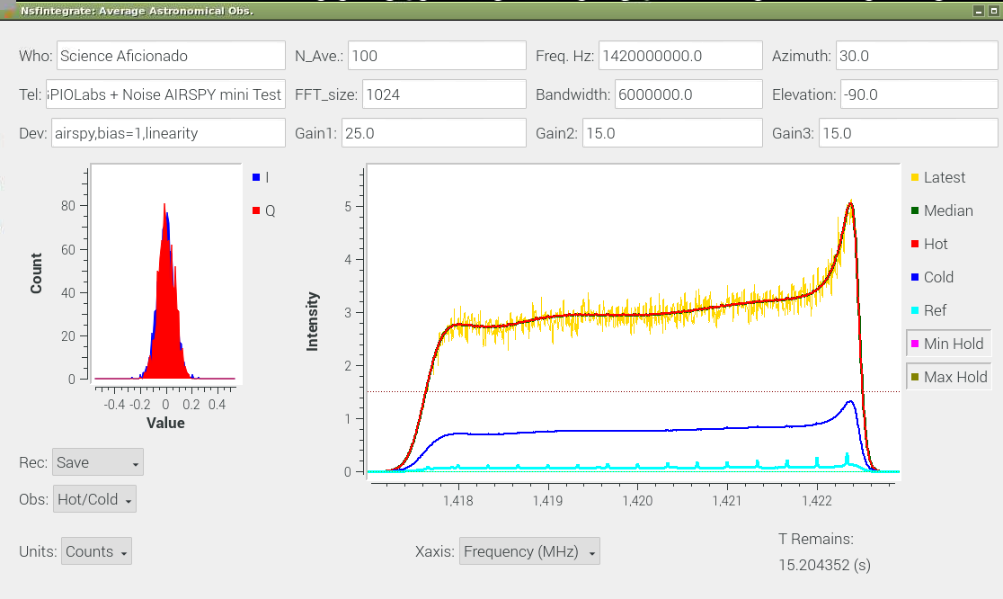
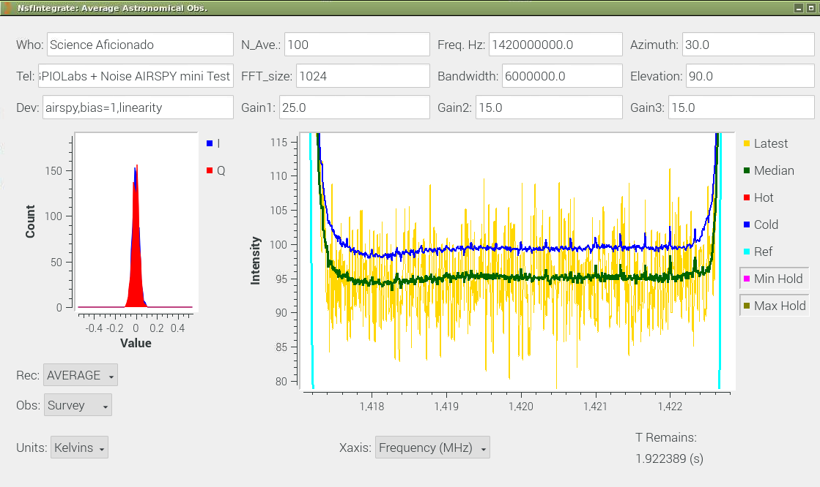
Test Goals

Figure 5: The Raw and Calibrated plots of the T_{rx} measurements with an AIRSPY mini, similar to those shown in Figures 3 and 4. At left is the plot of the raw data Intensities, in counts versus Frequency, in MHz. The 6 MHz band pass shape is characteristic of the AIRSPY mini. At right is a plot of two measurements of T_{rx}, calibrated in Kelvins. The measurements show similar, but slightly higher temperatures. The first measurement is 100 +/- 2 K and the second measurement is 95 +/- 2 K. The differences are likely due to amplifier gain changes during the measurement. The AIRSPY was not given much time to warm up and temperature stabilize before these measurements. Some internally generated RFI is seen in the calibrated spectra.
The first test goal is to confirm that the 1st LNA has sufficient gain to provide strong input to the SDR. The telescopes will detect remarkably weak signals from our Milky Way. Most key parts of the radio telescope are tested. If successful, these tests show the gain of the LNA is sufficient and the equivalent noise temperature of the LNA is low. You can make excellent observations of the Milky Way quickly and easily, if the effective LNA temperature is below 120 Kelvin. Good observations can be performed if the LNA has an effective temperature of less than 300 Kelvin. Note that if your telescope has almost any level of gain and effective noise temperature observations are possible. However, observations will take much longer if the LNA noise temperature is high or if the horn and feed probe gains are low.

The software is all available online, from github.com, as a part of the West Virginia University Radio Astronomy Instrumentation Lab (WVURAIL). See the installation guide for how to install and use the software.

The test uses a Raspberry Pi computer running one of the “NsfIntegrate??” programs to control the SDR record data with a Hot Load (the 50 Ohm Load) and a Cold Load, in this case, no input.

The real-time (NsfIntegrate??) software assumes room temperature for the Hot Load, 290 Kelvins (=71.3 F) and a Cold Load temperature of 10 Kelvins (= -441.7 F). The Hot Load effective temperature is probably close to room temperature. The Cold load temperature is probably an underestimate. For the purposes of confirming the amplifier is working, these estimates are sufficient. LightWork Memo 5 describes the Hot/Cold Load measurements and data processing.

Test Procedure
Once all the equipment is set up, then the tests are fairly simple. Here are the test steps:
  - Connect all the devices to be tested and turn on the Telescope Computer
  - Login to the Telescope computer via VNC on your home computer.
  - Start a terminal window on the Telescope computer.
  - Start the NsfIntegrate?? program appropriate for your SDR.
    - For the Airspy (10MHz), run NsfIntegrate100
    - For the Airspy Mini (6MHz), run NsfIntegrate60
    - For the PlutoSdr and 4.5 MHz samples, run NsfIntegrate45
    - For the SdrPlay and 8 MHz samples, run NsfIntegrate80
    - For the NooElec or RTL-SDR with 2.4 MHz samples, run NsfIntegrate24
  - Attach the 50 Ohm Load to the input of the LNA
  - Set the Telescope Elevation to -90, which notes a Hot observation
  - Set the Nave parameter to about 100, to average 100 “medianed” spectra. Each of these programs “medians” 1024 spectra before sending this spectrum to the plotting program. This reduces the systems sensitivity to short term interference.
  - Start Spectral Averaging, using the pull-down menu on the left. (See Figure 3
  - Wait for 4, or so, spectra to be written out. The command line will show a list of spectra written, this will take 5 to 10 minutes.
  - Switch the Observing type to “Hot/Cold”. The plot should change, as a red (hot) line will appear over the average spectrum.
  - Pull down the Record mode to “Save”. After a few seconds the Hot load will be saved as a file.
  - Now set the Observing mode to “Survey”
  - Set the Record mode to “Wait”
  - Change the elevation to + 90, which tells the system this is a cold load measurement.
  - Remove the 50 Ohm load from the input to the amplifier.
  - Set the Record mode to “Average”
  - Wait for 4 or so spectra to be averaged.
  - Set the Obs mode to “Hot/Cold”
  - Set the Record mode to “Save”
  - After a few seconds a Cold.ast file will be saved. Your calibration is complete. The observations are saved in the data directory. You can also see the results immediately.
  - Set the Obs Mode to “Survey”
  - Set the Record mode to “Wait”
  - Set the Units mode to “Kelvins”. The plot of receiver temperature vs frequency will appear. Every few seconds a new print out of minimum, maximum and median receiver temperature will be printed in the terminal window. You should consider the median receiver temperature the most reliable estimate of the sensitivity of your amplifier.
  - Done!
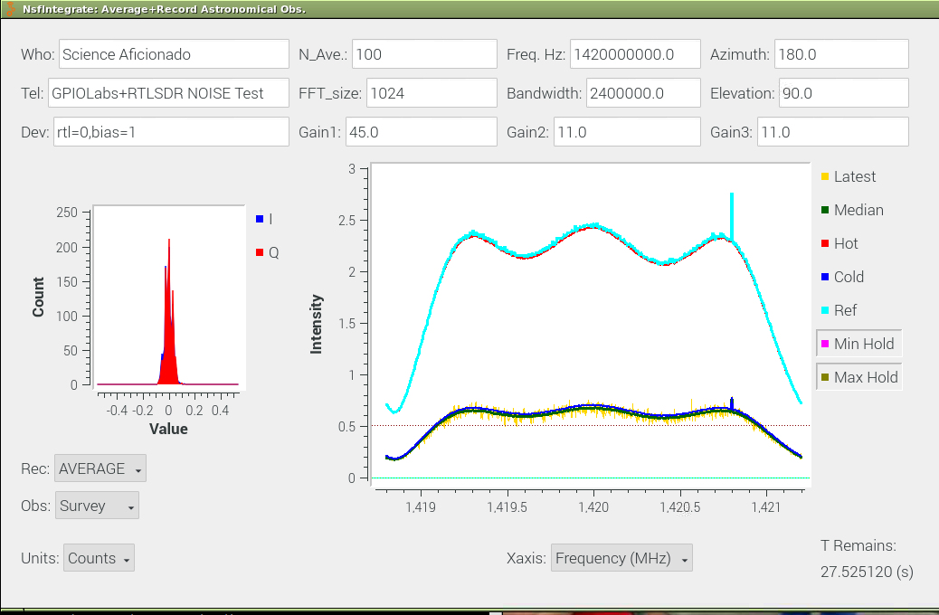
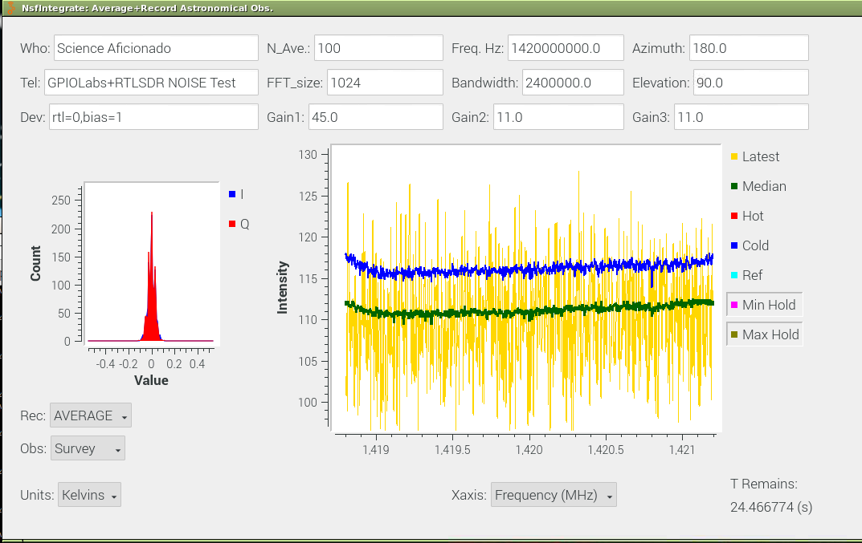

Figure 6: The Raw and Calibrated plots of the T_{rx} measurements with an RTL-SDR, similar to those shown in previous figures. At left is the plot of the raw data Intensities, in counts versus Frequency, in MHz. The 2.4 MHz band pass shape is characteristic of these low cost SDRs. At right is a plot of two measurements of T_{rx}, calibrated in Kelvins. The measurements show similar, but slightly higher temperatures. The first measurement is 112 +/- 2 K and the second measurement is 116 +/- 2 K. Again, the differences are likely due to amplifier gain changes during the measurement. The low cost SDRs have only 8 bit samplers. This introduces some noise into the measurements, potentially increasing the measured T_{rx}

SDRPlay + GPIOLabs HI

We have 4 radio telescopes operating day and night (for months at a time). All have SDRPlay RSP1A SDRs (both original and clone versions). The results are good for each of the 4 horns, even though we use different amplifier combinations. If starting out again, I’d recommend the GPIOLabs HI amplifier and a clone version of the SDRPlay RSP1A. The clones have the advantage of being in a smaller metal box than the original. The clone has a higher power bias-tee, allowing the GPIOLabs and NooElec HI amplifiers to be powered without an additional bias-tee. The original RSP1A, while of very good quality, does not have sufficient power to use the NooElec HI amplifier alone. For the original RSP1A, you must add a bias-tee to the computer box to power the amplifier.

Figure 3 shows the observing interface while making the measurements. The computer interface, created with the marvelous GnuRadio Companion tool, and some custom software I wrote, has two plots. The plot at left is a histogram of the input samples from the SDRPlay. The power level of the input signal is correct when most of the samples cover the range of +/-0.1. The SDRPlay device has several amplifiers and also attenuators to reduce the signal. By setting the first gain to 0, this configures several amplifiers to give the maximum gain at 1420 MHz. The second gain setting is for reducing the power level, by many dB of attenuation.

Figure 4 shows the measurements of Trx as a function of frequency over the 8 MHz bandwidth. This is shown while the observations are running by selecting the plot units of “Kelvins”. The design of the SDRPlay allows no less than 20 dB of attenuation, with as much as 60 dB. The GPIOLabs HI amplifier has just enough gain for this combination. For these tests we used a 21 dB attenuation level, one less than the minimum allowed.

We repeated the tests a couple times and found good consistency in the results. For this combination the T_{rx} value is 91+/-2 K, which is very good.

The 8 MHz bandwidth of the SDRPlay is sufficient for galactic radio astronomy. When running at 8 MHz a Raspberry Pi 4 can keep up with this data rate.

AIRSPY-mini + GPIOLabs HI
These tests were also performed with two other SDRs. Figure 5 shows the AIRSPY mini tests with 6 MHz bandwidth. The same GPIOLabs HI amplifier was tested, to confirm the measurements are not strongly dependent on the SDR used. Both the raw and calibrated observations are shown in this figure. The gain settings are different for the AIRSPY and the SDRPlay as the amplifier designs are different.

The AIRSPY has 3 amplifiers to control. The GnuRadio software for controlling the AIRSPY has changed in the years I’ve been using the AIRSPY and I no longer completely understand the best method for setup. However, through experiment we’ve found a reliable way of getting good consistent results. First, set all three amplifier gains to 0. The histogram plot will show all samples are now zero. Second set the 2nd amplifier gain to 15. Next set the 3rd amplifier gain to 15. Finally set the 1st amplifier gain to 25. For the GPIOLabs HI amplifier you’ll have a good power level for the measurements. For different amplifiers you will set the 1st amplifier gain to different levels.

The performance is good with this combination. The AIRSPY-mini with GPIOLabs amplifier yielded 98 +/- 4 K T_{rx}. You can perform very sensitive radio astronomy observations with this combination.

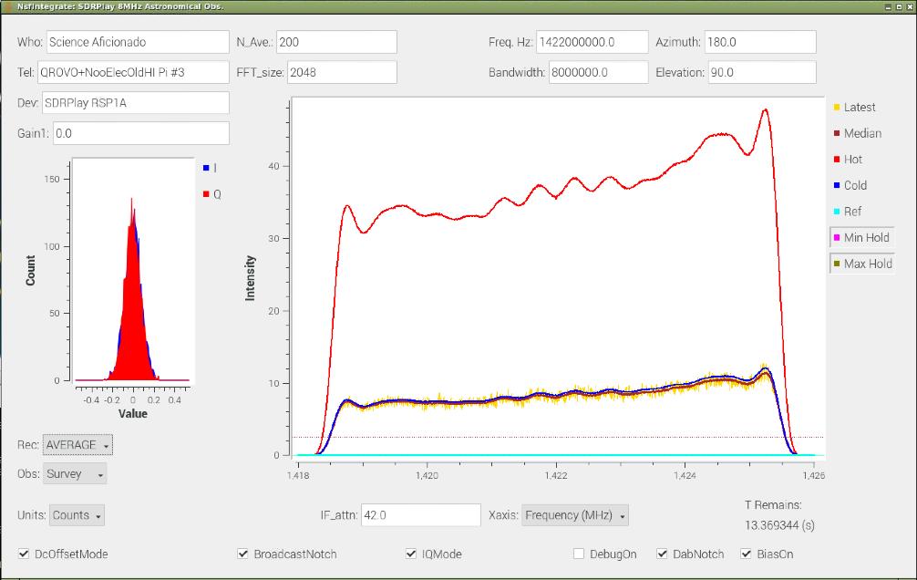
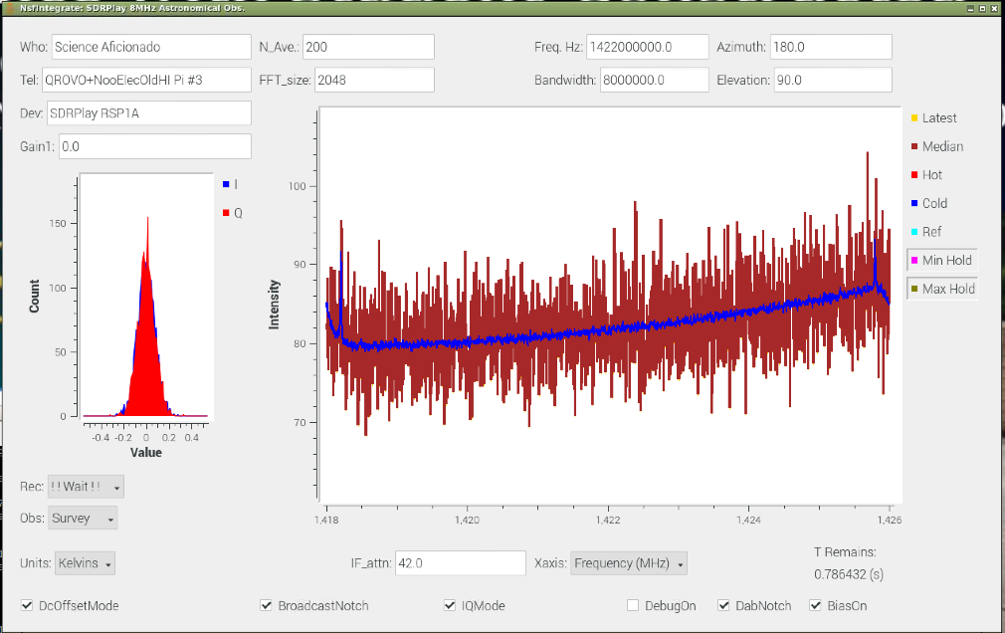
RTL-SDR + GPIOLabs HI

Figure 7: The Raw and Calibrated plots of the T_{rx} measurements for the QORVO amplifier and SDRPlay, similar to those shown in previous figures. At left is the plot of the raw data Intensities, in counts versus Frequency, in MHz. Notice how many more counts are seen with the hot load (top) compared with the cold load (bottom), indicating a very low Trx. At right is a plot of T_{rx}, calibrated in Kelvins. The dark blue line shows the measurement of average Trx and the thicker, noise measurement is a single spectrum. The measurements show a lower temperature 82 +/- 2 K.

The final test is with the low-cost RTL-SDR dongle which is available in a number of forms. The NESDR SMArTee SDR version is advertised to have the highest quality amplifiers and precision timing. This SDR has the simplest amplifier, a single very high gain amplifier with gain from 0 to 47 dB of gain. You must also turn on the bias-tee. The configuration is shown in Figure 6.

The measurements yield good results, with higher Trx, probably due to the 8-bit sampling of the SDR. The maximum usable bandwidth is 2.4 MHz. The RTL-SDR with GPIOLabs amplifier yielded 114 +/- 4 K T_{rx}. This is sufficiently sensitive for radio astronomy observations. The 2.4 MHz bandwidth is a bit too narrow to see all the hydrogen emission from the Milky Way, but is not too bad for such a low cost SDR!

Test Summary
We found that the GPIO Labs HI amplifier worked well with all 3 SDRs tested. We found that the combination of SDRPlay and GPIO Labs HI amplifier yielded the lowest receiver temperature, T_{rx}. This is my recommended system. The repeatability of the measurements was good with each SDR. The amplifier gain variations in the GPIOLabs are not thought to be a big contributor to the differences in measurements. This could be further checked by multiple cycles of tests.

Test of QORVO TQP3M9036 Amplifier + SDRPlay
As a final test, we configured a pair of amplifiers to get a very low noise system. The QORVO TQP3M9036 Amplifier works over a very wide frequency range, 50 to 2000 MHz. It is advertised as an ultra-low noise amplifier, with a noise figure of 0.38 dB at 1500 MHz. The noise figure is an unusual measurement unit (at least to me). The basic idea is that a device at room temperature (290 K) that reduces the signal by some number of dB, will also increase the noise temperature some amount. There are several noise-figure-temperature calculators online. For this low noise figure, the expected Trx is very small, only 27 K. 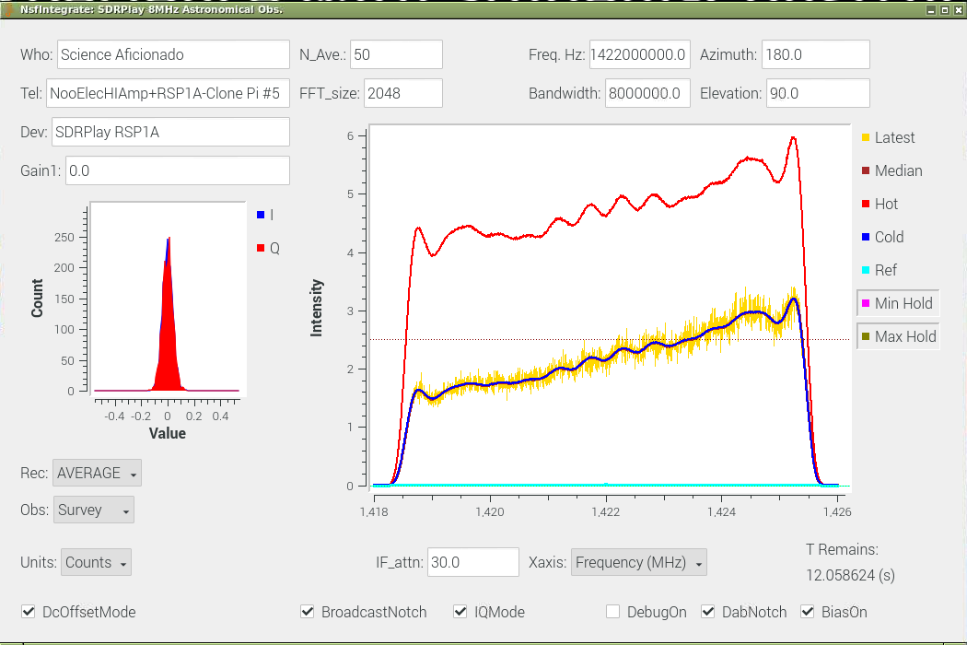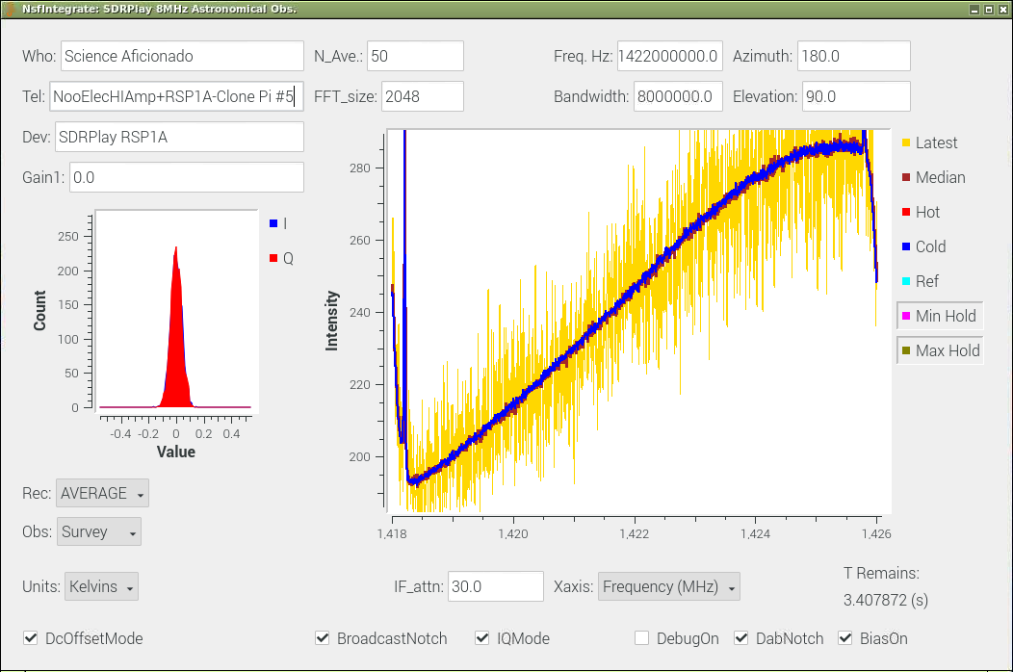

Figure 8: The Raw and Calibrated plots of the T_{rx} measurements of an NooElec Neutral Hydrogen (HI) Amplifier. At left is the plot of the raw data Intensities, in counts versus Frequency, in MHz. . At right is a plot of two measurements of T_{rx}, calibrated in Kelvins. These tests were performed with both an SDRPlay RSP1A (original) and SDR RSP1A Clone. Both SDRs gave similar results. The NooElec has a significantly higher noise temperature, 180 to 280 K. These temperatures correspond to a noise figure of 2 to 3 dB for the NooElec HI amplifier in this frequency range. Compare this figure with Figures 3 and 4. We estimate Trx = 230+/-50 K.

We used the amplifier mounted on an evaluation board ($66) and then followed by a NooElec wideband amplifier ($35). This amplifier has an excellent feature that the DC voltage is available as pins on the early version of the amplifier. That is convenient for powering the QORVO amplifier board. Figure 7 shows the QROVO test measurements and results. The system temperature is indeed lower, 82+/-2 K, but at a cost of about twice the price of the GPIOLabs HI amplifier.

NooElec HI Amp and SDRPlay Clone
We also tested the newest NooElec HI amplifier with both the SDRPlay RSP1A and an SDRPlay RSP1A Clone. Both SDRs yielded similar results. The test measurements are shown in Figure 8. Note that the signal level of the hot load (top) is about a factor of two higher than the cold load (no input) middle. The lowest curve (cyan) is without any amplifier attached to the SDRPlay. Note that these measurements show a fairly strong sensitivity gradient across the 8 MHz bandwidth of these observations. We estimate the Trx is 230 +/- 50 K.

The NooElec Amplifier does enable measurements of the Milky Way. However, these measurements would require about 4 times the observing time as using the GPIOLabs amplifier. The manner in which I’ve been observing the Milky Way, by letting the sky drift overhead, this sensitivity does not make too much difference.

Also note that the SDRPlay RSP1A clone is just sensitive enough to make observations of the RSP1A noise figure without any first low noise LNA. Without any input amplifier, we measured the effective noise figure of the SDRPlay clone. The measurements are very uncertain, but show a noise figure of 17+/- 2 dB, corresponding to an effective temperature of 14000 Kelvin. Without a first LNA none of the SDRs tested are sensitive enough to observe the Milky Way.

The first version of this amplifier (NooElec barebones), has an interesting calibration feature that could be very valuable for astronomy, but significantly adds to the Trx value, coming in at roughly 350 K. The NooElec HI amplifiers have an excellent band pass filter, reducing RFI, is low cost, and is readily available.

Miscellaneous Notes
We performed many other measurements and have lots of data. Maybe in the future we’ll get these written up. Prof. Kevin Bandura, at West Virginia University, designed a special purpose amplifier for radio astronomy. This has excellent performance, with roughly 85 K Trx. The good performance is due to his careful design, with three sensitive amplifiers on a single circuit board. The circuit is designed with careful attention to minimizing noise from the power for the amplifiers. This board has the highest gain of the amplifiers tested. Plenty of gain for all SDRs tested. The major upside is that you get to learn soldering surface mount parts, because you must build this amplifier board yourself. This has been done by many students. The instruction guides for the amplifier and use are on his “Classroom Radio Astronomy” site. The downside for me, anyway, is that I don’t have that level of skill.

Nuand also sells a wideband amplifier, but this has too low of gain and has a roughly T_{rx} of 250 K. To use this amplifier for astronomy, at least two would be needed, and powering them becomes more complex.

I did not test the LNA4ALL amplifier, available at very low cost, because I had trouble with soldering power leads. I never used these amplifiers for astronomy, due to reliability problems.

Conclusion
We have presented a method for measuring the performance of the 1st LNA’s effective noise temperature, T_{rx}. The measurement procedure is described for the freely available software. Examples of measurements are provided for three combinations of amplifiers and SDRs.

The three SDRs tested, in combination with the GPIOLabs HI amplifier, were each demonstrated to function well as the core part of a very sensitive radio telescope. If you have the construction skill, Kevin Bandura’s amplifier provides better sensitivity and higher gain.

For those starting out, I recommend a telescope based on the GPIOLabs HI amplifier and the SDRPlay RSP1A Clone.

Good luck with all of you in exploring the universe with your radio telescopes!

Thanks to the many people working to enable astronomy for all. Thanks to the U.S. National Science Foundation Astronomy Division for encouraging these efforts.
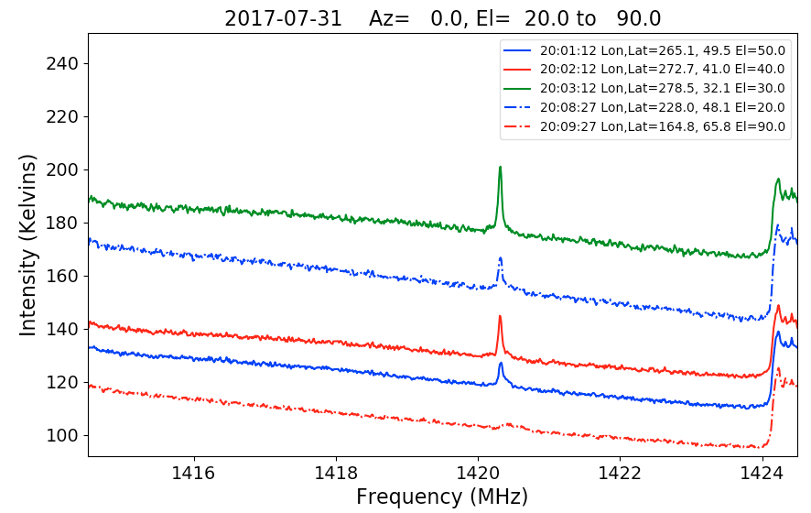
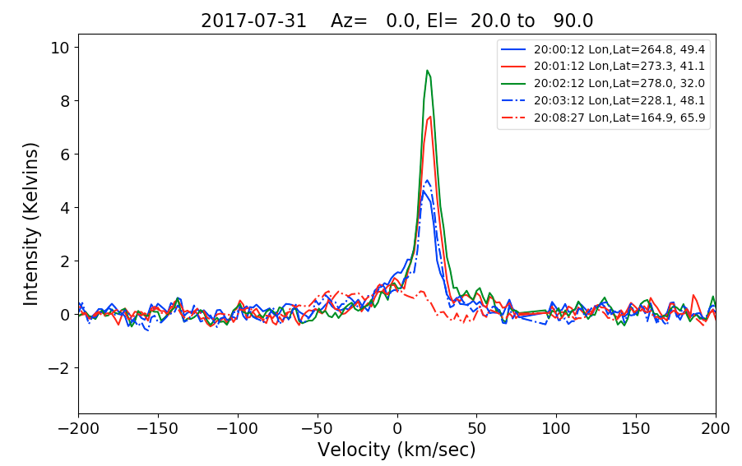
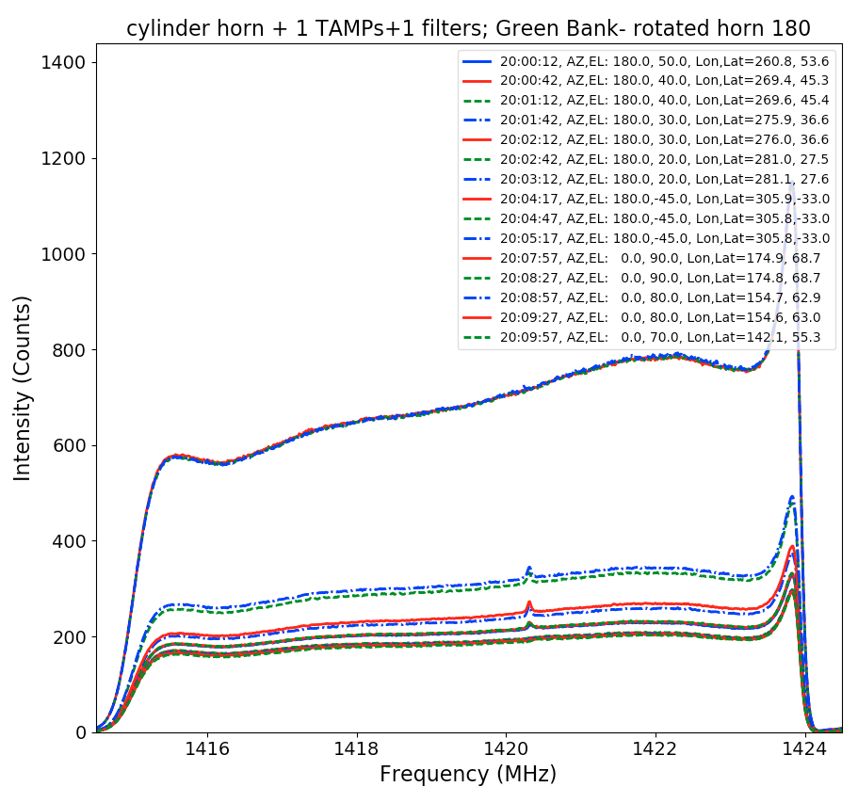

GPIO Labs sells good quality Radio Frequency Amplifiers, Bias-Tees and Filters
50 Ohm Load is available from Amazon, from several vendors.

