Memo: LightWork Memo 35 - Assemble Cone-Horn Radio Telescope
From: Glen Langston (glen.i.langston@gmail.com, glangsto@nsf.gov), Steve White (swhite@nrao.edu), Sue Ann Heatherly (sheather@nrao.edu), Kait Chen, Micheal Munnelly, Nana Nyarko, Sophie Robertson, Austin Webb,
DSPIRA collaboration, dispira-lessons@reply.github.com
Date: 2025 March 21

Summary: Assembling a Cone-Horn Radio Telescope Construction Guide enables your discovery of the Milky Way! Radio telescopes have a great variety of sizes and shapes. We’ve been working to devise the simplest (cheapest) telescope that has good performance, Our telescope is tuned to the most common element in the universe, Hydrogen. The cone is made from parts available online, including aluminum flashing. The support pieces are made of wood. The supplies needed and measurements are listed.
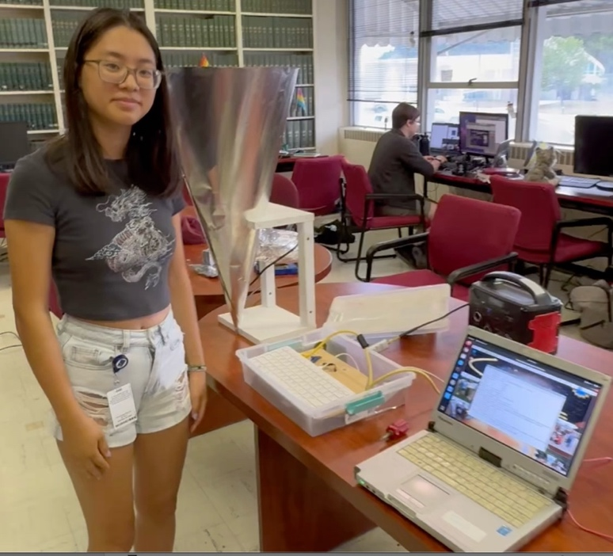
The 2024 Green Bank Summer students created videos showing how you can build a Radio Telescope. Radio telescopes come in all kinds of shapes and sizes, depending on your research goals. If you’re hoping to quickly and easily find the arms of our Milky Way Galaxy, what would telescope be the most sensitive and cheapest? Answer: A cone-horn radio telescope!

Here, we present the construction guide for your radio telescope. With your telescope, you will be able to see the Milky Way in just a second or two.

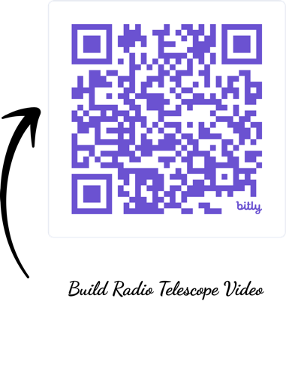
The key features of a radio telescope are size of the collecting area of the horn, the opening angle and the precise position of the feed probe, which collects the radio waves and sends the signals to the 1st, very sensitive amplifier. Because radio telescopes are usually left outside, the horn must be durable and water resistant. Most people want an inexpensive telescope they can build themselves. The telescope should be able to see the Milky Way in just a second or two. Summer student Kait showed us the complete telescope in Fig. 1!
Watch Students build a Radio Telescope on YouTube
Fig 1: 2024 Green Bank Summer Student Kait with the completed telescope (left), Raspberry Pi telescope computer (middle), and display computer (right). With this system you can find the Milky Way spiral arms any time, day or night.

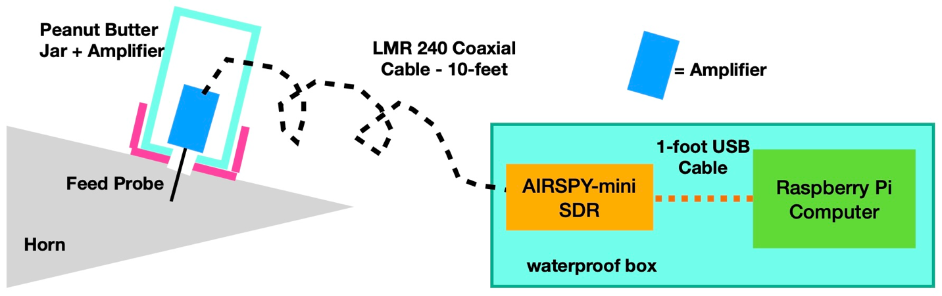
This memo describes the construction of the cone horn telescope, and elevation mount. This horn includes the first Low Noise Amplifier (LNA), a high-quality cable taking the signal to the Software Defined Radio (SDR). We prefer the AIRSPY-Mini SDR, which has the capacity to see all the hydrogen from our Milky Way Galaxy in a single observation.
Fig 2: Diagram showing the connections between the radio frequency parts of our horn telescope. The signal flows from left to right, starting with the horn. The signal is maximum at the feed probe. The probe is directly attached to the amplifier. After amplifying, the signal goes through a coaxial cable to the SDR.

Our telescope is a big funnel that collects the signals from our Milky Way to a location about 10.5 inches from the point of the horn. Fig 2. shows the signals flowing in and cause tiny voltages to oscillate on our silver wire, about 2-inches long. Our very sensitive LNA, a NooElec HI amplifier multiples the signal by about a 2000. From there, the signal is strong enough to pass along a high quality (LMR 240) coaxial cable to a Software Defined Radio (SDR). We strongly prefer the AIRSPY-mini SDR, which is easy to work with and can see all the frequencies of our Milky Way where hydrogen is visible. The AIRSPY-mini is connected to a low-cost, but capable, Raspberry Pi 400 computer. The computer powers the AIRSPY and the amplifier. You will need to borrow an HDMI monitor for testing.

Other LightWork memos describe the construction of the telescope base and another guiding the use of software for displaying the plot showing us the arms of the Milky Way.

National Science Foundation’s (NSF’s) Green Bank Observatory (GBO) and the West Virginia University Radio Astronomy Instrumentation Lab (WVURAIL) are leaders in bringing radio astronomy to the public. Though their guidance, they enable everyone to discover the immense size of our Milky Way Galaxy. The WVURAIL team of teachers and engineers enable everyone to find their place in the galaxy. The appendix of this memo has links to more background info and is a starting point for your research.

This document is based on an earlier design is described in LightWork Memo 32, Gather a Pail of Milky Way. In that document, we used pails to avoid cutting metal, but the resulting telescope was less sensitive that the super-sensitive cone-horn we present here.

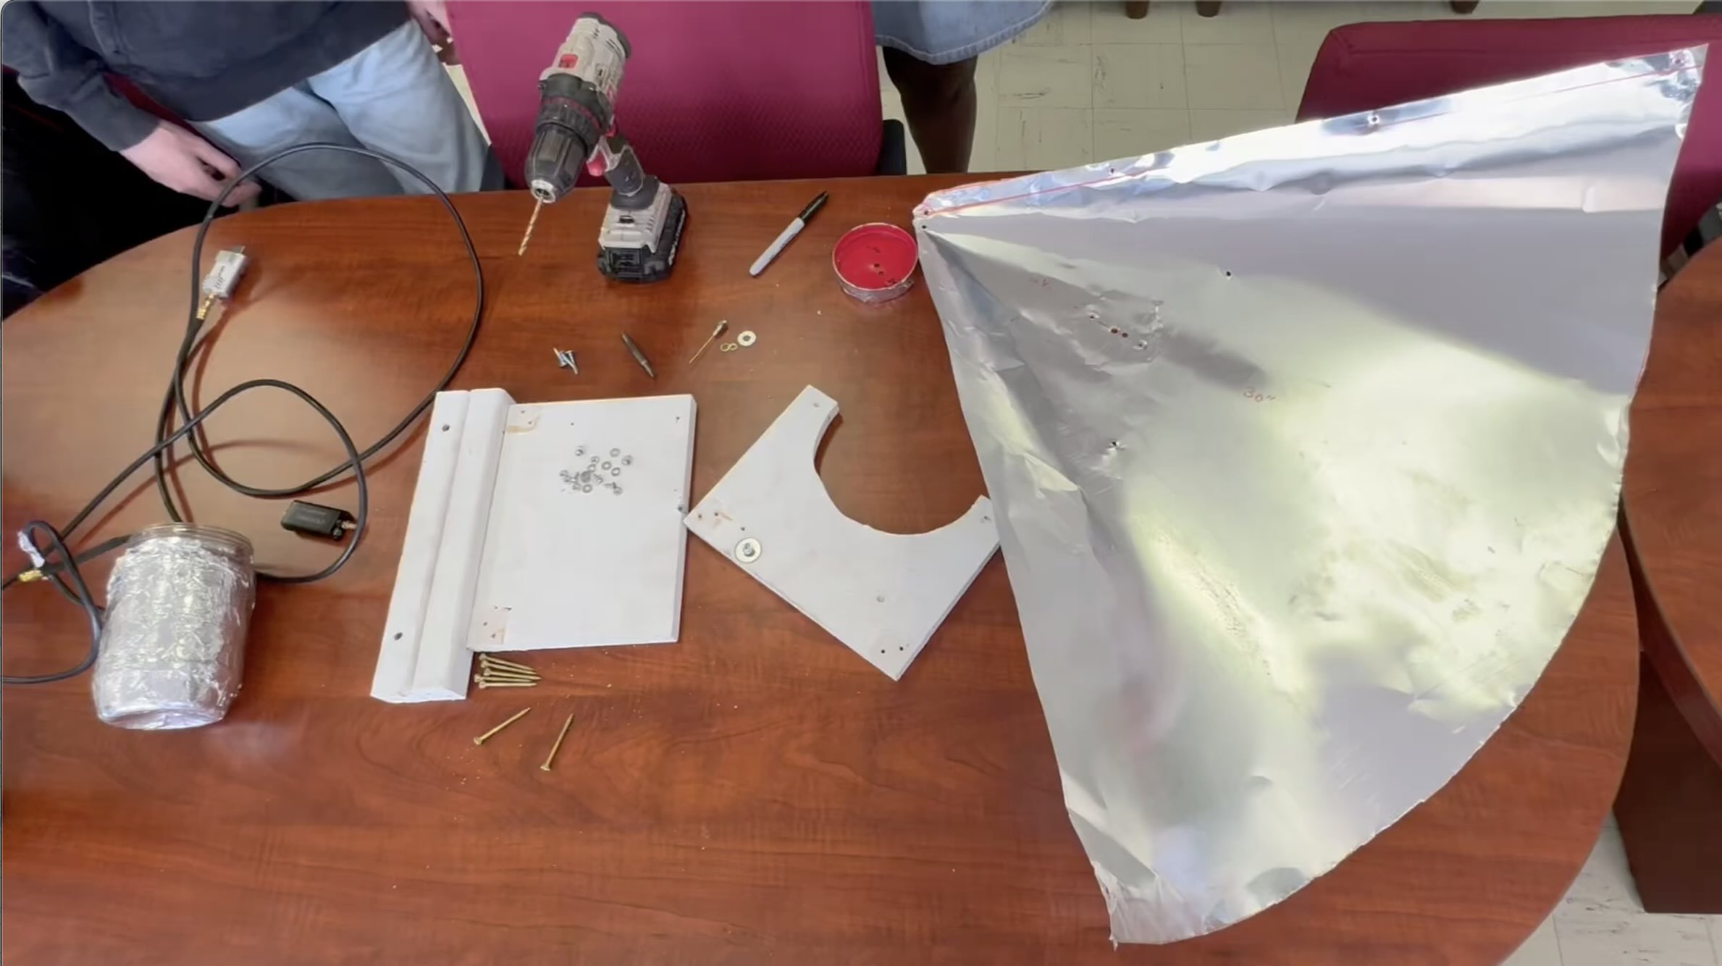
Tools
Fig 3: All the parts need to build the cone-horn radio telescope. The biggest piece is the aluminum flashing (right). The wooden parts of the mount are painted white (middle). The mount is held together with wood screws. At left are the LNA, metal tape covered peanut butter jar, high-quality coaxial cable (LMR 240) attached to the AIRSPY-Mini SDR. The feed probe and metal screws are at the top middle.

Only a few tools are needed to build the cone-horn radio telescope, if the wooden parts are pre-cut. You will need scissors, a permanent marker, a battery powered electric drill and a short multi-purpose screwdriver, with both Philips and flat head ends. You will need a 5/16 wrench and a set of drill bits (1/8 to 3/8-inches and ½-inch). We used a set of #6 machine screws for connecting the sides of the cone and attaching the peanut better jar.

You will need a coping hand saw to cut the front of the elevation mount to shape. You will need a 1/2-inch drill bit for a hole to the back of the mount. Use the template in the appendix to make drawing the shapes easier.

Parts
You will need two 14-inch-long balusters (which are 1.25-inches square). You will also need two 8x10-inch boards, ¾-inch thick. Paint these with primer, then decorate as you want. You need 12 two-inch-long wood screws and a set of #6 stainless machine screws, with lock-washers and nuts. We found that a white plastic version of the 8-inch wide board is a good option.

We’ve created an Amazon parts list with all the parts needed to build the telescope. The parts list includes some extra parts, so that more telescopes can be built a little cheaper than just one.

See: https://www.amazon.com/hz/wishlist/ls/2ISJ3MOI7V2ZY?ref_=wl_share
The AIRSPY-mini is available online from AIRSPY.

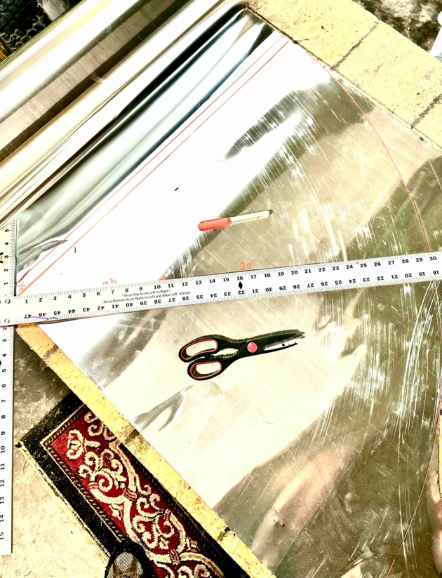
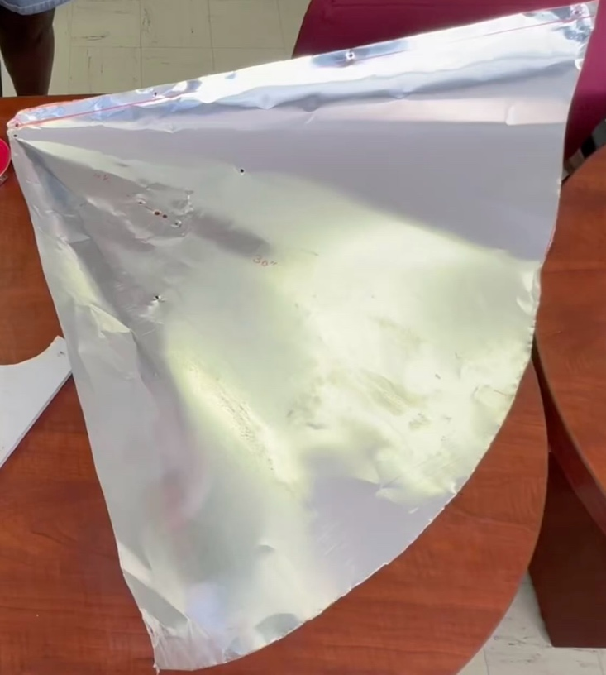
Since your telescope will be left outside for years of observing, the amplifier must be put in a waterproof container. We’ve found that a large peanut butter jar is about perfect for this, as it seals nicely, is flexible and can protect the amplifier from interference by covering it with aluminum muffler tape. You need a roll of 2-inch-wide muffler tape. About a 15-foot roll is sufficient.
Fig 4: Draw ¼ of a circle on your flashing with a ruler (left). Screw reference point through the flashing and board holding the flashing. Draw an arc of circle the width of the flashing. Use a permanent marker. The flashing should be 20-inches or wider. Arc should go one inch further than a quarter-circle, so there will be an overlap when bolting the cone together. Use scissors to cut the flashing, creating a big semi-circle (right).

The horn will be attached to the wooden elevation mount with three stainless 1.25-inch-long wood screws with large pan-heads.

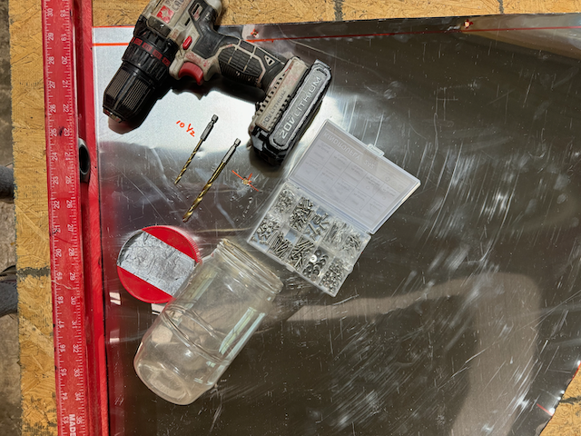
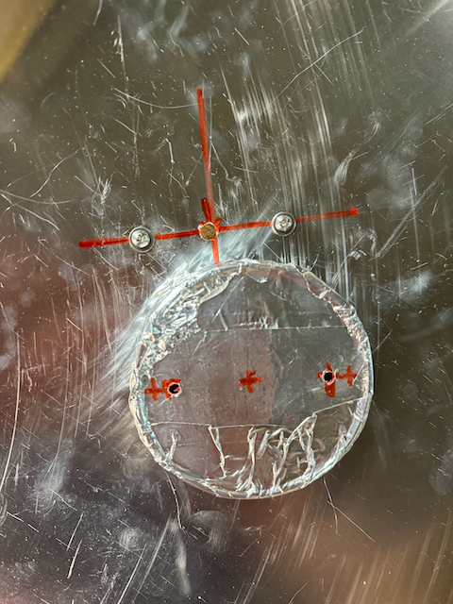
Radio Frequency Parts
Fig 5: After cutting the semi-circle of flashing, the next step is drilling the holes for the feed probe and the screws holding the lid in place (left). The feed probe hole should be 10.5-inches from the corner of the semi-circle. After drilling the feed probe, drill two holes either side of the probe hole, spaced by 1.25-inches along the line. Then place the screws and washers in the mounting holes. Place the lid on the other side of the flashing and bolt in place (right).

The radio parts of the telescope are very simple to assemble. These parts are available due to the fantastic efforts by many experts. The parts connections are shown in Fig 2. The AIRSPY-mini is about $100, and the NooElec amplifier is $45. The LMR 240 10-foot cable is $17. The 1-foot USB cable is about $8. Total is $170. These parts are included in the Amazon shopping list.

The total cost of your first telescope is about $500, if you use the shopping list.

Cone-Horn Assembly
Now we list all the steps of assembly. The figures showing these steps are noted:
- Cut the cone from flashing. Use flashing 20-inches wider or larger. Make a large semi-circle, with a 1-inch overlap added. Bigger flashing makes a better telescope. We used 30-inch-wide flashing in the example. See Fig 4.
- Draw a line about 12 inches from the corner of the semi-circle to the middle of the circle arc. See Fig 4.
- Measure 10.5-inches from the corner along the line. This is the feed probe position. Use a 3/16 drill bit to drill holes at this point and 1.25-inches on either side along this line. See Fig 5, left.
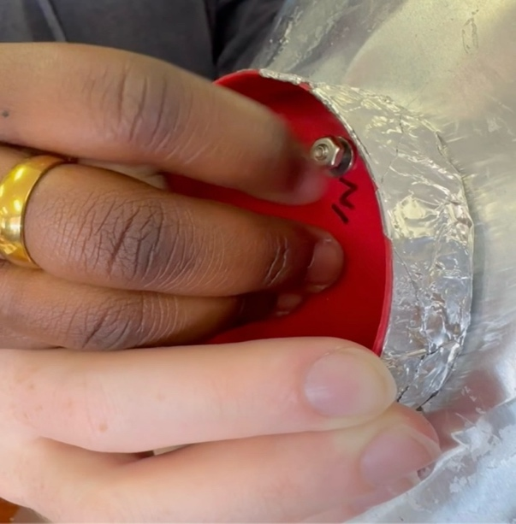
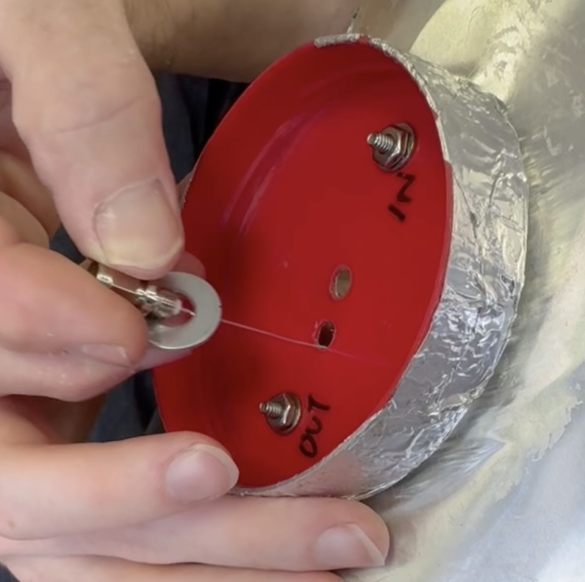
- Cover the peanut butter jar with aluminum muffler tape and drill a 3/16 inch hole in the middle. Put a temporary screw at this point and bolt in place, attaching to flashing. Now flip flashing and drill two more holes through the flashing, where you’d drilled before, through both flashing and jar lid. See Fig 5, right.
Fig 6: Bolt inside of peanut butter jar lid to the cone (left). Next, insert the feed probe into the horn, where the signals will be received (right). In this picture we’d moved the feed probe position to 10.5-inchs, from the original placement.
- Put short machine screws and washers through these holes. See Fig 6, left.
- Flip flashing again and bolt the peanut butter jar lid to the flashing.
- Use a ¼-inch bit to re-drill the center hole in the lid, where the feed probe will go.
See Fig 6, right. Great! You’ve finished getting ready to add the feed probe and amplifier!
- Insert the feed probe through the center hole and add two washers to the amplifier before inserting it through the ¼-inch hole. In the first version of the horn, the feed was separate from the amplifier. Because the feed would come loose, the signal would be weak. Soldering the feed directly into the amplifier made the telescope more reliable. See Fig 7.
- The feed probe will stick through about 1.73-inches. Add a lock washer over the feed probe and bold the probe in place. Use the 5/16 wrench to bolt the probe tightly. Be careful not to fold the feed probe over, while completing the cone.
- Now prepare to roll the flashing to make a cone. On the flashing, drill a 3/16-inch hole halfway between the bottom corner and the top edge of the circle. This hole should be on the overlap and be ½-inch from the edge.
- Now form the flashing into a cone, taping the cone in place so that the cone overlap is 2-inch at the far edge.
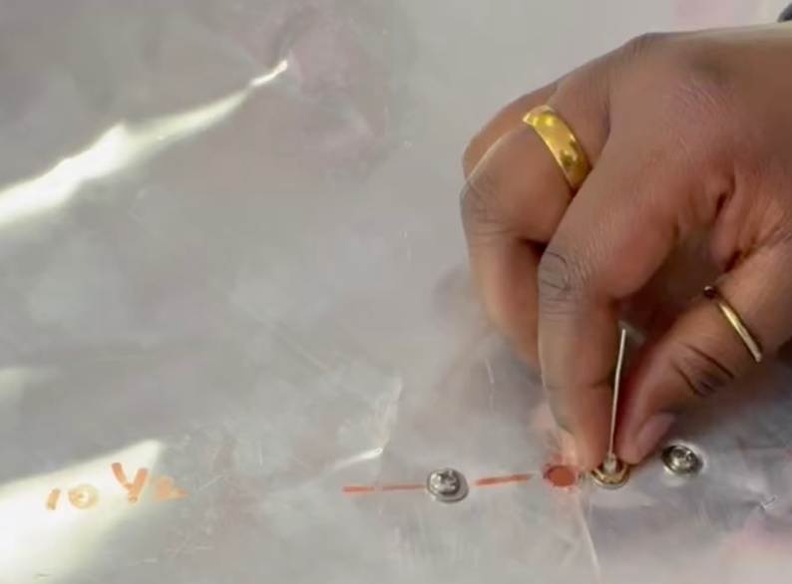
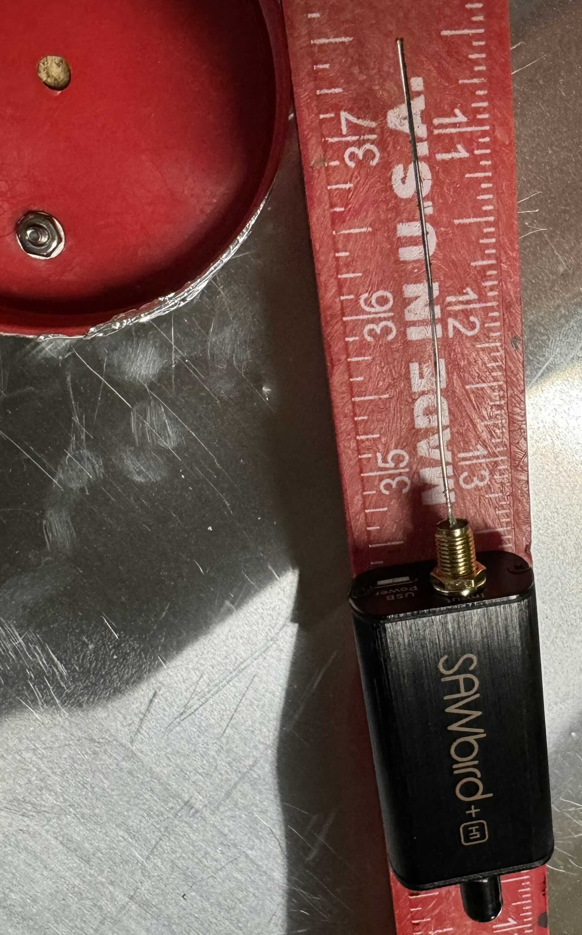
- Tape the cone overlap in place and make the cone come to a point. Where you drilled the overlap hole before, drill through to the other side of the cone.
Fig 7: The feed probe can be separate from the amplifier or directly soldered into the input of the amplifier (left). We found the telescope was more sensitive and reliable if the probe was soldered into the amplifier. Cut the feed probe to length, 1.73 inches. Add metal tape to make the transition from the flashing to probe smooth.
- Add washers on both in and outside of the cone and bolt in place. Remember the lock washer between washer and bolt.
- Now tape along the cone overlap.
- Drill a 3/16-inch hole at the top edge of the cone and bolt in place, like you did for the middle bolt.
- Cover the peanut butter jar with aluminum foil to protect the amplifier from interference.
- Drill a 3/8-inch hole in the peanut jar about one inch from the mouth of the jar.
- Insert 10-inches of the coaxial cable into the jar, bending it in an arc to attach to the amplifier.
- Pull the cable out and tightly attach the cable to the amplifier, using your 5/16 wrench. The end should be tight but be careful not to break the connection to the amplifier.
- Attach the peanut butter jar to the lid. Add some aluminum tape to hold the jar together and cover the hole for the coaxial cable. See Fig. 8.
- Next assemble the elevation mount, which will hold the horn for observations. The wooden parts are shown in Fig. 9.
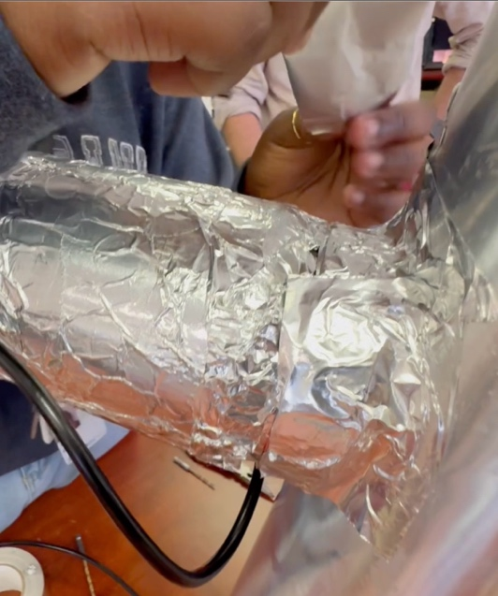
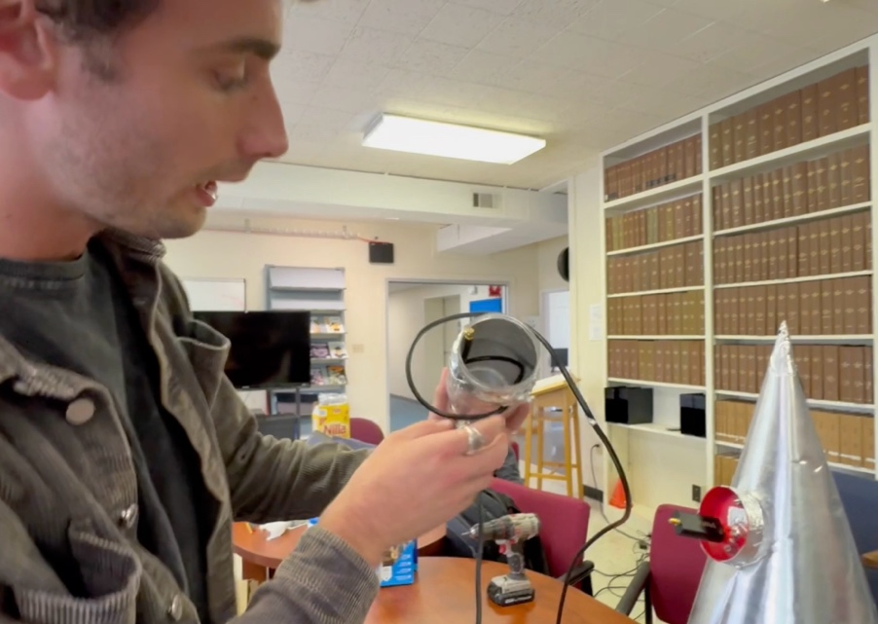
- Use the template in the appendix to cut the front and back pieces of the mount with the correct shapes. These pieces start out as 10x8 inches pieces of ¾-inch thick lumber. The front template is a semi-circle with 3 7/8-inch radius. The back template is a single ½-inch hole hear the top center of the board.
Fig 8: Michael inserts to coaxial cable into a hole in the side of the peanut butter jar (left). The cable is bent into the bottom of the jar with coaxial cable end pointed toward the output end of the amplifier. After placing the jar on the lid, add aluminum tape to waterproof the connection between lid and jar (right).

- Cut the template along the lines. And mark the pieces. Use a coping saw to cut the front piece.
- Cut the baluster into two 14-inch-long pieces. Drill two holes on each baluster. The first hole should be 2 inches from the end of each baluster. The second hole should be exactly 21-cm (the wavelength of hydrogen) from the second. Pre drill with 1/8-inch drill bit, the re-drill with 3/8 inch
- Now use eight 2-inch-long pan head screws to assemble the elevation mount. First pre-drill holes with 1/8-inch drill bit. It’s best for one person to hold the parts while the other person screws the pieces together. See Fig. 9.
- Now use aluminum tape to cover up sharp edges on the horn. See Fig 10 left.
- Attach the pointed end of the cone to the rear piece, drilling a 1/8=inch hole, then putting the point of the cone through the ½-inch hole you drilled. See Fig. 10 right.
- Now attach the cone to the front of the elevation mount. Drill from the side through the wooden part and through the aluminum flashing. Do this on both sides of the front of the elevation mount. See Fig. 11.
- From the inside of the cone use a short screwdriver to screw two short screws through the flashing to hold the front in place. See Fig 12 left.
- The feed probe should be sticking straight out of the flashing. If it got bended over, you should be able to bend it back straight without problem. See Fig. 12 right.
- Your corn-horn receiver is complete! See Fig. 12.
- Other memos describe building the telescope base to attach to the horn. Another memo describes the computer system and its connections.
- Attach the other end of the cable to the AIRSPY-mini. Add the 1-foot USB-extender cable to the AIRSPY.
- One great thing about a radio telescope is that as soon as your done, you can take it right outside and find our Milky Way!
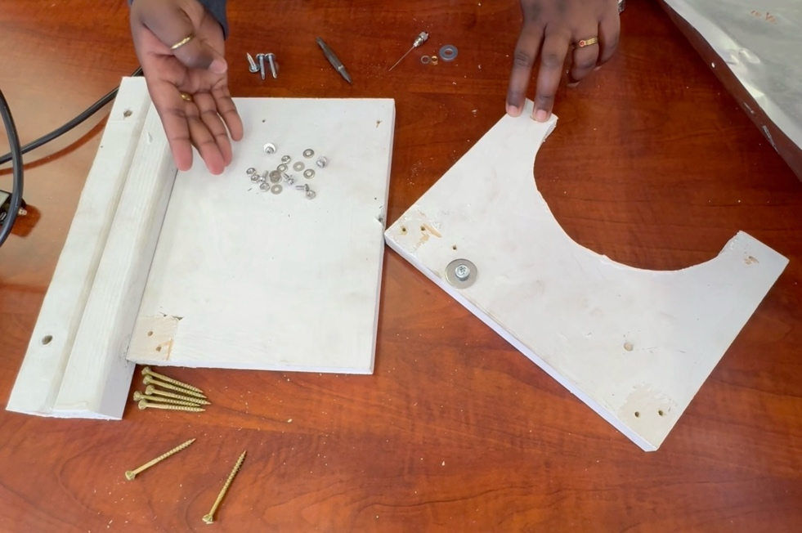
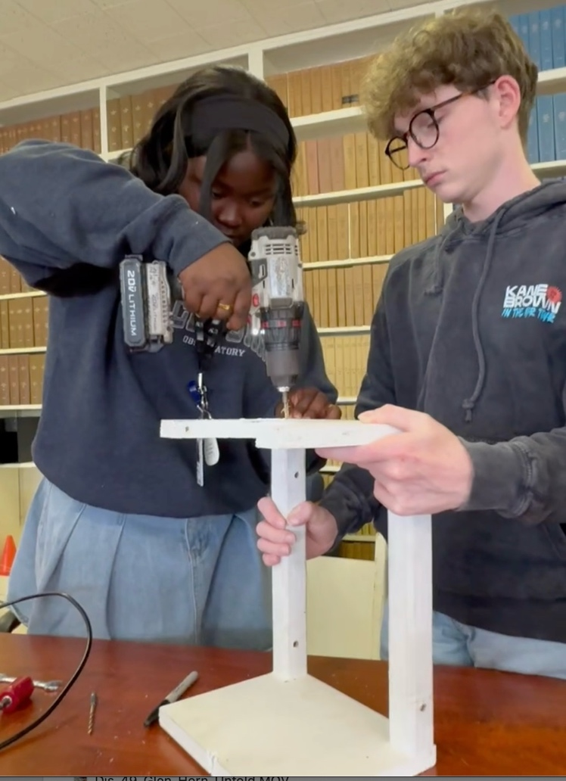
Fig 9: The wooden pieces of the horn elevation mount (left). The front piece is cut in circular shapes of the template in the appendix. The straight pieces are 14-inch long balusters. Nana and Austin assemble the elevation mount, screwing two 2-inch long wood screws through the front and back pieces, The finished mount is 15.5-inches long and 10 inches wide.

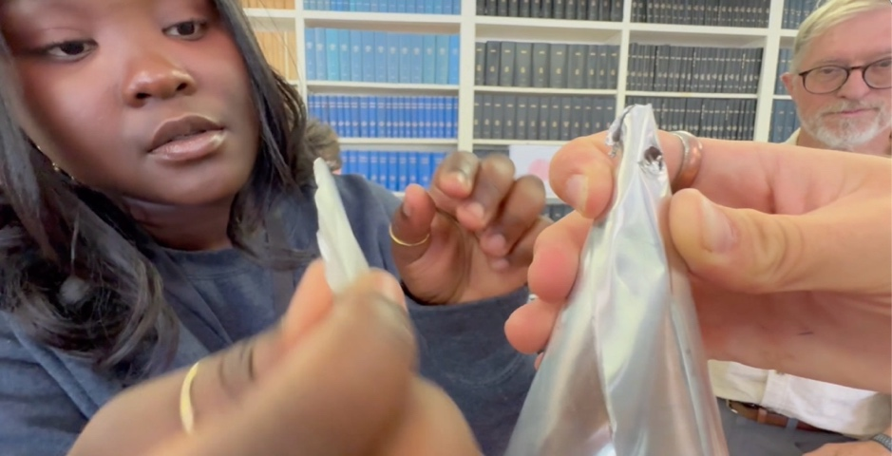
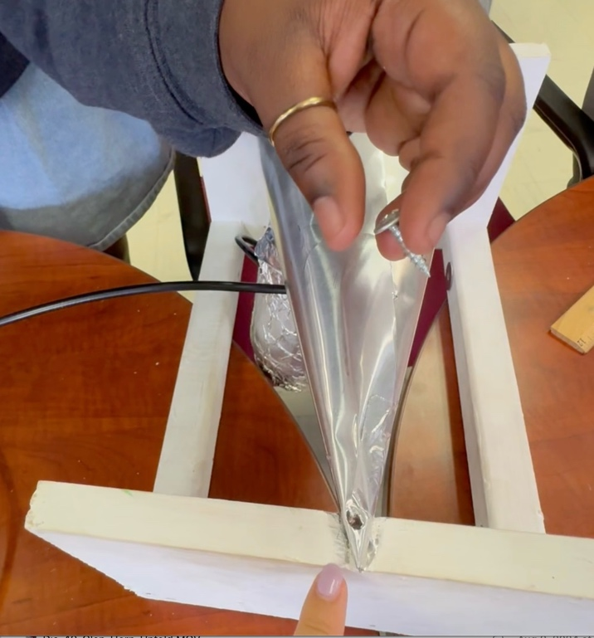
Fig 10: Nana, Austin and Glen secure the pointed end of the cone and protect us from sharp edges of the flashing (left). Nana screws the point of the cone to the back of the elevation mount with a 1.25-inch-long wood screw (right).

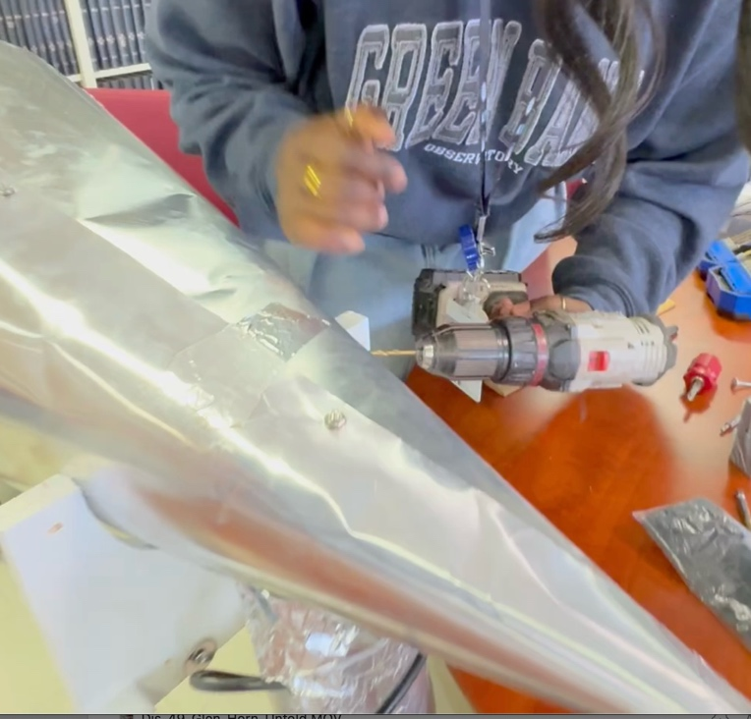
Design Updates
Fig 11: Nana drills through the sides of the wooden front part of the elevation mount. After drilling, we attach the cone-horn to the elevation mount from the inside, with two 1.25-inch-long wood screws.
Since our initial version, I and several others have successfully built this horn telescope design 3 dozen times. We’ve used the horn well at outreach events and easily done our favorite “Find the Milky Way Activity” where setup the telescope disconnected from the telescope base and let people look for the Milky Way. With a very short introduction they’re easily able to find the Miky Way disk and a few spiral arms.

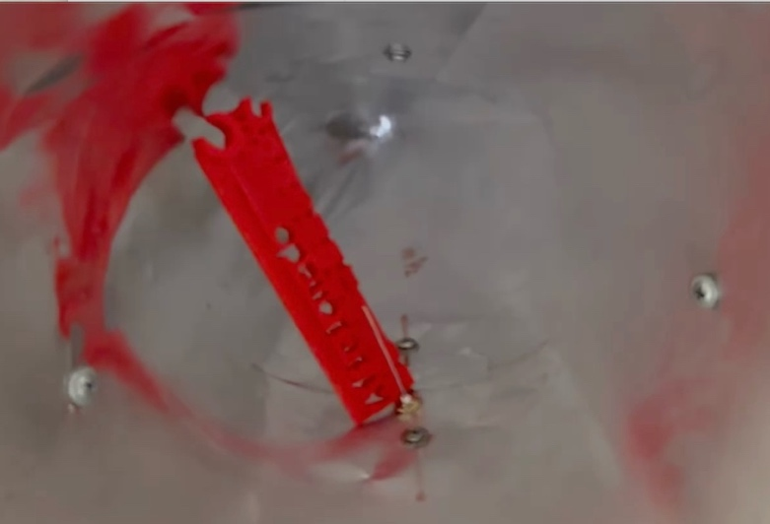
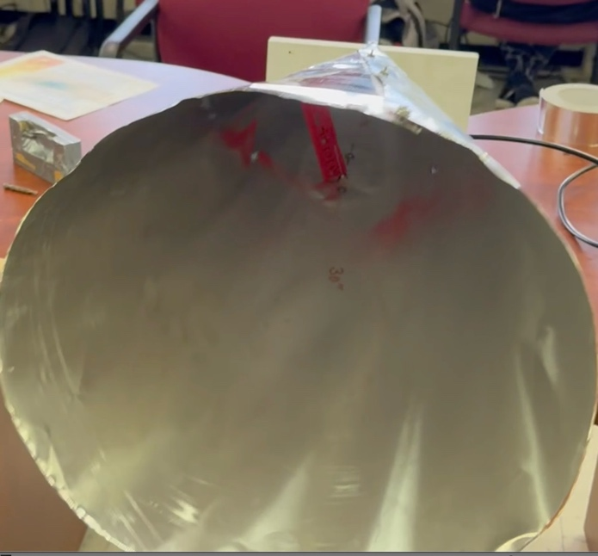
We now recommend adding an additional part to the horn, a strap to more firmly attach the middle of the horn to the elevation mount. Several of the horns have been outside in snow, rain and wind. When there is very high wind, we’ve had the horn separate from the front of the elevation mount, because it is only held in place by two screws. The pointed end of the horn stayed attached, and the horn did not blow away.
Fig 12: The assembled cone-horn opening, showing the feed probe in front of a short red ruler (left). The feed probe is 10.5-inches from the point of the cone. At right, we zoom in on the feed probe, which is the thin silver wire. The heads of the wood screws for attaching the cone to the mount are visible on the sides.

To help with this problem we found low-cost plastic pipe strap works well. We screwed the pipe strap to the sides of the elevation mount. This does not add too much cost to the telescope. A 25 ft roll, ¾ inch wide is $7. The shopping list link (above) includes plenty of screws for the attachment. We also drilled a hole through the strap on top and connected the horn to the strap with a short machine screw. There are extra machine screws, if using the shopping list.

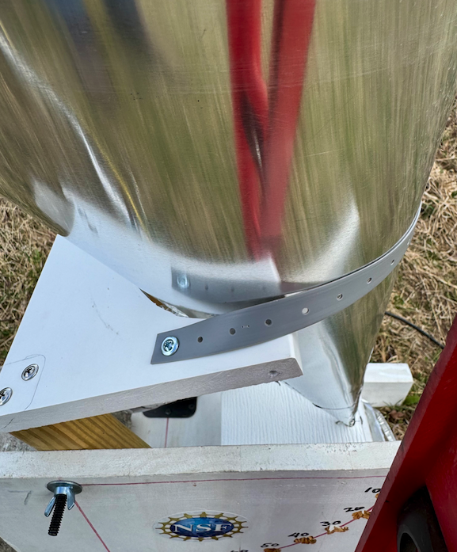
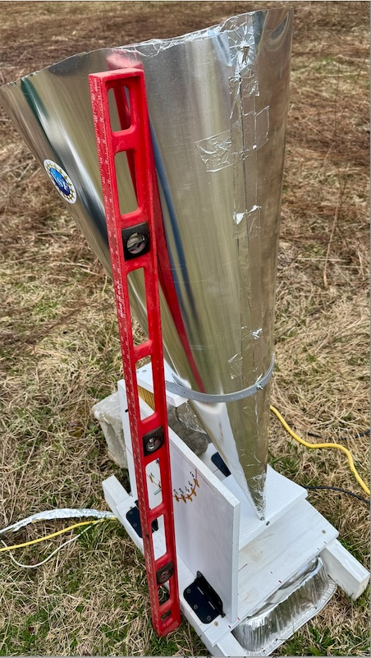
We did not have trouble with snow in the horn. The cone shape seemed to hold together with the weight of the snow, even though the horn was half full of snow. We had more trouble with rain, as we used too much tape. The horn filled up with water to above the feed probe height, filling the amplifier jar with water. We drilled another hole at the tip to let water drain better. The amplifier still worked after drying out! Figure 13 shows the updates.
Fig 13: Completed telescope, built from 40in flashing (left). This horn is a little bigger due to finding a source for larger flashing. The red ruler is 4ft tall, for scale. Bigger is better, except in the wind! It needs the pipe strap to hold the horn in place. The strapping is attached by two large head Phillips Screws. The image at right is a zoom in on the strap attachment. One screw on each side is sufficient. I did add a machine screw through the strapping in the middle to hold the horn to the strap. Not sure if that is needed. Tape might be sufficient.

Conclusion

Fig 14: Green Bank 2024 Summer Students jump for joy after completing their radio Telescope! We used our telescope to discover the Milky Way and enjoy a beautiful evening under the stars.
You’ve constructed your horn radio telescope and are ready to find the Milky Way. There is still lots to learn about science and astronomy. We hope that with this tool, you’ll better understand our place in the Milky Way and the Milky Way’s place in the universe.

After you’ve made your first experiments, which we will share with you, we hope you’ll invent your own experiments and make your own discoveries!

Fig. 14 shows hints at the excitement the Green Bank Summer students had when they first discovered the Milky Way for themselves!

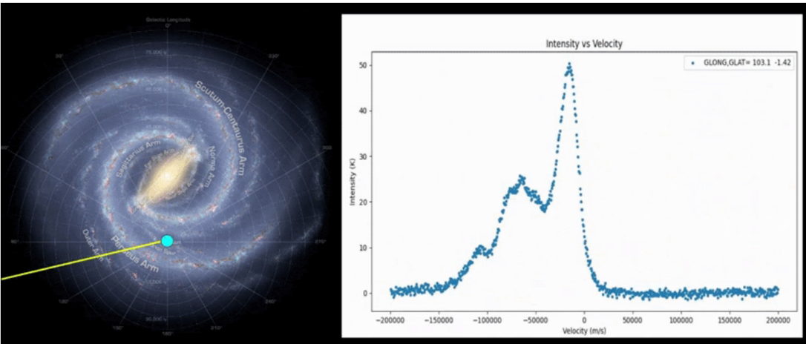
Fig 15: Maine East High School students scanned our Galaxy with their telescope. At left is a line showing where they pointed their telescope in Milky Way. At right is a plot of what they saw, intensity versus the Doppler Shift motion of hydrogen in our galaxy. Each of the peaks in the plot corresponds to a spiral arm of the Milky Way, each moving at incredibly high speeds.
Note: What will you see with your telescope?

You’ll see, with some imagination, the moving spiral arms of our Milky Way. Fig 15. shows an example image taken with their telescope, at high school students near Chicago. Credit: Dave Schultz.

Appendix: Template for Cutting the Elevation Mount

The template is available online at
the bottom of the page of this
link: LightWork Memos. Print it out
at 100% scaling so that the size
matches the cone you made.

