|  |  |
| --- | --- |
|  |  |

Experience with Student-Constructed Telescopes for Radio Astronomy

Glen I. Langston(1), Sue Ann Heatherly(2), Kevin Bandura(3)

(1) National Science Foundation, Alexandria, VA, e-mail: glangsto@nsf.gov;

(2) Green Bank Observatory, Green Bank, WV, e-mail: [sheather@nrao.edu](mailto:sheather@nrao.edu)

(3) West Virginia University, Morgantown, WV, e-mail: kbandura@gmail.com

Project-Based Learning (PBL) is known to motivate students and is a better model real-world engineering experience than school lectures. Our group has worked with high school students and teachers to design a Radio Astronomy PBL experience. We’ve designed, documented construction and operated Radio Telescopes intended for use by high schools, colleges, hobbyists and other *Science Aficionados*. Optimum PBL experiences need a balance of simple initial instructions, combined with more open-ended questions to challenge participants.

We first designed and constructed several versions of our own telescopes, to confirm that a sensitive telescope was within the reach of the participants’ skills and budgets. The designs were documents on-line in advance. Materials and tools were purchased before the participants arrived. We’re encouraging all *Science Aficionados*, (i.e. participants) to add to the <http://OpenSourceRadioTelescopes.org> web site. Pictures of students’ designs and instructions for the first two student-constructed telescopes are there. We’re encouraging everyone to add to the PBL documentation, by signing up for a [Wiki](https://tinyurl.com/osrt-wiki) account. We’ve incorporated lessons-learned into improved documentation in the [LightWork memo series.](https://tinyurl.com/lightwork-memo) Our goal is to encourage *Science Aficionados* to improve these documents. The intent is to build a community so that other students can take advantage of new capabilities, growing the areas of study in this PBL experience. It is well known that teamwork, and the required documentation of efforts, are critical for real-world engineering projects.

A radio telescope has a fairly large number of components. The basic telescope overview is now documented in *LightWork* [Memo 14](http://www.gb.nrao.edu/~glangsto/LightWorkMemo014r9.pdf) and [Memo 15](http://www.gb.nrao.edu/~glangsto/LightWorkMemo015-2.pdf). We’re looking forward to more contributions to the memos!

After the initial telescope designs were created, the materials were tested with two different groups. The first project was lead by Sue Ann Heather of the Green Bank Observatory (GBO), and involved 20 rising college freshmen, who were entering West Virginia University that fall. **Figure 1** shows some of the students in the four-week program; these students were given an overview of how a radio telescope works and shown the example radio telescopes that we’d created. They were then given all the material, a few rudimentary guides and told to go to work. They had access to two-by-fours, plywood, reflective foam board, reflective bubble wrap, drills, and power-saws. A critical part of a well functioning telescope is a very sensitive amplifier chain, with a factor of a million gain. These parts were purchased in advance for a cost of about $200 per telescope.

The students reported learning a lot from their experience, notably how science and engineering projects are actually done. Their telescopes had unique design features that were later incorporated into our standard documentation. The telescopes were not initially as sensitive as the telescopes we’d built in advance and a significant amount of time was taken in reworking a number of design choices. In the end, with some consultations, their telescopes worked! In future, we will give more step-by-step guides, so the students can spend more time with the observations and mapping the Milky Way Galaxy.

Dr. Kevin Bandura, of West Virginia University Lane School of Engineering, was supported by a National Science Foundation grant to work with high school teachers. He had also previously built a telescope and had made a number of significant improvements to the radio frequency electronics. **Figure 2** shows some of his 10 teachers who participated in their 8 week program on the basics of electronics and digital signal processing, culminating in soldering of parts onto a very sensitive custom amplifier board. Dr. Bandura was able to reduce the cost of the amplifiers significantly, by mass production and custom assembly. The electronics development and telescope construction was completed in week 6 and the teachers went to GBO to test their telescopes. The teachers each built their own telescope following a design that they developed as a group.

Both these PLB experiences were successful for the participants. The teachers are working on lesson plans for use by other teachers leading Radio Astronomy Projects.

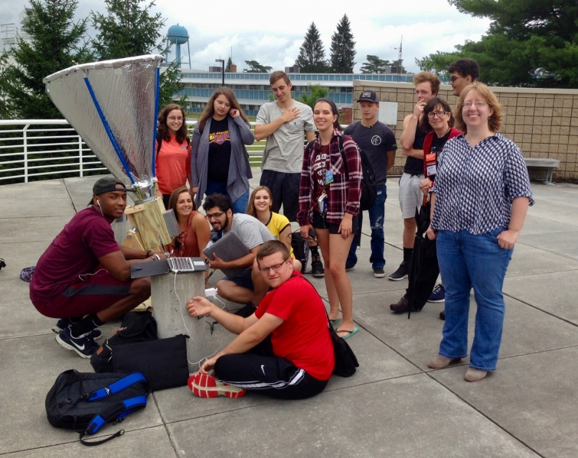Figure . West Virginia University Students, and serveral co-authors, with their student-built radio telescope, named Alexander, in operation at the Green Bank Observatory (GBO) in West Virginia. The horn-shaped telescope was constructed from bubble wrap, and other commercially available parts and electronics. The Students observed our Milky Way Galaxy, using GnuRadio software modified by the authors. This software is optimized for observation of neutral hydrogen atoms at 1420.4 MHz.

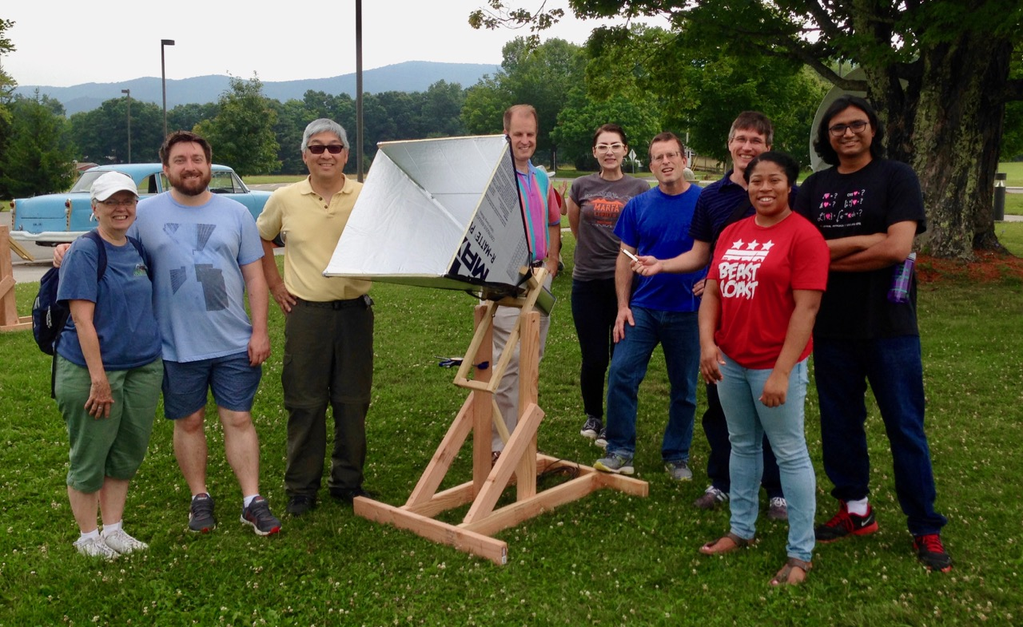

Figure . Kevin Bandura (WVU) with one of a dozen High School Teacher-Constructed radio telescopes. These telescopes were prototypes for telescopes to be constructed through the United States as part of a science and engineering education project. This project is supported by the National Science Foundation.

In order to become a radio astronomer the students and teachers need a number of skills, including the basics of software-defined radio (SDR), some “Maker Skills”, including using saws and drills, and some python data reduction. **Figure 3** shows the observer interface, created using Gnu-radio companion software. The students only need to operate the observing software, but several of them found building their own new observer interfaces both possible and enjoyable.

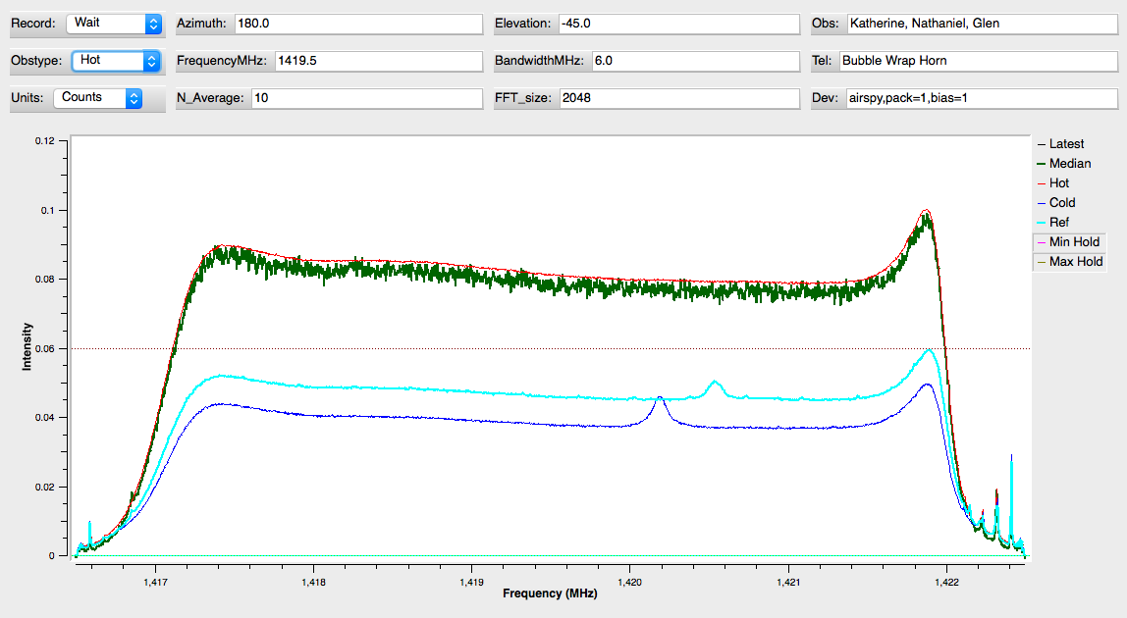

**Figure 3: Plot of Raw Intensity (counts) versus Frequency in MHz for spectra selected using the RA_Integrate block. The RA_Integrate block is used to confirm proper operation of the telescope. The observer inputs the direction the telescope is pointing and frequency setup information. The plots show intensity versus Frequency (MHz). The intensity axis has three possible units, 1) counts, 2) power in dB and 3) calibrated intensity in Kelvins. This plot shows the intensity in counts. The little peaks near 1420.4 MHz are due to galactic hydrogen, which is clearly visible in these observations. Each of these observations are only a few seconds long. The thick green lines shows a short duration hot load observation, when the telescope was pointed at the ground. The long duration average hot load signal is the thin red line.**

The observer interface is built with Gnu-radio Companion (GRC), a graphical programming tool. Figure 4 shows all the processing blocks used to create the interface shown in Figure 3.

The user can create and share these blocks for use by others. This interface requires installation of Gnuradio and several system tools, all free. The interface itself is also is available for free from Github (http://github.com/glangsto/gr-nsf).

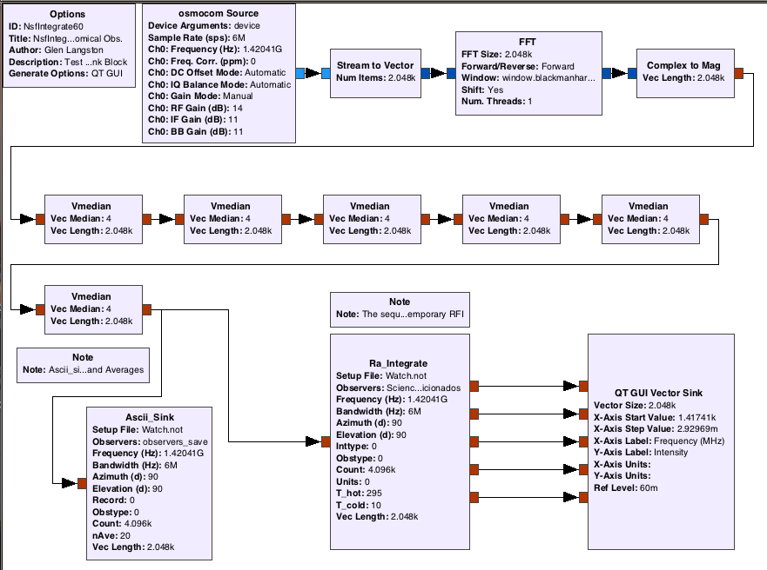**Figure 4: GRC visual program for Radio Telescope Observations. The data flow is simple, from the OSMOSDR source, on the top left, through a block to create a complex vector and a Fourier Transform. The data rate is reduced via a sequence of 6 Vector Median blocks, each that take 4 input vectors and produce a single output vector. These 6 blocks reduce the data rate from one new spectrum every 0.0003 seconds to one spectrum every 1.4 seconds. This reduces the CPU load for plotting and averaging so that all data may be captured with a modest multi-core computer. The filtered data are fed to the data writing block, Ascii_Sink and also to the RA_Integrate block and plotter to monitor the observations.**

Finally the collected data must be viewed and understood. The telescope is very sensitive and good observations can be taken in just a few minutes. All the collected data are written to ascii files, so the users can directly examine the observations. With some python plotting programs the data can be averaged, calibrated and displayed. Figure 5 shows a comparision of 10 minutes of data taken with the telescope pointed at different elevations.

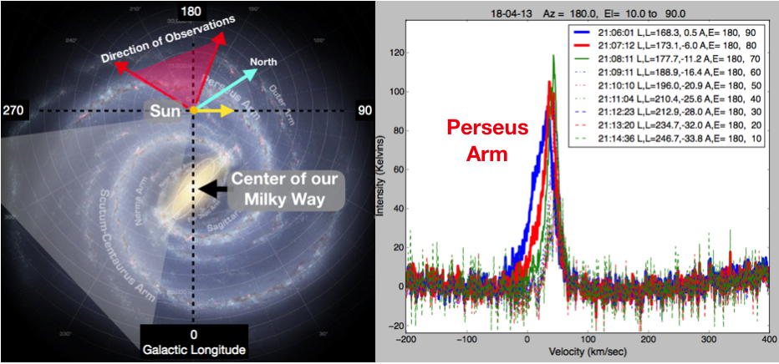***Figure 5: Overview of our place in the Milky Way Galaxy (Left) and 10 Minutes of Observations of the Perseus Arm. The sketch at left shows our Sun (and us) far from the center of the Milky Way. The image was drawn as if we are way above our galaxy. Our galaxy is a disk and the coordinate of the center of our galaxy is at Galactic Longitude = 0. The galactic longitude, latitude coordinates are centered on us. The plot at right shows 9 beautiful minutes of data. With some research, you can figure out that you’ve discovered the Perseus Arm of our Galaxy. The plot shows calibrated intensity (Kelvins) versus the velocity of the hydrogen measured. The observations were taken with telescope Azimuth=180 degrees, and different Elevations (A,E =). The GRC block calculates the Longitude and Latitude (L,L=) for the time of the observations (21:06 to 21:15 UTC).***

#### Conclusion

Radio Astronomy is within reach of high school students and teachers. With an investiment of time motivated students can discover our Milky Way Galaxy from their own back yard.

Figures 3, 4 and 5 are from LightWork [Memo 20](http://www.gb.nrao.edu/~glangsto/LightWorkMemo020-r3.pdf). More construction details are available form the WIKI.