DSPIRA Memo #2: LNA
  - Design and operation of low cost and simple LNA for use with Software Defined Radio
  - 2017 technical memo

Introduction
For low cost neutral hydrogen measurements, one of the current cost drivers is purchasing commercial LNA’s to achieve a low system temperature. This memo describes the design of a Low cost design, with the goal of designing a kit that can be purchased for ~$30.

Design
The circuit was designed and simulated using the software qucs. https://sourceforge.net/projects/qucs/
The predicted performance was a < 0.4 db Noise figure and 52 db of gain at 1420 MHz. See plots below:
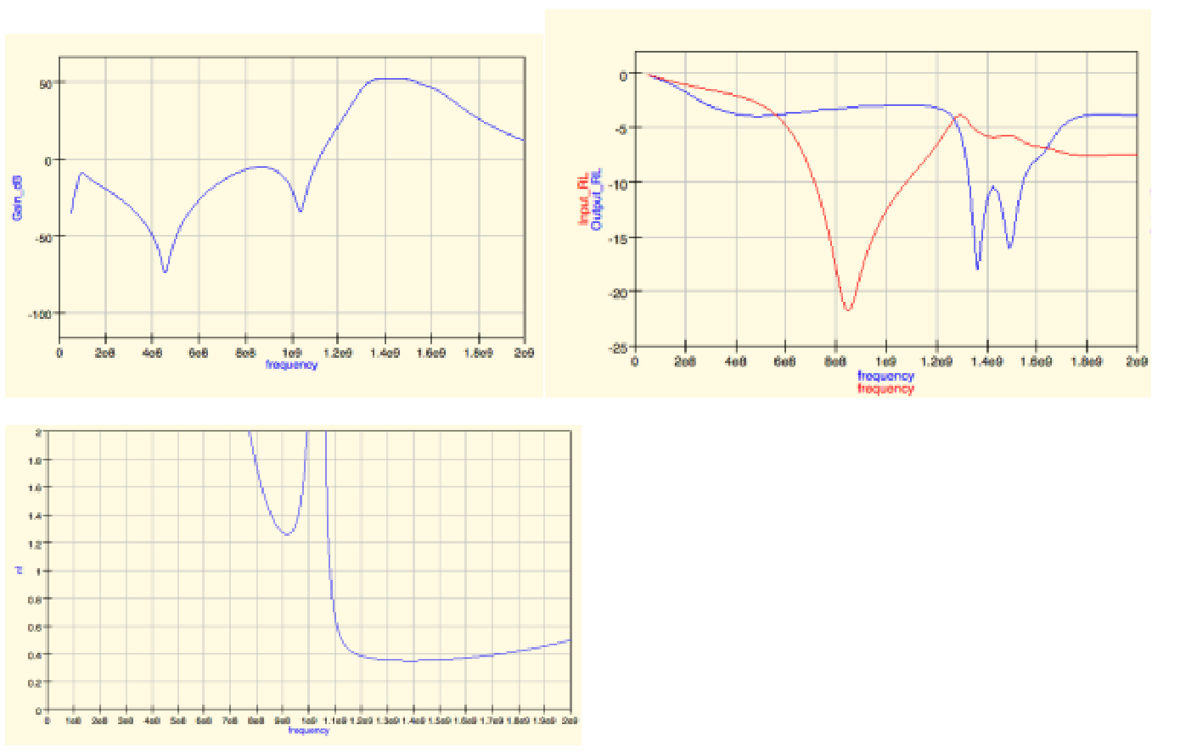

Circuit and initial layout
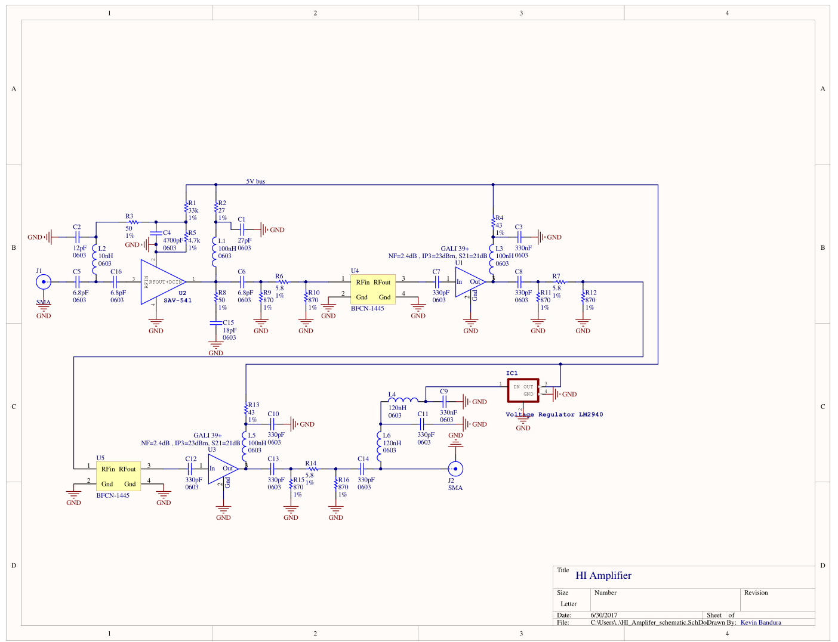
Circuit schematic: Kevin Bandura.
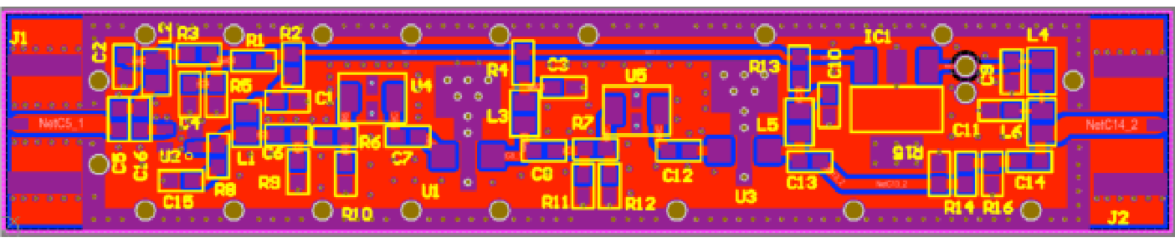
Initial board layout.

Assembled board
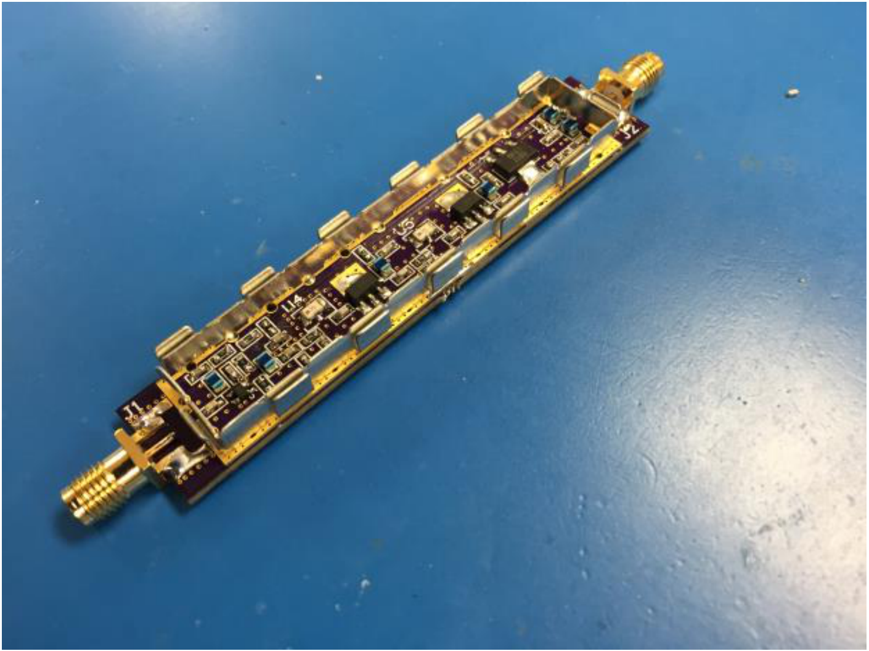
Where there is a removable shield, and the board makes one side of the shield. The EMI protection is moderate, and hasn’t been tested if this is adequate for use, but also significantly reduces the cost. Current draw is ~170mA. This is higher than desired, but also necessary with so much gain. The Airspy is rated to have a bias-T current of 50mA, but uses a LP5907 regulator, which is spec’d to 250mA of current. Most likely the rating comes from an inductor. Will test, and replace the inductor if necessary.

Measured lab performance
Since the gain is so high, the performance was measured using 2 power levels, ‘low power’ (blue) and ‘high power’ (orange). The low power is more valid for the S21 (gain) measurement, and the high power mode better measures S11 and S22. (recreate plots with only the ‘correct’ power plotted.)
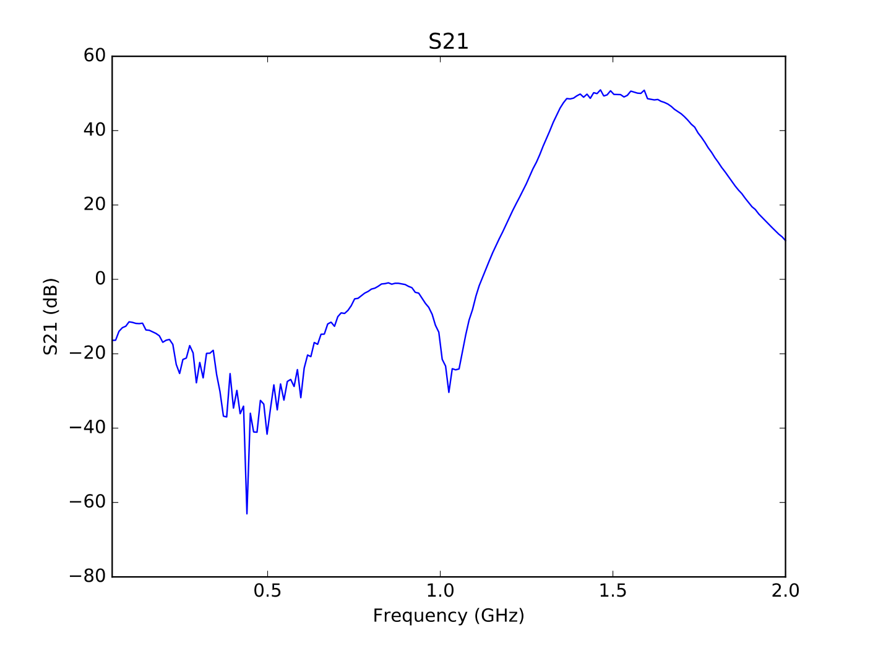
S21: amplifier gain.
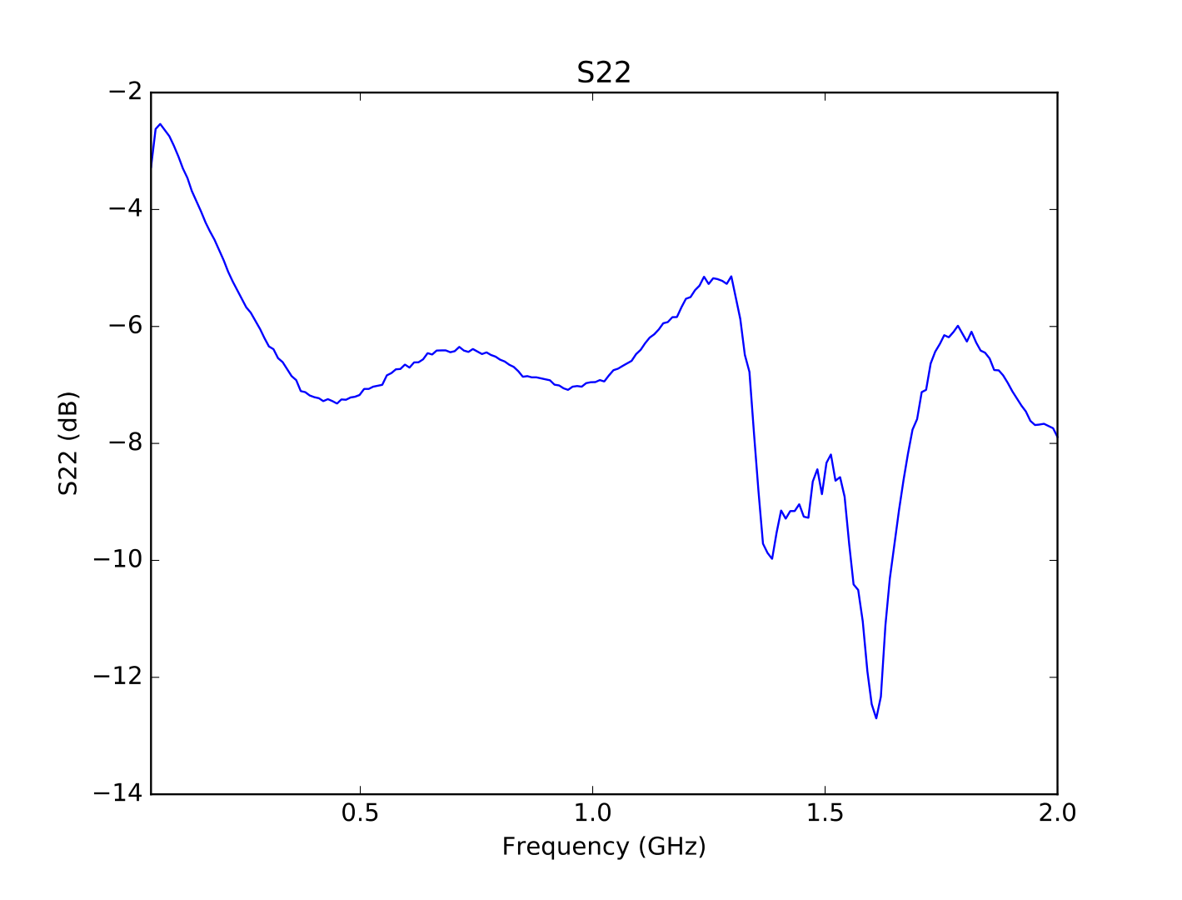
S22: output reflection.

Input reflection and noise figure
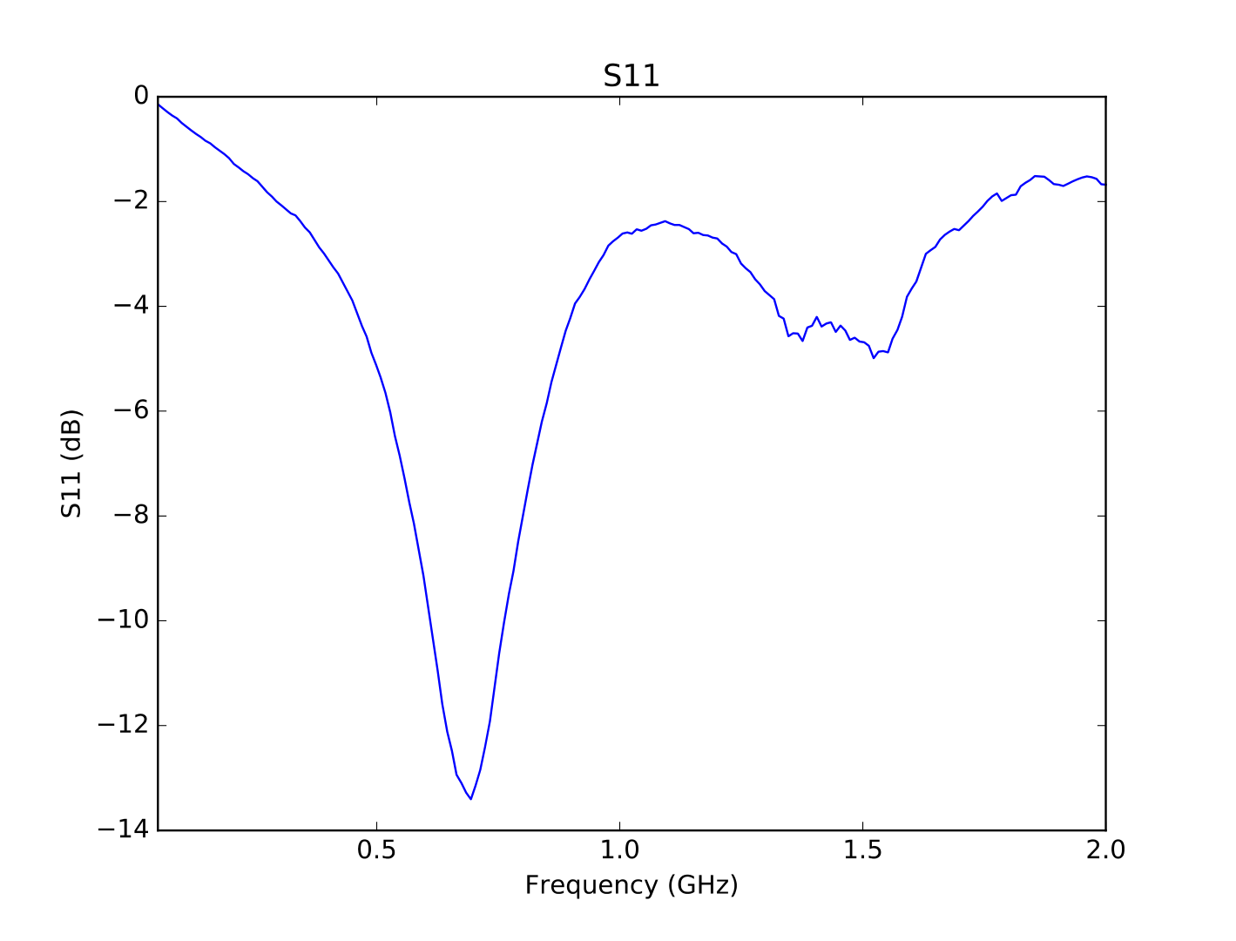
S11: input reflection.
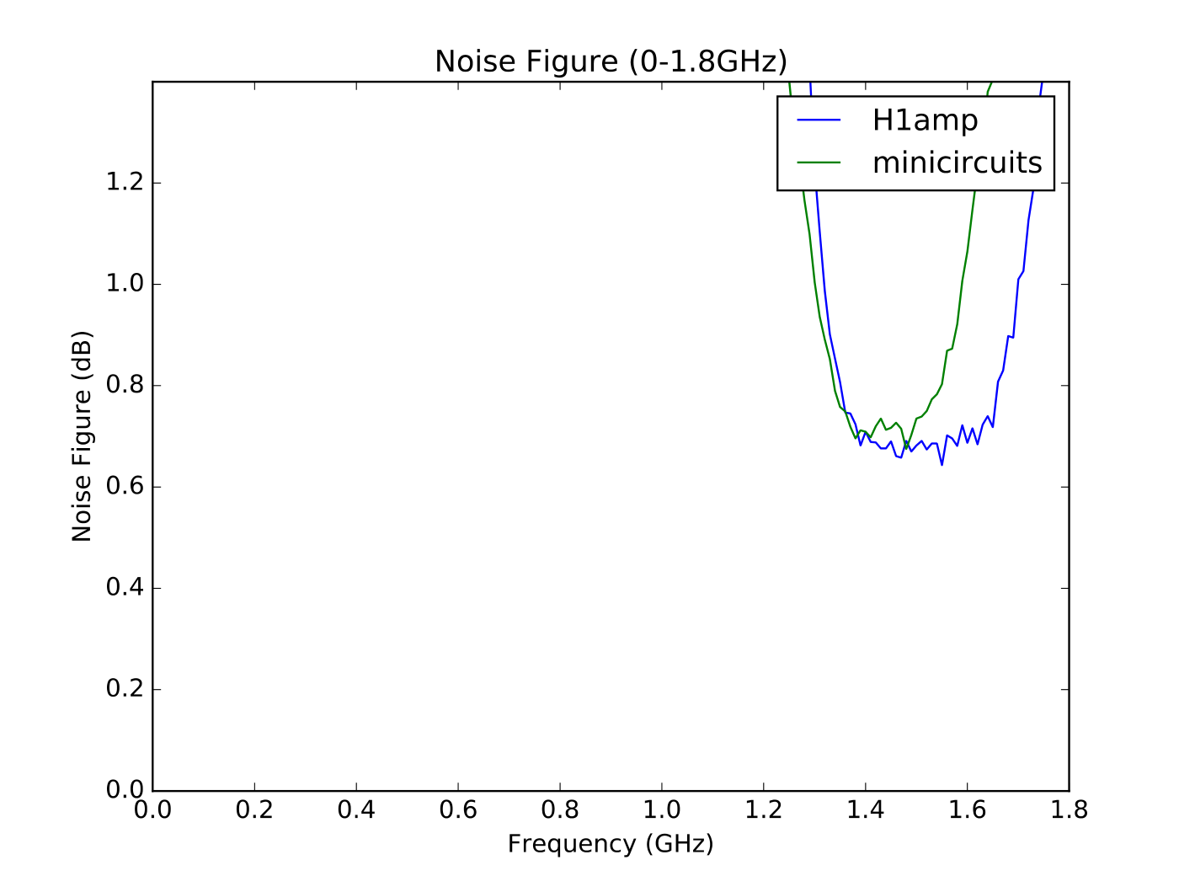
Noise figure.
Here the ‘minicircuts’ plot refers to the chain used in memo 1. The noise figure is significantly affected by the filters.

Cost
Initial cost comes out to $36 per board when buying components in quantity of ~100.

Use with Airspy
Designed to be used with airspy and powered by its internal bias-T. So entire analog chain is: Telescope- >LNA->Airspy. The LNA draws 170mA of current, which is higher than the publicly posted 50mA output of the airspy. The unit I have uses a voltage regulator internal that is rated for 250mA, and my airspy worked well. It may be hitting limits of the USB power for older laptops to power both the airspy and the amplifer. First measure of Tsys was ~200K with my horn setup, but should be able to get down significantly lower. Current estimates of system temperature have a very large variance.
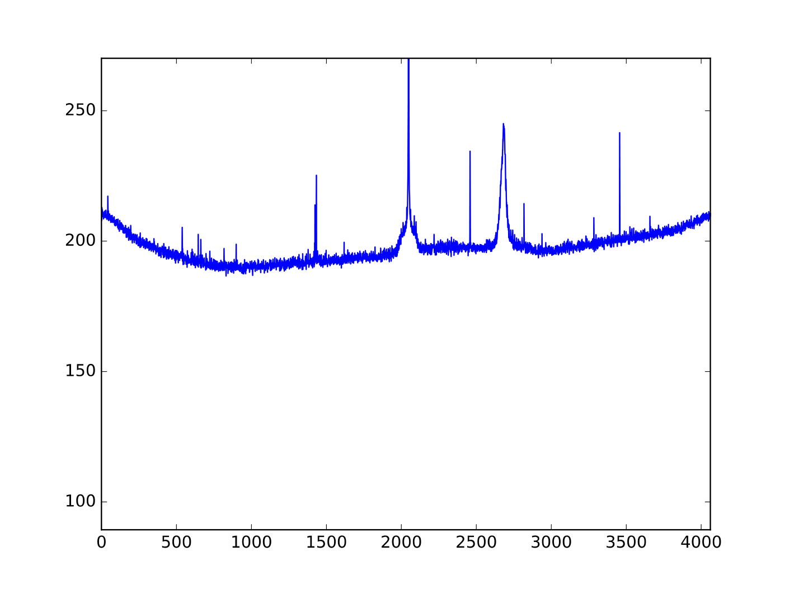
Initial system-temperature measurement.

