DSPIRA 2018 LNA assembly
  - Pranav Sanghavi | June 22, 2018
Institute reference. Match these component values to your board revision.
Refer to the schematic and layout in Figures 1 and 2 while assembling the LNA.

Assembly
Assemble all surface mount passives first: resistors, capacitors, and inductors. Work from left to right on the board. Install components with the same value together.
Component Label | Value
L2 | 10 nH
L1, L3, L4, L5, L6 | 100 nH
C6 | 9.1 pF
C1, C5 | 27 pF
C15 | 6.8 pF
C4 | 4700 pF
C2, C3, C7, C8, C9, C10, C11, C12, C13, C14 | 330 pF
R5 | 4.7k Ω
R2 | 27k Ω
R1 | 33k Ω
R3 | 50 Ω
R8 | 150 Ω
R4, R13 | 43 Ω
R6 | 17.4 Ω
R7, R14 | 5.8 Ω
R9, R10 | 287 Ω
R11, R12, R15, R16 | 870 Ω

Now place the actives:
Component label | Value | Notes
U2 | SAV-541 | Make sure the large pad lines up with the big foot
U1, U3 | GALI-39+
U4, U5 | BFCN-1445 | Align dot to point towards input
IC1 | LM2940

Figure 1: LNA circuit schematic
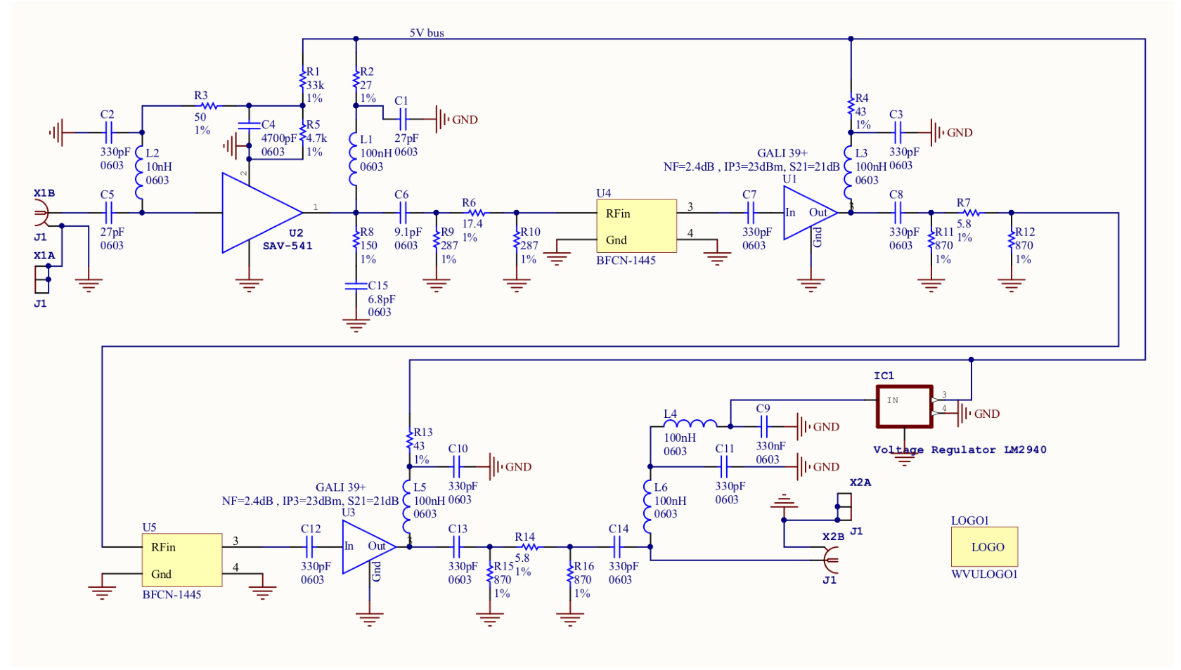

Figure 2: LNA board layout
