DSPIRA H1 LNA assembly
  - Kevin Bandura | Institute assembly notes
Earlier design reference. Component choices differ from later boards.

Schematic and board image
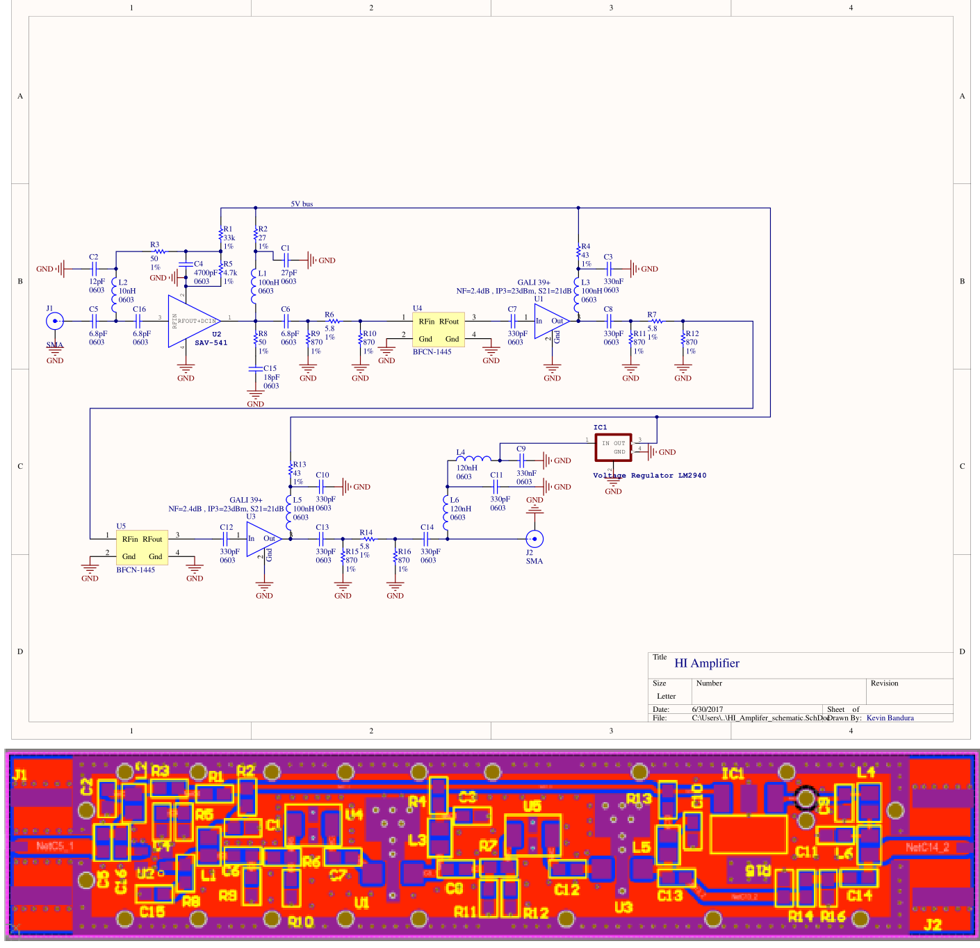

Assembly
Assemble all the surface mount passives first (Resistors, Capacitors and Inductors). Try to work from Left to right on the board, but also put on all components with the same value at once.
1) C5, C6 – 6.8pF capacitor
2) C2 – 12pF capacitor
3) C16 – MISS-LABELED, should be L16 – 6.8nH
4) L2 – 10 nH
5) R3,R8 – 50 ohm
6) C4 – 4700pF
7) R5 – 4.7k 7a) R1 33kohm
8) C15 – 18pF
9) L1, L3, L5 – 100nH
10) C1 – 27pF
11) R9,R10,R11,R12,R15,R16 – 870ohm
12) R6, R7,R14 – 5.8ohm
13) C7, C8,C3, C12,C13,C10,C14,C11 – 330pF
14) R4,R13 – 43 ohm
15) L6, L4 – 120nH
16) C9 - 330nF
Now place the actives:
17) U2 – SAV541. Align the dot and make sure the large pad lines up
18) U1,U3 – GALI 39
19) U4, U5 - BFCN-1445
20) IC1 – LM2940
21) J1 and J2. The input and output SMA connectors
22) R2 27 ohm
Finally add the Casing. Once everything lined up with holes, should just push on. Connect each tab on the underside.

