Geranium Instant Report

## Instant Report for PAC 13.

Basic statistics:

Table 1: Basic statistics

| No of Pus | No of CFs | Total Area, km2 | Total Area, PUs, km2 | Terrestrial Area, PUs, km2 | Marine Area, PUs, km2 |
| --- | --- | --- | --- | --- | --- |
| 39 | 16 | 34818.15 | 35100 | 4700.7 | 30399.3 |

Concern Indexes:

Table 2: Concern Indexes

| SR, % | MNSR, % | SA, % | MNSA, % |
| --- | --- | --- | --- |
| 205.3 | 197.6 | 29.2 | 33.5 |

Activity Indexes:

Table 3: Activity Indexes

| CAPR, % | CAP, % | AAR, % |
| --- | --- | --- |
| 1567.9 |  | 641.2 |

Conservation Concern Level by Month:

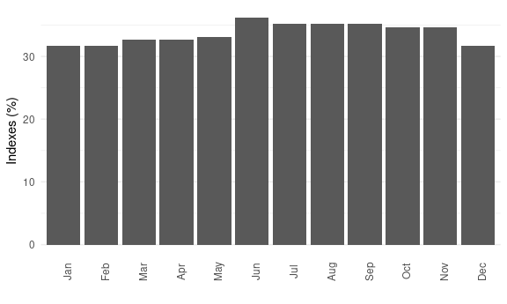

Figure 2: Conservation Concern Level by Month

Conservation Concern Level by Activity:

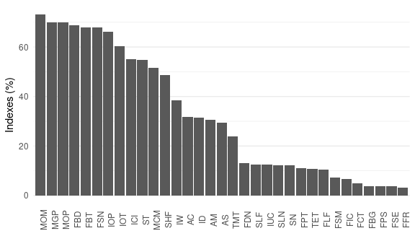

Figure 1: Conservation Concern Level by Activity

Table 4: List of Activities ranged by Conservation Concern Level

| Activity ID | Activity |  | MNSA, % |
| --- | --- | --- | --- |
| MOM | Other minerals production/mining |  | 73.2 |
| MGP | gas production |  | 70.0 |
| MOP | oil production |  | 70.0 |
| FBD | bottom dredging |  | 68.8 |
| FBT | bottom trawling |  | 67.9 |
| FSN | snurrevod |  | 67.9 |
| IOP | Underwater oil&gas pipes |  | 66.0 |
| IOT | Oil terminals |  | 60.2 |
| ICI | Coastal infrastructure |  | 54.9 |
| ST | Tanker (oil and petrochemicals) |  | 54.9 |
| MCM | Coastal mining |  | 51.5 |
| SHF | Cargo/Container/Passenger - Heavy Fuel Oil |  | 48.7 |
| IW | Windmills, windparks |  | 38.4 |
| AC | Cages (salmon, cod etc) |  | 31.8 |
| ID | Dredging |  | 31.5 |
| AM | Mussels, Oysters, scallops etc |  | 30.7 |
| AS | seaweed farming |  | 29.4 |
| TMT | Mass tourism |  | 23.8 |
| FDN | drift nets |  | 13.2 |
| SLF | Cargo/Container/Passenger - Light Fuel Oil |  | 12.6 |
| IUC | Underwater cables |  | 12.6 |
| SLN | Cargo/Container/Passenger - LNG-powered vessel |  | 12.1 |
| SN | Nuclear-powered vessel |  | 12.1 |
| FPT | pelagic trawling |  | 11.2 |
| TET | Small-ship expedition cruises and other small-scale tourism activities |  | 10.7 |
| FLF | Longline fishing |  | 10.3 |
| FSM | seaweed mowing |  | 7.3 |
| FIC | invertebrates collection by divers |  | 6.7 |
| FCT | Crab traps |  | 4.9 |
| FBG | bottom gillnets |  | 3.6 |
| FPS | purse seiner |  | 3.6 |
| FSE | steine and stationary seine |  | 3.6 |
| FFR | fishing rods |  | 3.1 |

CF list by Concern:

Table 5: CF list by Concern

| CF ID | CF Name | MNSCF, % |
| --- | --- | --- |
| 9030 | Polar bear (*Ursus maritimus*), Laptev Sea subpopulation, denning grounds | 89.4 |
| 1013 | Walrus (*Odobaenus rosmarus divergens*) Laptev population, haulouts | 78.4 |
| 6080 | Thick-billed murre (*Uria lomvia eleonorae*) breeding colonies | 49.4 |
| 7009 | Benthic biomass hotspot, east of Taymyr Peninsula | 42.9 |
| 1014 | Walrus (*Odobaenus rosmarus divergens*) Laptev population, winter grounds | 39.5 |
| 2013 | Bearded seal (*Erignatus barbatus*) whelping grounds, Laptev Sea | 26.9 |
| 6006 | Dark-bellied brent goose (*Branta bernicla bernicla*) breeding / moulting grounds | 17.7 |
| 4015 | Broad whitefish (*Coregonus nasus*), American populations, feeding grounds | 15.2 |
| 4095 | Brackish water fish complex, Khatanga-Lena rivers estuaries | 10.5 |
| 4010 | Muksun (*Coregonus muksun*) feeding grounds | 8.4 |
| 4014 | Siberian whitefish (*Coregonus pidschian*) feeding grounds | 8.4 |
| 4021 | Inconnu (*Stenodus leucichthys nelma*), Eurasian populations, feeding grounds | 7.0 |
| 6104 | Thick-billed murre (*Uria lomvia eleonorae*) breeding colonies foraging range buffer | 6.7 |
| 4036 | Borisov’s Arctic cod (*Arctogadus borisovi*) range | 5.4 |
| 7115 | Benthic communities, II.1.1.9. Laptev Sea middle shelf | 1.0 |
| 7114 | Benthic communities, II.1.1.8. Laptev Sea inner shelf | 1.0 |

Top CFs by Cover (all with cover above 20%):

Table 6: Top CFs by Cover

| CF ID | CF Name | Cover, % | MNSCF, % |
| --- | --- | --- | --- |
| 7009 | Benthic biomass hotspot, east of Taymyr Peninsula | 69.5 | 42.9 |
| 6080 | Thick-billed murre (*Uria lomvia eleonorae*) breeding colonies | 22.2 | 49.4 |
| 1013 | Walrus (*Odobaenus rosmarus divergens*) Laptev population, haulouts | 20.0 | 78.4 |