Geranium Instant Report

## Instant Report for PAC 22.

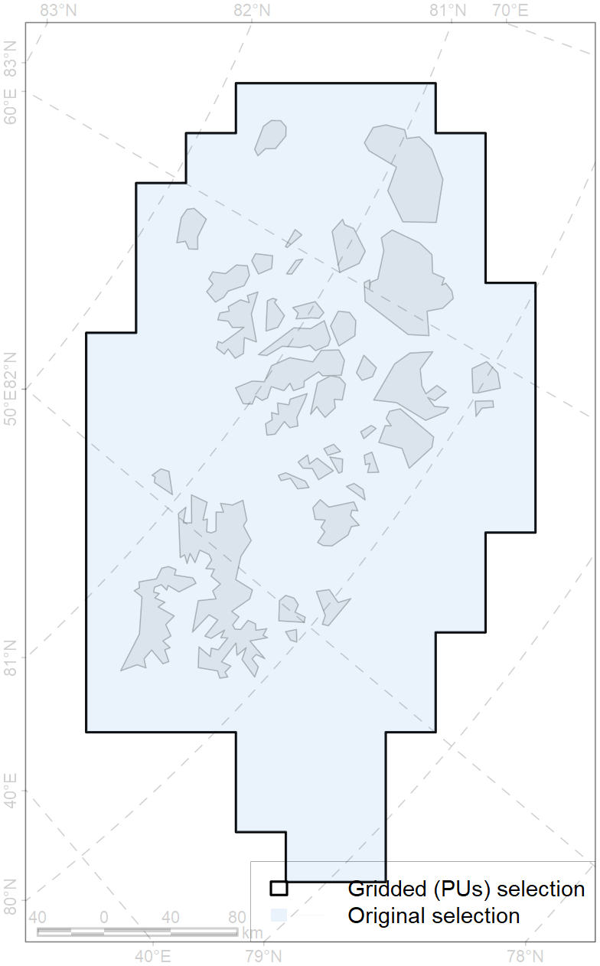

Figure 1: Selected Area

Basic statistics:

Table 1: Basic statistics

| No of Pus | No of CFs | Total Area, km2 | Total Area, PUs, km2 | Terrestrial Area, PUs, km2 | Marine Area, PUs, km2 |
| --- | --- | --- | --- | --- | --- |
| 106 | 50 | 94584.51 | 95400 | 14293.8 | 81106.2 |

Concern Indexes:

Table 2: Concern Indexes

| SR, % | MNSR, % | SA, % | MNSA, % |
| --- | --- | --- | --- |
| 732.3 | 683.5 | 184.9 | 172.6 |

Activity Indexes:

Table 3: Activity Indexes

| CAPR, % | CAP, % | AAR, % |
| --- | --- | --- |
| 7.1 | 13.8 | 1.8 |

Conservation Concern Level by Month:

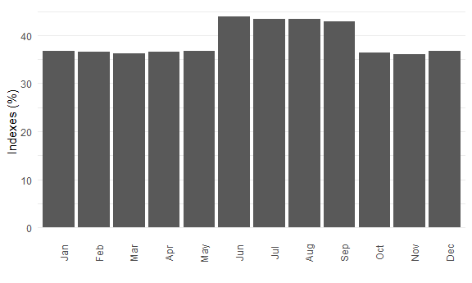

Figure 2: Conservation Concern Level by Month

Conservation Concern Level by Activity:

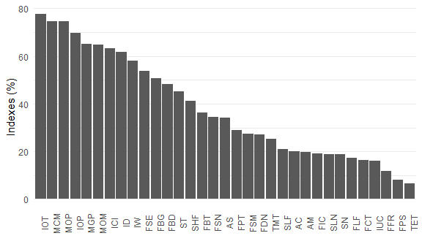

Figure 3: Conservation Concern Level by Activity

Table 4: List of Activities ordered by Conservation Concern Level by Activity

| Activity ID | Activity | MNSA, % |
| --- | --- | --- |
| IOT | Coastal Oil Terminals | 77.6 |
| MCM | Coastal Onshore Mining | 74.6 |
| MOP | Offshore Oil & Gas-condensate Production | 74.6 |
| IOP | Underwater Oil & Gas Pipelines | 69.8 |
| MGP | Offshore Gas Production | 65.2 |
| MOM | Other Offshore Mining | 64.8 |
| ICI | Coastal Infrastructure | 63.4 |
| ID | Dredging | 61.6 |
| IW | Offshore Wind Farms | 58.2 |
| FSE | Seine and Stationary Seine Fishing | 53.6 |
| FBG | Bottom Gillnets Fishing | 50.6 |
| FBD | Dredge Fishing | 48.2 |
| ST | Tankers carrying oil and other petrochemicals | 45.3 |
| SHF | Cargo Vessels - Heavy Fuel Oil | 41.3 |
| FBT | Bottom Trawling | 36.2 |
| FSN | Snurrevad Fishing | 34.3 |
| AS | Seaweed Farms | 34.1 |
| FPT | Pelagic Trawling | 28.9 |
| FSM | Seaweed Mowing | 27.3 |
| FDN | Drift Net Fishing | 27.0 |
| TMT | Mass tourism | 25.2 |
| SLF | Cargo Vessels – Light Fuel Oil | 20.9 |
| AC | Finfish Farms | 20.1 |
| AM | Shellfish Farms | 19.6 |
| FIC | Invertebrates Collection by Divers | 19.2 |
| SLN | Cargo LNG-powered Vessels | 18.9 |
| SN | Nuclear-powered Vessels | 18.9 |
| FLF | Longline Fishing | 17.4 |
| FCT | Pot and Trap Fishing | 16.2 |
| IUC | Submarine Communication Cables | 16.0 |
| FFR | Pole and Line Fishing | 11.8 |
| FPS | Purse Seine Fishing | 8.2 |
| TET | Ecotourism | 6.4 |

CF list by Concern:

Table 5: CF list by Concern

| CF ID | CF Name | MNSCF, % |
| --- | --- | --- |
| 9038 | Polar bear (*Ursus maritimus*), Barents Sea subpopulation, denning grounds | 86.9 |
| 6003 | Little auk (*Alle alle polaris*) breeding colonies | 81.1 |
| 6082 | Thick-billed murre (*Uria lomvia lomvia*) breeding colonies | 80.8 |
| 6037 | Ivory gull (*Pagophila eburnea*) breeding colonies, FJL | 72.1 |
| 2046 | Ringed seal (*Phoca hispida*) whelping grounds, FJL region | 64.8 |
| 6047 | Black-legged kittiwake (*Rissa tridactyla pollicarius*) breeding colonies | 64.0 |
| 7219 | Kelp forests, FJL | 62.8 |
| 1008 | Walrus (*Odobenus rosmarus rosmarus*) haulouts, Spitsbergen and FJL region | 58.7 |
| 7253 | Benthic communities, FJL bank | 53.9 |
| 6053 | Common eider (*Somateria mollissima borealis*) breeding / moulting grounds, FJL | 53.4 |
| 5023 | Beluga (*Delphinapterus leucas*), Barent-Kara-Laptev Seas stock, summer / autumn grounds, FJL | 53.1 |
| 5079 | Narwhal (*Monodon monoceros*), FJL stock, summer grounds / core area | 49.0 |
| 8039 | Biological communities, glacial termini, FJL | 47.8 |
| 7265 | Benthic communities, Barents and Kara sea throughs | 45.1 |
| 1005 | Walrus (*Odobenus rosmarus rosmarus*) winter grounds, Spitsbergen and FJL region | 27.6 |
| 2011 | Bearded seal (*Erignatus barbatus*) whelping grounds, Kara Sea | 27.0 |
| 5045 | Bowhead whale (*Balaena mysticetus*), Spitsbergen population home range, core area | 26.9 |
| 1006 | Walrus (*Odobenus rosmarus rosmarus*) summer grounds, Spitsbergen and FJL region | 26.7 |
| 5046 | Bowhead whale (*Balaena mysticetus*), Spitsbergen population, home range | 24.6 |
| 6009 | Brent goose (*Branta bernicla hrota*) breeding / moulting grounds, Greenland, Spitsbergen and FJL | 19.1 |
| 5080 | Narwhal (*Monodon monoceros*), FJL stock, summer grounds | 18.3 |
| 2020 | Harp seal (*Pagophilus groenlandicus*) feeding grounds, Barents Sea | 16.5 |
| 6015 | Black guillemot (*Cepphus grylle mandti*) breeding grounds | 13.3 |
| 2061 | Ringed seal (*Phoca hispida*) feeding grounds, as predicted by MIZ distribution | 9.3 |
| 6089 | Little auk (*Alle alle polaris*) breeding colonies foraging range buffer | 7.2 |
| 6106 | Thick-billed murre (*Uria lomvia lomvia*) breeding colonies foraging range buffer | 6.3 |
| 9003 | Polar bear (*Ursus maritimus*), Barents Sea subpopulation, home range | 6.0 |
| 6028 | Glaucous gull (*Larus hyperboreus hyperboreus*) breeding grounds | 5.8 |
| 5112 | Arctic Cetaceans - beluga whale (*Delphinapterus leucas*), bowhead (*Balaena myscicetus*), narwhal (*Monodon monoceros*) winter habitats, as predicterd by MIZ | 5.7 |
| 6099 | Black-legged kittiwake (*Rissa tridactyla tridactyla*) breeding colonies foraging range buffer | 5.4 |
| 5090 | Narwhal (*Monodon monoceros*) assumed summer grounds, Russian Arctic | 4.7 |
| 6040 | Ivory gull (*Pagophila eburnea*) postbreeding grounds, Barents and Kara Sea | 4.6 |
| 6096 | Ivory gull (*Pagophila eburnea*) breeding colonies foraging range buffer, FJL | 4.3 |
| 4038 | Polar cod (*Boreogadus saida*) feeding grounds, Barents Sea | 2.6 |
| 4003 | Capelin (*Mallotus villosus villosus*) home range | 2.0 |
| 4045 | Atlantic cod (*Gadus morhua*) feeding / migration grounds | 1.8 |
| 4037 | Glacial cod (*Arctogadus glacialis*) home range | 1.6 |
| 4057 | American plaice (*Hippoglossoides platessoides*), American populations, home range | 1.5 |
| 4041 | Polar cod (*Boreogadus saida*) home range | 1.5 |
| 4059 | Greenland halibut (*Reinhardtius hippoglossoides*) home range, Atlantic Arctic | 1.4 |
| 4032 | Arctic skate (*Amblyraja hyperborea*) home range | 1.3 |
| 4017 | Greenland Shark (*Somniosus microcephalus*) feeding / migration grounds | 1.3 |
| 4046 | Thorny skate (*Amblyraja radiata*) home range | 1.3 |
| 7074 | Benthic communities, I.1.3.2. FJL archipelago straits and coastal waters | 1.0 |
| 7041 | Benthic communities, Transitional Zoogeographic zone, south-eastern Barents - White Sea | 1.0 |
| 7066 | Benthic communities, I.1.1.3. Barents and Kara Seas shelf plains | 1.0 |
| 7067 | Benthic communities, I.1.1.4. Barents and Kara Seas shelf troughs | 1.0 |
| 7068 | Benthic communities, I.1.1.5.1. Barents and Kara Seas shelf banks, shallow (* <100 m*) | 1.0 |
| 7069 | Benthic communities, I.1.1.5.2. Barents and Kara Seas shelf banks, moderate (*>100 m*) | 1.0 |
| 7025 | Benthic communities, Eurasian bathyal Zoogeographic region | 1.0 |

Top CFs by Cover (all with cover above 20%):

Table 6: Top CFs by Cover

| CF ID | CF Name | Cover, % | MNSCF, % |
| --- | --- | --- | --- |
| 5079 | Narwhal (*Monodon monoceros*), FJL stock, summer grounds / core area | 100.0 | 49.0 |
| 6053 | Common eider (*Somateria mollissima borealis*) breeding / moulting grounds, FJL | 100.0 | 53.4 |
| 8039 | Biological communities, glacial termini, FJL | 100.0 | 47.8 |
| 5023 | Beluga (*Delphinapterus leucas*), Barent-Kara-Laptev Seas stock, summer / autumn grounds, FJL | 99.8 | 53.1 |
| 5080 | Narwhal (*Monodon monoceros*), FJL stock, summer grounds | 99.5 | 18.3 |
| 2046 | Ringed seal (*Phoca hispida*) whelping grounds, FJL region | 92.2 | 64.8 |
| 6037 | Ivory gull (*Pagophila eburnea*) breeding colonies, FJL | 86.4 | 72.1 |
| 7253 | Benthic communities, FJL bank | 80.2 | 53.9 |
| 7219 | Kelp forests, FJL | 80.0 | 62.8 |
| 6003 | Little auk (*Alle alle polaris*) breeding colonies | 79.8 | 81.1 |
| 9038 | Polar bear (*Ursus maritimus*), Barents Sea subpopulation, denning grounds | 65.0 | 86.9 |
| 7074 | Benthic communities, I.1.3.2. FJL archipelago straits and coastal waters | 57.4 | 1.0 |
| 6096 | Ivory gull (*Pagophila eburnea*) breeding colonies foraging range buffer, FJL | 50.2 | 4.3 |
| 6089 | Little auk (*Alle alle polaris*) breeding colonies foraging range buffer | 38.0 | 7.2 |
| 6009 | Brent goose (*Branta bernicla hrota*) breeding / moulting grounds, Greenland, Spitsbergen and FJL | 34.0 | 19.1 |
| 6028 | Glaucous gull (*Larus hyperboreus hyperboreus*) breeding grounds | 24.1 | 5.8 |
| 1005 | Walrus (*Odobenus rosmarus rosmarus*) winter grounds, Spitsbergen and FJL region | 21.8 | 27.6 |
| 7041 | Benthic communities, Transitional Zoogeographic zone, south-eastern Barents - White Sea | 21.7 | 1.0 |