**Assignment 4**

1. What is the super class of Circle and Rectangle?

ANS GeometricObject class

1. What methods called in Circle and Rectangle objects are inherited from the superclass?

ANS getDateCreated(), getColor() and isFilled()

1. In Triangle class, which method(s) is/are overriding method(s)? Why?

ANS toString() method because toString is a method in Object class

1. Answer the following sub questions. Snapshot your screen to show to support your answers
   1. 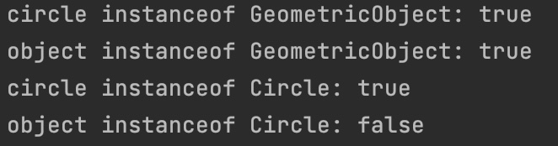
   2. Yes
   3. No

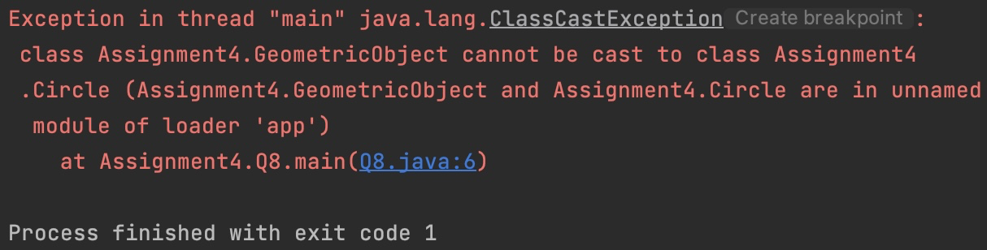

1. Show your result when you compare these two Circle objects implicitly casted to Object type in your main method as shown below



1. Replace the equals method in Step. 9 with the equals method (a) in Circle class. What would be the output when you run Step. 10 again? Which equals method (in Circle or in its superclass) is called?

1. Then, if Object is replaced by Circle in the main method, what would be the output when you run Step. 10 again? Explain your result.



ANS since you use equals method(a) it will not override equal method of Object class so when you called it will use equal method of Object class.