Лекция 14

ПСКП, ПОИТ-3

**Node.js: GraphQL**

1. **GraphQL:** формальныйязык запросов;особенности: позволяет делать агрегированные запросы (можно в одном запросе запросить все необходимые данные), использует систему типов.

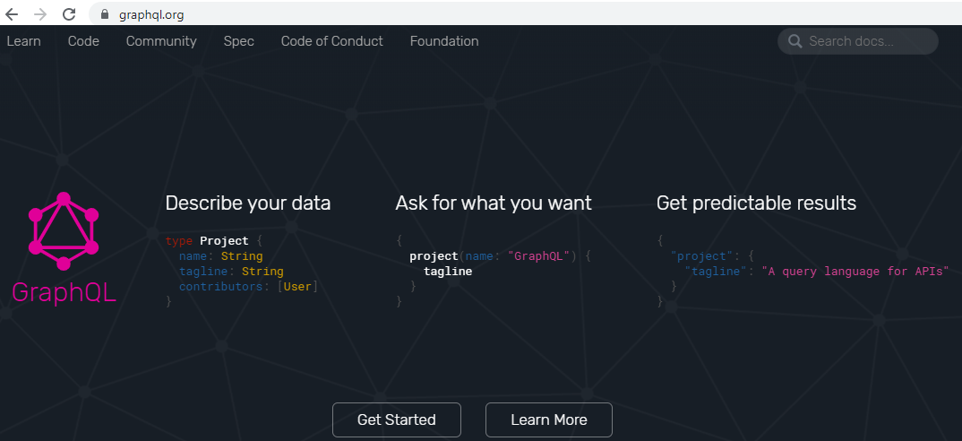

1. **GraphQL:** diskstation, /Для_студентов_ФИТ_БГТУ/ЛИТЕРАТУРА/GRAPHQL
2. **GraphQL:** несколько реализаций: **Node.js**, Java, .NET C#, Python,…
3. **GraphQL:** npm install **graphql**, <https://graphql.org/graphql-js/>
4. **GraphQL:** основные компоненты: **schema**, **query/mutation/subscription**, **resolvers**.
5. **GraphQL:** архитектура



1. **GraphQL:** схема, SDL (Schema Definition Language), .gql/.graphql

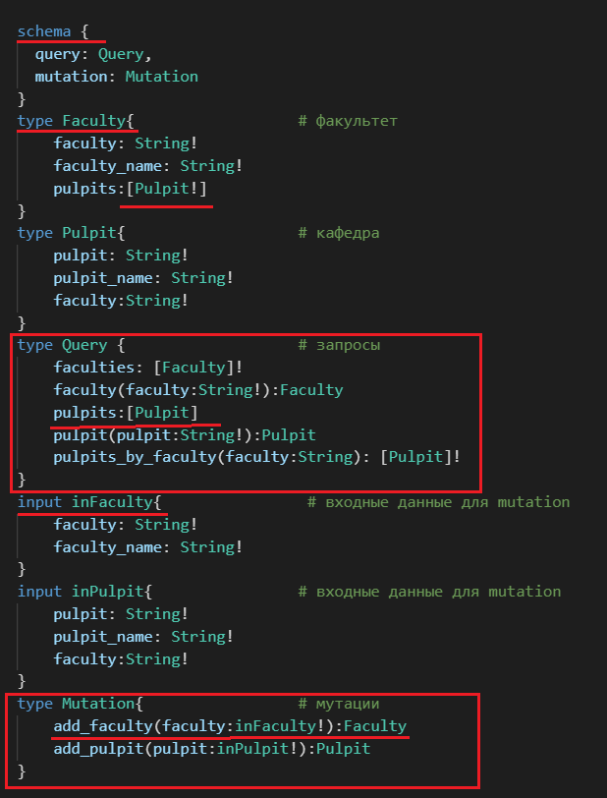

1. **GraphQL:** query, execute

|  |  |
| --- | --- |
| query {      faculties {          faculty,          faculty_name,          pulpits {              pulpit          }      }  } |  |

1. **GraphQL:** schema, resolvers, context

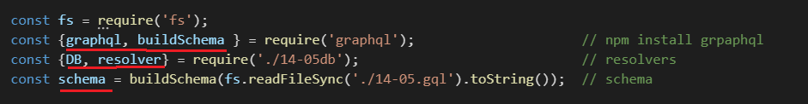

1. **GraphQL:** graphql, schema, resolvers, context(DB)

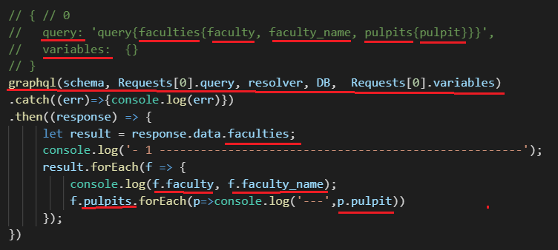

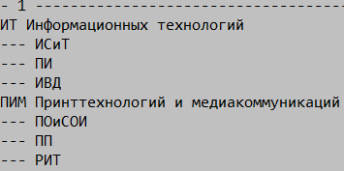

1. **GraphQL:** graphql, schema, resolvers, context(DB)

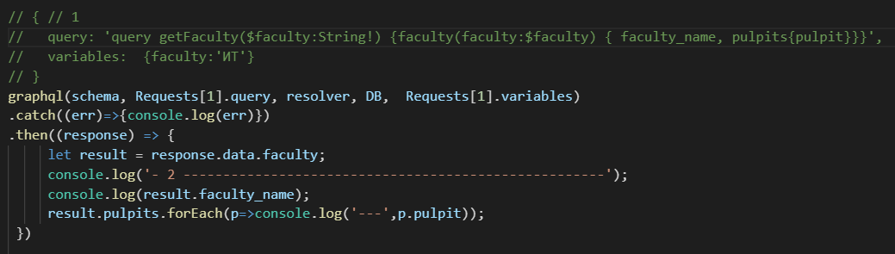

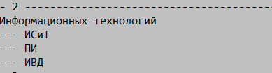

1. **GraphQL:** graphql, schema, resolvers, context(DB)

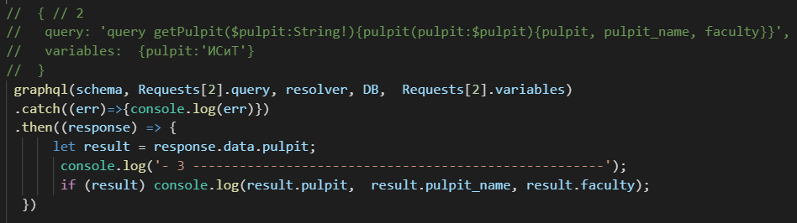



1. **GraphQL:** graphql, schema, resolvers, context(DB)

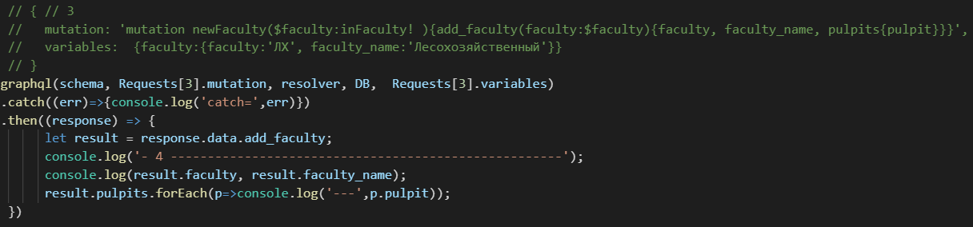



1. **GraphQL:** graphql, schema, resolvers, context(DB)

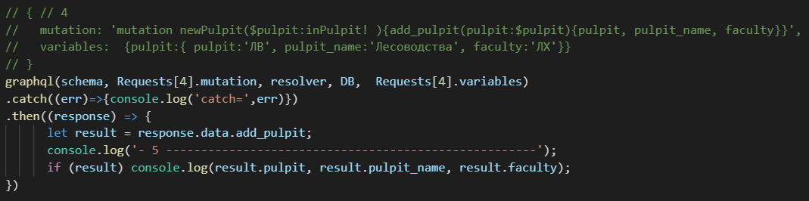



1. **GraphQL:** graphql, schema, resolvers, context(DB)

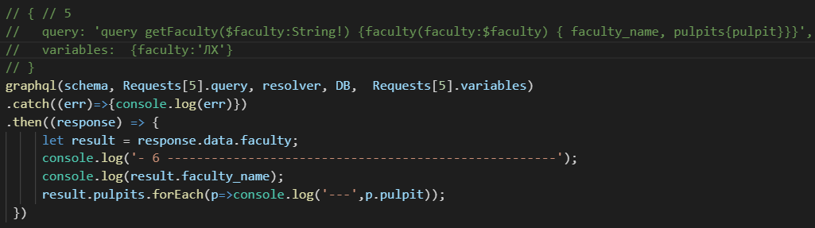



1. **GraphQL:** schema, query, mutation



1. **GraphQL:** query, mutation, resolvers

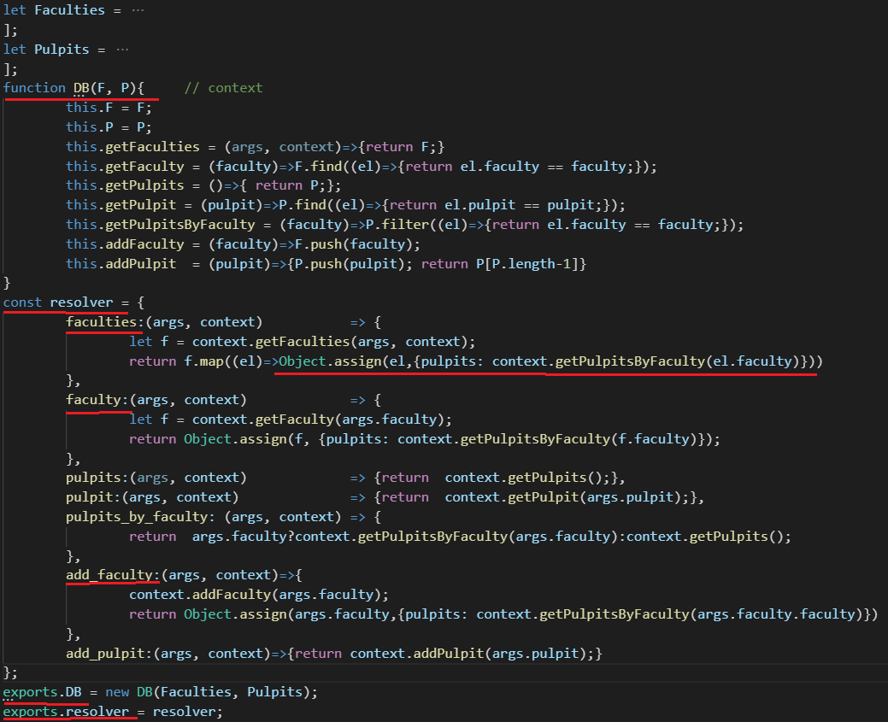

1. **GraphQL:** http, graphql, postman

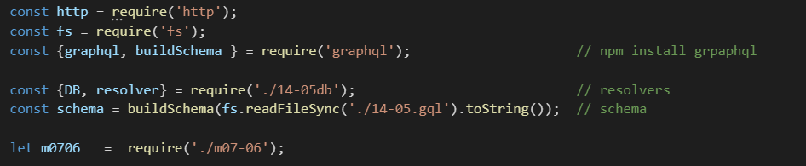

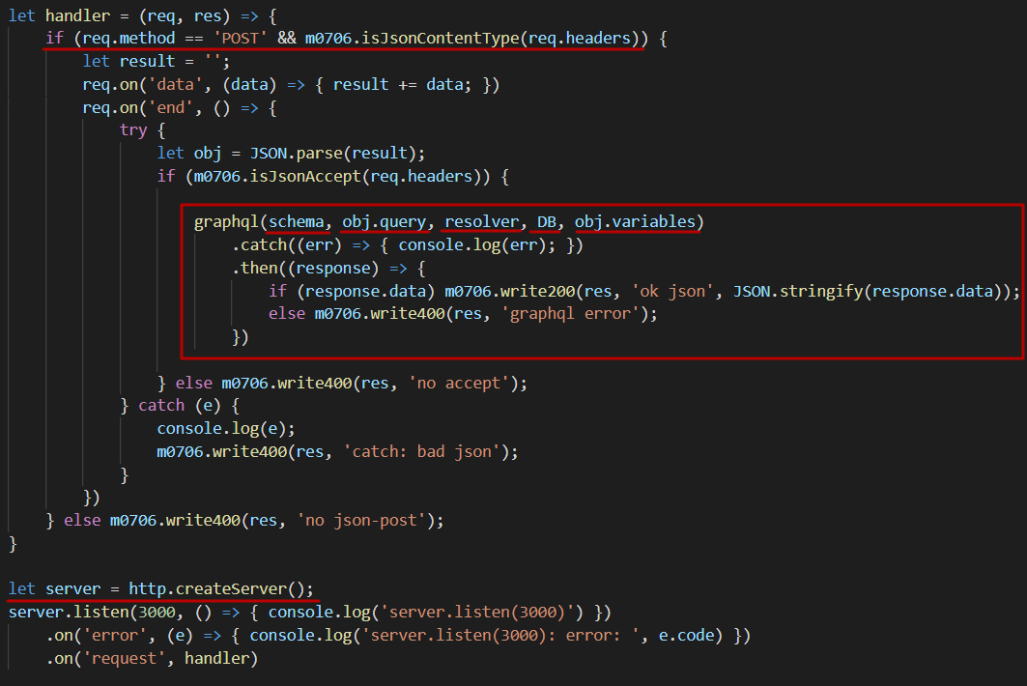

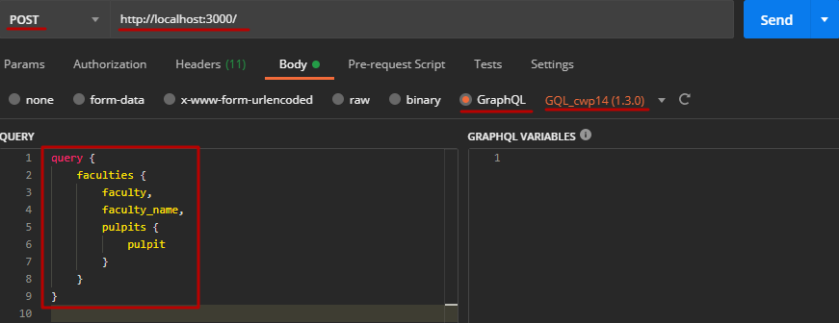

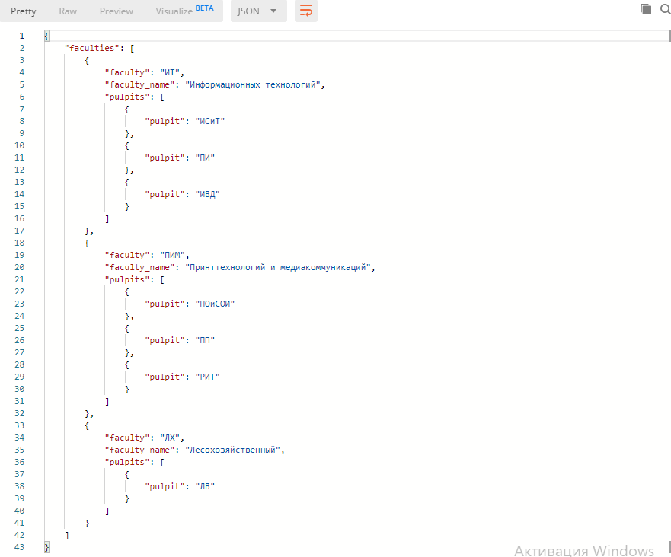

1. **GraphQL:** http, graphql, mssql

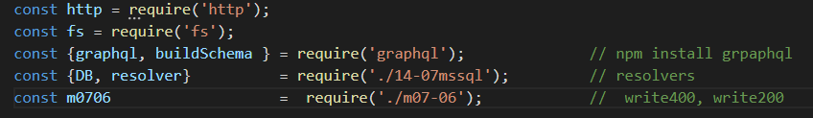

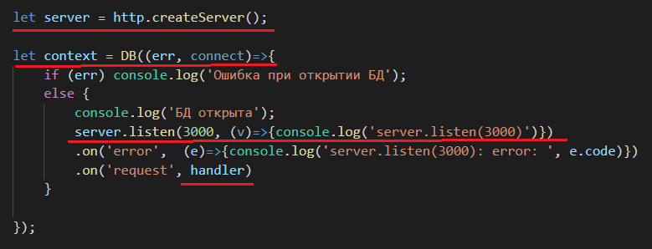

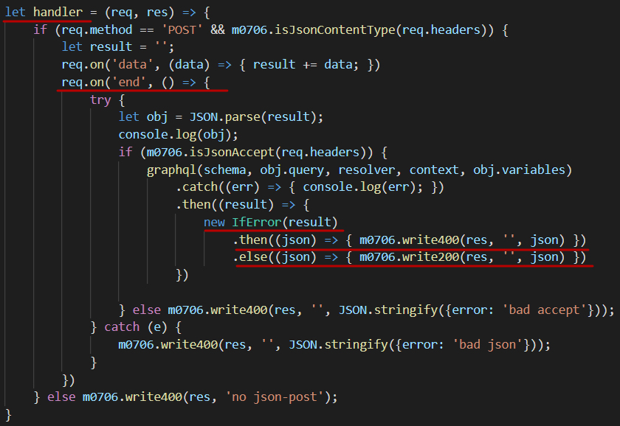

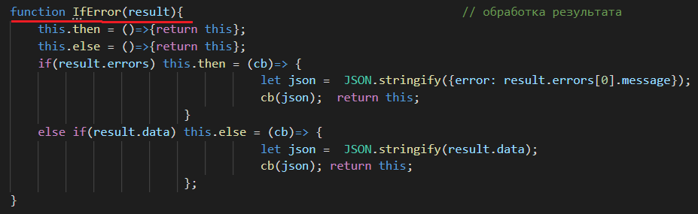

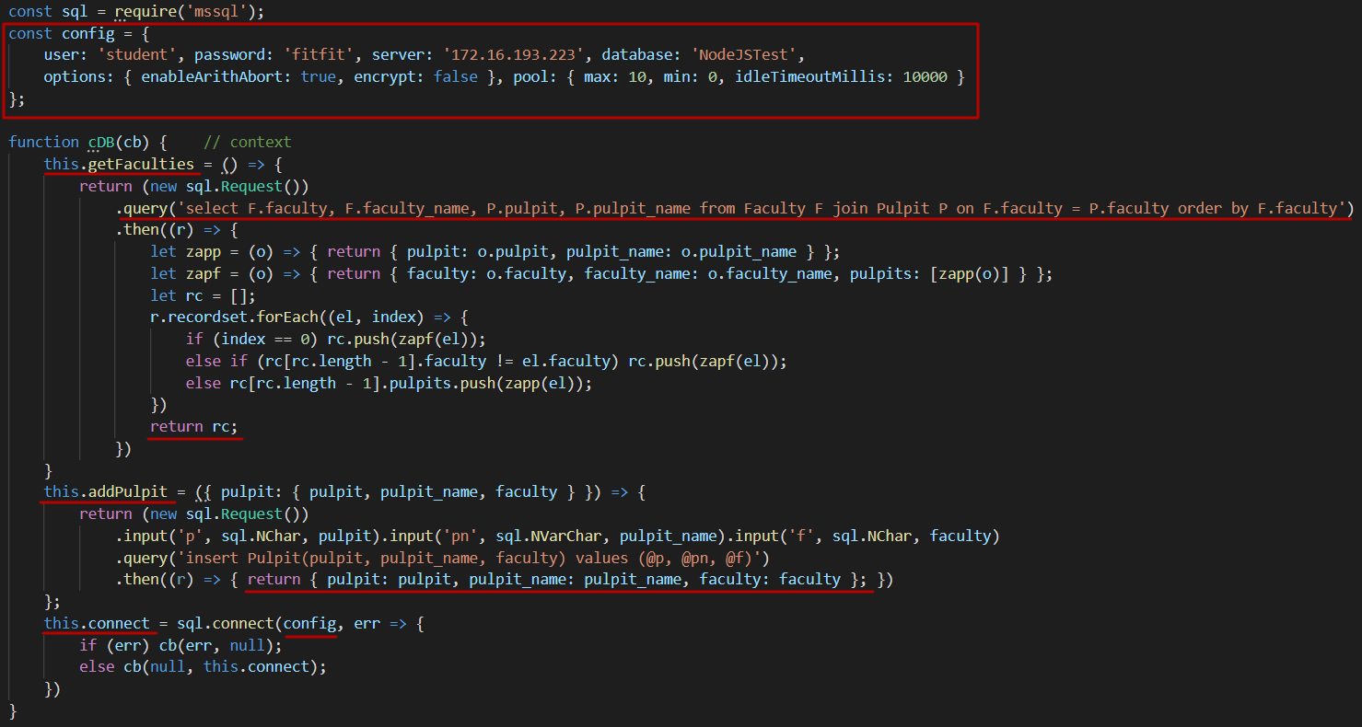

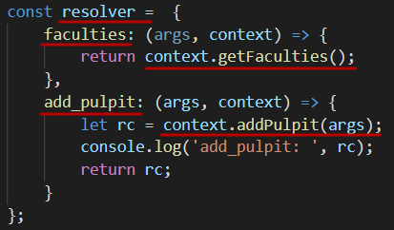

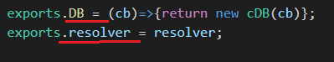

1. **GraphQL:** npm install **graphql-tools**
2. **GraphQL:** enum, interface, union, inline fragment, fragment

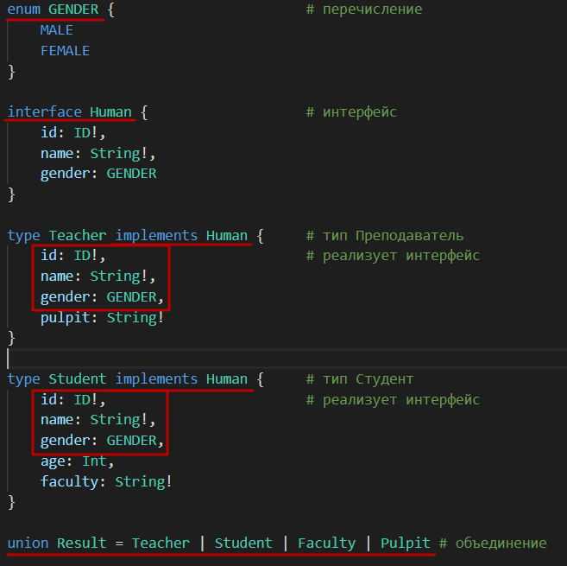

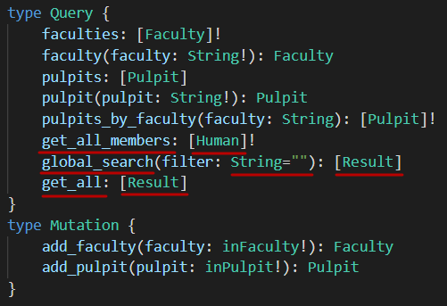

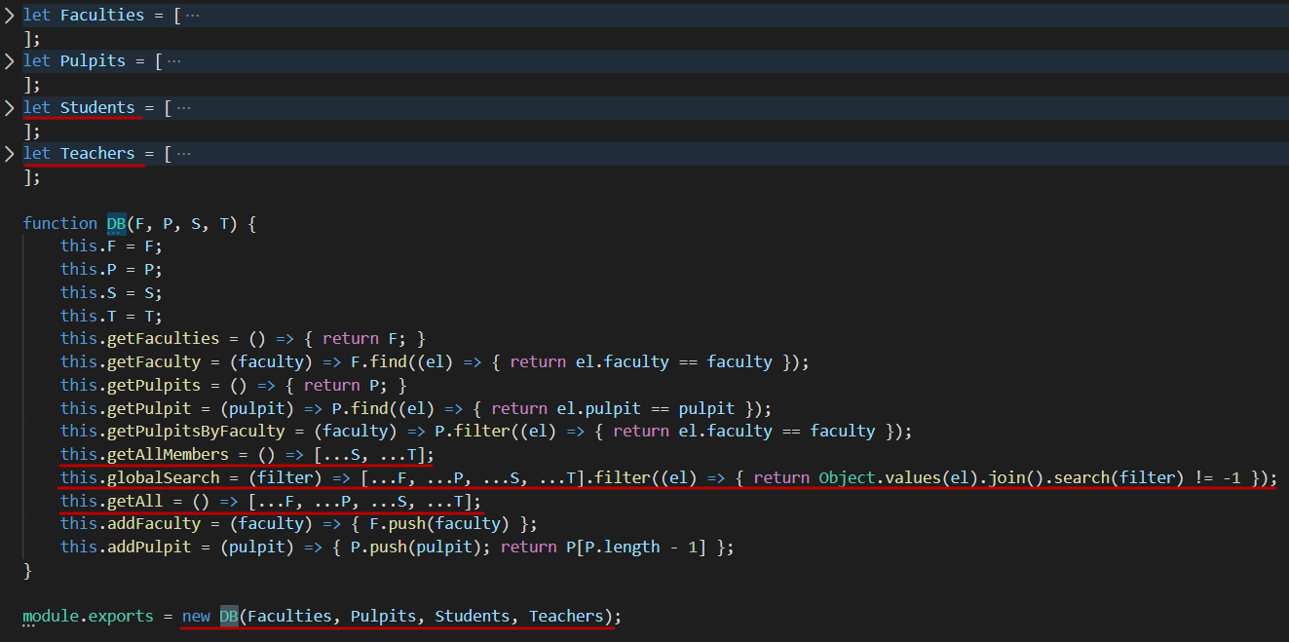

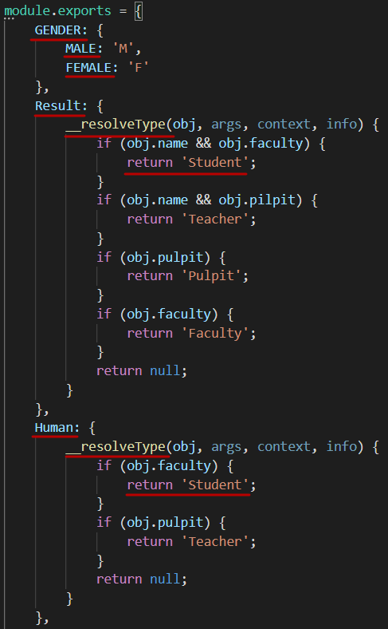

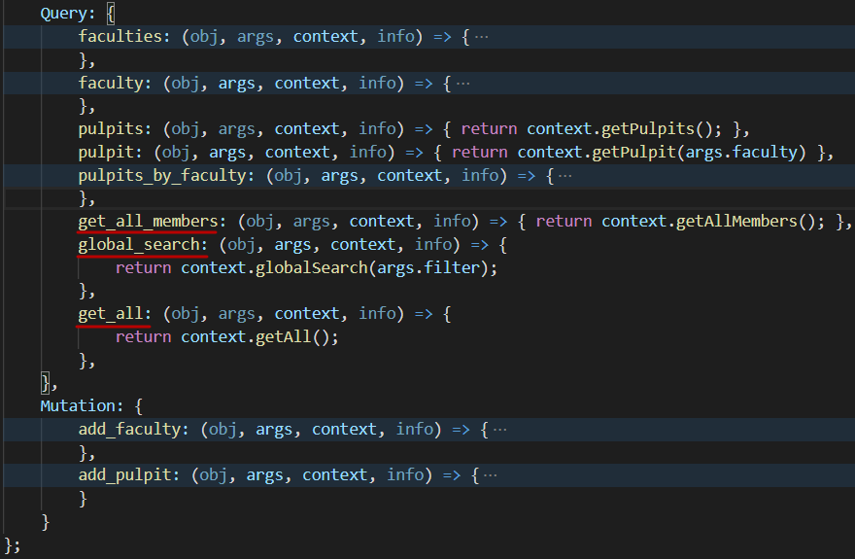

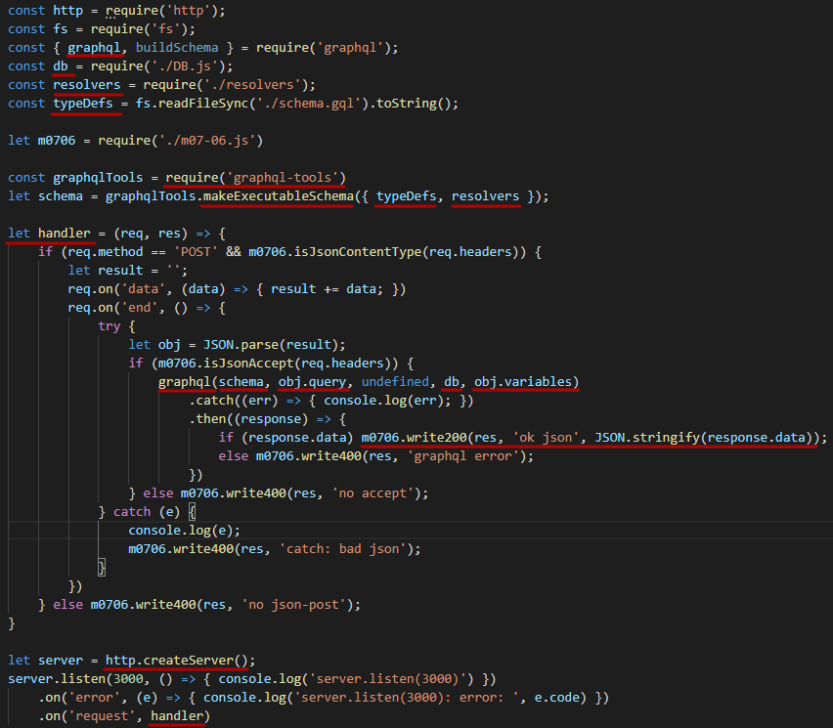

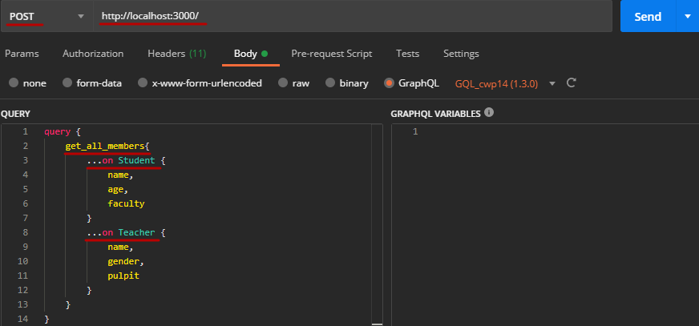

|  |  |
| --- | --- |
|  |  |
|  |

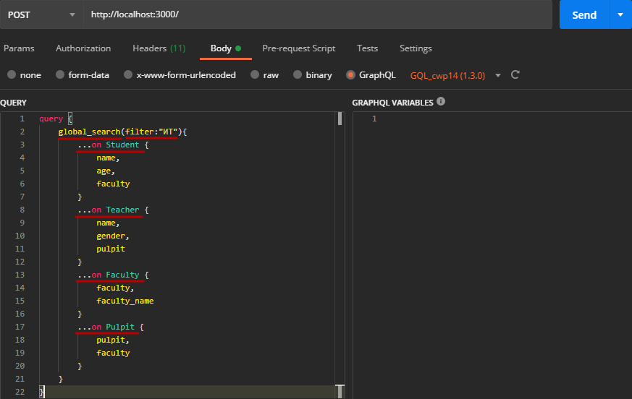

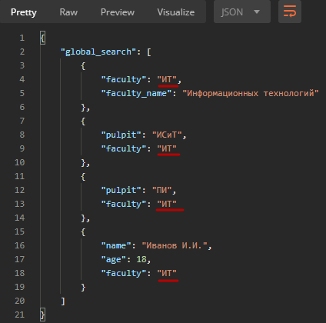

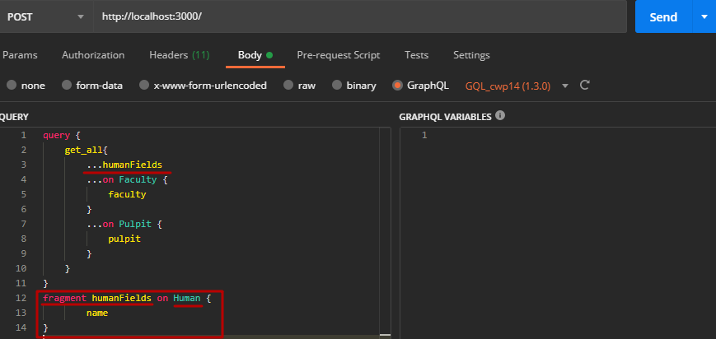

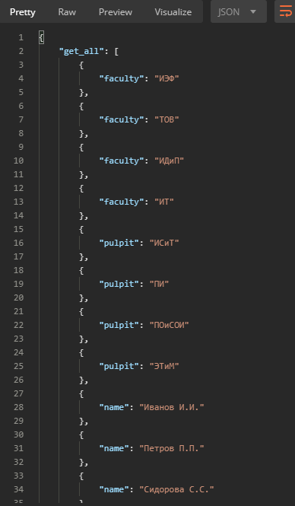

1. **GraphQL:** npm install **graphql-subscriptions**
2. **GraphQL:** npm install **subscriptions-transport-ws**
3. **GraphQL:** subscription

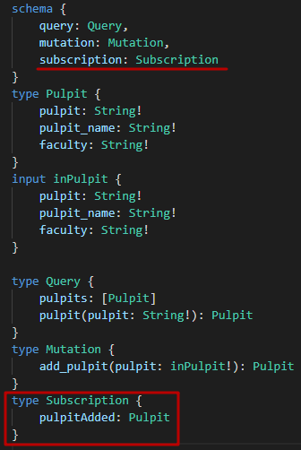

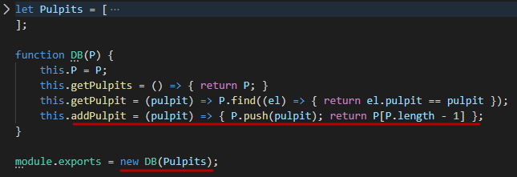

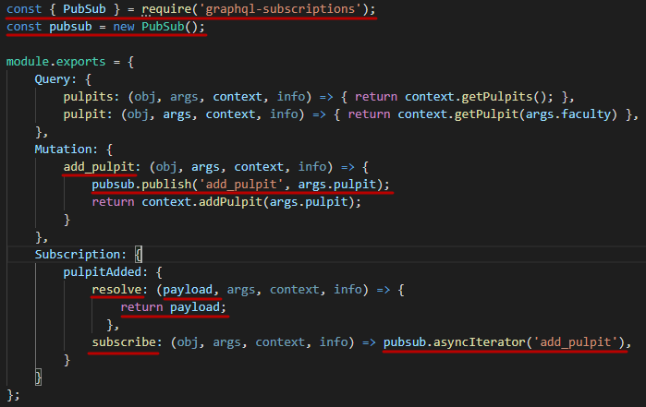

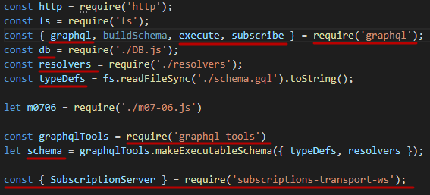

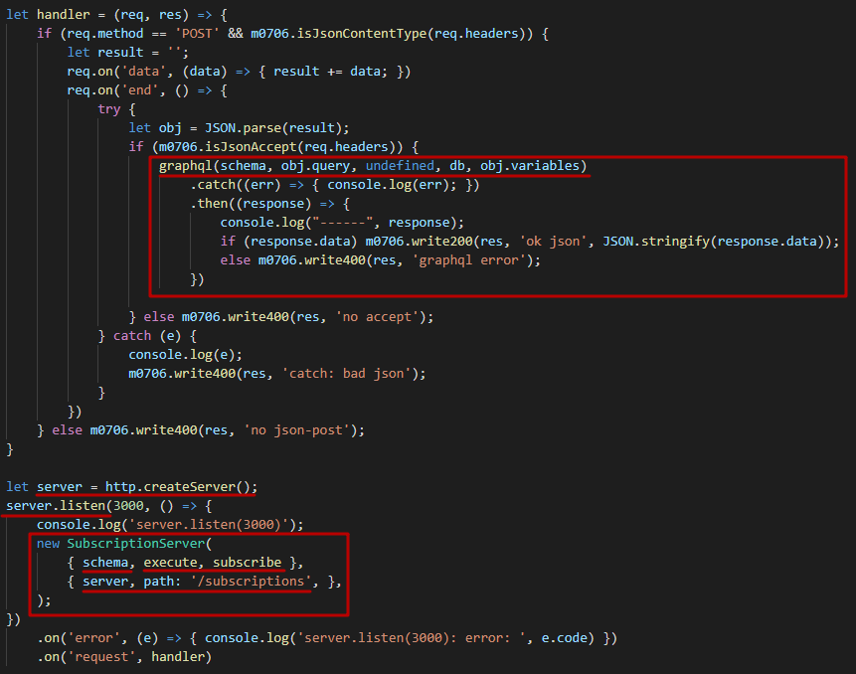

1. **GraphQL:** client**,** npm install **graphql-subscriptions-client**

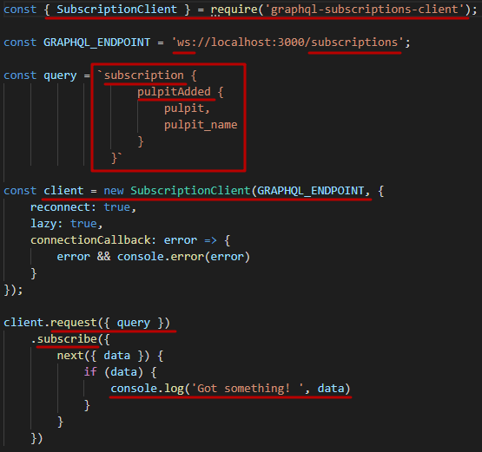

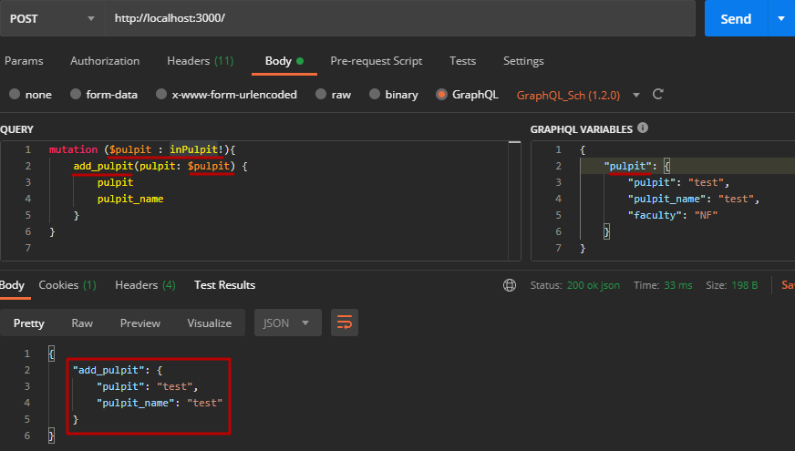



1. **GraphQL:** рекомендуется использовать какую-либо реализацию PubSubEngine из пакета graphql-subscriptions (например, graphql-google-pubsub, graphql-redis-subscriptions, graphql-postgres-subscriptions, …)
2. **GraphQL:** field resolvers, 1 способ

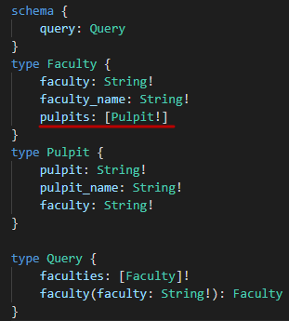 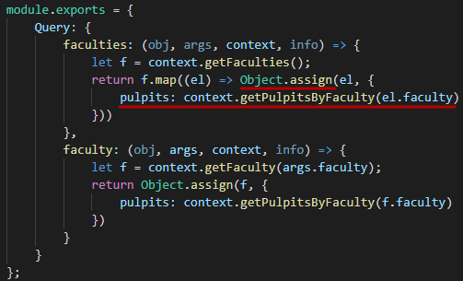

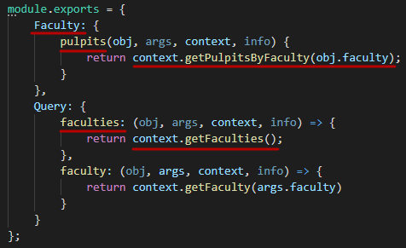

1. **GraphQL:** field resolvers, 2 способ

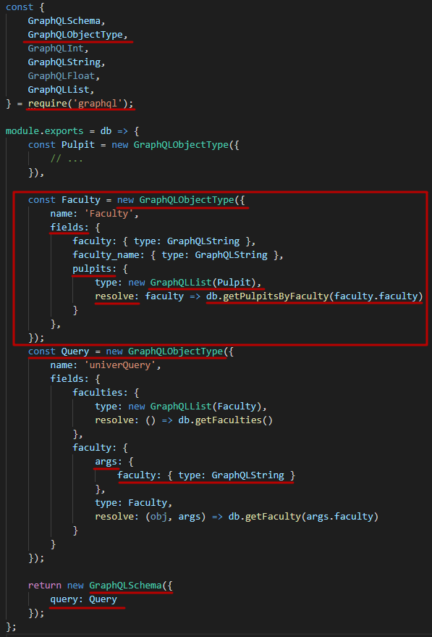

1. **GraphQL:** GraphQL IDE**: Postman, GraphiQL, GraphQL Playground, …**
2. **GraphQL:** GraphQL client**:** запросы с помощью **fetch и др., graphql-request, Relay, Apollo Client, …**