**The WEIRD problem in a “non-WEIRD” context: A meta-research on the representativeness of human subjects in Chinese psychological research**

Lei Yue 1, 2, Xi-Nian Zuo 3,Hu Chuan-Peng 1*

1. School of Psychology, Nanjing Normal University, Nanjing, China.

2. School of Psychology, Central China Normal University, Wuhan, China.

3. State Key Laboratory of Cognitive Neuroscience and Learning, International Data Group/McGovern Institute for Brain Research, Beijing Normal University, Beijing, China.

**\*Corresponding author:** Hu Chuan-Peng, School of Psychology, Nanjing Normal University, No. 122 Ninghai Road, Gulou District, Nanjing, China;

Email: hu.chuan-peng@nnu.edu.cn, or, hcp4715@hotmail.com

**Abstract**

Psychological science aims at understanding human mind and behavior, but it primarily relies on subjects from Western, Educated, Industrialized, Rich, and Democratic regions, i.e., the WEIRD problem. This lack of diversity and representativeness of subjects compromised the generalizability of psychological science. To address this issue, large-scale international collaborative projects were initiated, and more data are collected from non-WEIRD regions. However, it is unknown whether subjects from “non-WEIRD” regions can represent their local population. In this meta-research, we plan to survey the characteristics of Chinese subjects reported in empirical studies published in five mainstream Chinese psychological journals and in large-scale international collaborations. The results will provide a realistic picture of Chinese participants in psychology, and we will discuss potential solutions to the issue of representativeness in both China and worldwide.

**Keywords:** Meta-science; Population psychology; Representativeness; WEIRD; Generalizability

**1 Introduction**

Psychological science aims at understanding human mind and behaviour. However, it largely relies on unrepresentative human samples: most human participants in published psychological studies are undergraduate students who take psychology courses from “Western, Educated, Industrialized, Rich, and Democratic” (WEIRD) regions (Henrich et al., 2010; Henry, 2008; Sears, 1986). For example, Arnett (2008) analysed articles in six premier American Psychology Association (APA) journals and found that 96% relied on samples drawn from Western industrialized nations (Europe, North America, Australia, or Israel). More recent surveys found little change in the past decade (Nielsen et al., 2017; Pollet & Saxton, 2019; Rad et al., 2018). However, the population in WEIRD regions is only consistent less than ¼ of the global population (Henrich et al., 2010). The lack of representativeness in psychological science and related fields (such as cognitive neuroscience, (Zuo et al., 2019)) limits our understanding of the whole picture of human mind and behavior (Apicella et al., 2020; Barrett, 2020; Jones, 2010)[1] and may lead to incorrect policies (Arnett, 2008). This issue, combined with other methodological issues, created a generalizability crisis in psychology (Yarkoni, 2020).

As a starting point to solve this problem, researchers in the field started to include more diverse data. Many international collaborative projects have been initiated (Gordon et al., 2020; Moshontz et al., 2018). Typically, these projects invite collaborators globally, especially those from non-WEIRD regions, such as Asia, Middle East, Latin America, and Africa. These efforts are applaudable and indeed increased the geographical diversity and sample size of psychological science. These projects, however, have not examined whether data collected from non-WEIRD regions are representative of the local population. Left this issue unaddressed, these large collaboration projects may create an illusion that the representativeness problem can be solved by involving more researchers from non-WEIRD regions, ignoring the fact that data collected from non-WEIRD regions may suffer a problem of representativeness (see also Forscher et al., 2021). In fact, there are great variations within non-WEIRD regions (Ghai, 2021). However, the convenient sampling method employed by psychologists will cause the problem of unrepresentativeness in both WEIRD and non-WEIRD regions.

To understand how representative is the sample in psychological research from a typical non-WEIRD, China, we propose to survey the studies conducted by Chinese psychological researchers. China is the second-largest economy and has the largest population in the world, yet with a very different history and cultural tradition from the West. In recent years, Chinese researchers have actively participated in international collaborations (e.g., Human Penguin Projects, Many Labs 5, Psychological Science Accelerator). However, it is unknown whether Chinese psychological participants represent the Chinese population. By the word “represent”, we mean the sample in a study (or studies) should be a miniature of the targeted population without selection biases, or theoretically can be a miniature of the targeted population and without selection bias (Kruskal & Mosteller, 1979a, 1979b, 1979c, 1980; Kukull & Ganguli, 2012).

In the current study, we will explore the representativeness of Chinese psychological participants by examining three issues (see Figure 1). Firstly, whether the characteristics of Chinese samples reported in large-scale international collaborations are similar to those reported in Chinese psychological journals. Secondly, to what extent the Chinese participants in psychological science represent the Chinese population, as compared with the census data from the National Bureau of Statistics of China and data from a large-scale social survey, Chinese Family Panel Study (CFPS). Lastly, we will explore the shared and distinct patterns of Chinese samples and samples from other regions. In addition, we will provide preliminary evidence about the “default participant” in Chinese psychological research. And we will compare the similarities and differences between the keywords of the big team projects and Chinese journals’ articles based on bibliometric methods.

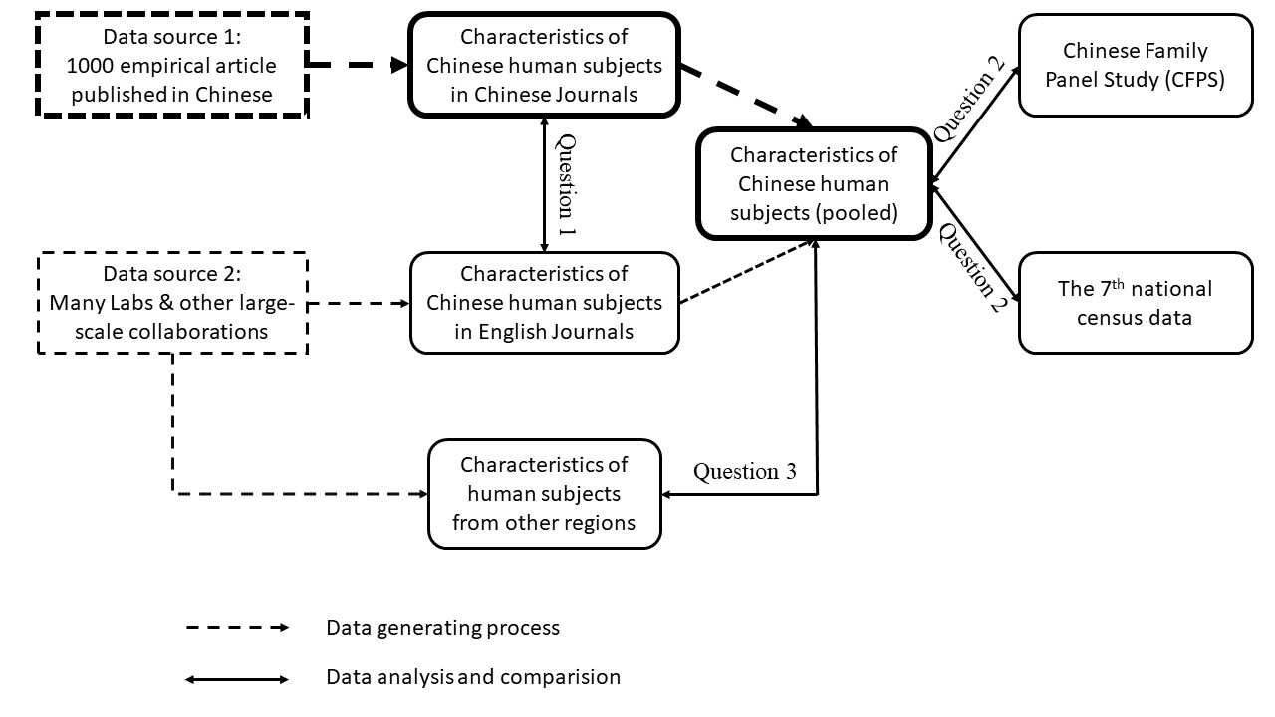

Figure 1. Schema of the current meta-research. Question 1: Whether characteristics of Chinese participants reported in large-scale international collaboration are similar to those reported in Chinese psychological journals, given they have the same target population; Question 2: To what extent the Chinese participants in psychological science can represent their target population, e.g., the whole population of census data from the National Bureau of Statistics of China and from a large-scale social survey, Chinese Family Panel Study (CFPS); Question3: What are the shared and distinct patterns of Chinese participants and participants from other regions?

**2 Method**

**2.1 Data sources**

Data will come from two sources. The first data source is 1000 empirical studies published in five mainstream Chinese journals: *Acta Psychological Sinica, Journal of Psychological Science, Chinese Journal of Clinical Psychology, Psychological Development and Education, Psychological and Behavioral Studies*. These journals are chosen because the following reasons. First, these five journals are indexed by CSSCI (Chinese Social Sciences Citation Index), which is regarded as authoritative and comprehensive database for bibliometric studies of China’s social sciences (e.g., Gong & Cheng, 2022). Thus, all these five journals are selected as of high-quality among all Chinese psychological journals. Second, these five journals cover most fields of psychology. Among them, *Acta Psychological Sinica*, *Journal of Psychological Science*, and *Psychological and Behavioral Studies* are comprehensive journals, studies from all sub-fields of psychology are included; *Psychological Development and Education* is the only journal for developmental and educational psychology in China; *Chinese Journal of Clinical Psychology* focuses studies in clinical psychology and mental health. Of 1000 empirical papers, 500 were published between 2017 to 2018 that were selected by Wang et al. (2021). Another 500 papers will be selected from the same five journals but published at different time points. To be specific, we will select 250 articles published in 2008 and 250 articles in 2020~2021. The criteria and procedure of article selection, same as Wang et al. (2021), are described as below:

Step 1: Assigning identifiers to articles. For papers published in different periods, we will obtain information of all the papers published in those journals in three different periods and assign a unique identifier to each article. Each article ID has 8 digits. The first four number represents the selected period (we will use 2008, 2018, 2021 to represent articles from three different periods), the fifth number represents the journal ID, from 1 to 5, and the last three number represent the order of the paper in the journal. For example, the first article in *Acta Psychologica Sinica* from 2008 is coded as 20081001, the second article in *Acta Psychologica Sinica* at the same year is coded as 20081002. All articles and their ID can be found at https://osf.io/avb7t/?view_only=a7e4610491374093851fc2b7da57e85c.

Step 2: Random sampling from all articles. We will use the `*sample*` function of R base to randomly select a certain number of papers from all the papers in each journal (see the code at https://osf.io/avb7t/?view_only=a7e4610491374093851fc2b7da57e85c). The number of papers sampled from each journal will be weighted by the total number of papers published in that year (the total papers each period and the number of sampled papers, see Table 1). After getting the identifiers of the selected papers, two independent researchers will check each article to make sure that it is an empirical study. If not, we will replace the article with the empirical article, which has the smallest distance to the article whose identifier is sampled.

The second source of data will come from large-scale international collaborations that are aimed at addressing the WEIRD problem. More specifically, we will check the data from all Many Labs projects (especially Man Lab 2 (Klein et al., 2018)), the Human Penguin Project (Hu et al., 2019; IJzerman et al., 2018), and all finished projects from PSA (Jones et al., 2021; Wang et al., 2021). These projects were chosen because they opened raw data. If possible, we will also include data from other large-scale collaborations which contain samples from China. We will search and extract demographical characteristics of Chinese samples and other samples reported in those studies.

Table 1 The number of articles in five Chinese Psychological Journals

|  |  |  |  |
| --- | --- | --- | --- |
| Journal | 2008 | 2017~2018 | 2020~2021 |
| *Acta Psychological Sinica* | 138 (39) | 246 (95) | 91 (28) |
| *Journal of Psychological Science* | 379 (107) | 299 (115) | 203 (61) |
| *Chinese Journal of Clinical Psychology* | 227 (64) | 379 (146) | 310 (94) |
| *Psychological Development and Education* | 87 (24) | 162 (62) | 95 (29) |
| *Psychological and Behavioral Studies* | 57 (16) | 213 (82) | 125 (38) |

*Note:* Each column includes the total number of articles published in each journal at that time interval and the number of articles selected (inside parentheses)

**2.2 Articles code**

We will extract the data from the first source. The data extraction procedure has three stages: pre-coding, coding, and proofreading.

In the pre-coding stage, we first developed the initial version code manual based on the previous study (Arnett, 2008; Nielsen et al., 2017; Pollet & Saxton, 2019; Rad et al., 2018). Then, at least two coders will code ten random articles independently, they will compare the results, resolve the differences and revise the manual. After that, they will code another ten articles and compare the results and revise the coding manual again. This procedure will iterate until the disagreement between two coders is negligible.

When the formal coding manual is established, we will start to code all 1000 papers. In this stage, we will randomly divide the 1000 papers into several parts. For each part, there will be two coders who independently extract data from papers based on the coding manual. Each coder will go through the methods section and further inspect the data used in those studies. Note that studies used secondary data, data from web or app scraping, large-scale databases or using animals, or case studies will be excluded. For the remaining studies, we will extract the following information of the study: articles IDs, article title, study number, participants’ group, study type, sample type, sample size, sampling method, and methods for participant recruitment. More importantly, we will extract all information, if available, about participants: sex, age, socio-economic status, educational attainment, ethnicity, occupation, religion, and region for participants' recruitment.

Given that representativeness depends on the target population, we will also read the conclusion or other parts of articles to extract statements about the target population to which studies were intended to be generalized. However, representativeness has not been taken seriously in the field (see, Thalmayer et al., 2021). This situation is similar to causality in psychology (Grosz et al., 2020): researchers may use vague statements about representativeness or generality. Our initial coding, based on a few papers from the same 5 journals but not the final sample of papers, suggested that it is difficult to code the target population. To make the coding task more doable, we added the two items related to the target population (or generality) in our coding manual. The first item is the target population to which the studies intended to generalize. We will divide all the subjects into four categories: stated specific population; inferred specific population; inferred general population; stated general population. The second item is the exact sentences/words excerpted from the full text of the paper that is associated with the statement about the target population. The coder will be instructed to search sentences related to the target population in the conclusion section of the papers. If no related information was found, they will search for information in other parts of the articles (firstly introduction, and then, results or other parts). These two items will code both the target population but also keep the transparency of the coding process. See the supplemental document "Code_Manual_Chin_Subj_V2" for more details (https://osf.io/avb7t/?view_only=a7e4610491374093851fc2b7da57e85c).

Additionally, we will export the keywords of Chinese journals’ articles and the big team projects through CNKI (China National Knowledge Infrastructure) and Web of Science, and then, if feasible, try to use bibliometric methods to compare the similarities and differences between the keywords of the big team projects and Chinese journals’ articles. Also, we will record when did researchers do not report details of the sample to provide preliminary evidence about the “default participant” in Chinese psychological research. Specifically, we will first recode whether the articles mention participants' information in the abstract. And then we will code distinguish studies that relied only on college students’ samples and studies used other samples. We will then compare the percentage of mentioned and not mentioned in two groups of studies (see below for the template of our table 2).

Table 2. Different study types and their sample mentions.

|  |  |  |  |
| --- | --- | --- | --- |
| Study type | Samples mentioned | Sample not mentioned | Total |
| Only college students |  |  |  |
| College students & other populations |  |  |  |
| Only sample outside colleges |  |  |  |
| Total |  |  |  |

To ensure the accuracy of the coding content, the results from the two coders are compared after completing the initial coding. Two coders rate the consistency of each article from 0 to 1, with 0 represents completely different and 1 represents identical. This consistency score will be then used for calculating the inter-rater reliability. We will use the R package *irr* for this index (Gamer et al., 2019).

**2.3 Data analysis**

We will use R 4.1.1 to pre-process and visualise data (R Core Team, 2021) and Bayes factor analyses. Bayes factor was chosen because it can provide evidence for both null hypothesis and the alternative hypothesis (Dienes, 2016; Dienes & Mclatchie, 2018; Hu et al., 2018; Wagenmakers et al., 2018). Given that the final data are count data that distributed in different categories of certain dimensions (e.g., sex, age bins), we will use Bayesian multinomial test (corresponding to frequentists’ goodness-of-fit test or χ2) to test whether data from two sources differ from each other on certain dimension (e.g., sex, age, education attainment).

The multinomial distribution is a generalization of the binomial distribution to variables that can take values in categories. The parameters of multinomial is a vector of probabilities, , with which *N* observations are distributed across *K* categories. The distribution of the parameters of multinomial distribution follows a Dirichlet distribution with concentration parameters , where each is larger than zero. In Bayesian multinomial test, the null hypothesis (*H0*) is a point hypothesis that the parameters, , of the observed percentage data equal to the expected, which is a point in the Dirichlet distribution, see Sarafoglou et al. (2020) for details. Usually, the *H0* is tested against the encompassing hypotheses, or alternative hypothesis (*Ha*), that all category proportions are free to vary. See the details of testing our first question below.

**2.3.1 Data analysis plan for the first question**

Our first question is whether there are differences between Chinese human subjects reported in Chinese journals and in large-scale international collaborative projects. Given that studies from Chinese psychological journals may have different target populations as compared to international collaborative projects, we compare samples from studies that share the same target population. More specifically, only if articles from Chinese psychological journals and international collaborative projects targeted the general population (inferred or stated Chinese population or humans), we will compare their sample characteristics. In the same vein, samples from other shared target populations by both Chinese psychological journal articles and international collaborative projects, e.g., adolescents, will also be compared.

We will first visualize the proportion of the reported information of subjects in several dimensions (e.g., sex ratio). These visualizations will provide intuitive information.

Then, we will compare subjects from Chinese psychology journals and Chinese subjects from international collaborative projects with regard to sex, age, educational attainment, and, if possible, geographical distribution. As mentioned above, we will use Bayes multinomial test for our statistical inference. Here we elaborate on how to compare the two data in terms of sex ratio and age. In the final analysis, we may also include educational attainment geographical distributions. We implement Bayesian multinomial test using R code based on JASP 0.16.4 (see the R script in R Notebook for more details).

***Sex ratio*** We will test whether the sex ratio of subjects from international collaborative projects (observed data) is sampled from a distribution with parameters equal to the proportions of data extracted from Chinese psychology journals (expected data). The *H0* and *Ha* are specified as below:

*H0*: the observed data are sampled from a multinomial distribution with a parameter *P* = *Pr*(*x1*, *x2* | *n* = *N*, *p1*, *p2*), where (*p1*, *p2*) equals to expected data, which is a fixed point in d *Dirichlet* distribution.

*Ha*: the observed data are sampled from a binomial distribution with parameter *P* = *Pr*(*x1*, *x2* | *n* = *N*, *p1*, *p2*), where (*p1*, *p2*) is distributed as a Dirichlet distribution with concentration parameter .

We will use the Bayesian multinomial test for hypothesis testing. The prior is non-informative prior, i.e., *Dirichlet*. Bayes factor will be interpreted as recommended in (Wagenmakers et al., 2018): *BF10* >= 10 or log(*BF10*) >= 2.303 means strong evidence for *Ha*, and 6 <= *BF10* < 10 or 1.792 <= log(*BF10*) < 2.303 means moderate evidence for *Ha*, *BF10* <= 1/10 or log(*BF10*) <= -2.303 means strong evidence for *Ha*, and 1/10 <= *BF10* < 1/6 or -2.303 <= log(*BF10*) < -1.792 means moderate evidence for *H0*.

We conducted a simulation to check whether the non-informative prior is reasonable when using the criterion of BF >= 6 . Firstly, we choose the smallest effect size of interest based on data from Rad et al (2018). From the supplementary material of Rad et al (2018), we found 21 papers (33 studies in total) that reported sex ratio. From these data, we calculated the mean and 95% CIs of the absolute deviation of sex ratio from a hypothesized expected sex ratio 0.5, which revealed that the mean of absolute deviation is 0.085, 95% CIs are [0.061 0.115]. We use the lower limit of the 95% CIs as the smallest effect size of interest. Then, we used conducted the simulation using two different strategies. One approach fixed prior to non-informative and vary the sample size *N*, and the other fixed the sample size *N* and vary the prior. Our results showed that for the fixed prior simulation, when sample size *N* >= 1200, the proportion of getting evidence for both H0 and Ha is greater than 80%. However, for the simulation with fixed *N*, varying prior won’t increase the proportion of getting evidence for *Ha*.

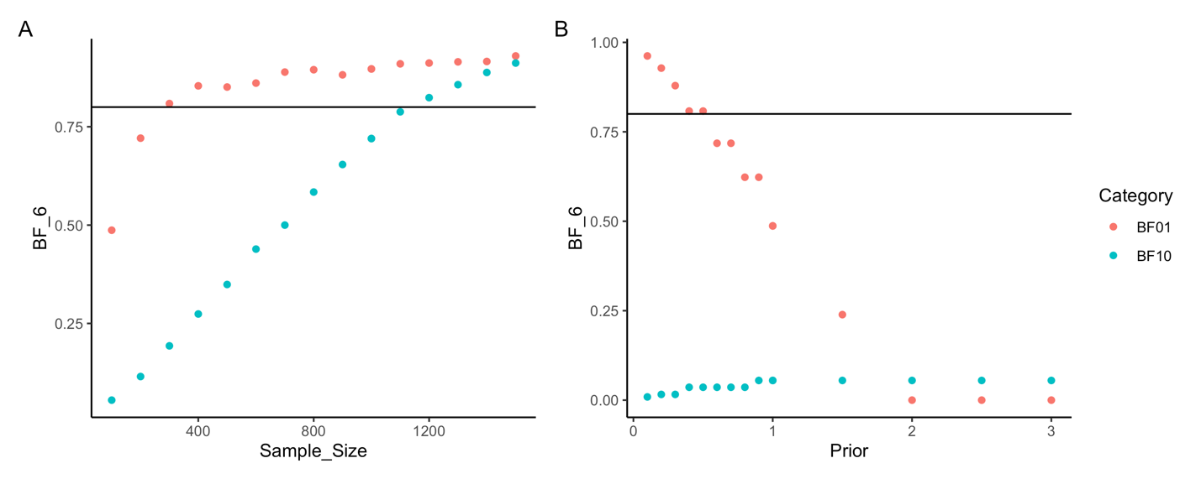

Fig 2. Simulation results. (A) Simulation with fixed prior and varying *N*, the x-axis is sample size *N*, and the y-axis is the proportion of BF values that are greater than 6. (B) Simulation with fixed *N*, the x-axis is the prior, the y-axis is the proportion of BF values that are greater than 6.

Based on the simulation, we decided to use the non-informative prior because the final data will have a large enough sample size (>=1200). For large-team studies, each participating team was usually required to collect more than 100 participants. In other words, if there are twelve or more big-team studies with Chinese participants, the number of Chinese participants will be greater than 1200. So far, we have collected 27 big-team studies which included Chinese participants and the number of Chinese participants from 21 studies is more than 19, 000. For studies published in Chinese journals, we will extract data from 1000 empirical studies, which means if each paper only contains one study with 20 participants, the final dataset will have 2000 participants. Thus the sample in our study is enough for our Bayesian multinomial test for sex ratio.

***Age distribution*** For the age distribution, we will create age bins using two different approaches. The first approach is based on the developmental stage, which is more important in psychological research than biological age itself. We created five age bins based on developmental stages: 0 ~ 17 (children and adolescents), 18 ~ 25 (early adulthood), 26 ~ 40 (middle adulthood), 41 ~ 59 (later adulthood), and >= 60 (elders). The second approach is similar to census data’s age bins: 0 ~9, 10 ~ 19, 20 ~ 29, 30 ~ 39, 40 ~ 49, 50 ~ 59, and >=60[2]. Unless stated, we will report statistical results based on the first approach of age bins in the main text and results based on the second approach in the supplementary results. In this case, the *H0* and *Ha* are specified as below:

*H0*: the count data in different age bins of Chinese participants from big-team science are sampled from a multinomial distribution with parameters *P* = *Pr*(*x1*, *x2*, *…*, *x5* | *n* = *N*, *p1*, *p2*, *…*, *p5*), where (*p1*, *p2*, *…*, *p5*) is the percentage data of Chinese subjects from Chinese psychology journals, which can be view as a point in a Dirichlet distribution.

*Ha*: the count data in different age bins of Chinese participants from big-team science are sampled from a multinomial distribution with parameters *P* = *Pr*(*x1*, *x2*, *…*, *x5* | *n* = *N*, *p1*, *p2*, *…*, *p5*), where (*p1*, *p2*, *…*, *p5*) is distributed as a Dirichlet distribution with concentration parameter .

As for the sex ratio, we will also use the Bayesian multinomial test for hypothesis testing, with non-informative prior, i.e., *Dirichlet* distribution. The resulting Bayes factor will be interpreted same as the sex ratio.

To test the minimal effect that the Bayesian multinomial test can detect with non-informative prior and sample size *N* >= 1200, we conduct a simulation with a simple assumption that age data are normal distribution for two the observed and the expected data. The simulations as follows:

Step 1: We estimated the mean (23.01) and *SD* (4.65) of Chinese participants’ age from Jones et al (2021). These data provide a starting point for simulation.

Step 2: We use the mean age 23.01 as the mean age of observed, and we choose a mean age difference (e.g., diff_age = 1 year), the mean age of the second group will be 23.01 + diff_age. We assume that both groups share the same *SD*.

Step 3: We generate multinomial data in the same way we will generate count data for different age bins when individual data is not available. For example, we generate the count number of participants under 18 by using `round((pnorm(18, mean = Mean1, sd =SD1) * 1200))`, and the count number of participants between 18 and 26 by using `round((pnorm(26, mean = Mean1, sd =SD1) * 1200)) - round((pnorm(18, mean = Mean1, sd =SD1) * 1200))`. Replace “Mean1” and “SD1” we get the data for group 1 and group 2. If the count data is zero for certain age bin, we replace zero with one to avoid error when calculating the Bayes factor.

Step 4: We conduct the Bayesian multinomial test, using data from group 1 as the observed and data from group 2 as the expected. We save the BF10 and logBF10 resulting from this step.

Step 5: We repeated the Step 2 to Step 4, iterating the diff_age from 0 to 2, with the interval of 0.05, and save the BF10 and logBF10 for each mean age difference.

Finally, we repeated the above Step 2 to Step 5 with different mean age of group 1 from 10 to 60, with 5 years as the interval, and fixed the *SD* as 4.65, we found that when the mean age is moving toward two ends (0 or 60), the current setting will no longer be able to detect the mean age difference. However, this is pattern is understandable because when the mean age is moving closer to either end of the ages, most of the generated count data will be in the age bin at that end and few data in other age bins.

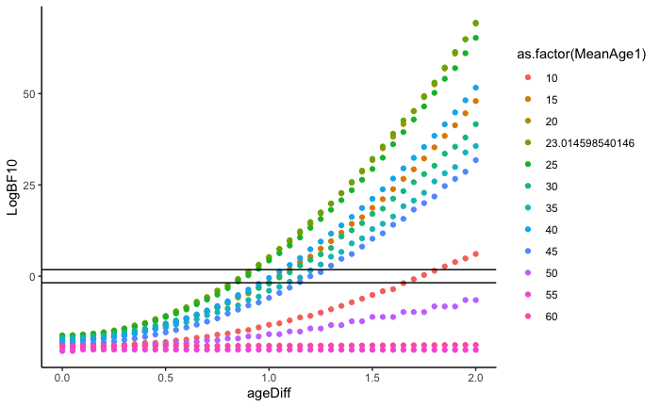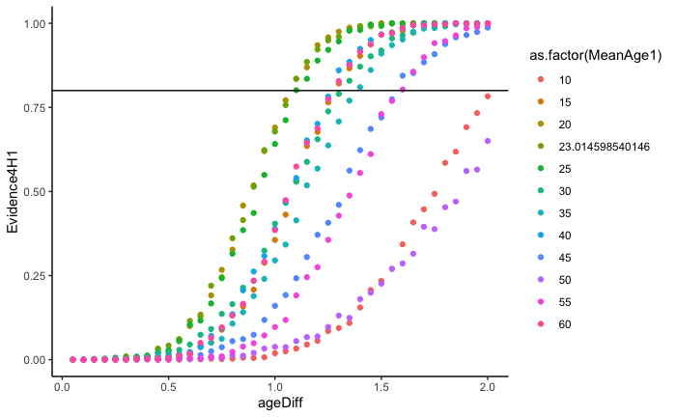

Figure R2. (A) Simulated results of Log BF10 (y-axis) for different mean age differences (x-axis) and different mean ages (colors of dots). The two black horizontal lines represent logBF10 > log(6) (upper) and logBF10 < log(1/6) (lower). (B) Results of the alternative simulation with sample size *N* = 1200. The x-axis is the differences between the means of group 2’s age and group 1’s age, different colors represent different means ages from group 1. The y-axis is the percentage of BF >= 6 in 1000 simulations.

The above simulation suggests that our Bayesian Multinomial test with non-informative prior and *N* = 1200 can detect a mean age difference of 0.95 to 1.35, when the mean age is between 15 years old and 45 years old (See figure R2 A). Please note that a mean age of 15 to 45 is consistent the observation from the literature. For instance, in the supplementary of Rad et al (2018), 21 out of 33 studies investigated young and mid-aged adults, with mean age range from 18.63 to 36.81. The mean age difference of 0.95, to be expressed more intuitively, is corresponding to Cohen’s *d* = 0.2041, and the mean age 1.35 corresponds to Cohen’s *d* = 0.29, if we assume the age data are normally distributed with *SD* = 4.65. Also, note that the simulation above lacks of stochastic process, each mean age difference only returns one BF value, we conducted an alternative simulation, in which we generate age data and convert these age data into age bins, instead of generating count data for each age bin directly, the results revealed that, when the mean age is from 15 to 45, the current setting can detect a mean age difference from 1.1 years to 1.6 years, corresponding to Cohen’s *d* of 0.236 to 0.344 (Figure R2 B, see our online Rmarkdown for details).

The above simulation revealed that with a sample size of 1200 and non-informative prior, the current Bayesian multinomial test can detect a mean difference of 0.95 years (in the best case) to 1.6 years (in the worst case) when participants are young or mid-aged adults. As the final sample size will be larger than 1200, the current setting will be sensitive to detect the even smaller difference.

**2.3.2 Data analysis plan for the second question**

The second question of this study is whether all Chinese sample data available, regardless of the sources of the data (see Figure 1), come from a very narrow slice of the Chinese population. Given sample representativeness indeed depend on the target population, we will further distinguish two types of analyses. For studies that targeted the general population, inferred or stated, we will compare their sample characteristics to the whole census data from the National Bureau of Statistics.

For studies that targeted a specific population, we will compare the sample characteristics to that specific population selected from census data. If the information of that specific population is not available in census data, we will search for other reliable data sources as the reference data. We will also use the Bayesian multinomial test for statistical inference. For those targeted at the general population, we will use the pooled Chinese subjects’ data from both sources as the “observed” and the census data as the “expected”. The age bins will be the same as we tested the first hypothesis. The prior setting of Bayes factor analyses and the criteria for interpreting the Bayes factor will be the same as in testing our first question. Note that the sample size might be smaller than 1200 for studies aimed at generalized to a specific population. In this case, we will interpret our results as exploratory.

**2.3.3 Data analysis plan for the third question**

For the third question, whether Chinese psychological samples differ from other countries’ samples, we will visualize the distributions of the participants from different countries and visually compare other countries with the Chinese samples. We will also compare each country’s data with Chinese data using the Bayesian multinomial test, where the other countries’ data are treated as “observed” and Chinese data are “expected. The null hypothesis (*H0*) is that the parameters of the observed sex and age distributions equal the expected proportions (i.e., Chinese psychological samples). The alternative (*Ha*) is that those parameters are free to vary. The prior setting of Bayes factor analyses and the criteria for interpreting the Bayes factor will be the same as in testing our first question. Note that the sample size might be smaller than 1200 for some countries, in these cases, we will interpret our results as exploratory.

It should be noted that the graphics mentioned above are not fixed, and we will choose the graphics that can best illustrate the data characteristics according to the actual situation. The specific analysis code will be updated in OSF (<https://osf.io/avb7t/?view_only=a7e4610491374093851fc2b7da57e85c>) or GitHub (https://github.com/hcp4715/chin-subj).

**3 Results**

**3.1 Overview of participants**

[Here we will insert the graph info with China’s map; relative density of participants in different dimensions]

**3.2 Comparing Chinese papers and international collaborations**

We predict that there will be moderate to strong evidence that the Chinese samples in Chinese papers and in international collaborations have similar sex ratio, age distribution, and distribution along other dimensions (if data are available), *BF01s* ≥ 6.

[*Here we will insert Figure 2 to visualize the comparisons between two data sources. Also, Bayes factors will also be reported here*]

**3.3 Comparing Chinese samples and samples from census data and CFPS**

We will pool data from both data sources and compare with CFPS and census data. [The results will be reported as below, using data from international collaboration data]

*We used PSA 001 data (Jones et al., 2021) as the Chinese sample to demonstrate the analyses and visualization, see below (all code is available at osf.io/y9hwq/). Note that these results will be replaced by the final results after data are collected and analyses carried out.*

*First, we compared the Chinese samples (Jones et al., 2021) with the CFPS data in 2018 with China’s census data. We tested whether the sex ratio in psychological sample is different from that of the census data using the Bayesian multinomial test (Bayesian version of Goodness-of-fit). The results revealed strong evidence that the psychological sample data (Jones et al., 2021) is different from the census data, log(BF10) = 3.73. In contrast to psychological sample data, data from sociology, CFPS 2018 data, is not different from census data, log(BF10) = -2.06. As we can see from Figure 3 A, Chinese psychological science sample included more female participants, while the CFPS data has a similar pattern as the census data.*

*For the age distribution, we found that the psychological samples’ age distribution is different from that of the census data, with strong evidence from the Bayesian multinomial test, log(BF10*) = 168.38*. This difference is further revealed by the demographic pyramid (See figure 3 B), which showed that the Chinese psychological samples consist of females aged 15~24 years.*



Figures 3. Preliminary results of the sex and age distribution from different data sources. (A) Sex ratio from the 7th census data, CFPS 2018 data, and psychological science sample (PSA 001’s data is used as an example); (B) Age distribution of the 7th census data the transparent bar plot, and psychological science samples (PSA 001’s data as an example), the y-axis is age bins, the x-axis on the top is for the line plot of PSA 001 and the x-axis on the bottom is for the pyramid plot of the 7th census data.

**3.4 Comparing Chinese samples and samples from other countries**

We also explore the common and distinct pattern between Chinese psychological samples and psychological samples from other regions.

*The preliminary results from available data illustrate how the final results will look like. These results will be replaced by the final results after data collection. For sex ratio, the pairwise Bayesian multinomial test revealed that data from 9 countries have different sex ratios as compared to Chinese psychological samples (see Figure 4A). Twenty-three countries have higher proportion of female participants than Chinese samples (see Figure 4C). For age distribution, the pairwise Bayesian multinomial test revealed strong evidence that samples from fourteen countries are the same as Chinese psychological samples (see Figure 4B, 4D). These preliminary results indicated that the psychological samples from many regions are similar, probably most of them are college students or communities around university campuses (Arnett, 2008), but also there is variability in both sex ratio and age distribution.*

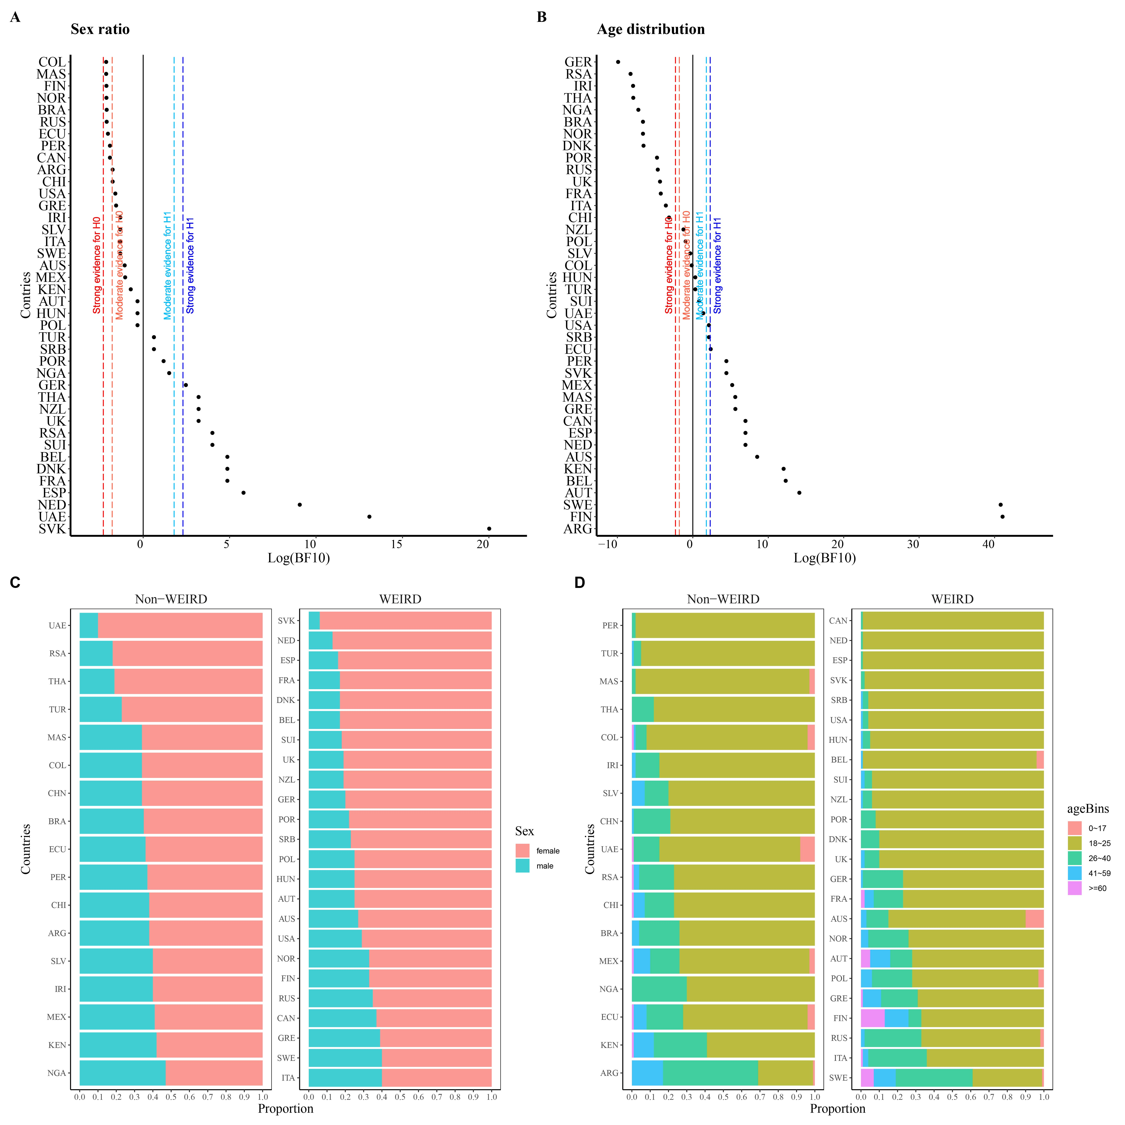

Figure 4. The sex and age distribution from PSA 001. (A) Pairwise comparisons of sex ratio between Chinese psychological sample and available data from other countries; (B) Pairwise comparisons of age distribution between Chinese psychological sample and available data from other countries; (C) Sex ratio of all data; (D) Age proportion of all data. Country code:

United Arab Emirates (UAE), South Africa (RSA), Thailand (THA), Turkey (TUR), Malaysia (MAS), China (CHN), Ecuador (ECU), Colombia (COL), Brazil (BRA), Peru (PER), Iran (IRI), Chile (CHI), El Salvador (SLV), Argentina (ARG), Nigeria (NGA), Kenya (KEN), Mexico (MEX), Slovakia (SVK), Romania (ROU), Netherlands (NED), France (FRA), Denmark (DNK), Switzerland (SUI), Spain (ESP), New Zealand (NZL), Portugal (POR), United Kingdom (UK), Germany (GER), Poland (POL), Serbia (SRB), Hungary (HUN), Australia (AUS), Austria (AUT), Finland (FIN), Russia (RUS), Norway (NOR), Italy (ITA), United States (USA), Canada (CAN), Greece (GRE), Sweden (SWE).

**4 Discussion**

[recap of the results]

…..

Overview of the research question, hypotheses, analytical plan, and interpretations of the current study

|  |  |  |  |
| --- | --- | --- | --- |
| **Question** | **Hypothesis** | **Analysis Plan** | **Interpretation given**  **different outcomes** |
| 1. Whether characteristics of Chinese participants reported in large-scale international collaborative projects are similar to those reported in Chinese psychological journals? | H1: There is no difference between Chinese human subjects reported in Chinese journals and in large-scale international collaborative projects. | We will visualize and compare the sample characteristics from Chinese psychological journals and international collaboration projects based on their targeted population. Also, we will use Bayesian multinomial test to inspect their similarity. | H1 is supported if the background information of the subjects in the Chinese psychological articles is similar to that in the international collaborative projects (visual inspection).  If BF01 > = 6, we infer there is relatively strong evidence that this hypothesis is supported. |
| 2. To what extent the Chinese participants in psychological science can represent Chinese population, as compared with the census data from the National Bureau of Statistics of China and from a large-scale social survey, Chinese Family Panel Study (CFPS). | H2: As WEIRD sample only represents a narrow slice of human beings, the Chinese samples also come from a very narrow slice of the Chinese population. | We will visualize the Chinese sample (Chinese journal articles and international collaboration projects) to inspect their representativeness relative to their targeted population from reliable data sources (e.g., census data). For example, when the articles are targeting at the general population, we will compare the sample to the whole population of census data. We will also use Bayesian multinomial test to compare the Chinese sample with census data (or CFPS or other reliable data). | H2 is supported if the subject in Chinese psychology is from a narrow slice of the entire population in China, which is estimated by the census data from the National Bureau of Statistics of China and CFPS (visual inspection).  If BF10 > = 6, we infer there is relatively strong evidence that this hypothesis is supported. |
| 3. What are the shared and distinct patterns of Chinese participants and participants from other regions? | H3: Chinese human subjects share many characteristics as most other non-WEIRD and WEIRD samples. | We will visualize the distributions of the participants from different countries and visually compare others countries with the Chinese samples. We will also compare the distributions of participants with that of the Chinese participants, with the data from Chinese participants as expected and data from other countries as observed. | H3 is supported if the characteristics of subjects in Chinese psychology articles share characteristics with more than half of other non-WEIRD regions or WEIRD regions in describing statistical results and visualizations.  If BF01 > = 6 for more than half of the other countries, we infer there is relatively strong evidence that this hypothesis is supported. |

**Reference**

Apicella, C., Norenzayan, A., & Henrich, J. (2020). Beyond WEIRD: A review of the last decade and a look ahead to the global laboratory of the future. *Evolution and Human Behavior*, *41*(5), 319–329. <https://doi.org/10.1016/j.evolhumbehav.2020.07.015>

Arnett, J. J. (2008). The neglected 95%: Why American psychology needs to become less American. *American Psychologist*, *63*(7), 602–614. <https://doi.org/10.1037/0003-066X.63.7.602>

Barrett, H. C. (2020). Towards a cognitive science of the human: Cross-cultural approaches and their urgency. *Trends in Cognitive Sciences*, *24*(8), 620–638. <https://doi.org/10.1016/j.tics.2020.05.007>

Bryan, C. J., Tipton, E., & Yeager, D. S. (2021). Behavioural science is unlikely to change the world without a heterogeneity revolution. *Nature Human Behaviour*, *5*, 980–989. <https://doi.org/10.1038/s41562-021-01143-3>

Dienes, Z. (2016). How Bayes factors change scientific practice. *Journal of Mathematical Psychology, 72*, 78–89. <https://doi.org/10.1016/j.jmp.2015.10.003>

Dienes, Z. (2021). How to use and report Bayesian hypothesis tests. *Psychology of Consciousness: Theory, Research, and Practice*, *8*(1), 9–26. <https://doi.org/10.1037/cns0000258>

Dienes, Z., & Mclatchie, N. (2018). Four reasons to prefer Bayesian analyses over significance testing. *Psychonomic Bulletin & Review, 25*(1), 207–218. <https://doi.org/10.3758/s13423-017-1266-z>

Forscher, P. S., Basnight-Brown, D. M., Dutra, N., Adetula, A., Silan, M., & IJzerman, H. (2021). *Psychological science needs the entire globe, part 3: Does psychological science deserve brilliant researchers from outside north America and Europe?* Association For Psychological Science. <https://www.psychologicalscience.org/observer/entire-globe-part-3>

Gamer, M., Lemon, J., & Singh, I. F. P. (2019). *irr: Various coefficients of interrater reliability and agreement (R package version 0.84.1) [Computer software]*. <https://CRAN.R-project.org/package=irr>

Ghai, S. (2021). It’s time to reimagine sample diversity and retire the WEIRD dichotomy. *Nature Human Behaviour*, *5*, 971–972. <https://doi.org/10.1038/s41562-021-01175-9>

Gong, K., & Cheng, Y. (2022). Patterns and impact of collaboration in China’s social sciences: cross-database comparisons between CSSCI and SSCI. *Scientometrics*. <https://doi.org/10.1007/s11192-022-04483-7>

Gordon, M., Viganola, D., Bishop, M., Chen, Y., Dreber, A., Goldfedder, B., Holzmeister, F., Johannesson, M., Liu, Y., Twardy, C., Wang, J., & Pfeiffer, T. (2020). Are replication rates the same across academic fields? Community forecasts from the DARPA SCORE programme. *Royal Society Open Science*, *7*(7), 200566. <https://doi.org/10.1098/rsos.200566>

Grosz, M. P., Rohrer, J. M., & Thoemmes, F. (2020). The taboo against explicit causal inference in nonexperimental psychology. *Perspectives on Psychological Science*, *15*(5), 1243–1255. <https://doi.org/10.1177/1745691620921521>

Henrich, J., Heine, S. J., & Norenzayan, A. (2010). The weirdest people in the world? *Behavioral and Brain Sciences*, *33*(2–3), 61–83. <https://doi.org/10.1017/S0140525X0999152X>

Henry, P. J. (2008). College sophomores in the laboratory redux: Influences of a narrow data base on social psychology's view of the nature of prejudice. *Psychological Inquiry*, *19*(2), 49–71. <https://doi.org/10.1080/10478400802049936>

Hoijtink, H., Mulder, J., van Lissa, C., & Gu, X. (2019). A tutorial on testing hypotheses using the Bayes factor. *Psychological Methods*, *24*(5), 539–556. <https://doi.org/10.1037/met0000201>

Hu, C.-P., Kong, X.-Z., Wagenmakers, E.-J., Ly, A., & Peng, K. (2018). Bayes Factor and Its Implementation in JASP: A Practical Primer (in Chinese). *Advances in Psychological Science, 26*(6), 951–965. <https://doi.org/10.3724/SP.J.1042.2018.00951>

Hu, C.-P., Yin, J.-X., Lindenberg, S., Dalğar, İ., Weissgerber, S. C., Vergara, R. C., Cairo, A. H., Čolić, M. V., Dursun, P., Frankowska, N., Hadi, R., Hall, C. J., Hong, Y., Joy-Gaba, J., Lazarević, D., Lazarević, L. B., Parzuchowski, M., Ratner, K. G., Rothman, D., Sim, S., Simão, C., Song, M., Stojilović, D., Blomster, J. K., Brito, R., Hennecke, M., Jaume-Guazzini, F., Schubert, T. W., Schütz, A., Seibt, B., Zickfeld, J. H., & Ijzerman, H. (2019). Data from the Human Penguin Project, a cross-national dataset testing social thermoregulation principles. *Scientific Data, 6*, 32. <https://doi.org/10.1038/s41597-019-0029-2>

Ijzerman, H., Lewis, N. A., Przybylski, A. K., Weinstein, N., DeBruine, L., Ritchie, S. J., Vazire, S., Forscher, P. S., Morey, R. D., Ivory, J. D., & Anvari, F. (2020). Use caution when applying behavioural science to policy. *Nature Human Behaviour*, *4*(11), 1092-1094. <https://doi.org/10.1038/s41562-020-00990-w>

Ijzerman, H., Lindenberg, S., Dalğar, İ., Weissgerber, S. S. C., Vergara, R. C., Cairo, A. H., Čolić, M. V., Dursun, P., Frankowska, N., Hadi, R., Hall, C. J., Hong, Y., Hu, C.-P., Joy-Gaba, J., Lazarević, D., Lazarević, L. B., Parzuchowski, M., Ratner, K. G., Rothman, D., Sim, S., Simão, C., Song, M., Stojilović, D., Blomster, J. K., Brito, R., Hennecke, M., Jaume-Guazzini, F., Schubert, T. W., Schütz, A., Seibt, B., & Zickfeld, J. H. (2018). The Human Penguin Project: Climate, social integration, and core body temperature. *Collabra: Psychology*, *4*(1), 37. <https://doi.org/10.1525/collabra.165>

Jamil, T., Ly, A., Morey, R. D., Love, J., Marsman, M., & Wagenmakers, E.-J. (2017). Default “Gunel and Dickey” Bayes factors for contingency tables. *Behavior Research Methods, 49*(2), 638–652. <https://doi.org/10.3758/s13428-016-0739-8>

Jones, B. C., DeBruine, L. M., Flake, J. K., Liuzza, M. T., Antfolk, J., Arinze, N. C., Ndukaihe, I. L. G., Bloxsom, N. G., Lewis, S. C., Foroni, F., Willis, M. L., Cubillas, C. P., Vadillo, M. A., Turiegano, E., Gilead, M., Simchon, A., Saribay, S. A., Owsley, N. C., Jang, C., Mburu, G., Calvillo, D. P., Wlodarczyk, A., Qi, Y., Ariyabuddhiphongs, K., Jarukasemthawee, S., Manley, H., Suavansri, P., Taephant, N., Stolier, R. M., Evans, T. R., Bonick, J., Lindemans, J. W., Ashworth, L. F., Hahn, A. C., Chevallier, C., Kapucu, A., Karaaslan, A., Leongómez, J. D., Sánchez, O. R., Valderrama, E., Vásquez-Amézquita, M., Hajdu, N., Aczel, B., Szecsi, P., Andreychik, M., Musser, E. D., Batres, C., Hu, C.-P., Liu, Q.-L., Legate, N., Vaughn, L. A., Barzykowski, K., Golik, K., Schmid, I., Stieger, S., Artner, R., Mues, C., Vanpaemel, W., Jiang, Z., Wu, Q., Marcu, G. M., Stephen, I. D., Lu, J. G., Philipp, M. C., Arnal, J. D., Hehman, E., Xie, S. Y., Chopik, W. J., Seehuus, M., Azouaghe, S., Belhaj, A., Elouafa, J., Wilson, J. P., Kruse, E., Papadatou-Pastou, M., De La Rosa-Gómez, A., Barba-Sánchez, A. E., González-Santoyo, I., Hsu, T., Kung, C.-C., Wang, H.-H., Freeman, J. B., Oh, D. W., Schei, V., Sverdrup, T. E., Levitan, C. A., Cook, C. L., Chandel, P., Kujur, P., Parganiha, A., Parveen, N., Pati, A. K., Pradhan, S., Singh, M. M., Pande, B., Bavolar, J., Kačmár, P., Zakharov, I., Álvarez-Solas, S., Baskin, E., Thirkettle, M., Schmidt, K., Christopherson, C. D., Leonis, T., Suchow, J. W., Olofsson, J. K., Jernsäther, T., Lee, A.-S., Beaudry, J. L., Gogan, T. D., Oldmeadow, J. A., Balas, B., Stevens, L. M., Colloff, M. F., Flowe, H. D., Gülgöz, S., Brandt, M. J., Hoyer, K., Jaeger, B., Ren, D., Sleegers, W. W. A., Wissink, J., Kaminski, G., Floerke, V. A., Urry, H. L., Chen, S.-C., Pfuhl, G., Vally, Z., Basnight-Brown, D. M., Jzerman, H. I., Sarda, E., Neyroud, L., Badidi, T., Van der Linden, N., Tan, C. B. Y., Kovic, V., Sampaio, W., Ferreira, P., Santos, D., Burin, D. I., Gardiner, G., Protzko, J., Schild, C., Ścigała, K. A., Zettler, I., O’Mara Kunz, E. M., Storage, D., Wagemans, F. M. A., Saunders, B., Sirota, M., Sloane, G. V., Lima, T. J. S., Uittenhove, K., Vergauwe, E., Jaworska, K., Stern, J., Ask, K., van Zyl, C. J. J., Körner, A., Weissgerber, S. C., Boudesseul, J., Ruiz-Dodobara, F., Ritchie, K. L., Michalak, N. M., Blake, K. R., White, D., Gordon-Finlayson, A. R., Anne, M., Janssen, S. M. J., Lee, K. M., Nielsen, T. K., Tamnes, C. K., Zickfeld, J. H., Rosa, A. D., Vianello, M., Kocsor, F., Kozma, L., Putz, Á., Tressoldi, P., Irrazabal, N., Chatard, A., Lins, S., Pinto, I. R., Lutz, J., Adamkovic, M., Babincak, P., Baník, G., Ropovik, I., Coetzee, V., Dixson, B. J. W., Ribeiro, G., Peters, K., Steffens, N. K., Tan, K. W., Thorstenson, C. A., Fernandez, A. M., Hsu, R. M. C. S., Valentova, J. V., Varella, M. A. C., Corral-Frías, N. S., Frías-Armenta, M., Hatami, J., Monajem, A., Sharifian, M., Frohlich, B., Lin, H., Inzlicht, M., Alaei, R., Rule, N. O., Lamm, C., Pronizius, E., Voracek, M., Olsen, J., Giolla, E. M., Akgoz, A., Özdoğru, A. A., Crawford, M. T., Bennett-Day, B., Koehn, M. A., Okan, C., Gill, T., Miller, J. K., Dunham, Y., Yang, X., Alper, S., Borras-Guevara, M. L., Cai, S. J., Tiantian, D., Danvers, A. F., Feinberg, D. R., Armstrong, M. M., Gilboa-Schechtman, E., McCarthy, R. J., Muñoz-Reyes, J. A., Polo, P., Shiramazu, V. K. M., Yan, W.-J., Carvalho, L., Forscher, P. S., Chartier, C. R., & Coles, N. A. (2021). To which world regions does the valence–dominance model of social perception apply? *Nature Human Behaviour*, *5*, 159–169. <https://doi.org/10.1038/s41562-020-01007-2>

Jones, D. (2010). A WEIRD view of human nature skews psychologists' studies. *Science*, *328*(5986), 1627–1627. <https://doi.org/10.1126/science.328.5986.1627>

Klein, R. A., Vianello, M., Hasselman, F., Adams, B. G., Adams, R. B., Alper, S., Aveyard, M., Axt, J. R., Babalola, M. T., Bahník, Š., Batra, R., Berkics, M., Bernstein, M. J., Berry, D. R., Bialobrzeska, O., Binan, E. D., Bocian, K., Brandt, M. J., Busching, R., Rédei, A. C., Cai, H., Cambier, F., Cantarero, K., Carmichael, C. L., Ceric, F., Chandler, J., Chang, J.-H., Chatard, A., Chen, E. E., Cheong, W., Cicero, D. C., Coen, S., Coleman, J. A., Collisson, B., Conway, M. A., Corker, K. S., Curran, P. G., Cushman, F., Dagona, Z. K., Dalgar, I., Dalla Rosa, A., Davis, W. E., de Bruijn, M., De Schutter, L., Devos, T., de Vries, M., Doğulu, C., Dozo, N., Dukes, K. N., Dunham, Y., Durrheim, K., Ebersole, C. R., Edlund, J. E., Eller, A., English, A. S., Finck, C., Frankowska, N., Freyre, M.-Á., Friedman, M., Galliani, E. M., Gandi, J. C., Ghoshal, T., Giessner, S. R., Gill, T., Gnambs, T., Gómez, Á., González, R., Graham, J., Grahe, J. E., Grahek, I., Green, E. G. T., Hai, K., Haigh, M., Haines, E. L., Hall, M. P., Heffernan, M. E., Hicks, J. A., Houdek, P., Huntsinger, J. R., Huynh, H. P., Ijzerman, H., Inbar, Y., Innes-Ker, Å. H., Jiménez-Leal, W., John, M.-S., Joy-Gaba, J. A., Kamiloğlu, R. G., Kappes, H. B., Karabati, S., Karick, H., Keller, V. N., Kende, A., Kervyn, N., Knežević, G., Kovacs, C., Krueger, L. E., Kurapov, G., Kurtz, J., Lakens, D., Lazarević, L. B., Levitan, C. A., Lewis, N. A., Lins, S., Lipsey, N. P., Losee, J. E., Maassen, E., Maitner, A. T., Malingumu, W., Mallett, R. K., Marotta, S. A., Međedović, J., Mena-Pacheco, F., Milfont, T. L., Morris, W. L., Murphy, S. C., Myachykov, A., Neave, N., Neijenhuijs, K., Nelson, A. J., Neto, F., Lee Nichols, A., Ocampo, A., O’Donnell, S. L., Oikawa, H., Oikawa, M., Ong, E., Orosz, G., Osowiecka, M., Packard, G., Pérez-Sánchez, R., Petrović, B., Pilati, R., Pinter, B., Podesta, L., Pogge, G., Pollmann, M. M. H., Rutchick, A. M., Saavedra, P., Saeri, A. K., Salomon, E., Schmidt, K., Schönbrodt, F. D., Sekerdej, M. B., Sirlopú, D., Skorinko, J. L. M., Smith, M. A., Smith-Castro, V., Smolders, K. C. H. J., Sobkow, A., Sowden, W., Spachtholz, P., Srivastava, M., Steiner, T. G., Stouten, J., Street, C. N. H., Sundfelt, O. K., Szeto, S., Szumowska, E., Tang, A. C. W., Tanzer, N., Tear, M. J., Theriault, J., Thomae, M., Torres, D., Traczyk, J., Tybur, J. M., Ujhelyi, A., van Aert, R. C. M., van Assen, M. A. L. M., van der Hulst, M., van Lange, P. A. M., van ’t Veer, A. E., Vásquez- Echeverría, A., Ann Vaughn, L., Vázquez, A., Vega, L. D., Verniers, C., Verschoor, M., Voermans, I. P. J., Vranka, M. A., Welch, C., Wichman, A. L., Williams, L. A., Wood, M., Woodzicka, J. A., Wronska, M. K., Young, L., Zelenski, J. M., Zhijia, Z., & Nosek, B. A. (2018). Many Labs 2: Investigating variation in replicability across samples and settings. *Advances in Methods and Practices in Psychological Science*, *1*(4), 443–490. <https://doi.org/10.1177/2515245918810225>

Kruskal, W., & Mosteller, F. (1979a). Representative sampling, I: Non-scientific literature. *International Statistical Review / Revue Internationale de Statistique*, *47*(1), 13–24. <https://doi.org/10.2307/1403202>

Kruskal, W., & Mosteller, F. (1979b). Representative sampling, II: Scientific literature, excluding statistics. *International Statistical Review / Revue Internationale de Statistique*, *47*(2), 111–127. <https://doi.org/10.2307/1402564>

Kruskal, W., & Mosteller, F. (1979c). Representative sampling, III: The current statistical literature. *International Statistical Review / Revue Internationale de Statistique*, *47*(3), 245–265. <https://doi.org/10.2307/1402647>

Kruskal, W., & Mosteller, F. (1980). Representative sampling, IV: The history of the concept in statistics, 1895-1939. *International Statistical Review / Revue Internationale de Statistique*, *48*(2), 169–195. <https://doi.org/10.2307/1403151>

Kukull, W. A., & Ganguli, M. (2012). Generalizability: The trees, the forest, and the low-hanging fruit. *Neurology*, *78*(23), 1886. <https://doi.org/10.1212/WNL.0b013e318258f812>

Mook, D. G. (1983). In defense of external invalidity. *American Psychologist*, *38*(4), 379–387. <https://doi.org/10.1037/0003-066X.38.4.379>

Moshontz, H., Campbell, L., Ebersole, C. R., Ijzerman, H., Urry, H. L., Forscher, P. S., Grahe, J. E., McCarthy, R. J., Musser, E. D., Antfolk, J., Castille, C. M., Evans, T. R., Fiedler, S., Flake, J. K., Forero, D. A., Janssen, S. M. J., Keene, J. R., Protzko, J., Aczel, B., Solas, S. Á., Ansari, D., Awlia, D., Baskin, E., Batres, C., Borras-Guevara, M. L., Brick, C., Chandel, P., Chatard, A., Chopik, W. J., Clarance, D., Coles, N. A., Corker, K. S., Dixson, B. J. W., Dranseika, V., Dunham, Y., Fox, N. W., Gardiner, G., Garrison, S. M., Gill, T., Hahn, A. C., Jaeger, B., Kačmár, P., Kaminski, G., Kanske, P., Kekecs, Z., Kline, M., Koehn, M. A., Kujur, P., Levitan, C. A., Miller, J. K., Okan, C., Olsen, J., Oviedo-Trespalacios, O., Özdoğru, A. A., Pande, B., Parganiha, A., Parveen, N., Pfuhl, G., Pradhan, S., Ropovik, I., Rule, N. O., Saunders, B., Schei, V., Schmidt, K., Singh, M. M., Sirota, M., Steltenpohl, C. N., Stieger, S., Storage, D., Sullivan, G. B., Szabelska, A., Tamnes, C. K., Vadillo, M. A., Valentova, J. V., Vanpaemel, W., Varella, M. A. C., Vergauwe, E., Verschoor, M., Vianello, M., Voracek, M., Williams, G. P., Wilson, J. P., Zickfeld, J. H., Arnal, J. D., Aydin, B., Chen, S.-C., DeBruine, L. M., Fernandez, A. M., Horstmann, K. T., Isager, P. M., Jones, B., Kapucu, A., Lin, H., Mensink, M. C., Navarrete, G., Silan, M. A., & Chartier, C. R. (2018). The Psychological Science Accelerator: Advancing psychology through a distributed collaborative network. *Advances in Methods and Practices in Psychological Science*, *1*(4), 501–515. <https://doi.org/10.1177/2515245918797607>

Nielsen, M., Haun, D., Kärtner, J., & Legare, C. H. (2017). The persistent sampling bias in developmental psychology: A call to action. *Journal of Experimental Child Psychology*, *162*, 31–38. <https://doi.org/10.1016/j.jecp.2017.04.017>

Pollet, T. V., & Saxton, T. K. (2019). How diverse are the samples used in the journals ‘Evolution & Human Behavior’ and ‘Evolutionary Psychology’? *Evolutionary Psychological Science*, *5*(3), 357–368. <https://doi.org/10.1007/s40806-019-00192-2>

R Core Team (2021). *R: A language and environment for statistical computing.* R Foundation for Statistical Computing, Vienna, Austria. [https://www.R-project.org/.](https://www.R-project.org/)

Rad, M. S., Martingano, A. J., & Ginges, J. (2018). Toward a psychology of Homo sapiens: Making psychological science more representative of the human population. *Proceedings of the National Academy of Sciences*, *115*(45), 11401–11405. <https://doi.org/10.1073/pnas.1721165115>

Sarafoglou, A., Haaf, J. M., Ly, A., Gronau, Q. F., Wagenmakers, E.-J., & Marsman, M. (2020). Evaluating Multinomial Order Restrictions with Bridge Sampling. PsyArXiv. <https://doi.org/10.31234/osf.io/bux7p>

Sears, D. O. (1986). College sophomores in the laboratory: Influences of a narrow data base on social psychology's view of human nature. *Journal of Personality and Social Psychology*, *51*(3), 515–530. <https://doi.org/10.1037/0022-3514.51.3.515>

Thalmayer, A. G., Toscanelli, C., & Arnett, J. J. (2021). The neglected 95% revisited: Is American psychology becoming less American? *American Psychologist*, *76*(1), 116–129. <https://doi.org/10.1037/amp0000622>

Wagenmakers, E.-J., Love, J., Marsman, M., Jamil, T., Ly, A., Verhagen, J., Selker, R., Gronau, Q. F., Dropmann, D., Boutin, B., Meerhoff, F., Knight, P., Raj, A., Kesteren, E.-J. v., Doorn, J. v., Smira, M., Epskamp, S., Etz, A., Matzke, D., Rouder, J. N., & Morey, R. D. (2018). Bayesian Inference for Psychology. Part II: Example Applications with JASP. *Psychonomic Bulletin & Review, 25*(1), 58–76. <https://doi.org/10.3758/s13423-017-1323-7>

Wagenmakers, E.-J., Love, J., Marsman, M., Jamil, T., Ly, A., Verhagen, J., Selker, R., Gronau, Q. F., Dropmann, D., Boutin, B., Meerhoff, F., Knight, P., Raj, A., van Kesteren, E.-J., van Doorn, J., Šmíra, M., Epskamp, S., Etz, A., Matzke, D., de Jong, T., van den Bergh, D., Sarafoglou, A., Steingroever, H., Derks, K., Rouder, J. N., & Morey, R. D. (2018). Bayesian inference for psychology. Part II: Example applications with JASP. *Psychonomic Bulletin & Review, 25*(1), 58–76. https://doi.org/10.3758/s13423-017-1323-7

Wang, J., Song, Q.-Y., Xu, Y.-P., Jia, B.-B., Lu, C.-L., Chen, X., Dai, Z.-X., Huang, Z.-Y., Z-J, L., Lin, J.-X., Luo, W.-Y., S-N, S., Zhang, Y.-Y., Zang, Y.-F., Zuo, X.-N., & Hu, C.-P. (2021). Interpreting nonsignificant results: A quantitative investigation based on 500 Chinese psychological research. *Advances in Psychological Science*, *29*(3), 381–393. <https://doi.org/10.3724/SP.J.1042.2021.00381>

Wang, K., Goldenberg, A., Dorison, C. A., Miller, J. K., Uusberg, A., Lerner, J. S., Gross, J. J., Agesin, B. B., Bernardo, M., Campos, O., Eudave, L., Grzech, K., Ozery, D. H., Jackson, E. A., Garcia, E. O. L., Drexler, S. M., Jurković, A. P., Rana, K., Wilson, J. P., Antoniadi, M., Desai, K., Gialitaki, Z., Kushnir, E., Nadif, K., Bravo, O. N., Nauman, R., Oosterlinck, M., Pantazi, M., Pilecka, N., Szabelska, A., van Steenkiste, I. M. M., Filip, K., Bozdoc, A. I., Marcu, G. M., Agadullina, E., Adamkovič, M., Roczniewska, M., Reyna, C., Kassianos, A. P., Westerlund, M., Ahlgren, L., Pöntinen, S., Adetula, G. A., Dursun, P., Arinze, A. I., Arinze, N. C., Ogbonnaya, C. E., Ndukaihe, I. L. G., Dalgar, I., Akkas, H., Macapagal, P. M., Lewis, S., Metin-Orta, I., Foroni, F., Willis, M., Santos, A. C., Mokady, A., Reggev, N., Kurfali, M. A., Vasilev, M. R., Nock, N. L., Parzuchowski, M., Espinoza Barría, M. F., Vranka, M., Kohlová, M. B., Ropovik, I., Harutyunyan, M., Wang, C., Yao, E., Becker, M., Manunta, E., Kaminski, G., Marko, D., Evans, K., Lewis, D. M. G., Findor, A., Landry, A. T., Aruta, J. J. B., Ortiz, M. S., Vally, Z., Pronizius, E., Voracek, M., Lamm, C., Grinberg, M., Li, R., Valentova, J. V., Mioni, G., Cellini, N., Chen, S.-C., Zickfeld, J., Moon, K., Azab, H., Levy, N., Karababa, A., Beaudry, J. L., Boucher, L., Collins, W. M., Todsen, A. L., van Schie, K., Vintr, J., Bavolar, J., Kaliska, L., Križanić, V., Samojlenko, L., Pourafshari, R., Geiger, S. J., Beitner, J., Warmelink, L., Ross, R. M., Stephen, I. D., Hostler, T. J., Azouaghe, S., McCarthy, R., Szala, A., Grano, C., Solorzano, C. S., Anjum, G., Jimenez-Leal, W., Bradford, M., Pérez, L. C., Cruz Vásquez, J. E., Galindo-Caballero, O. J., Vargas-Nieto, J. C., Kácha, O., Arvanitis, A., Xiao, Q., Cárcamo, R., Zorjan, S., Tajchman, Z., Vilares, I., Pavlacic, J. M., Kunst, J. R., Tamnes, C. K., von Bastian, C. C., Atari, M., Sharifian, M., Hricova, M., Kačmár, P., Schrötter, J., Rahal, R.-M., Cohen, N., FatahModarres, S., Zrimsek, M., Zakharov, I., Koehn, M. A., Esteban-Serna, C., Calin-Jageman, R. J., Krafnick, A. J., Štrukelj, E., Isager, P. M., Urban, J., Silva, J. R., Martončik, M., Očovaj, S. B., Šakan, D., Kuzminska, A. O., Djordjevic, J. M., Almeida, I. A. T., Ferreira, A., Lazarevic, L. B., Manley, H., Ricaurte, D. Z., Monteiro, R. P., Etabari, Z., Musser, E., Dunleavy, D., Chou, W., Godbersen, H., Ruiz-Fernández, S., Reeck, C., Batres, C., Kirgizova, K., Muminov, A., Azevedo, F., Alvarez, D. S., Butt, M. M., Lee, J. M., Chen, Z., Verbruggen, F., Ziano, I., Tümer, M., Charyate, A. C. A., Dubrov, D., Tejada Rivera, M. d. C. M. C., Aberson, C., Pálfi, B., Maldonado, M. A., Hubena, B., Sacakli, A., Ceary, C. D., Richard, K. L., Singer, G., Perillo, J. T., Ballantyne, T., Cyrus-Lai, W., Fedotov, M., Du, H., Wielgus, M., Pit, I. L., Hruška, M., Sousa, D., Aczel, B., Szaszi, B., Adamus, S., Barzykowski, K., Micheli, L., Schmidt, N.-D., Zsido, A. N., Paruzel-Czachura, M., Bialek, M., Kowal, M., Sorokowska, A., Misiak, M., Mola, D., Ortiz, M. V., Correa, P. S., Belaus, A., Muchembled, F., Ribeiro, R. R., Arriaga, P., Oliveira, R., Vaughn, L. A., Szwed, P., Kossowska, M., Czarnek, G., Kielińska, J., Antazo, B., Betlehem, R., Stieger, S., Nilsonne, G., Simonovic, N., Taber, J., Gourdon-Kanhukamwe, A., Domurat, A., Ihaya, K., Yamada, Y., Urooj, A., Gill, T., Čadek, M., Bylinina, L., Messerschmidt, J., Kurfalı, M., Adetula, A., Baklanova, E., Albayrak-Aydemir, N., Kappes, H. B., Gjoneska, B., House, T., Jones, M. V., Berkessel, J. B., Chopik, W. J., Çoksan, S., Seehuus, M., Khaoudi, A., Bokkour, A., El Arabi, K. A., Djamai, I., Iyer, A., Parashar, N., Adiguzel, A., Kocalar, H. E., Bundt, C., Norton, J. O., Papadatou-Pastou, M., De la Rosa-Gomez, A., Ankushev, V., Bogatyreva, N., Grigoryev, D., Ivanov, A., Prusova, I., Romanova, M., Sarieva, I., Terskova, M., Hristova, E., Kadreva, V. H., Janak, A., Schei, V., Sverdrup, T. E., Askelund, A. D., Pineda, L. M. S., Krupić, D., Levitan, C. A., Johannes, N., Ouherrou, N., Say, N., Sinkolova, S., Janjić, K., Stojanovska, M., Stojanovska, D., Khosla, M., Thomas, A. G., Kung, F. Y. H., Bijlstra, G., Mosannenzadeh, F., Balci, B. B., Reips, U.-D., Baskin, E., Ishkhanyan, B., Czamanski-Cohen, J., & Dixson, B. J. W. (2021). A multi-country test of brief reappraisal interventions on emotions during the COVID-19 pandemic. *Nature Human Behaviour*, *5*(8), 1089–1110. <https://doi.org/10.1038/s41562-021-01173-x>

Yarkoni, T. (2020). The generalizability crisis. *Behavioral and Brain Sciences*, 1–37. <https://doi.org/10.1017/S0140525X20001685>

Zuo, X.-N., Xu, T., & Milham, M. P. (2019). Harnessing reliability for neuroscience research. *Nature Human Behaviour*, *3*, 768–771. <https://doi.org/10.1038/s41562-019-0655-x>

1. While it is generally accepted that samples should be representative to the target population, Mook (1983) argued that generalization may be misplaced in some cases where showing some effects do exist, even in rare and artificial settings, is valuable. This argument is invalid because most psychological research aims higher than mere existence of certain effects (e.g., guide the polices, IJzerman et al., 2020). Also, focusing on a narrow sub-population, we may miss phenomena that are outside that sub-population and the consequence of these missed phenomena is unknown. Finally, the selection of samples reflect the fact that researchers themselves are from narrow sub-population, they may priorities the phenomena are importance to that sub-population and thus distort the whole picture of psychology.
2. Note that a more fine-grained age bins (with 5-year intervals) were only used for pyramid plot but not for statistical analysis.