Supplementary Results for

**The WEIRD problem in a “non-WEIRD” context: A meta-research on the representativeness of human subjects in Chinese psychological research**

Lei Yue 1, 2, Xi-Nian Zuo 3,Hu Chuan-Peng 1*

1. School of Psychology, Nanjing Normal University, Nanjing, China.

2. School of Psychology, Central China Normal University, Wuhan, China.

3. State Key Laboratory of Cognitive Neuroscience and Learning, International Data Group/McGovern Institute for Brain Research, Beijing Normal University, Beijing, China.

**\*Corresponding author:** Hu Chuan-Peng, School of Psychology, Nanjing Normal University, No. 122 Ninghai Road, Gulou District, Nanjing, China;

Email: hu.chuan-peng@nnu.edu.cn, or, hcp4715@hotmail.com

**Supplementary results**

The results 7-bins approach for age distribution were reported below.

For H2, we also found that the age distribution of PSA001 is different from that of the census data, with strong evidence from Bayesian multinomial test (log(BF10) = 125.27).

For H3, the pairwise Bayesian multinomial test revealed strong evidence that samples from eighteen countries are the same as Chinese psychological samples (see Figure S1a, S1b). These preliminary results was similar to the 5-bins approach for age bins. These results suggest that the psychological samples from many regions are similar, probably most of them are college students or communities around university campus (Arnett, 2008).

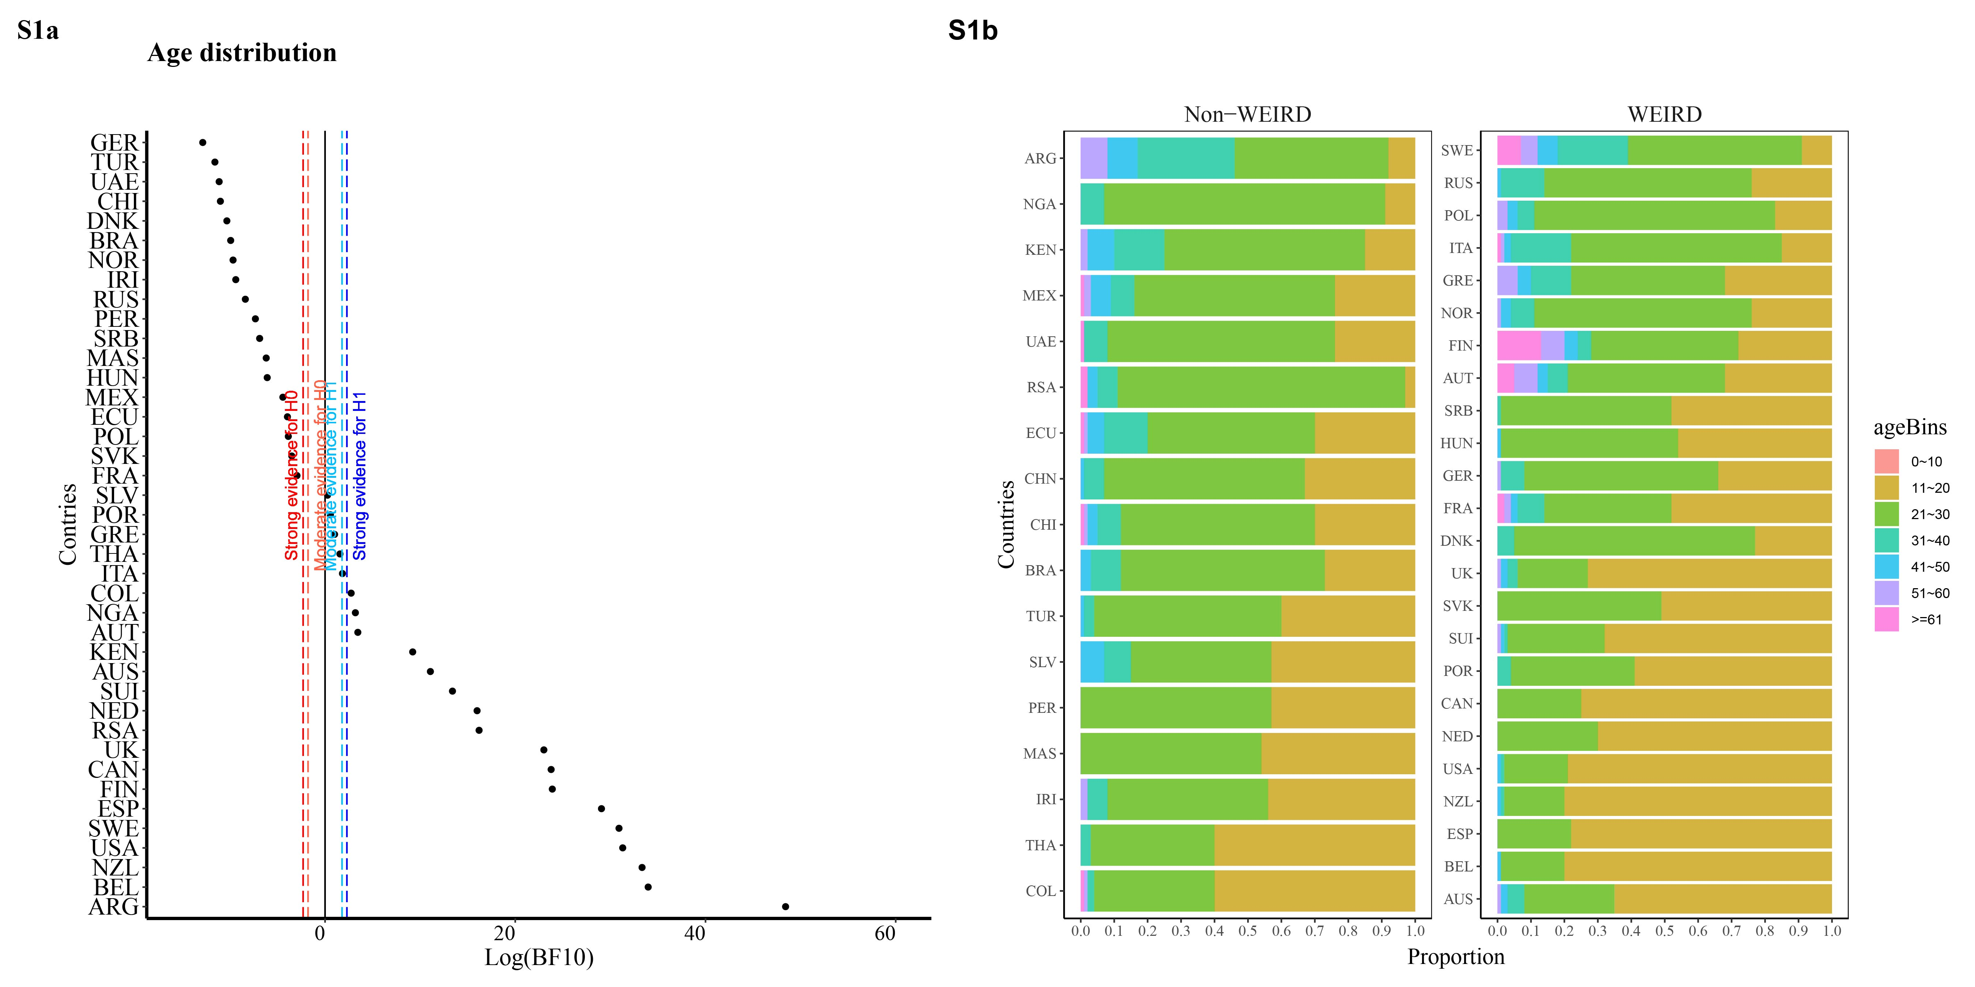

Figure S1a and S1b: The age distribution from PSA 001, with 10-year as intervals. (S1a) Pairwise comparisons of age distribution between Chinese psychological sample and available data from other countries; (S1b) Age proportion of all data. Country code: United Arab Emirates (UAE), South Africa (RSA), Thailand (THA), Turkey (TUR), Malaysia (MAS), China (CHN), Ecuador (ECU), Colombia (COL), Brazil (BRA), Peru (PER), Iran (IRI), Chile (CHI), El Salvador (SLV), Argentina (ARG), Nigeria (NGA), Kenya (KEN), Mexico (MEX), Slovakia (SVK), Romania (ROU), Netherlands (NED), France (FRA), Denmark (DNK), Switzerland (SUI), Spain (ESP), New Zealand (NZL), Portugal (POR), United Kingdom (UK), Germany (GER), Poland (POL), Serbia (SRB), Hungary (HUN), Australia (AUS), Austria (AUT), Finland (FIN), Russia (RUS), Norway (NOR), Italy (ITA), United States (USA), Canada (CAN), Greece (GRE), Sweden (SWE).