1.7

#include <iostream>

using namespace std;

int main()

{

int a,b,c;

int f(int x,int y,int z);

cin>>a>>b>>c;

c=f(a,b,c);

cout<<c<<endl;

return 0;

}

int f(int x,int y,int z)

{

int m;

if (x>y) m=x;

else m=y;

if (z>m) m=z;

return(m);

}

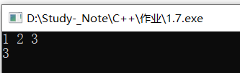

1.8

#include <iostream>

using namespace std;

int main()

{

void change(int &,int &);

int a,b;

cin>>a>>b;

if(a<b) change(a,b);

cout<<a<<" "<<b<<endl;

return 0;

}

void change(int &x,int &y)

{

int temp;

temp = x;

x = y;

y = temp;

}

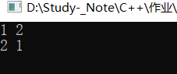

1.9

#include <iostream>

using namespace std;

int main()

{

void sort(int &,int &,int &);

int a,b,c,a1,b1,c1;

cout<<"Please enter 3 integers:";

cin>>a>>b>>c;

a1=a;b1=b;c1=c;

sort(a1,b1,c1);

cout<<a<<" "<<b<<" "<<c<<" in sorted order is ";

cout<<a1<<" "<<b1<<" "<<c1<<endl;

return 0;

}

void sort(int &i,int &j,int &k)

{ void change(int &,int &);

if (i>j) change(i,j);

if (i>k) change(i,k);

if (j>k) change(j,k);

}

void change(int &x,int &y)

{ int temp;

temp=x;

x=y;

y=temp;

}

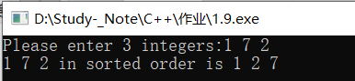

1.10

#include <iostream>

#include <string>

using namespace std;

int main(void)

{

string s1 = "c++",s2 = "NB";

cout<<"s1 = "<<s1<<endl;

cout<<"s2 = "<<s2<<endl;

s1 = s1+s2;

cout<<"the new string is "<<s1<<endl;

return 0;

}

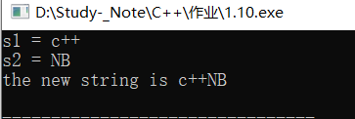

1.11

#include <iostream>

#include <string>

using namespace std;

int main()

{

string s1;

int i,n;

char temp;

cout<<"please cout a string";

cin>>s1;

n = s1.size();

for(i = 0;i<n/2;i++)

{

temp = s1[i];

s1[i] = s1[n-i-1];

s1[n-i-1] = temp;

}

cout<<s1<<endl;

return 0;

}

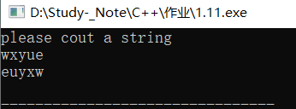

1.12

#include<iostream>

#include<string>

using namespace std;

int main()

{

int i;

string s1[5] = {"c++ teacher is so handsome",

"PH","c++","artist","deep dark fantastic"};

void sort(string []);

sort(s1);

for(i = 0;i < 5;i++)

{

cout<<s1[i]<<""<<endl;

}

return 0;

}

void sort(string s[])

{

int i,j;

string t;

for (i = 0;i < 5;i++)

for(j = 0;j < 5;j++)

if(s[i]>s[i+1])

{

t = s[i];

s[i] = s[i+1];

s[i+1] = t;

}

}

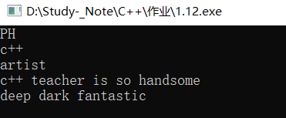

1.13

#include<iostream>

#include<string>

using namespace std;

int main()

{

int a[5] = {1,5,7,4,8};

float b[5] = {3.14,5.32,2.5,6.3,9.0};

long c[5] = {10120,-101023,118947,9034};

void sort(int []);

void sort(float []);

void sort(long []);

sort(a);

sort(b);

sort(c);

return 0;

}

void sort(int a[])

{

int i,j,min;

int t;

for(i = 0;i < 5;i++)

{

min = i;

for(j = i+1;j<5;j++)

if(a[min]>a[j]) min = j;

{

t = a[i];

a[i] = a[min];

a[min] = t;

}

}

cout<<"sorted:"<<endl;

for (i = 0;i < 5;i++)

cout<<a[i]<<" ";

cout<<endl<<endl;

}

void sort(float a[])

{

int i,j,min;

float t;

for(i = 0;i < 5;i++)

{

min = i;

for(j = i+1;j<5;j++)

if(a[min]>a[j]) min = j;

{

t = a[i];

a[i] = a[min];

a[min] = t;

}

}

cout<<"sorted:"<<endl;

for (i = 0;i < 5;i++)

cout<<a[i]<<" ";

cout<<endl<<endl;

}

void sort(long a[])

{

int i,j,min;

long t;

for(i = 0;i < 5;i++)

{

min = i;

for(j = i+1;j<5;j++)

if(a[min]>a[j]) min = j;

{

t = a[i];

a[i] = a[min];

a[min] = t;

}

}

cout<<"sorted:"<<endl;

for (i = 0;i < 5;i++)

cout<<a[i]<<" ";

cout<<endl<<endl;

}

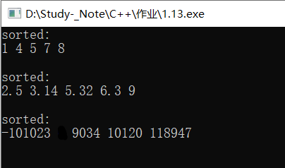

1.14

#include<iostream>

#include<string>

#define mina main

using namespace std;

template<typename T>

void sort(T a[])

{

int i,j,min;

T t;

for(i = 0;i < 5;i++)

{

min = i;

for(j = i+1;j<5;j++)

if(a[min]>a[j]) min = j;

{

t = a[i];

a[i] = a[min];

a[min] = t;

}

}

cout<<"sorted:"<<endl;

for (i = 0;i < 5;i++)

cout<<a[i]<<" ";

cout<<endl<<endl;

}

int mina()

{

int a[5] = {1,5,7,2,8};

float b[5] = {1.5,23.24,23.1,8976,1.0};

long c[5] = {102808749,2378127,2387,2189798,289738};

sort(a);

sort(b);

sort(c);

return 0;

}

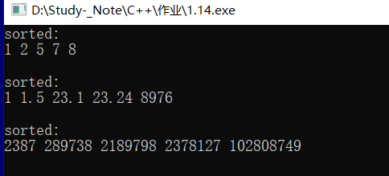

3.2

#include <iostream>

using namespace std;

class Date

{ public:

Date(int,int,int);

Date(int,int);

Date(int);

Date();

void display();

private:

int month;

int day;

int year;

};

Date::Date(int m,int d,int y):month(m),day(d),year(y) { }

Date::Date(int m,int d):month(m),day(d) {year=2005;}

Date::Date(int m):month(m)

{ day=1;

year=2005;

}

Date::Date()

{ month=1;

day=1;

year=2005;

}

void Date::display()

{

cout<<month<<"/"<<day<<"/"<<year<<endl;

}

int main()

{

Date d1(10,13,2005);

Date d2(12,30);

Date d3(10);

Date d4;

d1.display();

d2.display();

d3.display();

d4.display();

return 0;

}

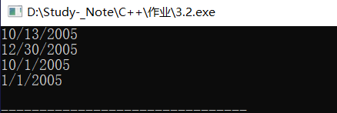

3.5

#include<iostream>

using namespace std;

class Student{

public:

Student(int n,float s):num(n),score(s){}

int num ;

float score;

};

int main()

{Student stu[5] = {

Student(1707004340,100.0),Student(1707004301,60.5),

Student(1707004342,89.2),Student(1707004341,99.0),

Student(1707004323,92.1)};

void max(Student[]);

Student *p = &stu[0];

max(p);

}

void max(Student *arr)

{

float max_score = arr[0].score;

int k = 0;

for (int i = 0;i < 5;i++)

{

if(arr[i].score > max_score)

{

max_score = arr[i].score;

k = i;

}

}

cout<<arr[k].num<<" "<<max_score<<endl;

}

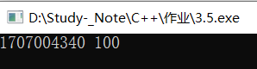

3.6

#include <iostream>

using namespace std;

class Student

{ public:

Student(int n,float s):num(n),score(s){}

void change(int n,float s) {num=n;score=s;}

void display(){cout<<num<<" "<<score<<endl;}

private:

int num;

float score;

};

int main()

{ Student stud(101,78.5);

stud.display();

stud.change(101,80.5);

stud.display();

return 0;

}

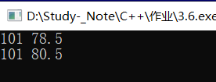

3.7

#include <iostream>

using namespace std;

class Student

{ public:

Student(int n,float s):num(n),score(s){}

void change(int n,float s) const {num=n;score=s;}

void display() const {cout<<num<<" "<<score<<endl;}

private:

int num;

float score;

};

int main()

{

const Student stud(101,78,5)

stud.display();

stud.change(101,80.5);

stud.display();

return 0;

}

//第三问：

int main()

{

Student stud(101,78,5);

Student *p = &stud;

p->display();

p->change(101,80.5);

p->display();

return 0;

}

3.8

#include <iostream>

using namespace std;

class Student

{ public:

Student(int n,float s):num(n),score(s){}

void change(int n,float s) {num=n;score=s;}

void display(){cout<<num<<" "<<score<<endl;}

private:

int num;

float score;

};

int main()

{

void fun(Student &);

Student stud(101,78.5);

fun(stud);

return 0;

}

void fun(Student &stu)

{

stu.display();

stu.change(101,80.5);

stu.display();

}

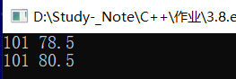

3.9

#include<iostream>

using namespace std;

class Shangpin{

public:

Shangpin(int n,int q,float p):num(n),quantity(q),price(p){};

void total();

static float ave();

static void display();

private:

int num;

int quantity;

float price;

static float discount;

static float sum;

static int n;

};

void Shangpin::total()

{

float rate = 1.0;

if (quantity > 10) rate = 0.98*rate;

sum = sum+quantity*price*(discount);

n = n + quantity;

}

void Shangpin::display()

{

cout<<sum<<endl;

cout<<ave()<<endl;

}

float Shangpin::ave()

{

return (sum/n);

}

float Shangpin::discount = 0.95;

float Shangpin::sum = 0;

int Shangpin::n = 0;

int main()

{

Shangpin sha[3] = {Shangpin(101,5,23.5),Shangpin(102,12,24.56),Shangpin(103,100,21.5)};

for(int i = 0;i < 3;i++)

{

sha[i].total();

Shangpin::display();

return 0;

}

}

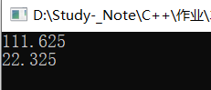

3.10

#include <iostream>

using namespace std;

class Date;

class Time

{ public:

Time(int,int,int);

friend void display(const Date &,const Time &);

private:

int hour;

int minute;

int sec;

};

Time::Time(int h,int m,int s)

{ hour=h;

minute=m;

sec=s;

}

class Date

{ public:

Date(int,int,int);

friend void display(const Date &,const Time &);

private:

int month;

int day;

int year;

};

Date::Date(int m,int d,int y)

{ month=m;

day=d;

year=y;

}

void display(const Date &d,const Time &t)

{

cout<<d.month<<"/"<<d.day<<"/"<<d.year<<endl;

cout<<t.hour<<":"<<t.minute<<":"<<t.sec<<endl;

}

int main()

{

Time t1(10,13,56);

Date d1(12,25,2019);

display(d1,t1);

return 0;

}

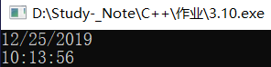

3.11

#include <iostream>

using namespace std;

class Time;

class Date

{ public:

Date(int,int,int);

friend Time;

private:

int month;

int day;

int year;

};

Date::Date(int m,int d,int y):month(m),day(d),year(y){ }

class Time

{ public:

Time(int,int,int);

void display(const Date &);

private:

int hour;

int minute;

int sec;

};

Time::Time(int h,int m,int s):hour(h),minute(m),sec(s){ }

void Time::display(const Date &d)

{

cout<<d.month<<"/"<<d.day<<"/"<<d.year<<endl;

cout<<hour<<":"<<minute<<":"<<sec<<endl;

}

int main()

{

Time t1(10,13,56);

Date d1(12,25,2019);

t1.display(d1);

return 0;

}

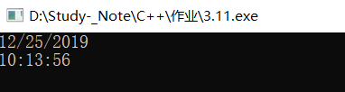

3.12

#include <iostream>

using namespace std;

template<class numtype>

class Compare

{ public:

Compare(numtype a,numtype b);

numtype max();

numtype min();

private:

numtype x,y;

};

template <class numtype>

Compare<numtype>::Compare(numtype a,numtype b)

{x=a;y=b;}

template <class numtype>

numtype Compare<numtype>::max()

{return (x>y)?x:y;}

template <class numtype>

numtype Compare<numtype>::min()

{return (x<y)?x:y;}

int main()

{ Compare<int> cmp1(3,7);

cout<<cmp1.max()<<" is the Maximum of two integer numbers."<<endl;

cout<<cmp1.min()<<" is the Minimum of two integer numbers."<<endl<<endl;

Compare<float> cmp2(45.78,93.6);

cout<<cmp2.max()<<" is the Maximum of two float numbers."<<endl;

cout<<cmp2.min()<<" is the Minimum of two float numbers."<<endl<<endl;

Compare<char> cmp3('a','A');

cout<<cmp3.max()<<" is the Maximum of two characters."<<endl;

cout<<cmp3.min()<<" is the Minimum of two characters."<<endl;

return 0;

}

