Chenyi Xu 260948311

Yongru Pan 261001758

Executive summary

The assignment is divided into two parts. For the first part, a VHDL implementation of a 4-bit circular barrel shifter was created. Both the structural and behavioral descriptions were included. The barrel shifter was built by using the idea of stacking two layers of four 2 x 1 multiplexers. For the second part of the assignment, the VHDL description of a ripple carry adder, a half adder, a full adder, and a one-digit BCD adder were implemented. All the aforementioned circuits were examined with a testbench code.

Code Explanations:

* 4 bit circular barrel shifter
  + The structural description of the 4-bit circular barrel shifter is autogenerated from the schematic design. Followed by that, the test bench code is generated as well. Since there are 6 inputs, there will be 2^6 possibilities. Therefore, we choose to use a FOR loop to replace the always part in the testbench file to generate all of the possible input patterns.
  + The bit is essentially shifting in a 4 bit circular barrel shifter. Under the condition of selected sel, conditions of Y is listed using input X.

Structural:

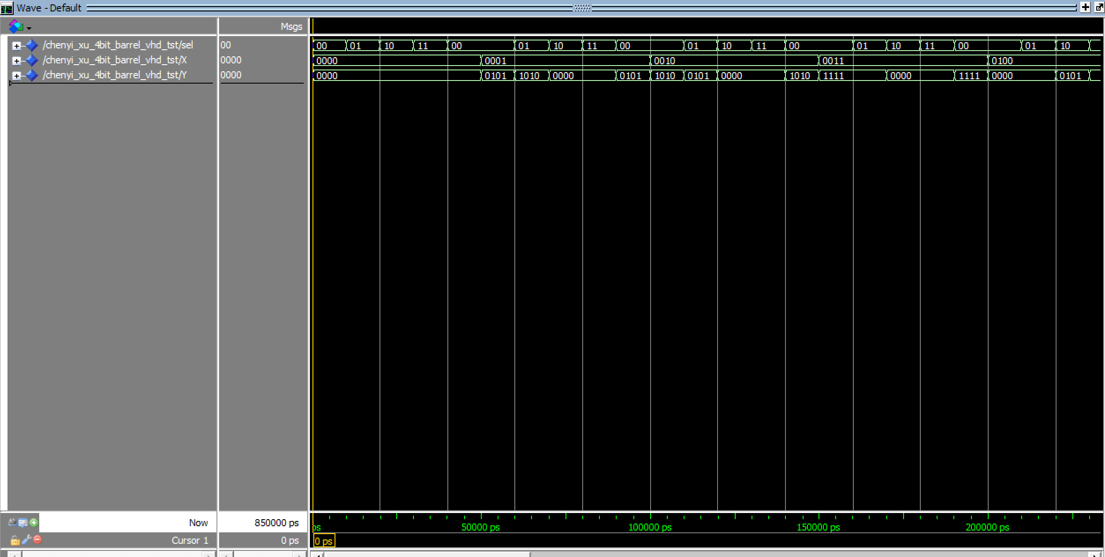

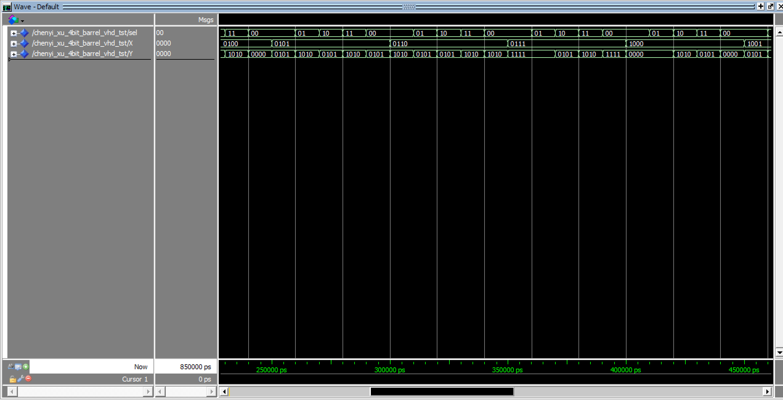

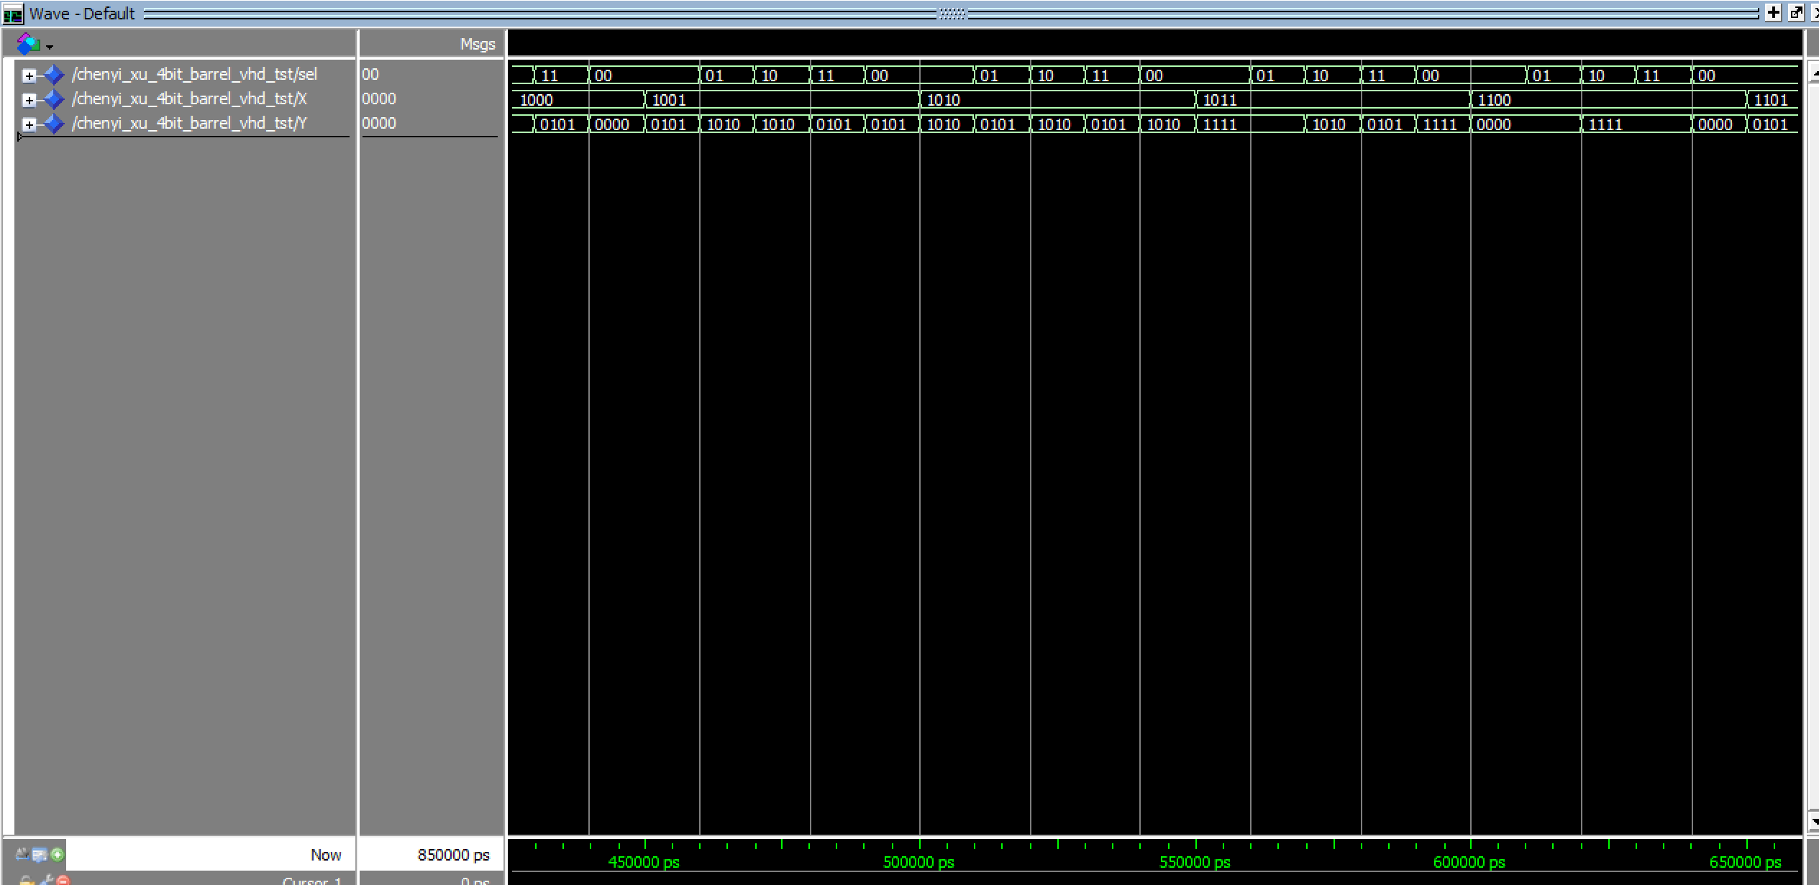

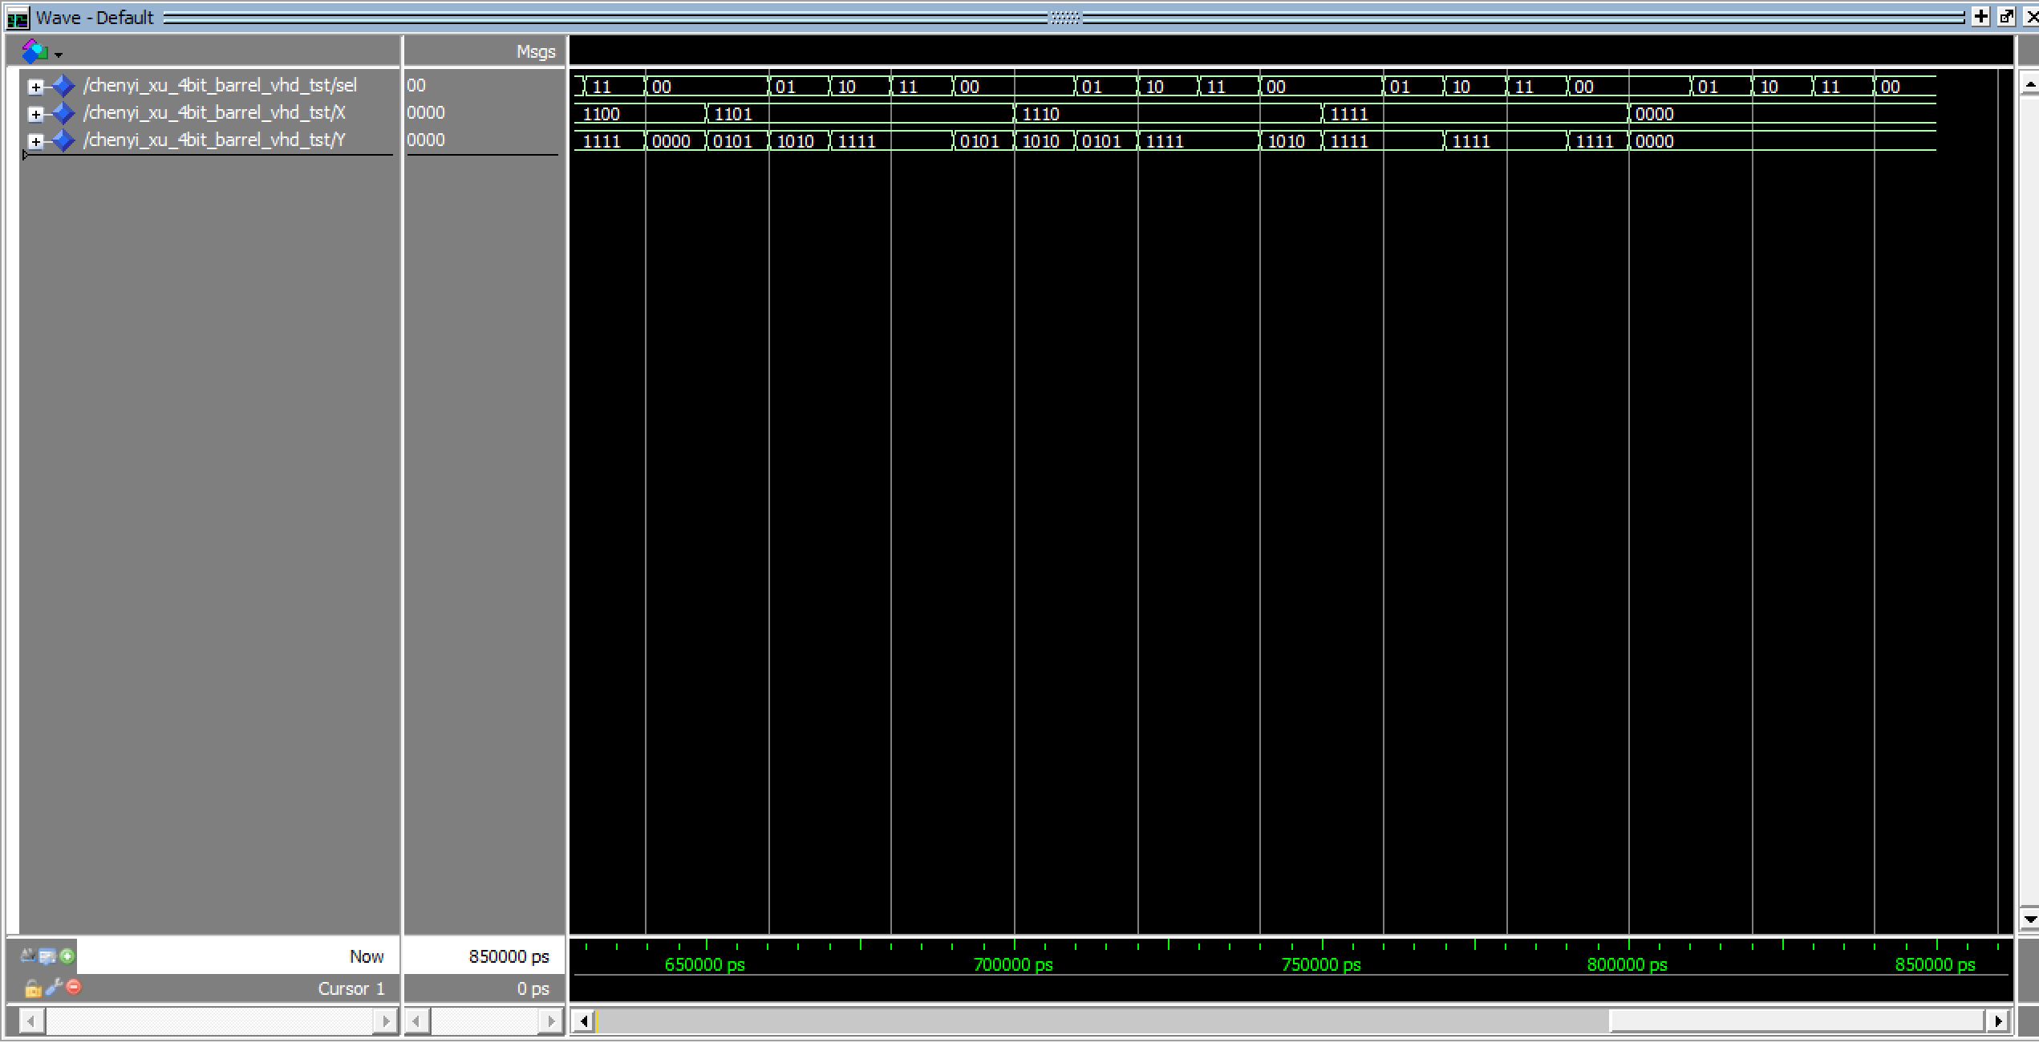

Behavioral

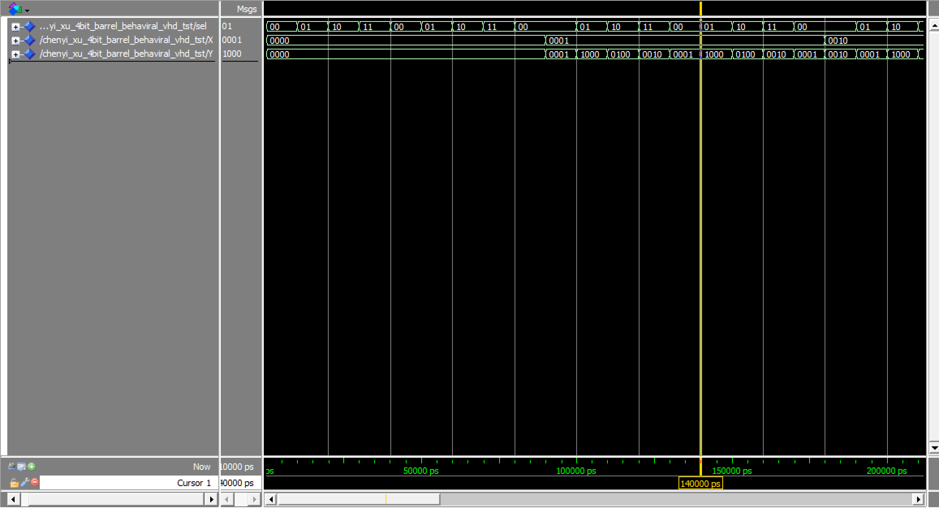

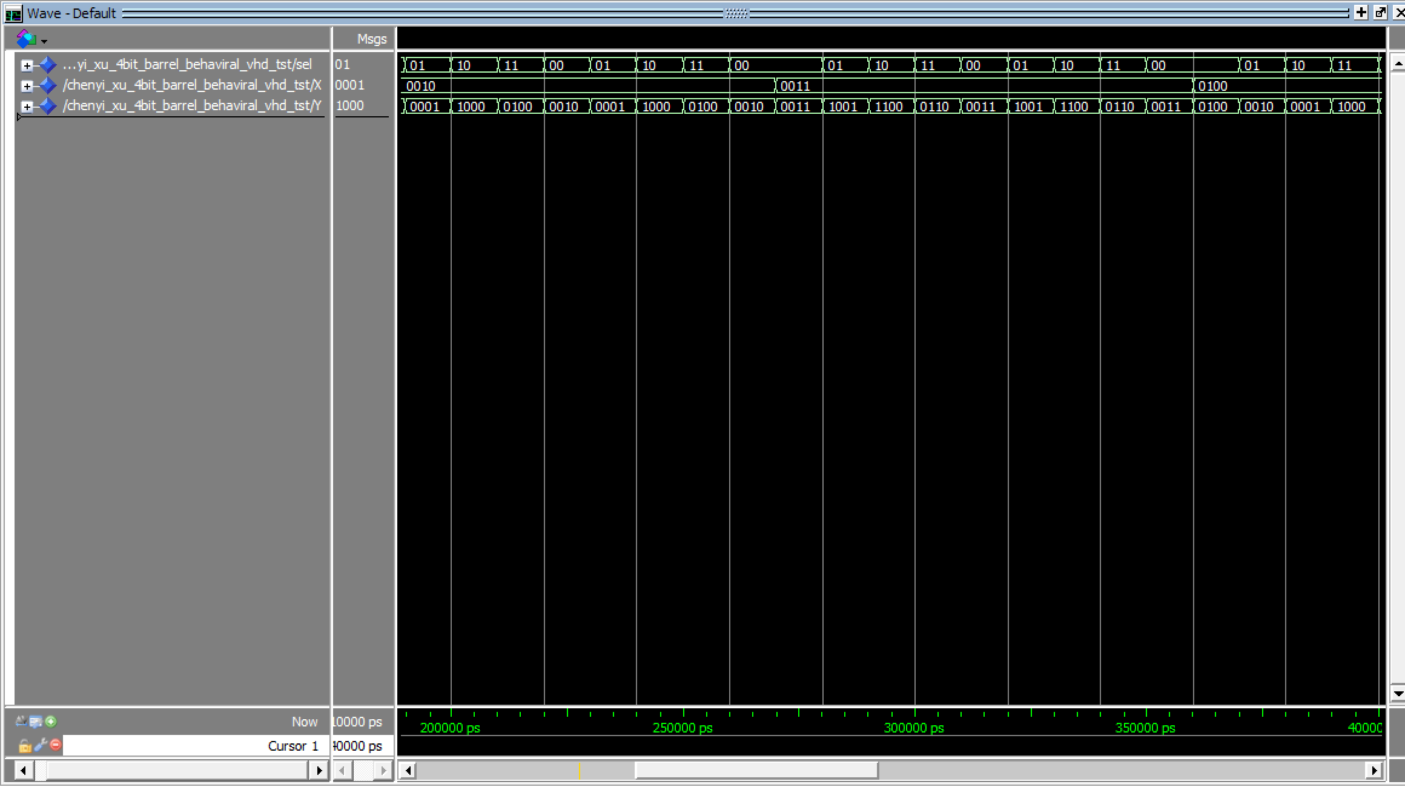

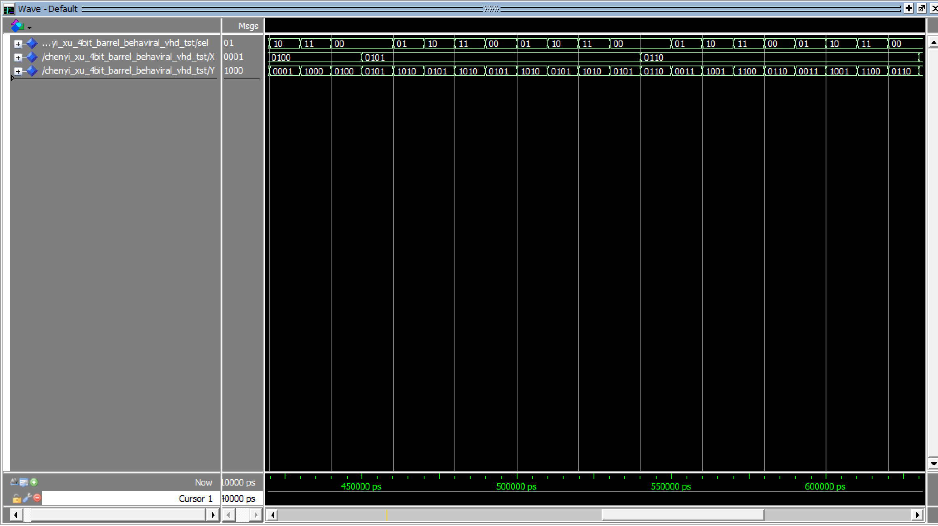

* Half adder
  + A Half-Adder is composed of 1 XOR gate and 1 AND gate with 2 inputs and 2 outputs. Input a XOR b would create an output sum which is s here. Moreover, input a AND input b would create an output carry which is c here. Drew the schematic diagram out and use the autogenerate function in Quartus to generate the structural design and its testbench.

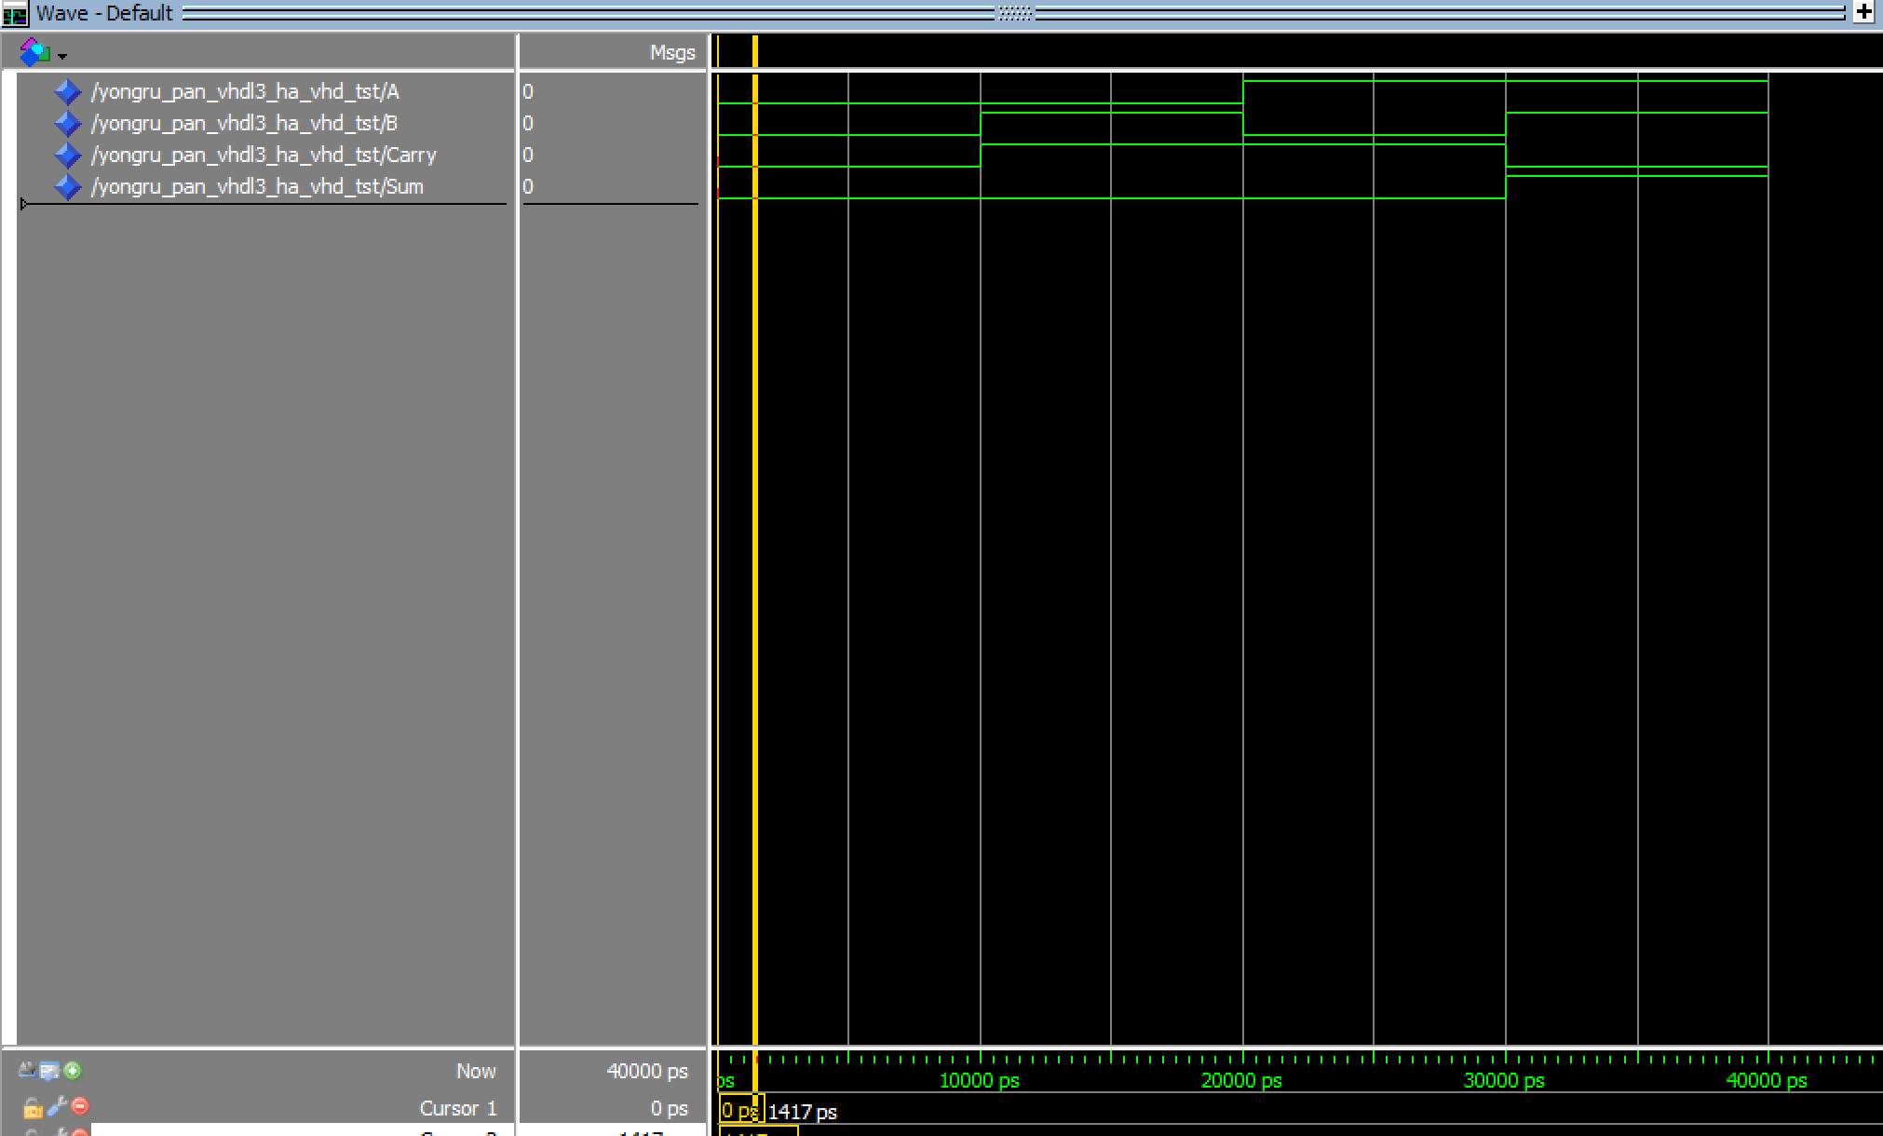

* Full adder
  + A Full-Adder is composed of 1 XOR gate, 3 AND gate, and 1 OR gate. The output sum which is s here is the XOR of input a, b, and c_in. The carry part consists of 3 AND gate and 1PR gate. The input of first AND gate is a and b. The input of second AND is a and c_in. The input of the third AND gate is b and c_in. The input of the OR gate consists of the outputs from the three AND gates.

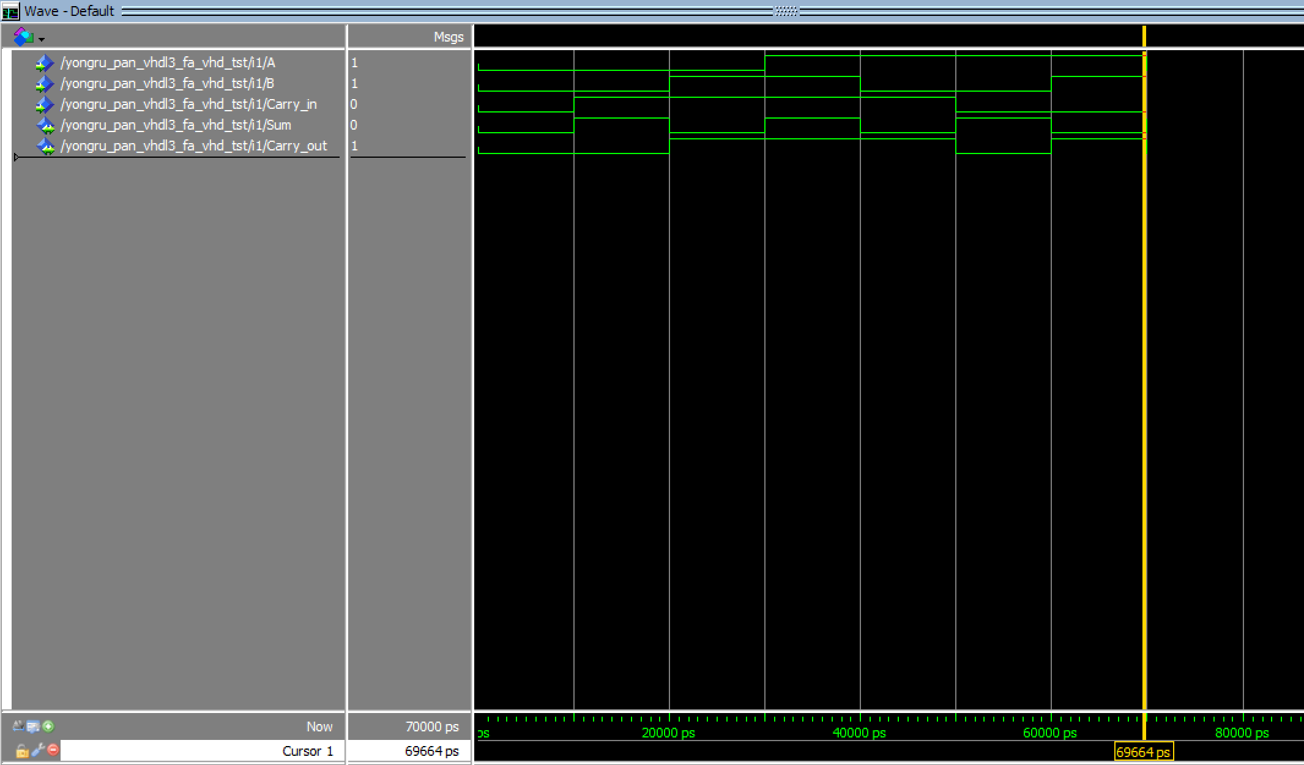

* RCA
  + A ripple carry adder consists of three full adders and one half adders. The schematic diagram of a 4-bit ripple carry adder is drawn. Quartus was used to generate behavioral design and testbench.
* One digit BCD Adder
  + BCD adder consists of two four-bit binary adder, two AND gates, and one OR gate. In BCD adder, when the intermediate carry out is less than or equal to 9, no need to perform another addition. When the intermediate carry out is more than 9, we need to add 6 to the result to get a carry out.

Behavioral

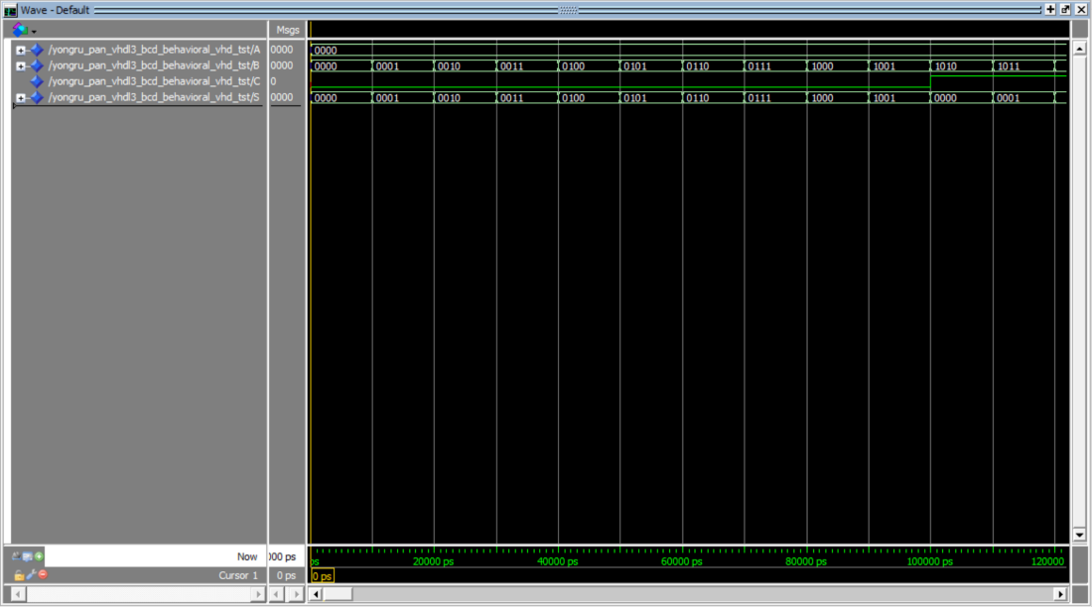

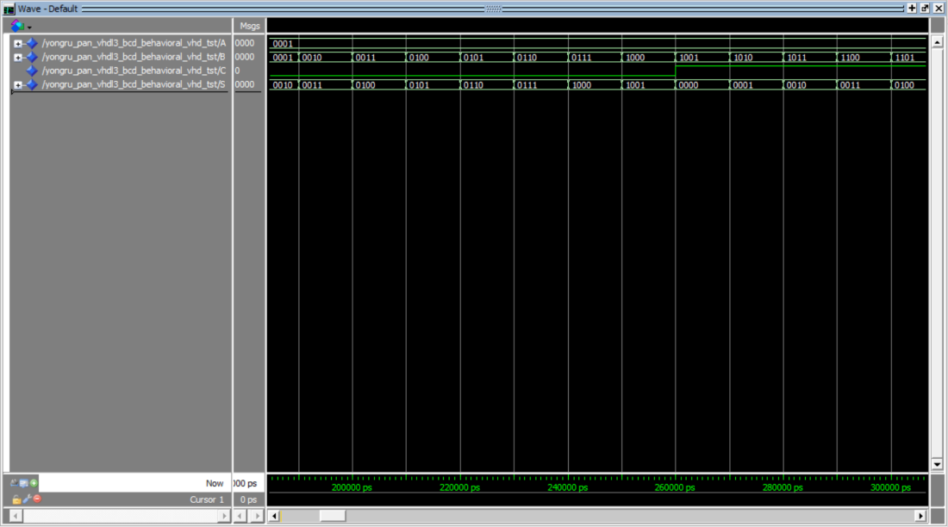

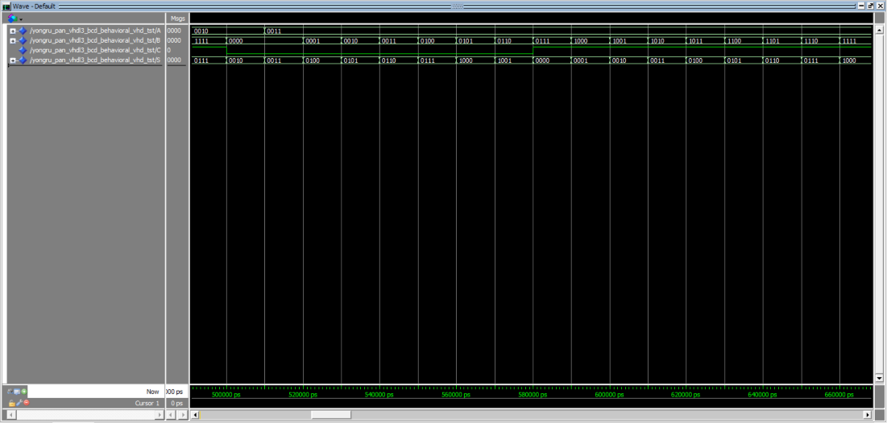

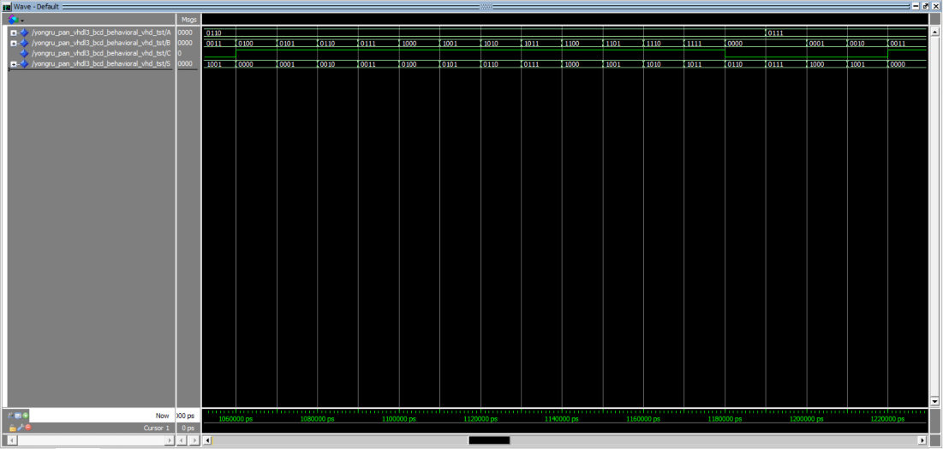

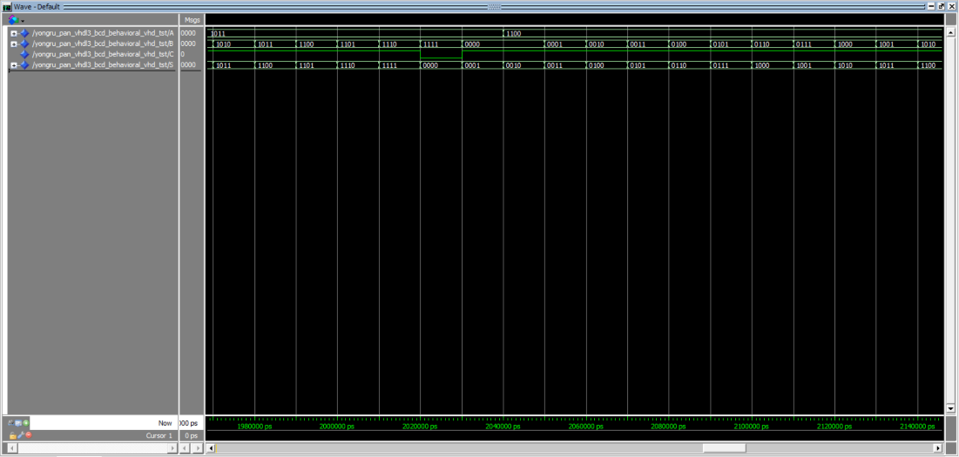

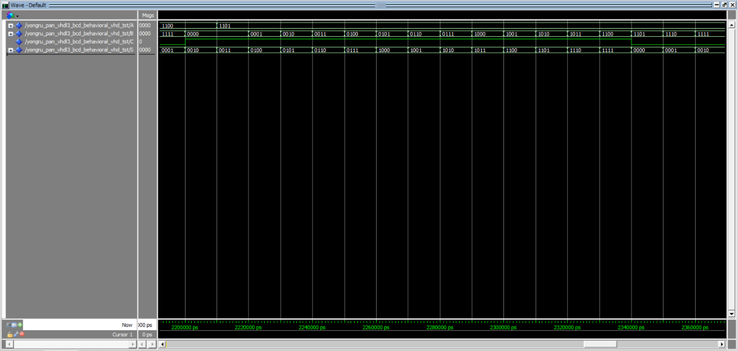

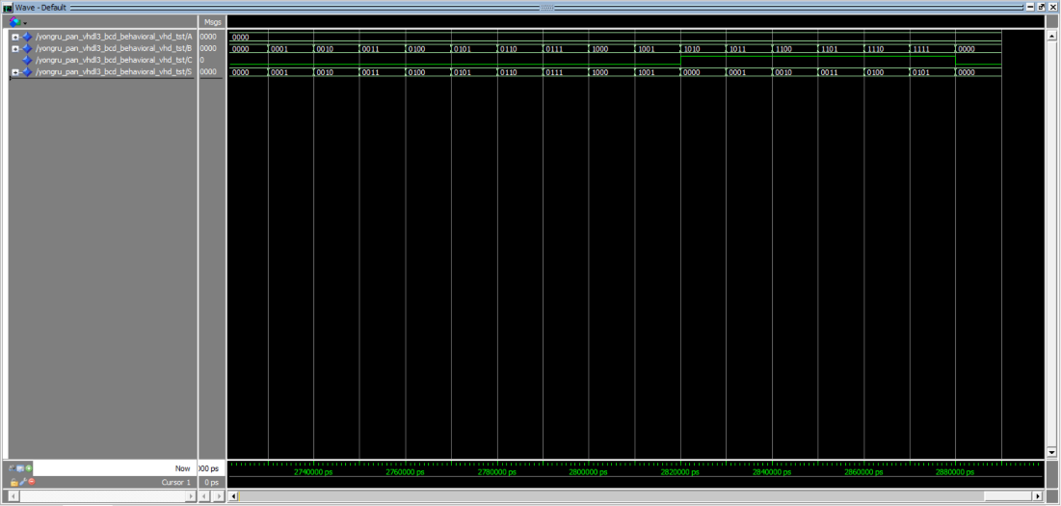

structural

|  |  |  |  |  |  |  |
| --- | --- | --- | --- | --- | --- | --- |
|  | 4 bit circular barrel shifter | | RCA | | One-digit BCD adder | |
|  | Structural | Behavioral | Structural | Behavioral | Structural | Behavioral |
| Logic utilization | 3 | 5 |  |  |  | 5 |
| Total pins | 10 | 10 |  |  |  | 13 |

Conclusion

Simulations of a 4-bit circular barrel shifter, half-adder, full adder, and one digit BCD adder structural are successfully created. RCA and BCD adder structural failed due to compiling issues that cannot be resolved.