**1.3 Autorecon**

**Overview**

Having an effective (both in data enumerated and efficiency in the time spent) approach to enumeration is a high priority for any penetration tester. While there are many approaches to enumeration, any task that you need to do more than once should be automated. Autorecon allows you to automate the enumeration phase of your penetration test, without compromising on detailed results.

**Autorecon**

**How is it used**

At its core, Autorecon is a Python application. It is installed by cloning the GitHub repository, and installing the dependencies. Once it is installed, you simply point the script at a target (the machine you are enumerating) and let it work through the scans. Once it is done, it will provide a directory which will be packed full of the scan results. You will also find a list of the commands Autorecon ran, along with a list of additional manual commands you may be interested in.

Autorecon also has the ability to scan targets from a target file . This is a text file with the IP address of each target, one per line.

Installing and using Autorecon will be covered in an exercise shortly.

**Why is this important**

Scanning targets is another penetration testing staple. Depending on the services initially uncovered with a recon tool such as nmap , the results will flow into another collection of tools for related scans. These in turn, can lead to a third tier of tools. If you are keeping up, this means you need to keep track of many dependent tools and commands.

Imagine you have started scanning a target, you find a service, and forgot to execute a command (to err is human). As a result, you have not seen a service, so you don't keep digging and you end up missing an opportunity for accessing the machine.

From the scenario above, it is clear that having consistent and repeatable results is extremely important in remaining methodical when enumerating targets.

**Real-world applications**

Consider the following scenario

You have been asked to conduct black-box testing on five targets in a lab. On one of the machines, you have been told to focus on the payment system web interface. For the other

four, you add their IP addresses to the targets file and run Autorecon . By the time you are finished conducting your command injection testing on the web application, you have detailed results from Autorecon, conveniently stored in an organised folder structure, along with a history of all commands run.

It should be clear that there are significant efficiencies in the use of automated tools as above. Having organised notes has already been discussed as being one of (if not the most) important aspects of penetration testing.

**Potential Issues**

Autorecon is an aggressive tool, it is more than capable of crashing some services and triggering preventative messages (such as fail2ban).

You need to run Autorecon with root level privileges. If you don't it will appear to work (the worst kind of broken), but it will miss out on enumerating key services. If you follow the setup section, you will be set up with shortcuts that automatically call it with sudo .

You will encounter some situations where you are unable to use autorecon, such as that described below.

Consider a scenario where you are attempting to scan a target over a pivot, or you have identified the target has services hosted on an IPv6 address. You will quickly encounter issues with autorecon in that it will attempt to use tools that do not function over certain pivot types, or that it does not currently work with IPv6 addresses at all.

In these instances, you would likely need to revert to manual enumeration. We will look at that in a future module.

**Exercise**

**Installation**

Start off by updating your list of packages:

sudo apt update

And install the package dependencies. Most will already be there, but just in case:

sudo apt install seclists curl enum4linux gobuster nbtscan nikto nmap onesixtyone oscanner smbclient smbmap smtp-user-enum snmp sslscan sipvicious tnscmd10g whatweb wkhtmltopdf python3-venv python3 python3-pip

Now to setup pipx <https://pypi.org/project/pipx/> (link provided for extra reading)

Don't use sudo or install as root for this part.

python3 -m pip install --user pipx

python3 -m pipx ensurepath

Close and re-open your terminal so it's all loaded.

You can check your version of pipx now, make sure it's modern (0.16.0.0+, you will have issues if it's 0.12.x.x which is the version installed through the kali package manager)

If you are on version 0.12.x.x , run sudo apt remove pipx and remove the package manager version.

Also, to upgrade it if it is <0.16.0.0 , run python3 -m pip install --user -U pipx

Now to install AutoRecon

pipx install git+https://github.com/Tib3rius/AutoRecon.git Assuming all went well, you will see an output like that below.

┌──(kali㉿kali02)-[~]

└─$ pipx install git+https:*//github.com/Tib3rius/AutoRecon.git* installed package autorecon 1.0.0, Python 3.9.1

These apps are now globally available

- autorecon

done! ✨ �� ✨

Let's try and run it:

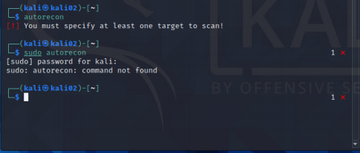

It works fine as the kali user, but not with sudo . If you recall, we need to run AutoRecon as root or with sudo so we need to get that fixed.

**Fixing sudo**

This part is easy and the AutoRecon GitHub offers a solution:

As the default shell on Kali is ZSH , we need to modify .zshrc which is in our home folder.

nano ~/.zshrc

Scroll down to the alias section and add the following line

alias sudo="sudo env \"PATH=$PATH\""

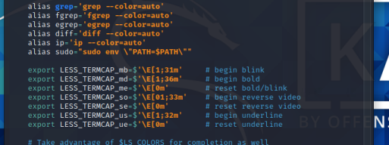Once that is done, either logout / login or use:

source ~/.zshrc

And you can now use sudo with AutoRecon



**Usage**

**Single Target**

A single target scan instructs AutoRecon to only target one host on the network. As per below, no additional flags or parameters are required.

sudo autorecon 192.168.0.114

**Multi-target, single line**

This example allows you to scan multiple targets (or networks using CIDR notation)

sudo autorecon 192.168.0.0/24 10.10.78.180 127.0.0.1

Note: AutoRecon will expand the CIDR notation in 192.168.0.0/24 and include all hosts automatically.

**Target File**

A target file is handy when you want to scan a collection of targets, without a need to constantly start AutoRecon.

Create your targets file. In the example below, I have called mine targets.txt and it contains four targets (one per line).

┌──(kali㉿kali02)-[~]

└─$ cat targets.txt

192.168.0.114

192.168.0.115

192.168.0.137

192.168.0.231

To specify the targets file, we use the -t flag.

sudo autorecon -t targets.txt

Note: remember, AutoRecon will appear to work without root privileges. Remember to run with sudo

Note: From the image, you can see that AutoRecon is threaded , meaning that it starts scans on multiple targets at once. This is much faster than scanning targets one at a time.

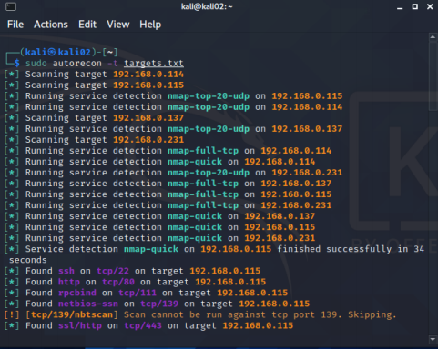**Accessing results**

By default, AutoRecon will store the results within a folder called results within the folder it is run. 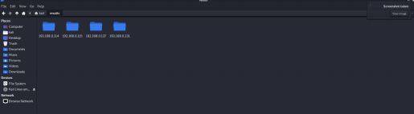You can drill down on these folders to locate sub-folders, like the scans folder shown below. This

folder contains the results of all scans completed against identified services.

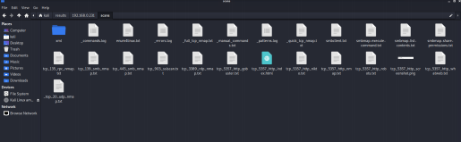**Results on a web server**

If you prefer viewing the results in a web server, you can use Python. You may recall these commands from the enumeration module. I have included both Python2 and Python3 , though you should focus on Python3 as Python2 is Deprecated.

Move into the results folder, and spawn your web server of choice using Python. **Python3**

/usr/bin/sudo python3 -m http.server 80

**Python2**

/usr/bin/sudo python2.7 -m SimpleHTTPServer 80

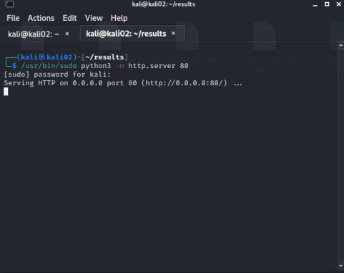

Once that is running, you may view the results as a web page

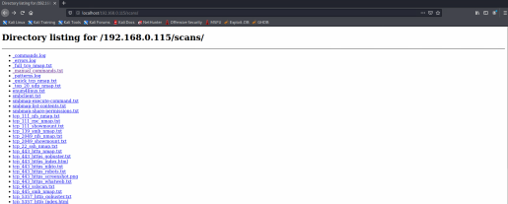

You may find this easier to read than using the kali file manager.

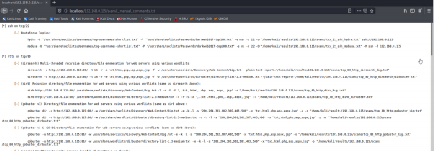**Adding an Alias**

You may also use the alias below to make hosting the web server easier. For example, typing pyweb 80 would host a web server on port 80, using the current folder as a web root. If you add the alias to your ~/.zshrc , be sure to run source ~/.zshrc and logout / login before you try and use it.

alias pyweb="/usr/bin/sudo python3 -m http.server"

Once the alias is sourced , you can call it with pyweb 1337 to host a web server of the current folder on port 1337 .

**Assessment**

Nil.